mongodb : version 1:3.6.3
node: v12.18.4
ngrok:2.3.35
install mongodb:

MongoDB is a cross-platform document-oriented database program. Classified as a NoSQL database program, MongoDB uses JSON-like documents with optional schemas. MongoDB is developed by MongoDB Inc. and licensed under the Server Side Public License.
1.Import the public key used by the package management system
$ sudo apt-key adv --keyserver hkp://keyserver.ubuntu.com:80 –recv 0C49F3730359A14518585931BC711F9BA15703C6
2.Create a list file for MongoDB:
$ echo "deb http://repo.mongodb.org/apt/ubuntu trusty/mongodb-org/3.4 multiverse" | sudo tee /etc/apt/sources.list.d/mongodb-org-3.4.list
3.Reload local package database:
$ sudo apt-get update
4.Install the MongoDB packages
$ sudo apt-get install -y mongodb-org

Start MongoDB:
$ sudo service mongod start

Stop MongoDB.
$ sudo service mongod stop

Restart MongoDB
$ sudo service mongod restart
install react native :
React Native is an open-source mobile application framework created by Facebook, Inc. It is used to develop applications for Android, Android TV, iOS, macOS, tvOS, Web, Windows and UWP by enabling developers to use React's framework along with native platform capabilities.

Setting up the development environment:
Assuming that you have Node 12 LTS or greater installed, you can use npm to install the Expo CLI command line utility:
$ npm install -g expo-cli
Then run the following commands to create a new React Native project called "AwesomeProject":
$ expo init AwesomeProject
$ cd AwesomeProject
$ npm start # you can also use: expo start
install node js ubuntu:

Introduction
Node.js is a JavaScript platform for general-purpose programming that allows users to build network applications quickly. By leveraging JavaScript on both the front and backend, Node.js makes development more consistent and integrated.
Ubuntu 18.04 contains a version of Node.js in its default repositories that can be used to provide a consistent experience across multiple systems. At the time of writing, the version in the repositories is 8.10.0. This will not be the latest version, but it should be stable and sufficient for quick experimentation with the language.
To get this version, you can use the apt package manager. Refresh your local package index by typing:
$ sudo apt update
Install Node.js from the repositories:
$ sudo apt install nodejs
If the package in the repositories suits your needs, this is all you need to do to get set up with Node.js. In most cases, you’ll also want to install npm, the Node.js package manager. You can do this by typing:
$ sudo apt install npm
This will allow you to install modules and packages to use with Node.js.
Because of a conflict with another package, the executable from the Ubuntu repositories is called nodejs instead of node. Keep this in mind as you are running software.
To check which version of Node.js you have installed after these initial steps, type:
$ nodejs -v
Install ngrok
ngrok secure introspectable tunnels to localhost webhook development tool and debugging tool.
To install ngrok, simply use the following command:
$ sudo snap install ngrok
ngrok allows you to expose a web server running on your local machine to the internet. Just tell ngrok what port your web server is listening on.

example: Expose a web server on port 80 of your local machine to the internet
ngrok http 80

Installing with npm:
To install Node-RED you can use the npm command that comes with node.js:
sudo npm install -g --unsafe-perm node-red
This command will install Node-RED as a global module along with its dependencies.
You can confirm it has succeeded if the end of the command output looks similar to:

Installing with docker:
To run in Docker in its simplest form just run:
docker run -it -p 1880:1880 --name mynodered nodered/node-red

Running:
Once installed as a global module you can use the node-red command to start Node-RED in your terminal. You can use Ctrl-C or close the terminal window to stop Node-RED.
$ node-red

Running under Docker:
To run in Docker in its simplest form just run:
docker run -it -p 1880:1880 -v node_red_data:/data --name mynodered nodered/node-red
Let’s dissect that command:
docker run - run this container, initially building locally if necessary
-it - attach a terminal session so we can see what is going on
-p 1880:1880 - connect local port 1880 to the exposed internal port 1880
-v node_red_data:/data - mount the host node_red_data directory to the container /data directory so any changes made to flows are persisted
--name mynodered - give this machine a friendly local name
nodered/node-red - the image to base it on - currently Node-RED v1.2.0
If you need to restart the container :
docker start mynodered
and stop it again when required:
docker stop mynodered

How to create user in MongoDB with read only privilege
We can create user in MongoDB with read-only privilege with few quick steps. During user creation, read-only role on a database will be assigned to the user.
Steps
Connect to MongoDB as the admin user
Create the user in MongoDB and assign read-only privilege to the user
Authenticate to MongoDB as the new user and test the read-only privilege

Connect to MongoDB as the admin user.
The admin user, being the privileged user should authenticate on “admin” database. Follow the below steps to connect to MongoDB as the admin user
$ mongo$ use adminMongoDB Enterprise > db.auth("admin","wysheid") # provide admin user and password

Create user in MongoDB and assign read-only privilege to the user.
Make sure that you are in the admin database before executing this command
MongoDB Enterprise > db.createUser({user: "user1",pwd: "test", roles: [{role:"read", db: "school"}]})

In above exampe,
use1==> username ,
pwd==> password
read==> read only role
db/school ==> name of the database
Authenticate to MongoDB as the new user and test the read-only privilege.
This read-only user should authenticate on the admin database before using the school database
$ mongo
execute the beloe command from MongDB Shell

MongoDB Enterprise > use admin MongoDB Enterprise > db.auth("user1","test") MongoDB Enterprise > use school MongoDB Enterprise > show collections MongoDB Enterprise > db.class.find() ==> this command will select the documents or records from class collection
install Docker:
Docker is a set of platform as a service products that use OS-level virtualization to deliver software in packages called containers. Containers are isolated from one another and bundle their own software, libraries and configuration files; they can communicate with each other through well-defined channels.

Uninstall old versions
Older versions of Docker were called docker, docker.io, or docker-engine. If these are installed, uninstall them:
$ sudo apt-get remove docker docker-engine docker.io containerd runc
It’s OK if apt-get reports that none of these packages are installed.

Install Docker Engine
$ sudo apt-get update
$ sudo apt-get install docker-ce docker-ce-cli containerd.io
=>To install a specific version of Docker Engine,
a.list the available versions in the repo, then select and install:
$ apt-cache madison docker-ce
b. Install a specific version using the version string from the second column, for example, 5:18.09.1~3-0~ubuntu-xenial.
$ sudo apt-get install docker-ce=<VERSION_STRING> docker-ce-cli=<VERSION_STRING> containerd.io
- Verify that Docker Engine is installed correctly by running the hello-world image.
$ sudo docker run hello-world
install hivemq:
HiveMQ is a MQTT broker - a messaging platform for fast, efficient and reliable data movement to and from connected IoT devices and enterprise systems.
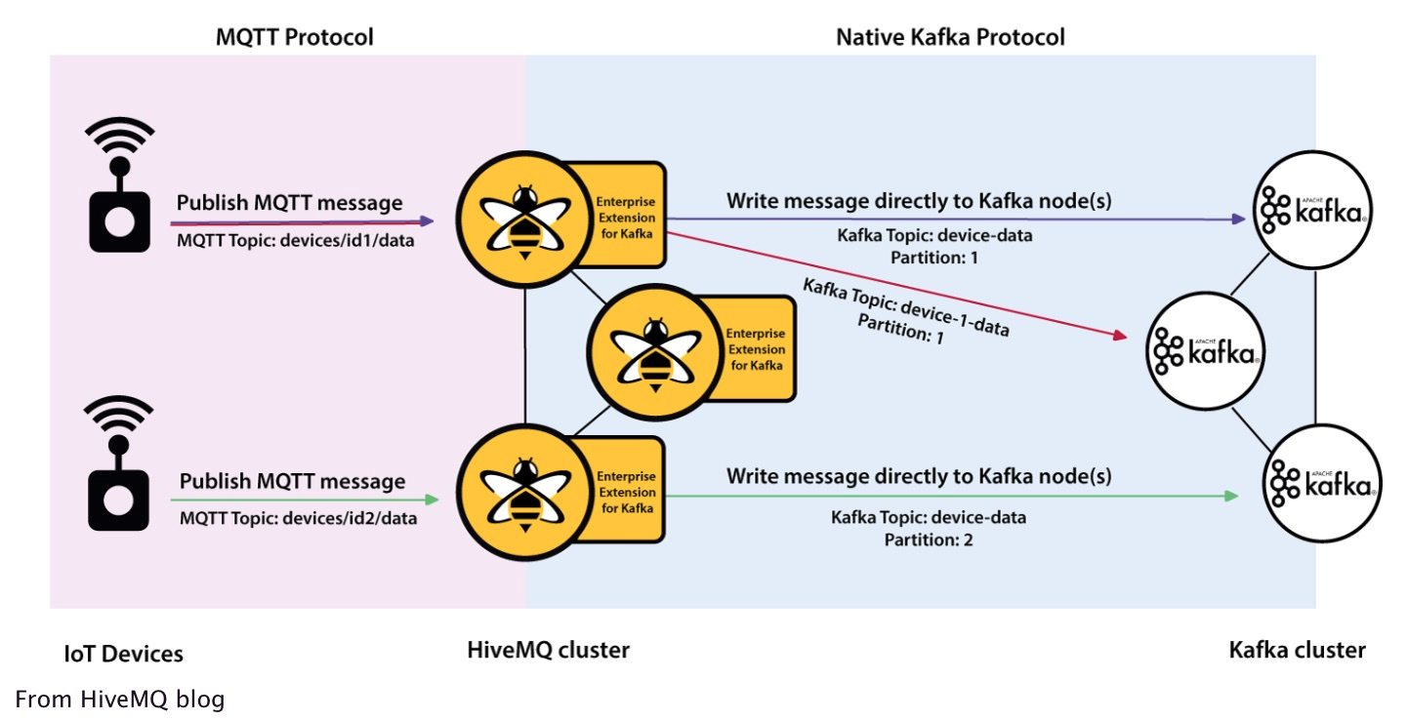

1.Download and run HiveMQ:
Running the HiveMQ trial with Docker is the simplest way to experiment with HiveMQ and MQTT. The following command downloads and starts a single HiveMQ trial node:
$ docker run -p 8080:8080 -p 1883:1883 hivemq/hivemq4

2.Try out:
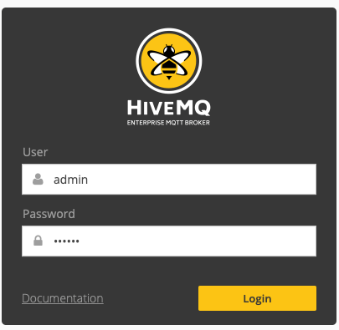

You can login with the default credentials (user: admin password: hivemq)
Any MQTT client can be connected to HiveMQ on port 1883 now.
=> https://www.emqx.io/

How to Build a Web App with React Native
The power of React Native as a framework continues to increase over time. For those who are unfamiliar, React Native is a cross-platform framework developed by Facebook. It’s open source and lets you build mobile applications using JavaScript as its core.
Thanks to Nicolas Gallagher’s open source project React Native for Web, now you can use React Native API components to build a web application that uses React DOM as its core. React Native already makes it convenient to write mobile apps for two platforms: iOS and Android. And now the web is slowly entering the picture. 🤩
Sounds interesting, right? In this tutorial, that’s what we’re going to do. We’re going to walk through, step-by-step, the process of integrating a Web App that uses React Native.

Requirements
- NodeJS version >= 8.x.x and npm/yarn
- Basic understanding of ES6 JavaScript features, ReactJS, and React Native will be helpful.

Getting Started: Create a React App
To start, go to your terminal and install the following command line tools. The first one will help you scaffold a React app, and the other one will run a React Native app:
npm install -g create-react-app expo
Note: You might have to use sudo in front of the above command if npm permissions are not set and everything is the default.
After the installation, run the following command from a terminal window in order to generate a new React project:
create-react-app reactnativeweb-demo
This will generate a new directory. A good thing about this project generating ( official) tool is that it already includes built-in support for aliasing react-native-web to react-native.
The next step is to install a couple more dependencies to make this project work like we want it to. Make sure you traverse inside the newly created project directory and then run the below command:
yarn add --dev babel-plugin-module-resolver
The babel plugin babel-plugin-module-resolver will help you resolve your project modules when compiling with Babel. React Native uses the Babel compiler internally. Now install the most essential dependencies, without which this project would not run.
yarn add react-native expo react-native-web
The last step, for now, is to create a file called .babelrc at the root of the project with the following snippet:

{
"plugins": [
[
"module-resolver",
{
"alias": {
"^react-native$": "react-native-web"
}
}
]
]
}
Note: If you want to configure a react-native-web app project where you use your own webpack configuration, or need to write modules with jest, or if you’re a fan of flow, you should take a look at this link in order to make things work properly.

Running on the Web
Before we proceed to build a demo application, let’s see if the current configuration works or not. Open your src/App.js file and replace the content inside it with the following snippet of code:

import React from "react"
import { StyleSheet, Text, View } from "react-native"
class App extends React.Component {
render() {
return (
<View>
<Text style={styles.text}>Hello, world!</Text>
</View>
)
}
}
const styles = StyleSheet.create({
text: {
fontWeight: "bold",
fontSize: 30
}
})
export default App
Here, we’re basically using the react-native API build UI components for the web application. Do note that, in React Native terms, View is the equivalent of a div in HTML and text is the equivalent of p or a span. There are a lot of similarities between the APIs of the mobile UI and the Web, but there are important differences to understand and keep in mind.
To run the application, go to a terminal window and write npm start and execute it. In a browser window, on visiting URL http://localhost:3000 you will get the following result.

