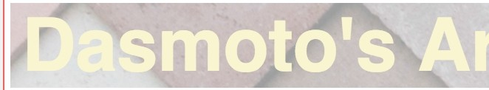

I

;:::=::=::=::=:::--

- ---

font-fami y: Helvetica;

font-size:lOOpx;

-i--;t;o;nt:.we. llt;.bold,

**color:khaki;**

font-size:32px;

font-weight:bold; color: white;

text is centered horizontal

background-color:mediumspringgreen;

# Hacksaw Brushes

font-fami y:Helvetica; font-weight:bo d;

color:blue;

Made of the highest quality oak, Hacksaw brushes are known for their weight and ability to hold paint in large amounts. Available in different sizes. Starti at $3.00 *I*

brush.



background-color:lightcoral;

# Art Frames (assorted)

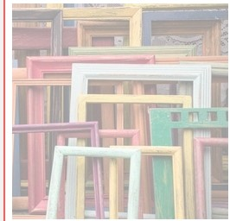

Assorted frames made of different material,including MDF,birchwood, and PDE. Select frames can be sanded and painted according to your needs. Starting at $2.00

*I* frame.

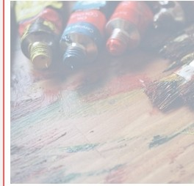 background-color: skyblue;

# Clean Finnish Paint

Imported paint from Finland.Over 256 colors available in-store,varying in quantity (1 oz. to 8 oz.). Clean Finnish paint microbinds to canvas, increasing the finish and longevity of any artwork. Starting at $5.00 *I* tube.