# Internship Project Report

Submitted in partial fulfillment of the requirement for the award of a certificate of internship programme

## in

**Dutta Computer Academy, Kolkata**

**Reg. under Govt. of WB | MSME, Govt. of India | ISO 9001:2015 Certified**

**Affiliated by: EMAX India Pvt. Ltd.**

**Submitted to**



**Submitted by**

**CHIRODEEP DUTTA**

**Under the Supervision of**

**Prof. Jhalak Dutta**

**Dutta Computer Academy**

**2/86 Bibeknagar, Kolkata-700075**

**www.duttacomputeracademy.co.in**

May 2025

**Dutta Computer Academy**

**INTERNSHIP PROJECT REPORT**

**CERTIFICATE**

This is to certify that the work embodies in this dissertation entitled **“Budget Tracker & Visualizer”** being submitted by **“CHIRODEEP DUTTA”** for partial fulfillment of the requirement for the award of **“Certificate”** during the one month internship programme is a record of a bonafide piece of work, which was carried out by him under my supervision and guidance.

Supervisor



Prof. Jhalak Dutta

**CANDIDATE’S DECLARATION**

I, Chirodeep Dutta hereby declare that the report entitled “Budget Tracker & Visualizer” which is being submitted to **DUTTA COMPUTER ACADEMY**, is my/our authentic work carried out during internship.

### I declare that my work has not been submitted in part or in full to any other university or institution for the award of any certificate.



CHIRODEEP DUTTA

**Dutta Computer Academy, Kolkata**

**INTERNSHIP PROJECT REPORT**

**Table of Content**

|  |  |  |
| --- | --- | --- |
| **Chapter** | **Content** | **Page No.** |
| 1 | **1. Introduction**  1.1 Background: Briefly describe the organization and its industry.  1.2 Objective of the Internship: State the purpose and goals of the internship. | 5 |
| 2 | **2. Internship Activities**  2.1 Description of Tasks and Responsibilities you were assigned  2.2 Projects/Modules Undertaken: Describe any specific projects you worked on.  2.3 Tools and Technologies Used: List any software, tools, or technologies you used during the internship.  2.4 Skills Acquired: Mention any new skills you learned.  2.4.1 Professional Skills: What professional skills did you develop?  2.4.2 Technical Skills: Any technical skills or knowledge gained.  2.4.3 Personal Growth: Reflect on how the internship contributed to your  personal development. | 6 |
| 3 | **3. Challenges and Solutions**  3.1 Challenges Faced: Describe any difficulties you encountered.  3.2 Solutions and Strategies: How did you overcome these challenges? | 7,8 |
| 4 | **Conclusion and Future Work**  - Summarize your overall experience, key learnings, and how the internship has influenced your career goals. Also mention the future work plan of your project. | 9,10 |
| 5 | **Appendices**  - Include any additional material, such as charts, graphs, or detailed descriptions of projects. | 11,12,13 |
| 6 | **References**  - List any books, articles, websites, or other resources you referred to during your internship. | 14 |

**Introduction**

* 1. **Background**

I was tasked with using Python to develop a desktop application that assists users in managing their personal finances as part of my internship at Dutta Computer Academy. The goal of the "Budget Tracker & Visualizer" project was to give users an easy-to-use platform for recording, classifying, and viewing informative

visualizations such as pie and bar charts. With the use of industry-standard tools like Tkinter, SQLite, Pandas, Matplotlib, and FPDF, the project sought to replicate a real-world software development task. In addition to honing my technical abilities, this internship gave me a comprehensive grasp of the creation and implementation of GUI-based applications.

**1.2 Objective of the Internship**

Using GUI tools and backend technologies, the internship's goal was to design and create an intuitive Python-based application for tracking, managing, and visualizing daily expenses.

**Internship Activities**

**2.1 Description of Tasks and Responsibilities**

I was responsible for designing the UI using Tkinter, implementing database operations using SQLite, integrating visualizations with Matplotlib, and enabling data export functionalities using Pandas and FPDF.

**2.2 Projects/Modules Undertaken**

The main project was titled 'Budget Tracker & Visualizer'. Key

modules included data entry form, transaction table display, pie and bar charts, and export options for CSV, Excel, and PDF.

**2.3 Tools and Technologies Used**

Python 3 – Tkinter – SQLite – Pandas – Matplotlib – FPDF - tkcalendar

**2.4 Skills Acquired- Professional Skills:**

* Professional Skills: UI design, documentation, problem-solving.
* Technical Skills: GUI programming, database management, data visualization.
* Personal Growth: Improved discipline, debugging techniques, and confidence in Python development.

**Challenges and Solutions**

**3.1 Challenges Faced**

During the development of the Budget Tracker & Visualizer application, I faced several technical and logical challenges:

* Database Integration: One of the initial difficulties was effectively integrating SQLite with Tkinter in a way that would allow seamless real-time updates to the GUI whenever data was added or deleted.
* Data Validation: Ensuring proper validation for each field (like cost, date, and purpose) was tricky, especially when users might leave fields blank or enter invalid inputs.
* Chart Visualization: Designing dynamic and meaningful charts using Matplotlib was initially confusing. Understanding how to group data by categories and represent it visually with appropriate formatting took some experimentation.
* Exporting to PDF/Excel: Creating export functions that could accurately format and export user data into professional-looking CSV, Excel, and PDF files was another complex part of the project.
* Styling and User Experience: Making the GUI aesthetically pleasing and user-friendly with consistent fonts, button placements, and layout design took extra time and care.

**3.2 Solutions and Strategies**

To overcome the challenges listed above, I followed a structured problem-solving approach:

* For database issues, I broke down each feature (add, delete, update) into smaller units and tested them individually. I referred to SQLite documentation and practiced simple CRUD operations before merging them into the project.
* I added form validation logic using if conditions and exception handling in Python to ensure the user couldn't submit incomplete or invalid data.
* For data visualization, I used grouping and aggregation features in Pandas to prepare datasets. I explored the Matplotlib documentation and referred to online tutorials to learn how to generate bar and pie charts dynamically.
* I learned how to use Pandas and FPDF libraries for export functionality. By writing the data to a DataFrame and then applying export methods, I was able to successfully generate CSV and Excel files. For PDFs, I used FPDF’s cell and line positioning features.
* Finally, I spent time refining the UI using color palettes, emojis, and font styling to improve the application's appearance and usability.

**Conclusion and Future Work**

**Conclusion**

My internship experience at Dutta Computer Academy has been a highly rewarding and transformative journey. Working on the Budget Tracker & Visualizer project allowed me to put my Python programming knowledge into real-world use. It provided me with practical exposure to GUI development using Tkinter, database operations with SQLite, and data visualization with Matplotlib and Pandas.

One of the most valuable lessons I learned was the importance of building clean, user-friendly interfaces that focus on the end user’s needs. I also gained hands-on experience with exporting functionalities and understood how to work with different file formats like CSV, Excel, and PDF through programming.

Beyond technical skills, this internship taught me how to debug efficiently, think logically, and approach problems systematically. It gave me a sense of independence and confidence in my ability to plan and execute a complete project from start to finish.

This experience has strengthened my interest in pursuing a career in software development, particularly in the area of Python-based application development and data-driven solutions.

**Future Work**

While the current version of the project is functional and meets all internship objectives, there are several enhancements I plan to implement in the future:

* User Login System: Add basic authentication so different users can track their own expenses securely.
* Cloud Integration: Shift from local SQLite to cloud-based storage for remote access and data backup.
* Graph Improvements: Introduce interactive charts and graphs using advanced libraries like Plotly or Seaborn.
* Mobile App Version: Convert the desktop-based tool into a responsive mobile app using frameworks like Kivy or Flutter.
* Spending Limit Alerts: Include monthly budget limits and alert users when they are about to exceed them.

**Appendices**

Main Dashboard: Shows the GUI layout with form fields, buttons, and transaction table.

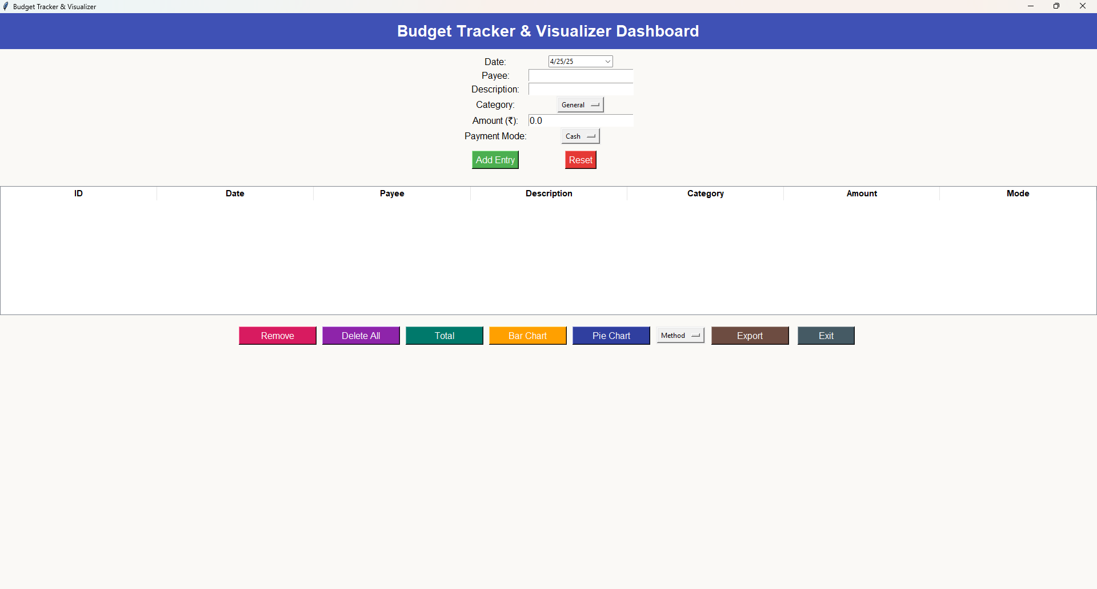

Add Expense Form: Displays how a user can enter new expense data using date, receiver, amount, and method.

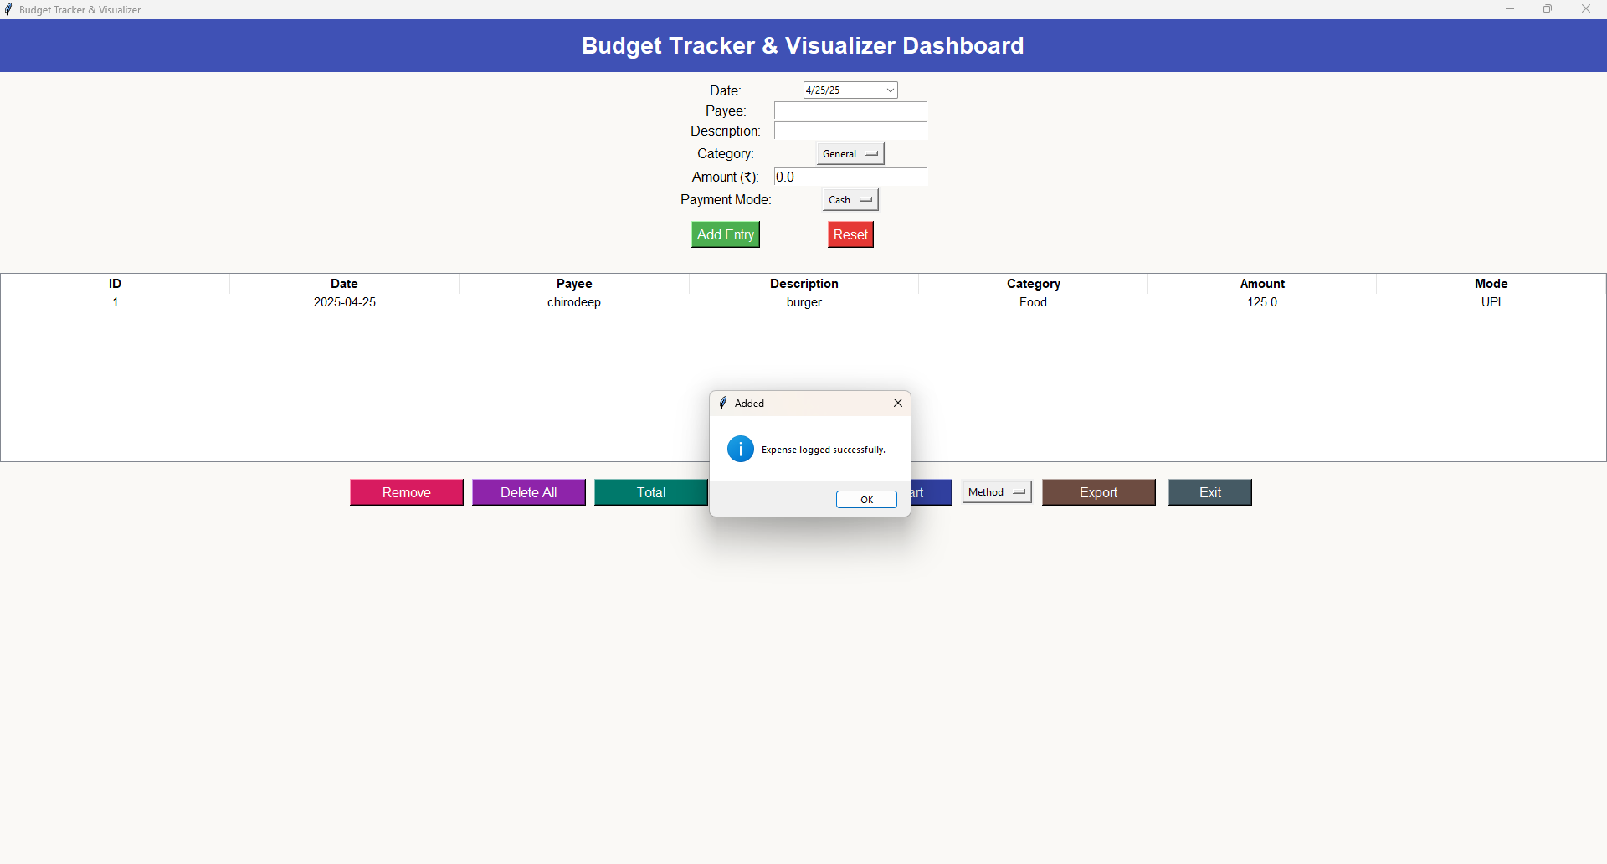

Chart View: Pie and bar charts representing spending patterns by category, method, or time.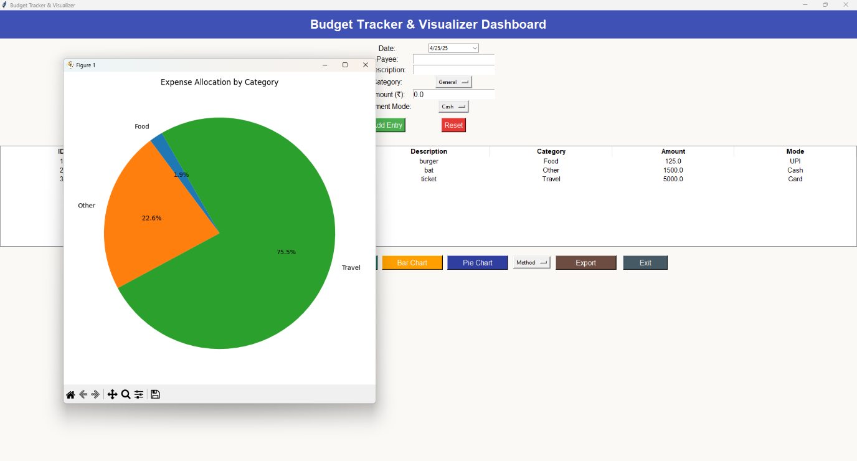

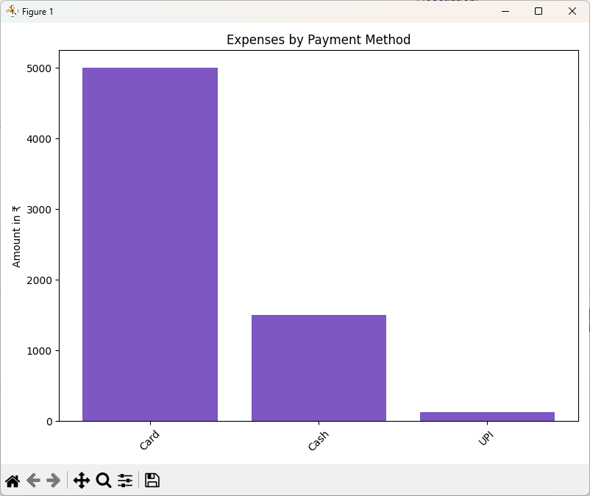

Export Window: Screenshot of the dialog box offering export options

(CSV, Excel, PDF).

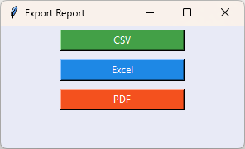

**References**

The following resources were consulted during the development of the Budget Tracker & Visualizer application and throughout the internship for learning and problem-solving:

1. [Python Official Documentation](https://docs.python.org/3/)
2. [Tkinter GUI Programming – TutorialsPoint](https://www.tutorialspoint.com/python/python_gui_programming.htm)
3. [GeeksforGeeks Python Resources](https://www.geeksforgeeks.org/python-programming-language/)
4. [Matplotlib Documentation](https://matplotlib.org/stable/index.html)
5. [Pandas Documentation](https://pandas.pydata.org/docs/)
6. [SQLite Official Site](https://www.sqlite.org/)
7. [FPDF Library for PDF Export](https://pyfpdf.github.io/fpdf2/)
8. [tkcalendar Documentation](https://github.com/j4321/tkcalendar)
9. [Stack Overflow – for resolving specific coding and debugging challenges](https://stackoverflow.com/)
10. [Dutta Computer Academy Class Materials and internal notes](https://www.duttacomputeracademy.co.in/)