**DSO 435: Enterprise Data Architecture**

**Homework 1**

**Northwind Traders Company**

Northwind Traders is a company that imports and exports food globally. The database captures all the sales transactions that occur between the company (Northwind) and its customers, as well as the purchase transactions between Northwind and its suppliers.

The following explains each table (used in this assignment) in the Northwind database:

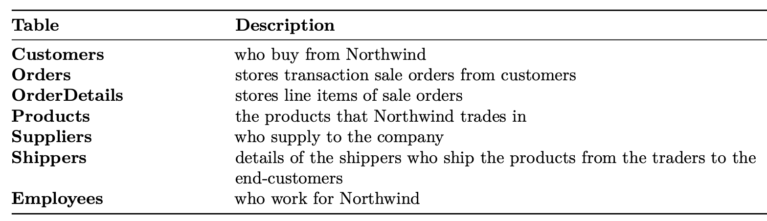

Check the ERD diagram below for more details on each of the above tables.

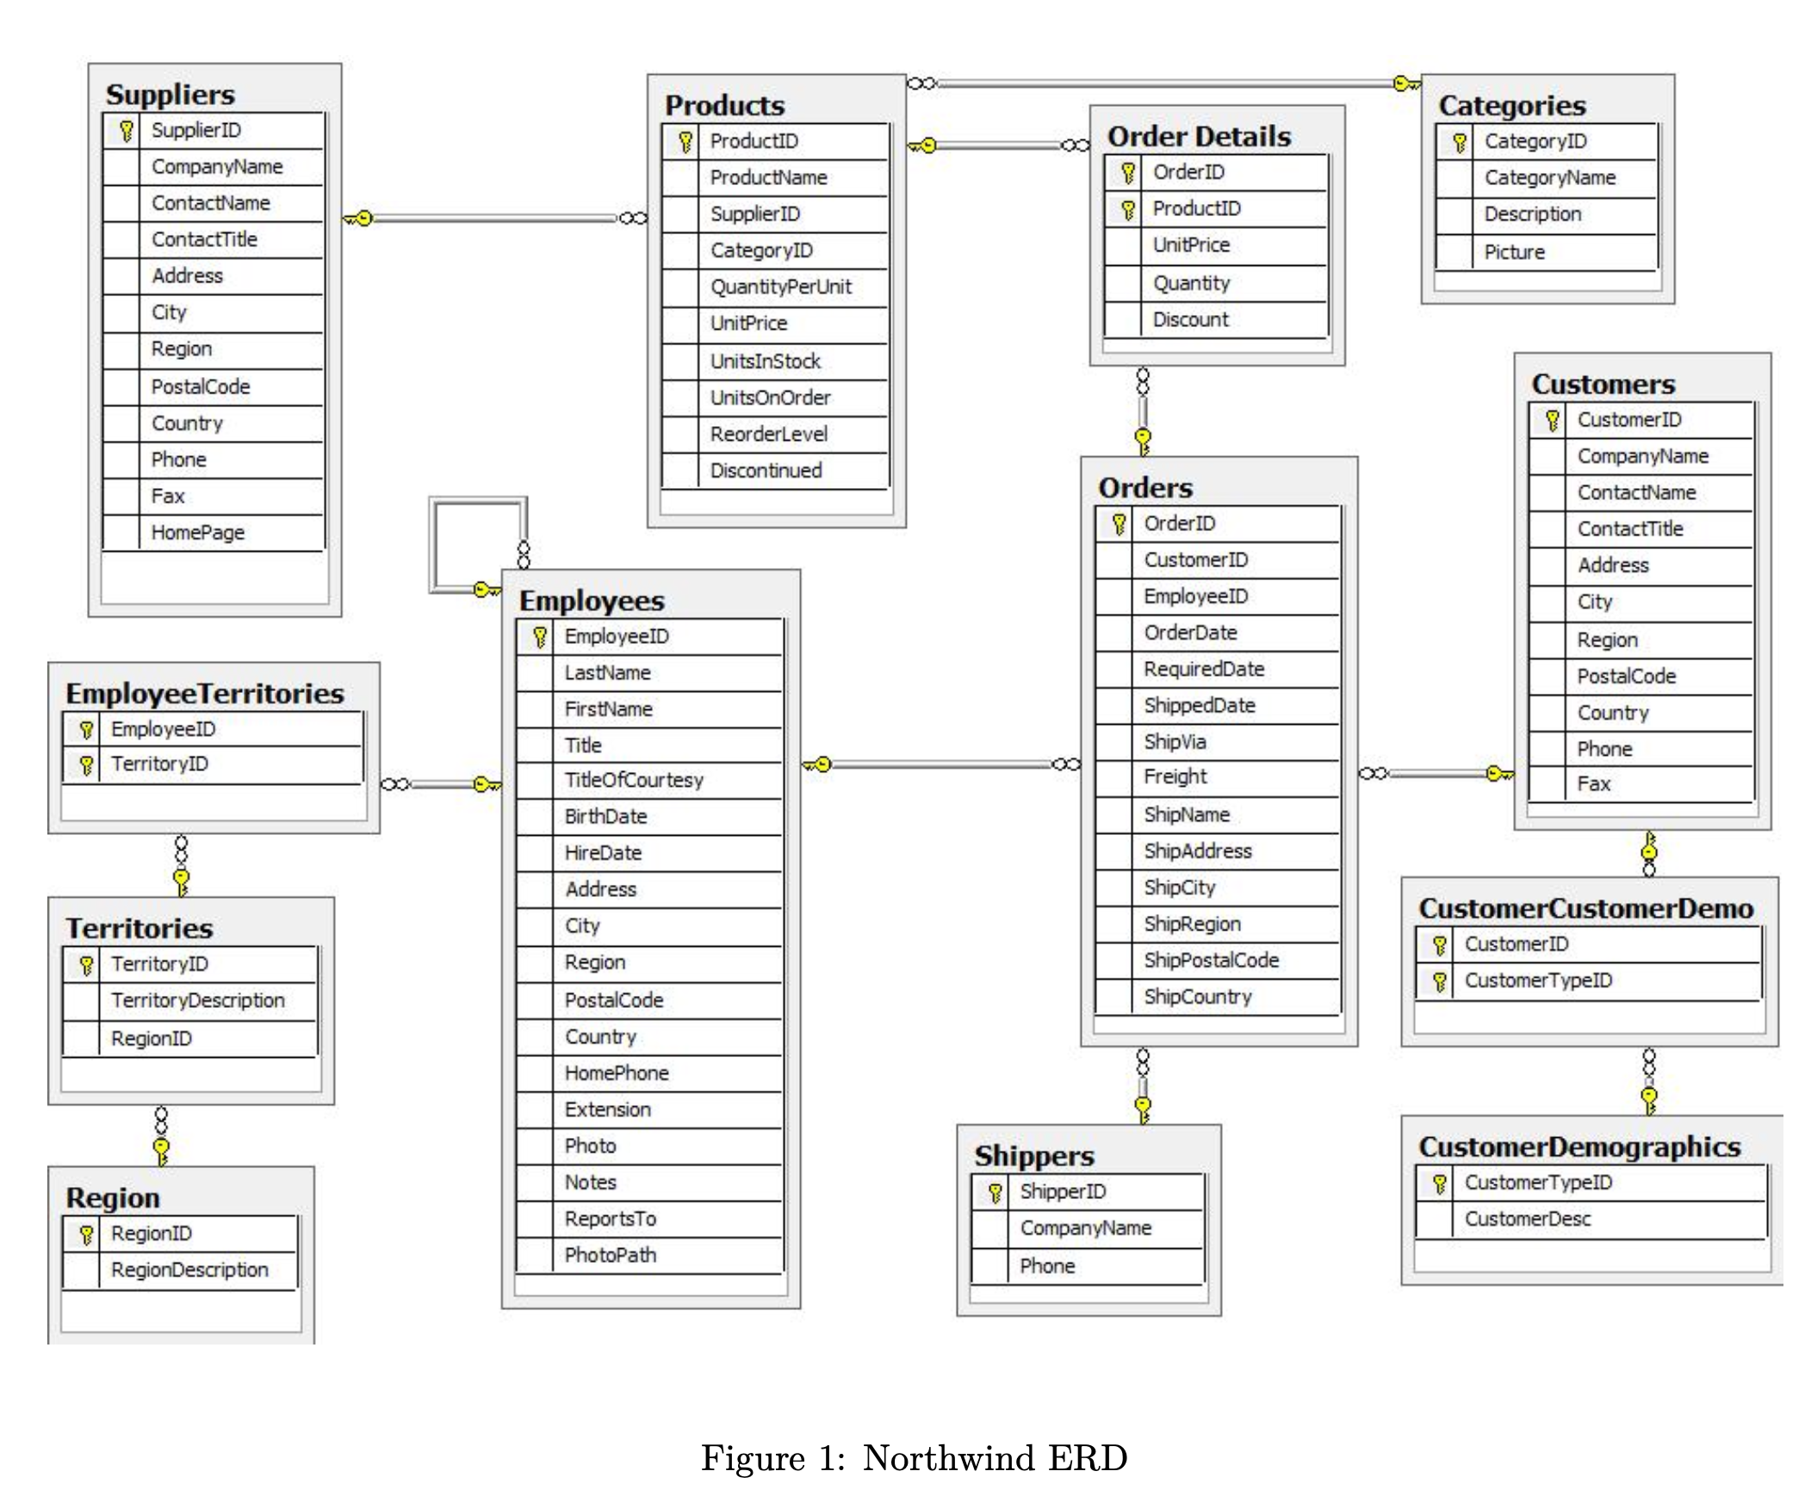

1. Which companies do Northwind Traders use for shipping their products? Provide the names of these companies, as well as their IDs. **No other columns should show up in the output. (1 point)***Sample Output:*

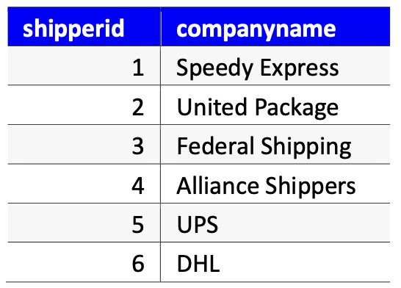

## Answer

**select** shipperid, companyname

**from shippers;**

1. Find the first name, last name, and hiring date of all employees with the title “Sales Representative” or “Inside Sales Coordinator”. **No other columns should show up in the output. (2 points)***Sample Output:*

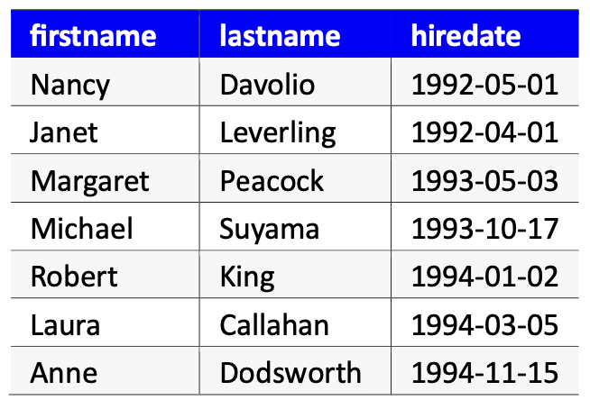

## Answer

select shipperid, companyname

from shippers;

**select** firstname, lastname, hiredate **from** employees

**where title in ('Sales Representative', 'Inside Sales Coordinator');**

1. Create a report showing the first name, last name, and country of all employees that are not in the United States. Order result alphabetically, by last name. **No other columns should show up in the output. (2 points)***Sample Output:*

## 

## Answer

**select** firstname, lastname, country **from** employees  
**where** country != **'USA'**

**order by lastname**

1. Query all employee names (first and last) who are hired before Jan 1, 1994. Sort your results from the newest hire to the oldest to point out who is the newest hire. **In the output only the first name, last name and hiredate should appear. (3 points)***Sample Output:*

## 

## Answer

**select** firstname , lastname , hiredate

**from** employees  
**where** hiredate < **'1994-01-01'**

**order by hiredate desc;**

1. Show all orders (and return all columns) that happened in Madrid in year 1996**. (3 points)***Sample Output:*

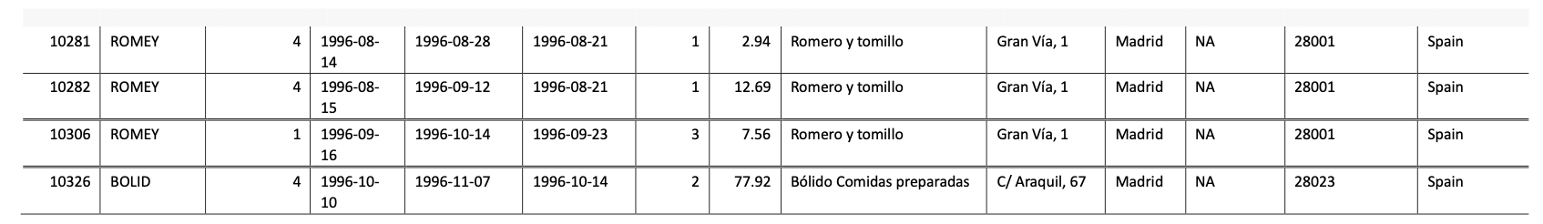

## Answer

**select** * **from** orders

**where orderdate < '1997-01-01' and orderdate >= '1996-01-01'**

**and shipcity = 'Madrid';**

1. Find and return only the product id and name for all “queso” products (i.e. products whose name includes “queso”) that have unit price greater than 30. Only print out product id and product name. **(3 points)**

*Sample Output:*

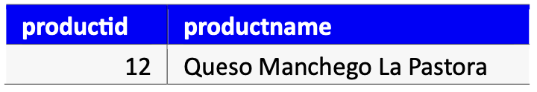

## Answer

**select** productid , productname **from** products

**where productname ilike '%queso%' and unitprice > 30;**

1. Query all the orders (only the columns orderid, customerid, shipcountry) shipping to the following countries in Latin America: Brazil, Mexico, Argentina, Venezuela. Sort by freight value, with the heaviest freight first. Show the first 10 results only. **(4 points)**

*Sample Output:*

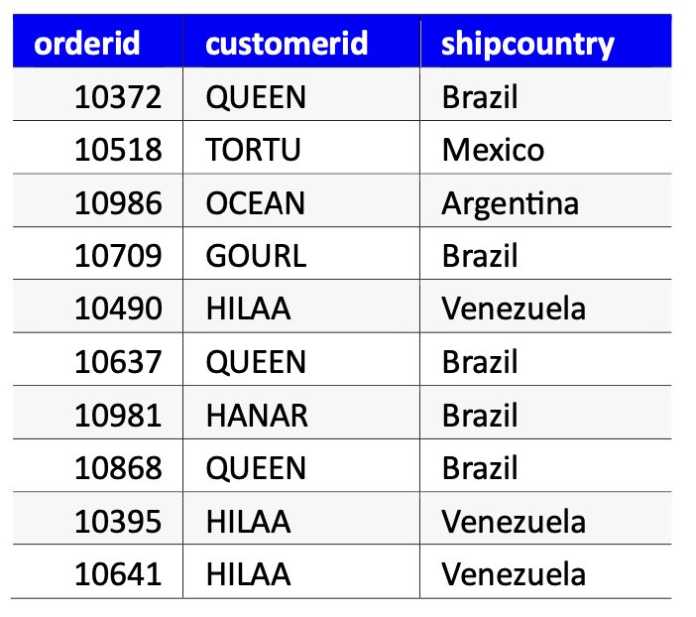

## Answer

**select** orderid , customerid , shipcountry  
**from** orders  
**where** shipcountry **in** (**'Brazil'**, **'Mexico'**, **'Argentina'**, **'Venezuela'**)

**order by** freight **desc**

**limit 10**

1. Create a report that shows the company name, contact title, city and country of all customers in Mexico, Brazil, or in any city in Spain except Madrid. **No other columns should show up in the output. (4 points)***Sample Output:*

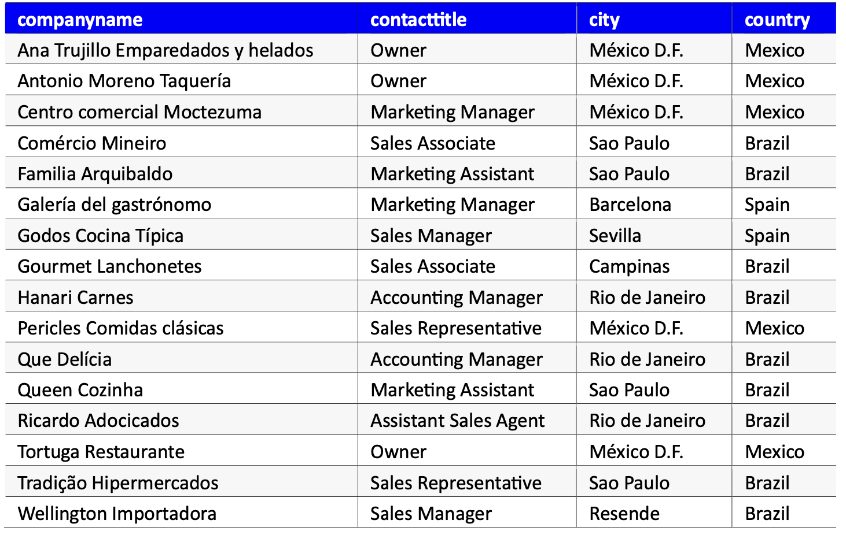

## Answer

**select** companyname , contacttitle , city , country **from** customers  
**where** country **in** (**'Mexico'**, **'Brazil'**, **'Spain'**)

**and city <> 'Madrid';**

1. What is the most expensive discontinued product that currently has units in stock? (Hint: A product is discontinued if the value of attribute “discontinued” in the table is 1 otherwise it is 0 if the product is not discontinued). Show all columns from the products table and order your results from most expensive to least expensive. **(4 points)***Sample Output:*

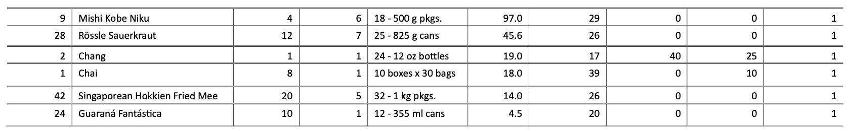

## Answer

**select** * **from** products  
**where** discontinued = 1 **and** unitsinstock > 0

**order by unitprice desc;**

1. Which order (order id) has the highest total value after the discount? Return only the orderid, productid, unitprice, quantity, discount, and total value of the order (in a column called totalvalue). Order the results in descending order of total value. Return only one result! **(5 points)***Sample Output:*

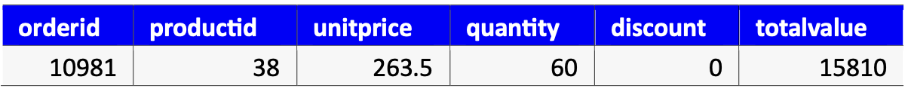

## Answer

**select** *, (unitprice * quantity) * (1 - discount) **as** *totalvalue* **from** orderdetails  
**order by *totalvalue* desc**

**limit 1**