
CS 2 : C++ Data Structures
Topic 2 : Fixed Stacks
Author: Satish Singhal Ph. D.
Version 1.0

You are already familiar with some of the data structures provided by C++. For example, Array is one kind of data structure, which can be used to store large amount of data in the program memory. The goal of certain type of data structure provided by a language is to facilitate certain type of operations on data during the course of use of a program. Using the data structure designed for a programming protocol fulfills that protocol easier. Take the example of arrays. If our programming protocol requires that:
- We have random access to the elements of a data structure
- We should be able to swap two members of the data structure easily
- Capacity of data structure in terms of maximum elements it can hold is known.
- We can iterate through the data structure sequentially if we like
Then all the above protocols boil down to the design of array data structure, which we use in C++.

Programming technology requires other protocols, depending upon the type of problem being solved by the software to be developed. For example, there are situations where program requires that we use a data structure, which fulfills the following protocols:
- Elements added to the data structure must only be added through one end. This means that element added most recently will be on the front of the data structure.
- Elements must also be removed from the data structure from the end that was used to add them. This means that items are removed in a manner that most recently added item will be removed first, and the item before that next and so on.
- All elements are same type, which means that the data structure is homogeneous in its membership.
These protocols have been reduced to a simple description called “Last In First Out” or LIFO. Therefore a condensed definition of a Stack is that it is a data structure in which elements are added and removed from only one end; and it behaves like a “last in, first out”(LIFO) structure. Figure 2.1 below shows some physical models of a stack.
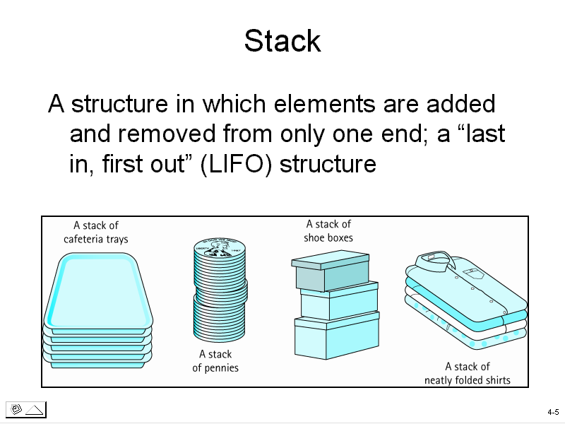
FIG 2.1
All items shown in the Figure 2.1 illustrate a common principle called “stack”. When cafeteria trays are “stacked”, the stack follows all the protocols described on the previous page. A stack of pennies, shoeboxes, folded shirts, or books will behave the same way. Looking from another perspective, a stack may be considered an “ordered” group of items because the elements occur in sequence according to the total time of their membership in the stack. The items that have been in the stack longest are at the bottom, whereas the recent items are on the top.

Logical Operational Design Details For a Stack
The above protocol description only gives us a logical picture of what a stack is and what are its most important characteristics. Now we need to design the operations on a stack data structure, which will help us use the stack and perform operations on it. Here is kind of a laundry list of operations one may need to perform on a stack:
- Add elements into a stack. This operation is commonly called “push”.
- Remove elements from a stack. This operation is commonly called “pop”.
- Peek at the top element of the stack and return a copy of it, with out removing it from the stack. This operation is commonly called “top” or “peek”.
- Find out if stack is empty or not. We can call this operation “isEmpty”.
- In a stack that has fixed capacity, find out if stack is full or not. We can call this operation “isFull”.

Notice that some of the operations we perform on the stack change it and some other do not. The operations that change the data structure are called “mutators” or “transformers”. The operations that do not change data structure but simply observe it and convey some information about it is called “observers”.

Question: In above list which operations are transformers and which ones are observers?

In order to design the stack to be used as a data structure in a C++ program, we may write it as a class called stack, and each of the operation performed on the stack may be coded as a member function of the class stack. For example we may have a function called push ( ) which when called by a stack type object will push an object of that type on the stack. Conversely when an object of type stack invokes the function pop ( ) the top element from the stack is removed and returned. The operations push and pop as performed by instance function calls may be illustrated by the Figure 2.2 below.
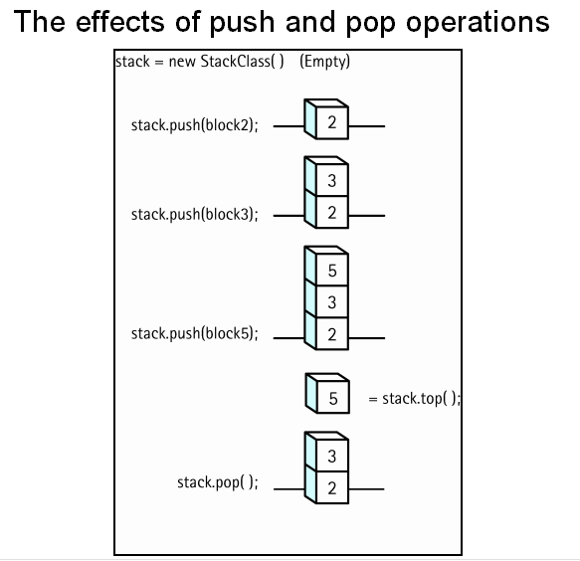
Stack stack;
FIG 2.2
The function push( ) adds the data members to the stack in the order in which function calls are made. And the function pop( ) removes them in accordance with the LIFO protocol.

Now knowing these operational details we can go a step further in the logical design of our stack data structure. During the discussions of C++ abstract classes, we indicated that the abstract class could be made as an expression of pure design (or at least the expression of pure “behavioral” design). We may in the process of writing functional stack classes consider writing an abstract class, which will capture the entire essence of the “behavior” of a stack, and then have the stack class derive from this abstract class. Why is the use of abstract class important? Because by designing the abstract class that governs the behavior of a stack data structure, we can communicate to the code writer very precisely as to what our design specifications are. The Listing 2.0A below gives us the code for the StackInterface, which the code writer for the class Stack can derive from.

class StackInterface
{
public:
/** Effect: Adds item to the top of this stack
Postconditions:
If (this stack is full)
User is informed that stack is full.
else
item is at the top of this stack*/
virtual void push (ItemType item) =0;
/**Effect: Removes top item from this stack
Postconditions: If (this stack is empty)
User is informed that stack is empty.
else
top element has been removed from this stack*/
virtual void pop( ) =0;
/**Effect: Returns the element on top of this stack
Postconditions: If (this stack is empty)
The user is informed that stack is empty and data returned is unreliable
else
return value = (top element of this stack)*/
virtual ItemType top( ) const =0;
/**Effect: Determines whether this stack is empty
Postcondition: Return value = (this stack is empty)*/
virtual bool isEmpty() const =0;
/** Effect: Determines whether this stack is full
Postcondition: Return value = (stack is full)*/
virtual bool isFull () const =0;
/**
*Default destructor
*/
virtual ~StackInterface( ){ }
/**
*Default constructor
*/
StackInterface( ){ }

};
//Listing 2.0A
For each function in the StackInterface, we describe the followings:
- Effect: This item describes as to what effect the function is going to create (if any) on the stack data structure.
- Postcondition: An assertion that must be true after the function has been called.
Importance of Pure Design using Abstract classes:
In software engineering, an important step is expression of pure design with out encumbering any implementation details at all. Using those abstract classes, which have only pure virtual functions as its members, a software engineer can design the interface for a derived class with highest level of flexibility and creativity. The corresponding entities in Java programming language are called interfaces, whose usage has proven the superior design flexibility of Java. An abstract class as shown in Listing 2.0A is an interface in purest sense as only thing it contains is the function signatures and description of effects, post-conditions, and pre-conditions. The implementer is very free to implement the functions or behaviors of the class as well as the data storage in any way they seem fit. Later on, we would show that for linked version of stack the function isFull is not needed in which case either designer can take it out or the implementer can always have it return false (as the linked stack has almost unlimited capacity). Same design of the abstract class StackInterface allows many different implementations, depending upon the software solution needed. Well design interfaces, when implemented lead to fewer software bugs, have lesser side affects and produce easy to maintain software.

Extension of StackInterface abstract class
The code for the array based stack class, which adheres to the design of the interface of Listing 2.0A is shown below in the Listing 2.0B. We also show the inheritance diagram showing the relationship between StackInterface and Stack classes.
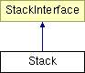
00001 #include "StackInterface.h"
00002
00003 const int MAX = 100;
00004
00005 class Stack :public StackInterface
00006 {
00007 private:
00008 int top_position;
00009 ItemType items[MAX];
00010 public:
00011 void push (ItemType item);
00012 void pop( );
00013 ItemType top( ) const;
00014 bool isEmpty() const;
00015 bool isFull() const;
00016 Stack();
00017 ~Stack();
00018 };
//Listing 2.0B
The file ItemType where the data type for the stack class are set is shown in Listing 2.0C, and the implementation file for the class Stack is shown in Listing 2.0D.
00001 typedef int ItemType;
//Listing 2.0C

00001 #include "Stack.h"
00002 #include <iostream>
00003 using namespace std;
00004
00005 Stack::Stack()
00006 {
00007 top_position = -1;
00008 }
00009 //-------------------------------
00010 Stack::~Stack()
00011 {
00012
00013 }
00014 //-----------------------------------
00015 bool Stack::isEmpty() const
00016 {
00017 return (top_position == -1);
00018 }
00019 //------------------------------------
00020 bool Stack::isFull() const
00021 {
00022 return (top_position == MAX-1);
00023 }
00024 //-----------------------------------
00025 ItemType Stack::top() const
00026 {
00027 if(isEmpty())
00028 {
00029 cerr<<"The stack is empty. Returned value not reliable.\n";
ItemType data = ItemType ();
return data;
00030 }
else
00031 return items [top_position];
00032 }
00033 //------------------------------------
00034 void Stack::pop()
00035 {
00036 if(isEmpty())
00037 {
00038 cerr<<"The stack is empty.\n";
00039 return;
00040 }
00041 else
00042 top_position--;
00043 }
00044 //------------------------------------------
00045 void Stack::push(ItemType newItem)
00046 {
00047 if(isFull())
00048 {
00049 cerr<<"The stack is full. The item is not added.\n";
00050 return;
00051 }
00052 else
00053 {
00054 top_position++;
00055 items [top_position] = newItem;
00056 }
00057 }//Listing 2.0D
The code for testing the Stack class is shown in Listing 2.0E below.
00001 #include "Stack.h"
00002 #include <iostream>
00003 using namespace std;
00004
00005 int main()
00006 {
00007 Stack Int_Stack;
00008 cout<<"We will push some integers on the stack now.\n";
00009 bool done = false;
00010 int val = int();
00011 while(!Int_Stack.isFull()&&!done)
00012 {
00013 cout<<"Please enter an integer to be pushed on stack : ";
00014 cin>>val;
00015 Int_Stack.push(val);
00016 cout<<"More data? Enter 0 to continue and 1 to exit: ";
00017 cin>>done;
00018 }
00019
00020 cout<<"Now printing the integers pushed on the stack.\n";
00021
00022 while(!Int_Stack.isEmpty())
00023 {
00024 cout<<Int_Stack.top()<<" ";
00025 Int_Stack.pop();
00026 }
00027 cout<<endl;
00028
00029 return 0;
00030 }
//Listing 2.0E
A sample output from Listing 2.0E is shown in the Figure 2. below.
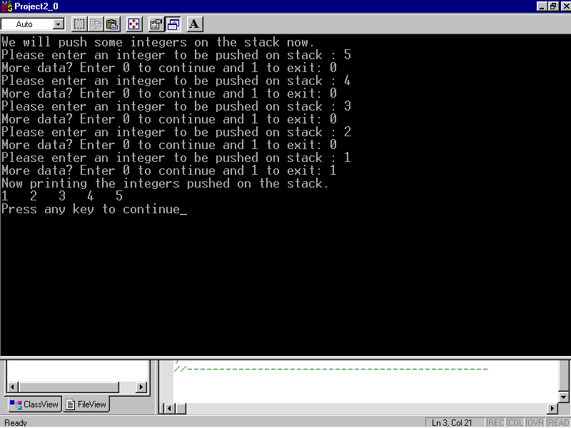
FIG. 2.3
Stack Applications #1 : Compiler/Debugger Operation
Stacks have many applications. Compilers use a function call stack to keep track of calls during the debug operation when the debugger is invoked. For example, consider the following C++ program (Listing 2.1).
#include <iostream>
using namespace std;
void function1();
void function2();
void function3();
void function4();
void function5();
void main()
{
function1();
}

void function1( )
{
cout<<"In function1\n";
function2();
}

void function2( )
{
cout<<"In function2\n";
function3();
}

void function3( )
{
cout<<"In function3\n";
function4();
}

void function4( )
{
cout<<"In function4\n";
function5();
}

void function5( )
{
cout<<"In function5\n";
}
//Listing 2.1
The program has a main function and five other C++ functions called function1 ( ), function2 ( ) etc. The key thing is that main function calls the function1 ( ), then function1 ( ) calls the function 2( ) , function 2 ( ) calls function 3 ( ) and so on. How does compiler keeps track as to where to return when one function call completes itself? Well it builds a stack structure as it piles up the locations where it was in each function. When the compiler is executing the function 5, the function call stack looks like the given figure 2.4.
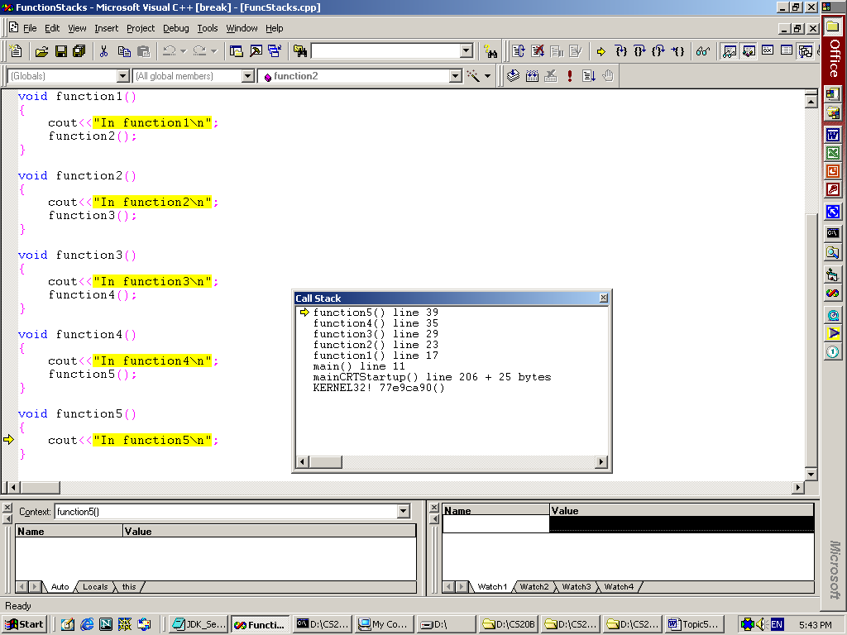
Function call stack. Debugger is right now at line 39 of program in function function5( ). When it starts to pop the stack, it will go to line 35 in function4 ( ) and then to function 3( ) and so on.
Compiler executing line in function5 ( )
FIG. 2.4
In Figure 2.4 the yellow arrow shows as to which line compiler will execute, when programmer moves execution forward (This is done by pressing F10 or F11 as the case may be). The call stack also shows as to where compiler is. Figures 2.5 A to E show as to how the call stack is popped by the compiler as the execution progresses beyond the state shown in Figure 2.4.
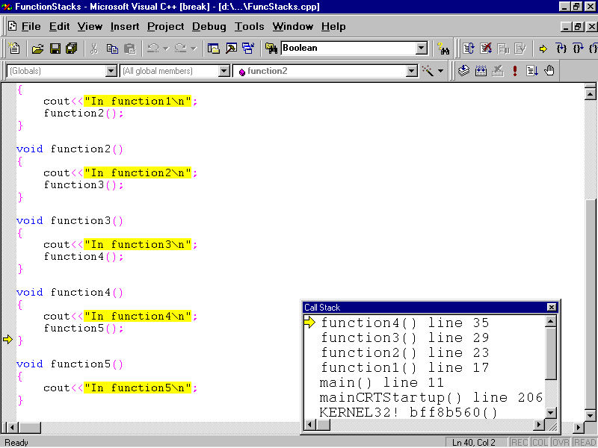
Call to function5 ( ) is popped off the stack. Control returns to function4( )
FIG. 2.5 A

Call to function4 ( ) is popped off the stack. Control returns to function3( )

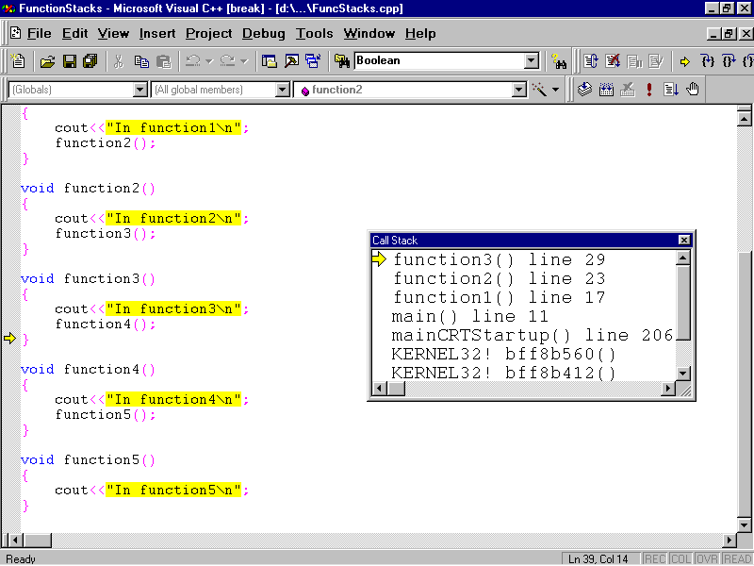
FIG. 2.5 B

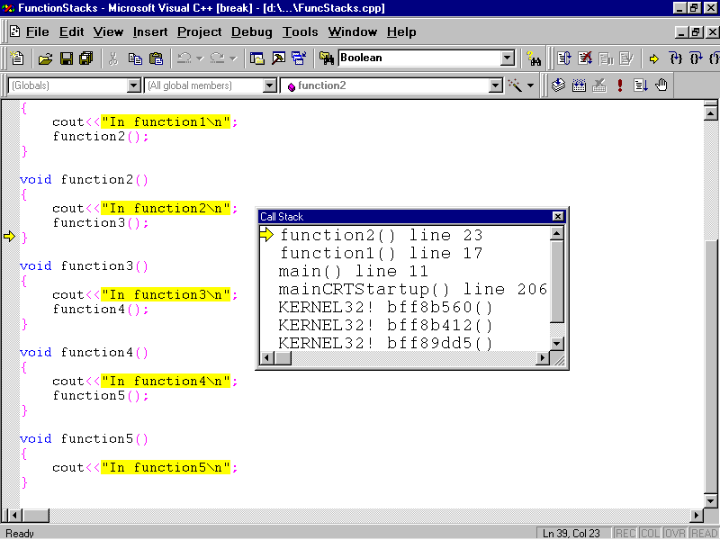
Call to function3 ( ) is popped off the stack. Control returns to function2( )

FIG. 2.5 C
Call to function2 ( ) is popped off the stack. Control returns to function1( )

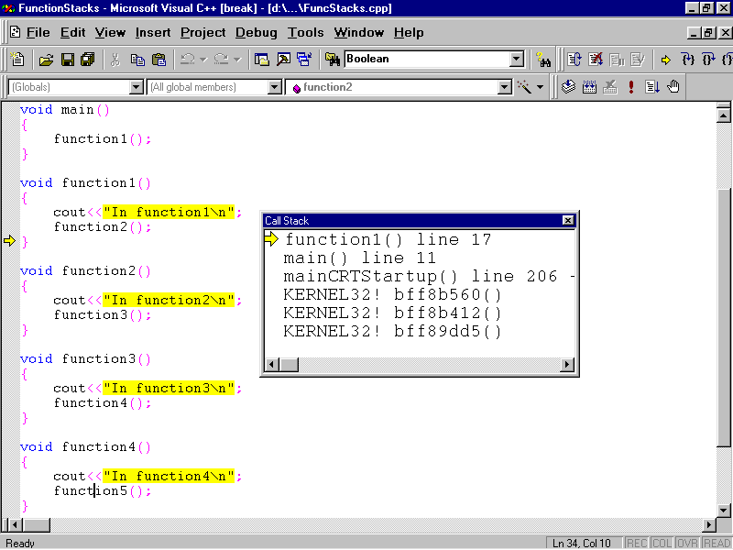
Fig. 2.5 D

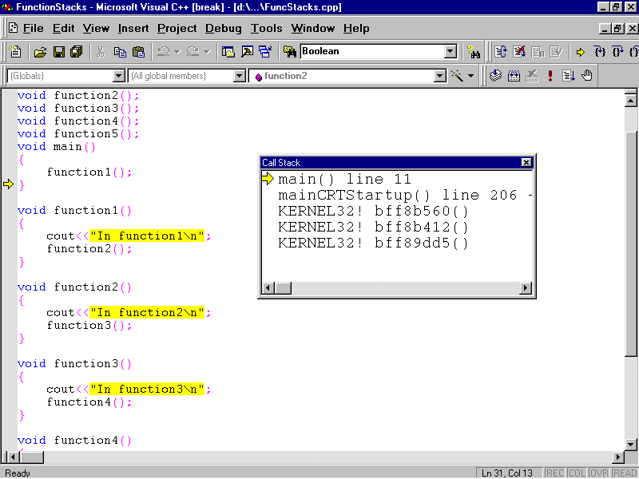
Call to function1 ( ) is popped off the stack. Control returns to main ( ).

Fig. 2.5 E
We see that compiler keeps track of as where to return in the program structure by looking at the function call stack it built, and then popping that stack as the calls to each function is completed. As execution of a certain function completes, it is taken off the stack and the control returns to the next function on the stack. A similar process is followed when a call stack is built up during recursion. We shall show this when we discuss recursion.

Stack Applications #2 : Conversion From Infix Expression to Postfix form:
Most people learn the algebraic expression in what is called “infix” form. When infix form is used, the binary operators such as +, -, *, and / are applied to two operands on either side of the operator. For example in expression ( a + b), the operator + is located in between the operands a and b, thus such expressions are called infix expressions. There are computers and calculators, however, which use a somewhat different way to apply binary operators to the operands. This form is called a “postfix” form. In postfix, form the operator is placed after the operands. For example the postfix form for ( a + b ) will be:
a b +
The advantage of postfix form is that one does not need to remember the operator precedence rules and unlike infix form, no parentheses are needed.

Example of Evaluation of a Postfix Expression
A POSTFIX expression such as:
5 7 + 6 2 - * will be evaluated as follows:
We scan from left to right, until we hit an operator. Then we take two operands before the operator just found and apply the operator to those two. Keep this process going until all the operators are consumed. For example in the above expression, scanning from left to right we hit operator '+' first. The two operands before this '+' operator are 5 and 7. This is
interpreted as 5 + 7 = 12, then our expression becomes: 12 6 2 - * . Then we scan again from left to right. This time we hit a '-' sign. The two operands before '-' are 6 and 2. This is evaluated as 6-2 = 4. This changes our expression to 12 4 * . Scanning left to right once more we hit '*' - the multiplication sign. Thus 12*4 is evaluated to 48, the final value of the POSTFIX expression 5 7 + 6 2 - *.

Using a Stack to Evaluate Postfix Expression
A stack can be used to evaluate a postfix expression. In fact, the stack's Last In First Out (LIFO) property fits extremely well to the process of such evaluation. This works as follows: The stack is used to store each operand, until we read a POSTFIX operator like (+, -, * or /). As soon as we read an operator we pop 2 operands from the stack and apply the Operator to the two Popped operands as follows:
Operand (2nd Pop)<Operator>Operand (1st Pop). This is shown further in the example given below.

The algorithm for the evaluation of the arithmetical POSTFIX expression is clearly demonstrated by the following example using the stacks data structure. Let us revisit our example of a POSTFIX arithmetical expression such as: 5 7 + 6 2 - * = ?
We scan from left to right and we find number ‘5’. We push this number into the stack as shown in the figure 2.6 A:
Stack
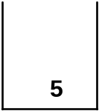
FIG. 2.6 A
Our topindex pointer is at point just after number 5. We show the location of the pointer by an
topindex location shown by using ‘
apostrophe as follows:

5’ 7 + 6 2 - * = ?
Then we move the pointer further and we find and read number 7. We push ‘7’ also on to the stack. The pointer and stacks now look as follows:
5 7’ + 6 2 - * = ?
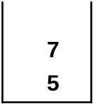
FIG. 2.6 B
Now we move the pointer to the right again to read the next character. This character is a binary arithmetical operator ‘+’. We now pop two operands ‘7’ and ‘5’ from the stack and apply the operator ‘+’ to them as follows: We add 5 to 7 and push the result back in the
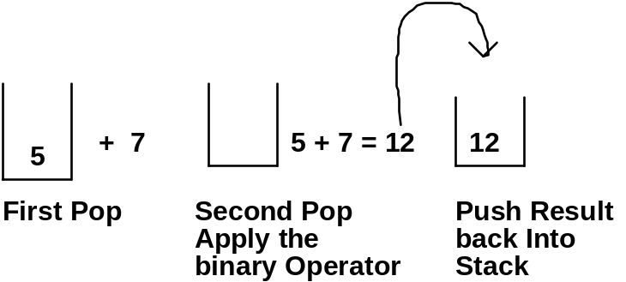
FIG. 2.6 C

stack as shown in the figure 2.6C. Our pointer now is placed after the binary operator ‘+’ as follows: 5 7 +’ 6 2 - * = ? Then we move the pointer once again to the right, and we read the number 6. We push the ‘6’ on to the stack as given by the figure 2.6 D:
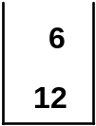
FIG. 2.6 D

Our pointer is now placed after the number ‘6’ as follows: 5 7 + 6’ 2 - * = ? Then we start reading again and this time we read number ‘2’. We push number ‘2’ on to the stack, as shown by the figure 2.6 E:
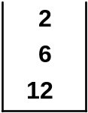
FIG. 2.6 E

Our pointer is now placed just after the number ‘2’ as follows: 5 7 + 6 2’ - * = ?
As we resume reading the next we read is the operator ‘-’. At this point we pop ‘2’ and ‘6’ from the stack and apply the binary subtraction to them as shown in the figure 2.6 F:
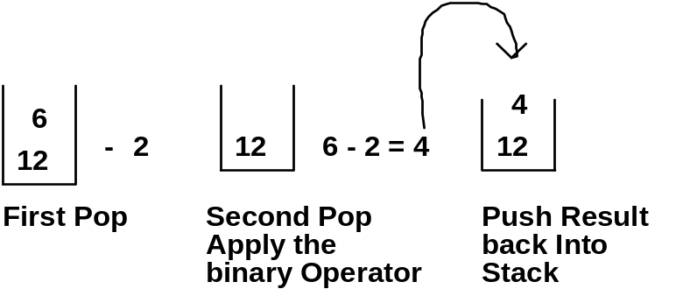
FIG. 2.6 F

Our pointer now is placed just after the subtraction operator ‘-’ as follows:
5 7 + 6 2 -’ * = ? As we read our final binary operator ‘*’ from the input expression, we pop the two values 12 and 4 from the stack and apply the binary ‘*’ multiplication operator as shown in the figure 2.6 G:
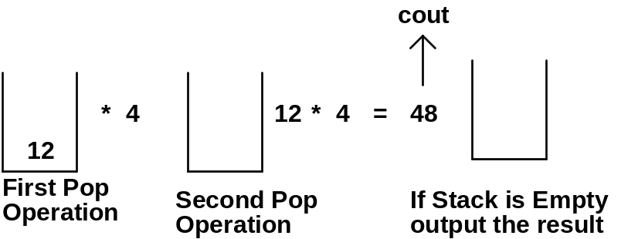
FIG. 2.6 G

The entire expression has now been read, and stack is empty, so the result ‘48’ is outputted to the screen or any other relevant output device. We may write our POSTFIX equation as follows: 5 7 + 6 2 - * = 48. The simple rule to remember here is that as we pop a value to apply a binary operator, we put the operator in front of the first popped value, and then we pop the second value and put it in the front of the binary operator.

Using a Stack to Convert From Infix form to Postfix Form
Very often for the evaluation of a complex infix expression, it is easier to convert it into POSTFIX form, and then apply the algorithm discussed above for its evaluation. Now we discuss an algorithm to convert an alphanumeric INFIX expression to the POSTFIX form. One fact you will remember from evaluation of postfix was that only operands went on stack, and operators were used as they were read. In case of infix to postfix conversion, the reverse is true. Only operators go on stack. Operands are outputted as they are read. So in infix to postfix conversion, the stack has to be a stack of characters! If you compare the infix and postfix forms, you would come up with a curious conclusion: the order of operands in both expressions (infix and postfix) is same. Only order of operators is different. The table below gives some examples of infix and postfix form.

Infix | Postfix
3 * X + (Y - 12) - Z | 3 X * Y 12 - + Z -
A * B + C * D | A B * C D * +
A * (B + C / D) | A B C D / + *

Critically looking at the table above confirms that in both infix and postfix forms the order of operands is same. Thus if you are doing conversion from infix to postfix form or vice versa, and you do not get the same order of operands, then something is wrong.

First, let us enumerate the rules of the conversion from infix to postfix form algorithm as follows:
One rule to remember up front (that is enforced by operator precedence rules) is that in stack built of operators, at any time, there should not be a lower precedence operator on top of a higher precedence operator (unless they are separated by a left parentheses in the stack. If that happens then there is something wrong.

Using a loop, until all tokens in the infix expression are consumed, use, the Following steps and Rules.
Determine if the next input is an operand, an operator, a left parenthesis, or a right parenthesis.
Rule 0. Only operators are pushed (if needed by the rules) on stack. Operands are simply outputted.
Rule 1. If the next input is a left parenthesis, i. e. a ‘(‘, then push it into the stack.
Rule 2. else if the next input is an operand (number or variable name), then output the operand or append to an output string.
Rule 3. else if the next input is an operator(-, +, *, /, %) then, pop all operators off the stack
A. until you reach a ‘(‘ ;
B. OR if the stack is empty then do nothing:
C. OR keep popping you reach an operator with a lower precedence than the operator just read (or stack becomes empty). (any lower precedence operator is left in the stack). Operator on stack that has equal precedence must be popped;
Then after above operation(s), push the newly read operator in the stack.
Rule 4. else If the next input is a right parenthesis, i. e. a ‘)’, then Pop and output all operators off the stack until you reach a corresponding left parenthesis i. e. a ‘(‘, or the stack is empty. Discard the matching left parenthesis “(“ Popped from the stack. If there is no matching left parenthesis is found then the INFIX expression was parenthetically unbalanced. An output message to this affect may be issued.
Rule 5. Repeat above until, there is no more input.

Let us show this algorithm in action by applying to the following expression such as:
3 * X + (Y - 12) – Z. In this case, also we use a stack to store the binary operators as well as left parentheses. In this case, all the operands (3, Y, X etc.) are outputted to the output stream as soon as they are read. This is how the sequence of events will work.
1. Reading from left to write, first we read operand ‘3’. This is outputted and stack is empty. This is shown in the figure 2.7A:

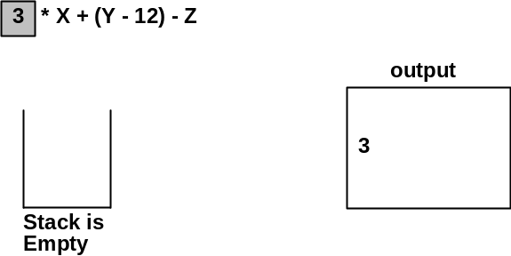
FIG. 2.7 A
The gray color in the figure above shows as to how much of the input expression has been read.
2. We read again to right and next we read the multiplication operator ‘*’. We push this operator into the stack as shown by the figure 2.7B. The output remains unchanged.
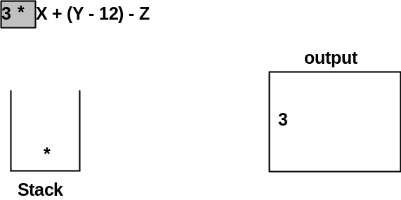
FIG. 2.7 B

3. We read to right again and we read the operand X, which is outputted. The stack remains unchanged. (Figure 2.7 C).
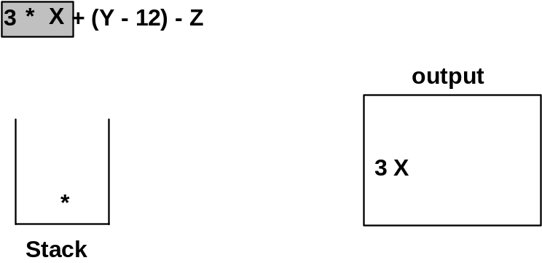
FIG. 2.7 C

4. Then we read the binary operator ‘+’, which is pushed on the stack, but before we do that, we examine the stack and output any operators that have either the equal or higher precedence than the ‘+’ operator we just read. The output gets the operator ‘*’ (Rule 3 above) as operator ‘+’ gets pushed to the stack, as shown by the figure 2.7D:

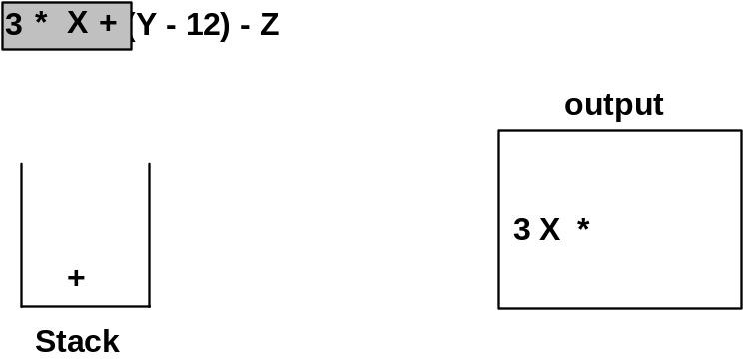
FIG. 2.7 D

5. Then as we resume reading we read the left parenthesis ‘(‘. We push that on to the stack (Rule 1). The output remains unchanged. (Figure 2.7 E).

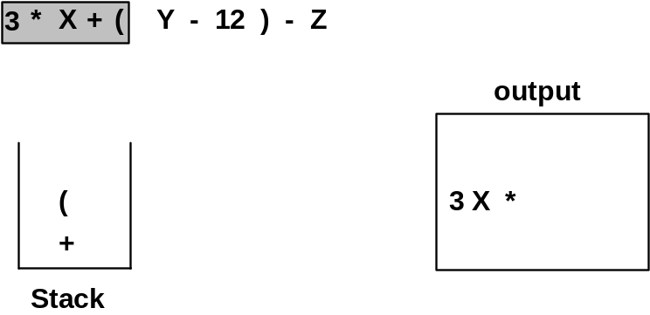
FIG. 2.7 E

6. We resume reading and we read the operand Y, which is outputted. The stack remains unchanged. (Figure 2.7 F).

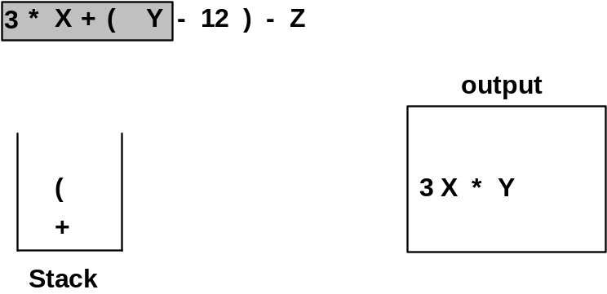
FIG. 2.7 F

7. Next we read the binary operator ‘-’. Now according to Rule 3, we examine the contents of stack. Since stack has only left parenthesis on the top, we do not output any thing. Rather we push the binary operator ‘-’ on to the stack. (Remember that the left parenthesis is to be taken out and discarded only when a right parenthesis ‘)’ is read.). The situation is shown by the figure 2.7G:
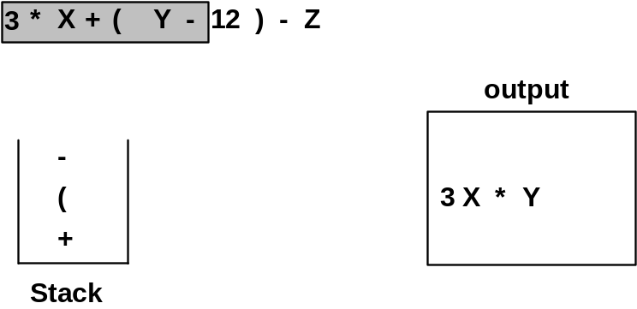
FIG. 2.7 G

8. Then we read the operand ‘12’ which is outputted(Rule 2). (Figure 2.7H).
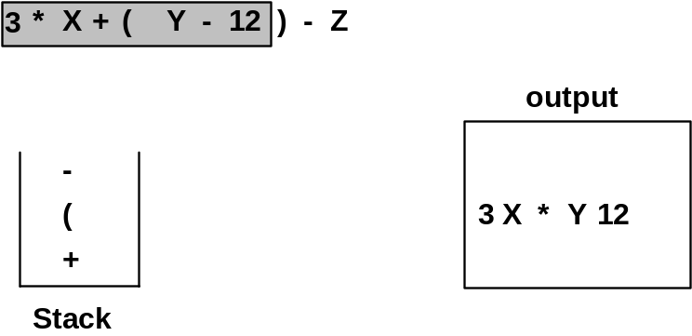
FIG. 2.7 H

9. Continuing reading to right, we read the right parenthesis ‘)’. According to Rule 4, we Pop and output the operator ‘-’ from the stack and then we Pop and discard the left parenthesis. The right parenthesis is discarded as well. This is shown in the figure 2.7 I:
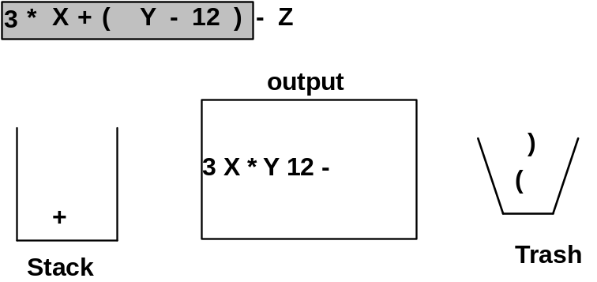
FIG. 2.7 I

10. Then we read the binary operator ‘-’. As per Rule 4, we examine the contents of our stack and output any operators of equal or higher precedence (until we reach the bottom or a left parenthesis or an operator of lower precedence). This require Popping and outputting the ‘+’ operator, and then we push the binary operator ‘-’ that was just read, on to the stack. (Figure 2.7J).

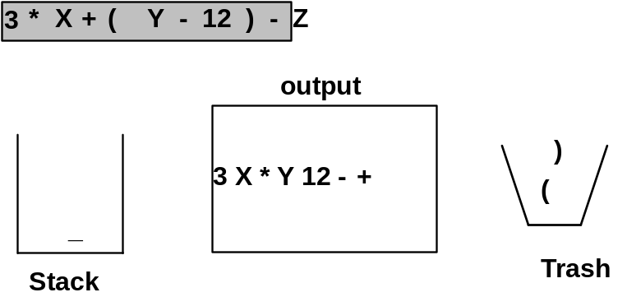
FIG. 2.7 J

11. We finally read the last operand in our expression ‘Z’. We output it (Rule 2). The stack remains unchanged. (Figure 2.7 K).
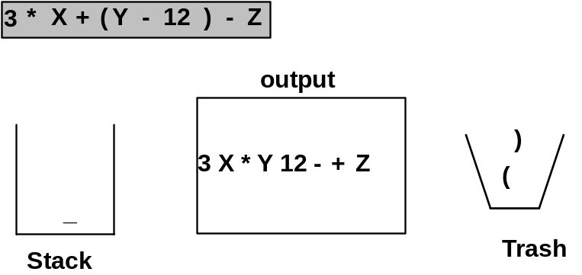
FIG. 2.7 K

12. As a last operation we output any operators left in the stack, so we output the operator ‘-’ from the stack, and stack is now empty, as well as our conversion from Infix Form to Postfix Form is complete. (Figure 2.7 L).
Postfix Form
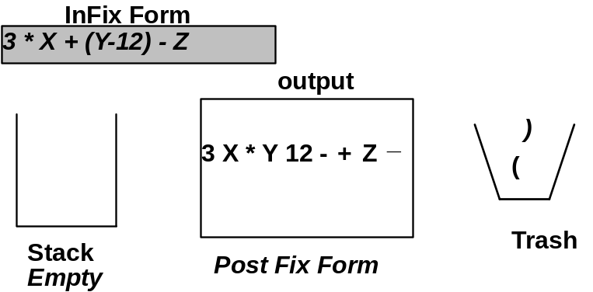
FIG. 2.7 L

Program to Convert an Infix Expression to Postfix form
Table 2.0 presents the summary of the design of a class called ReversePolishNotation, which converts an expression from the infix form to postfix form. Class ReversePolishNotation accepts a user inputted parenthetically balanced infix expression, and outputs its postfix form. Postfix form is easier to evaluate, as it needs no parenthesis.

Public Member Functions
 | ReversePolishNotation (const string input="", const string output="")
 | The default and explicit constructor.
 | ~ReversePolishNotation ( )
 | Default destructor.
const string | getInput () const
const string | Accessor function to get the inputted string.
void | setInput (const string input)
void | Sets the data member inputString to the value passed to the function.
const string | getOutput () const
const string | Accessor function to get the output.
void | setOutput (const string output)
void | Sets the data member outputString to the value passed to the function.
void | convert ()
void | The function convert takes the inputted infix expression as a STL string, generates its postfix form, and stores the result in the data member outputString.

Private Member Functions
int | priority (char s)
int | The function priority takes an operator character as an input and returns the integer indicating the priority for that operator.
string | inputString
string | The field inputString will be the user-inputted string for the infix expression.
string | outputString
string | The field outputString will be the form converted to postfix outputted for the user.
Table 2.0

This source code for the design of Table 2.0 is shown in the Listing 2.2. This listing essentially codes the algorithm we described on pages 17 to 22. Postfix expressions are also commonly called “Reverse Polish Notation” or RPN logic. Listing 2.2 gives a class called ReversePolishNotation, which asks user to input an infix expression and converts it to postfix form. We use the Stack class used earlier here in order to perform the necessary stack operations.
00001 #include <string>
00002 using namespace std;
00003
00010 class ReversePolishNotation
00011 {
00012 private:
00017 string inputString;
00022 string outputString;
00031 int priority(char s);
00032 public:
00039 ReversePolishNotation(const string input="",
00040 const string output="");
00044 ~ReversePolishNotation();
00049 const string getInput() const;
00054 void setInput(const string input);
00059 const string getOutput() const;
00064 void setOutput(const string output);
00070 void convert();
00071 };
//Listing 2.2A

00001 #include "ReversePolishNotation.h"
00002 #include "Stack.h"
00003 #include <iostream>
00004 #include <cstdlib>
00005 using namespace std;
00006
00007 //-----------------------------------------
00008 ReversePolishNotation::ReversePolishNotation(
00009 const string input, const string output):
00010 inputString(input), outputString(output)
00011 {
00012
00013 }
00014 //----------------------------------------
00015 ReversePolishNotation::~ReversePolishNotation()
00016 {
00017
00018 }
00019 //---------------------------------------------
00020 const string ReversePolishNotation::getInput() const
00021 {
00022 return inputString;
00023 }
00024 //------------------------------------------------
00025 void ReversePolishNotation::setInput(const string input)
00026 {
00027 inputString = input;
00028 }
00029 //-------------------------------------------------
00030 const string ReversePolishNotation::getOutput() const
00031 {
00032 return outputString;
00033 }
00034 //---------------------------------------------------
00035 void ReversePolishNotation::setOutput(const string output)
00036 {
00037 outputString = output;
00038 }
00039 //----------------------------------------------------
00040 int ReversePolishNotation::priority(char s)
00041 {
00042
00043 int operatorPriority = -1;
00044
00045 if (s=='[')
Assigned operator priority follows C++ operator precedence rules.
00046 operatorPriority = 0;
00047 else if (s=='(')
00048 operatorPriority = 1;
00049 else if (s=='+')
00050 operatorPriority = 2;
00051 else if (s=='-')
00052 operatorPriority = 2;
00053 else if (s=='*')
00054 operatorPriority = 3;
00055 else if (s=='/')
00056 operatorPriority = 3;
00057 else if (s=='^')
00058 operatorPriority = 4;
00059
00060 return(operatorPriority);
00061 }
00062 //---------------------------------------
00063 void ReversePolishNotation::convert()
00064 {
Scan the inputted string character by character.
00065 Stack myStack;
00066 char nextCharacter =' ';
00067 char topOfStack=' ';
00068
00069 for (int i = 0;i<inputString.length();i++)
Get the next character
00070 {
00071 nextCharacter = inputString[i];
00072 if (nextCharacter==')')
00073 {
Enforcing rule #4 on page 17.
00074 topOfStack = myStack.top();
00075 myStack.pop();
00076 while (!(topOfStack=='('))
00077 {
00078 outputString+=" ";
00079 outputString += topOfStack;
00080 topOfStack = myStack.top();
00081 myStack.pop();
00082 }
00083 }
00084 else if (nextCharacter==']')
00085 {
00086 topOfStack = myStack.top();
00087 myStack.pop();
00088 while (!(topOfStack=='['))
00089 {
00090 outputString+=" ";
Enforcing Rule #1 on page 17.
00091 outputString += topOfStack;
00092 topOfStack = myStack.top();
00093 myStack.pop();
00094 }
00095 }
00096 else if (nextCharacter=='(' || nextCharacter=='[')
00097 {
Enforcing
Rule #3 on page 17.
00098 myStack.push(nextCharacter);
00099 }
00100 else if (nextCharacter=='+' || nextCharacter=='-' ||
nextCharacter=='*' || nextCharacter=='/' ||
nextCharacter=='^')
00103 {
00104 topOfStack = myStack.top();
00105 while (priority(nextCharacter) <= priority(topOfStack))
00106 {
00107 topOfStack = myStack.top();
00108 myStack.pop();
00109 outputString+=" ";
00110 outputString += topOfStack;
00111 topOfStack = myStack.top();
00112 }
00113 myStack.push(nextCharacter);
00114 }
//This executes only when an alphanumeric character is //encountered
Enforces rule #2 on page 17.
00115 else
00116 {
00117 if (!isdigit(int(nextCharacter)))
00118 {
00119 outputString=outputString + " ";
00120 outputString += nextCharacter;
00121 outputString=outputString + " ";
00122 }
00123 else
00124 outputString += nextCharacter;
00125
00126 }
00127 }//end of for loop
00128 }//end of function convert
//Listing 2.2B
The stack used in Listing 2.2B is a character stack. Therefore, we modify the ItemType.h file as given below in Listing 2.2C. All stack files remain unchanged.
00001 #ifndef ITEMTYPE_H
00002 #define ITEMTYPE_H
00003 typedef char ItemType;
00004 #endif
//Listing 2.2C
The algorithm for infix to postfix conversion (pages 17-22) is implemented by class ReversePolishNotation as follows. The function convert gets the user entered infix expression as a string enclosed in a pair of square brackets. The function scans the expression character by character. Then the function invokes a system of nested if-else constructs and various portions of this construct enforce the four rules of infix to postfix conversion listed on page 17. For example, the rule #3, which the most complex is enforced by the function, convert as follows:
The code inside the else if clause given below is executed if the next character is a binary arithmetical operator.
else if (nextCharacter=='+' || nextCharacter=='-' ||
nextCharacter=='*' || nextCharacter=='/' ||
nextCharacter=='^')

Then rule three (page 17) is enforced by determining the priority of the next character in comparison to the priority of the characters (operators, left and right parentheses, and square bracket) in the stack. The function priority ( ) helps to enforce the rule three as shown in Table 2.1
Operator | Priority
Right square bracket or] | -1
Right parenthesis or) | -1
Left square bracket or [ | 0
Left parenthesis or ( | 1
Plus ( + ) | 2
Minus ( - ) | 2
Multiply ( * ) | 3
Divide ( / ) | 3
Exponentiation (^) | 4
Table 2.1

The loop given below is entered only if the priority assigned to the character read is lower or equal to the character on the top of the stack.
while (priority(nextCharacter) <= priority(topOfStack))
{
topOfStack = myStack.top();
myStack.pop();
outputString+=" ";
outputString += topOfStack;
topOfStack = myStack.top();
}

Notice that rule three will be enforced only if the next operator is one of the followings: +, -, *, /, ^ . This is because all other situations, where the character is other than mathematical operator are taken care by other rules. Therefore the function priority ( ) will return a value of two if the next character is + or -, a value of three if the next character is *, or /, and a value of four if the next character is an exponentiation ^. The while loop then pops the characters on the stack until an operator of lower precedence is seen. The last line of the code to enforce rule three pushes the next character on to the stack as follows:
myStack.push (nextCharacter);

Results From Listing 2.2
The Listing 2.2D below shows the main function used to test the functionality of class ReveresePolishNotation.
00001 #include "Stack.h"
00002 #include "ReversePolishNotation.h"
00003 #include <string>
00004 #include <iostream>
00005 using namespace std;
00006
00007 int main()
00008 {
00009 string str ="";
00010 bool done = false;
00011
00012 while(!done)
00013 {
00014 cout<<"Please enter the infix expression, which "
00015 <<"must be parenthetically balanced and\n must"
<<" be enclosed in square brackets. For example [a +b *c] .\n";
00017 getline (cin, str);
00018 ReversePolishNotation myConverter(str,"");
00019 myConverter.convert();
00020 cout<<"The postfix form of "<<str<<" is : \n";
00021 cout<<myConverter.getOutput ()<<endl;
00022 cout<<"More data? Enter 0 to continue and 1 to end : ";
00023 cin>>done;
00024 cin.ignore();
00025 }
00026
00027 return 0;
00028 }
//Listing 2.2D
User is prompted to input the infix expression enclosed in square brackets. The istream function getline gets the whole string. The constructor of class ReversePolishNotation is called with the user inputted expression as the first argument and a null string as the second one. Then the convert function is called to populate the outputString data member of ReversePolishNotation class, which forms the postfix form. The Figure 2.8 shows the typical results with the infix expressions and their postfix forms.

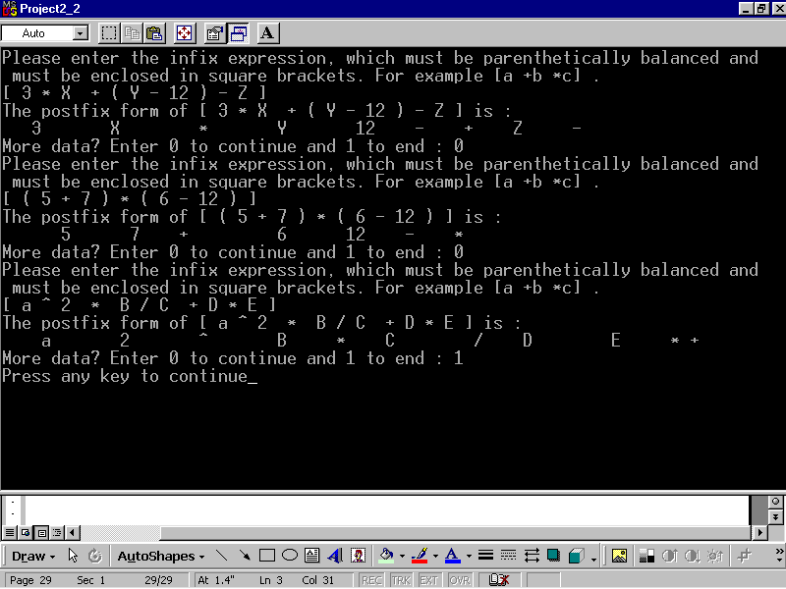
FIG. 2.8

When we need stacks of more than one data types in the same software application!
One cannot fail to notice that in using our stack class in Listing 2.0 and 2.2 we changed our ItemType.h file to ascertain that we can create the stack of the data type that we need to employ in that application. For example, in Listing 2.0 we wished to create an integer stack, therefore the ItemType.h file included the statement:
typedef int ItemType;
However, when we needed the stack of data type character in Listing 2.2, we changed the above typedef statement to:
typedef char ItemType;

One may ask then, that what would happen if the software solution needs stacks of more than one data types in the same application. Would we need to create separate versions of three stack files (StackInterface.h, Stack.h, and Stack.cpp) for each data type? The best solution to this dilemma is use of C++ templates, which we will cover later. In the interim however, one can use C++ union to define ItemType as per Listing 2.3A below.

00001 #ifndef ITEMTYPE_H
00002 #define ITEMTYPE_H
00003
00004 union ItemType
00005 {
00006 int Integer;
00007 float Float;
00008 char Character;
00009 long Long;
00010 double Double;
00011 short Short_Integer;
00012 long double Long_Double;
00013 };
00014 #endif
//Listing 2.3A
The advantage of defining ItemType in this manner is that one can create stacks of all data types listed inside the union with out generating extra versions of files StackInterface.h, Stack.h, and Stack.cpp. The reason for that is that C++ union, at one time behaves as a container for only one of its data member. The example of application is shown in the main function in Listing 2.3B. (All three stack files remain unchanged).
00001 #include "Stack.h"
00002 #include <iostream>
00003 using namespace std;
00004
00005 void testInt();
00006 void testChar();
00007 void testFloat();
00008 int main()
00009 {
00010
00011 testInt();
00012 testChar();
00013 testFloat();
00014 return 0;
00015 }
00016
00017 void testInt()
00018 {
00019 Stack Int_Stack;
00020 cout<<"We will push some integers on the stack now.\n";
00021 bool done = false;
00022 int val = int();
00023 while(!Int_Stack.isFull()&&!done)
00024 {
00025 cout<<"Please enter an integer to be pushed on stack : ";
00026 cin>>val;
00027 ItemType Value;
00028 Value.Integer = val;
00029 Int_Stack.push(Value);
00030 cout<<"More data? Enter 0 to continue and 1 to exit: ";
00031 cin>>done;
00032 }
00033
00034 cout<<"Now printing the integers pushed on the stack.\n";
00035
00036 while(!Int_Stack.isEmpty())
00037 {
00038 cout<<(Int_Stack.top()).Integer<<" ";
00039 Int_Stack.pop();
00040 }
00041 cout<<endl;
00042 }
00043 //---------------------------------------------------------------
00044 void testChar()
00045 {
00046 Stack Char_Stack;
00047 cout<<"We will push some characters on the stack now.\n";
00048 bool done = false;
00049 char val = char();
00050 while(!Char_Stack.isFull()&&!done)
00051 {
cout<<"Please enter an character to be pushed on stack : ";
00053 cin>>val;
00054 ItemType Value;
00055 Value.Character = val;
00056 Char_Stack.push(Value);
00057 cout<<"More data? Enter 0 to continue and 1 to exit: ";
00058 cin>>done;
00059 }
00060
cout<<"Now printing the integers pushed on the stack.\n";
00062
00063 while(!Char_Stack.isEmpty())
00064 {
00065 cout<<(Char_Stack.top()).Character<<" ";
00066 Char_Stack.pop();
00067 }
00068 cout<<endl;
00069 }
00070 //---------------------------------------------------------
00071 void testFloat()
00072 {
00073 Stack Float_Stack;
cout<<"We will push some floating point numbers on the “
<<” stack now.\n";
00075 bool done = false;
00076 float val = float();
00077 while(!Float_Stack.isFull()&&!done)
00078 {
cout<<"Please enter a floating point number to be pushed “
<<” on stack : ";
00080 cin>>val;
00081 ItemType Value;
00082 Value.Float = val;
00083 Float_Stack.push(Value);
00084 cout<<"More data? Enter 0 to continue and 1 to exit: ";
00085 cin>>done;
00086 }
00087
00088 cout<<"Now printing the integers pushed on the stack.\n";
00089
00090 while(!Float_Stack.isEmpty())
00091 {
00092 cout<<(Float_Stack.top()).Float<<" ";
00093 Float_Stack.pop();
00094 }
00095 cout<<endl;
00096 }
//Listing 2.3B
The program uses three different stacks one for integer, one for character and one for float, in the function testInt, testChar and testFloat respectively. The key attention to master is that when pushing the data on to the stack for certain data type, the client just need to access that data field of the union. For example in case of integer stack the value inputted by the user is inputted as follows:

ItemType Value;
Value.Integer = val;

Where the val is the user inputted integer and Integer is the field in the union Value, which is ItemType. Same instance of the union can also be used for inputting data types of any of union members. However, in that case the user will have to keep track as to which data types were entered in which sequence. The output of Listing 2.3 is shown below in Figure 2.9.
//*******************************************************
We will push some integers on the stack now.
Please enter an integer to be pushed on stack : 5
More data? Enter 0 to continue and 1 to exit: 0
Please enter an integer to be pushed on stack : 4
More data? Enter 0 to continue and 1 to exit: 0
Please enter an integer to be pushed on stack : 3
More data? Enter 0 to continue and 1 to exit: 0
Please enter an integer to be pushed on stack : 2
More data? Enter 0 to continue and 1 to exit: 0
Please enter an integer to be pushed on stack : 1
More data? Enter 0 to continue and 1 to exit: 1
Now printing the integers pushed on the stack.
1 2 3 4 5
We will push some characters on the stack now.
Please enter an character to be pushed on stack : E
More data? Enter 0 to continue and 1 to exit: 0
Please enter an character to be pushed on stack : D
More data? Enter 0 to continue and 1 to exit: 0
Please enter an character to be pushed on stack : C
More data? Enter 0 to continue and 1 to exit: 0
Please enter an character to be pushed on stack : B
More data? Enter 0 to continue and 1 to exit: 0
Please enter an character to be pushed on stack : A
More data? Enter 0 to continue and 1 to exit: 1
Now printing the integers pushed on the stack.
A B C D E
We will push some floating poinr numbers on the stack now.
We will push some floating poinr numbers on the stack now.
Please enter a floating point number to be pushed on stack : 0.99
More data? Enter 0 to continue and 1 to exit: 0
Please enter a floating point number to be pushed on stack : .088
More data? Enter 0 to continue and 1 to exit: 0
Please enter a floating point number to be pushed on stack : 0.77
More data? Enter 0 to continue and 1 to exit: 0
Please enter a floating point number to be pushed on stack : 0.66
More data? Enter 0 to continue and 1 to exit: 0
Please enter a floating point number to be pushed on stack : -1.2
More data? Enter 0 to continue and 1 to exit: 0
Please enter a floating point number to be pushed on stack : 2.222
More data? Enter 0 to continue and 1 to exit: 1
Now printing the integers pushed on the stack.
2.222 -1.2 0.66 0.77 0.088 0.99
//*******************************************************************
FIG. 2.9

When we need a stack of objects
C++ union cannot have an object such as an STL string its data member. Therefore, what would we do when we need to retain flexibility of using a stack for string and for primitive data types at the same time? The answer is to define ItemType as a C++ class with all the data member being public. The design of such class is given below in Listing 2.4A.
00001 #ifndef ITEMTYPE_H
00002 #define ITEMTYPE_H
00003 #include <string>
00004 using namespace std;
00005 class ItemType
00006 {
00007 public:
00008 int Integer;
00009 float Float;
00010 char Character;
00011 long Long;
00012 double Double;
00013 short Short_Integer;
00014 long double Long_Double;
00015 string string_data;
00016 };
00017 #endif
//Listing 2.4A
Because the class ItemType defines all data members public, it can easily be used to construct a stack for any of its members, as members are accessible directly using the dot operator. The main function testing this class for string stack is given in Listing 2.4B. All other stack classes remain unaltered.
00001 #include "Stack.h"
00002 #include <iostream>
00003 using namespace std;
00004
00005 void testString();
00006 int main()
00007 {
00008 testString();
00009 return 0;
00010 }
00011
00012 void testString()
00013 {
00014 Stack string_stack;
00015 cout<<"We will push some strings on the stack now.\n";
00016 bool done = false;
00017 string val = string();
00018 while(!string_stack.isFull()&&!done)
00019 {
00020 cout<<"Please enter an string to be pushed on stack : ";
00021 cin>>val;
00022 ItemType Value;
00023 Value.string_data = val;
00024 string_stack.push(Value);
00025 cout<<"More data? Enter 0 to continue and 1 to exit: ";
00026 cin>>done;
00027 }
00028
00029 cout<<"Now printing the strings pushed on the stack.\n";
00030
00031 while(!string_stack.isEmpty())
00032 {
00033 cout<<(string_stack.top()).string_data<<" ";
00034 string_stack.pop();
00035 }
00036 cout<<endl;
00037 }
//Listing 2.4B
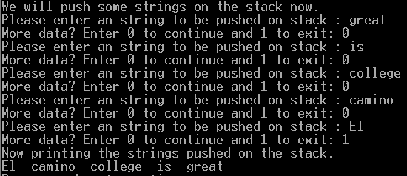
FIG. 2.10

The Figure 2.10 gives the results of forming a string stack in Listing 2.4B. User is able to put the string containing no space on the stack, pop them, and print them.

