Components

AC-DC Power Supply 12V 3A
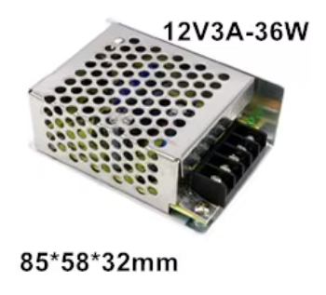
Dimensions: 85 * 58 * 32

USB Power Supply Box with 6x18650 Batteries
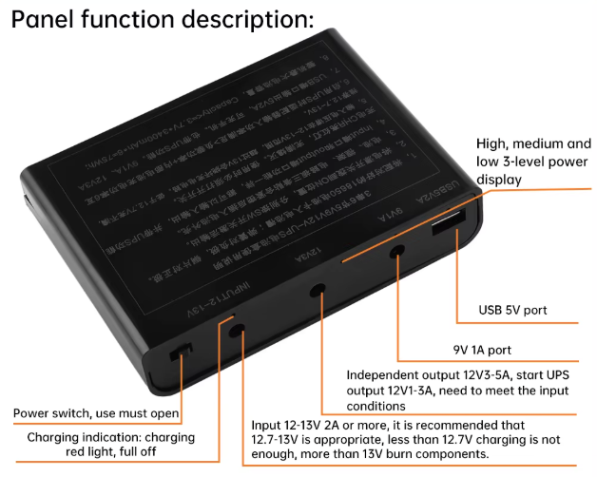
Dimensions: 120 × 90 × 25 ?

Digital booster module
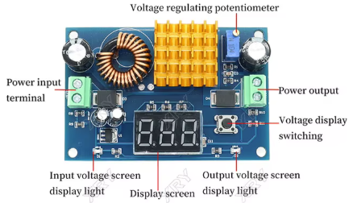
Dimensions: 72 * 48 * 16

Digital LCD Buck Boost Converter
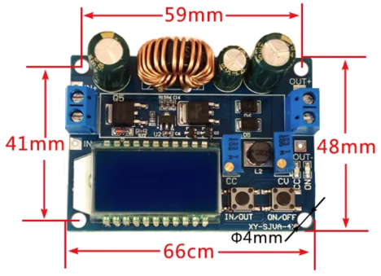
Dimensions: 66 * 48 * 21

ESP32
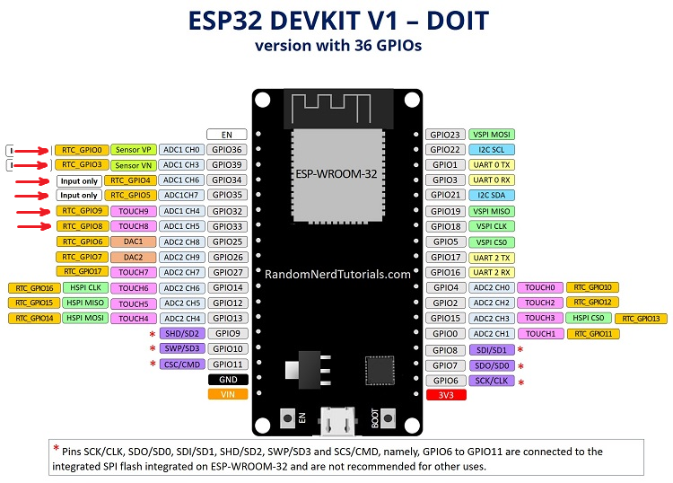
Dimensions: 52 * 26

Voltage sensor
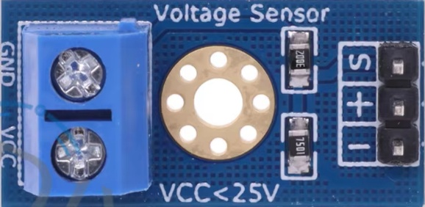
Dimensions: 27 * 14

