MEDR-Net: AI-Enhanced Multi-Degradation Restoration Network for Semiconductor Microscopic Image Restoration
Abstract:
Semiconductor microscopic images play a critical role in inspecting wafer surfaces, circuit patterns, material structures, and manufacturing defects; however, image quality can be significantly degraded by acquisition noise and reduced spatial resolution. Speckle noise introduces intensity fluctuations, Gaussian noise suppresses edge and fine structural information, and spatial downsampling causes the loss of high-frequency details required for accurate microscopic inspection. To address these challenges, this work proposes an AI-Enhanced Multi-Degradation Restoration Network (MEDR-Net) for Semiconductor Microscopic Image Restoration. The proposed network integrates degradation-aware feature extraction, multi-scale residual learning, edge-aware structural enhancement, and learned super-resolution within a unified restoration framework. The degradation-aware module identifies the characteristics of speckle noise, Gaussian noise, and spatial resolution degradation, while residual feature learning suppresses noise without eliminating important semiconductor structures. An edge-aware enhancement module further recovers fine boundaries and microscopic patterns, and a learned resolution reconstruction module restores degraded 128×128 microscopic images to the required 256×256 ground-truth resolution. Adaptive feature fusion combines denoised, structural, and high-frequency representations to generate an improved semiconductor microscopic image with enhanced clarity and structural fidelity. The network is optimized using a composite restoration objective that promotes pixel-level accuracy, structural consistency, edge preservation, and perceptual quality. Restoration performance is evaluated using Peak Signal-to-Noise Ratio (PSNR), Structural Similarity Index Measure (SSIM), and Learned Perceptual Image Patch Similarity (LPIPS) to quantify pixel fidelity, structural similarity, and perceptual reconstruction quality, respectively. The proposed MEDR-Net aims to provide robust and high-quality restoration of signal-degraded semiconductor microscopic images while recovering spatial details necessary for reliable microscopic inspection and analysis.
Architecture Diagram:
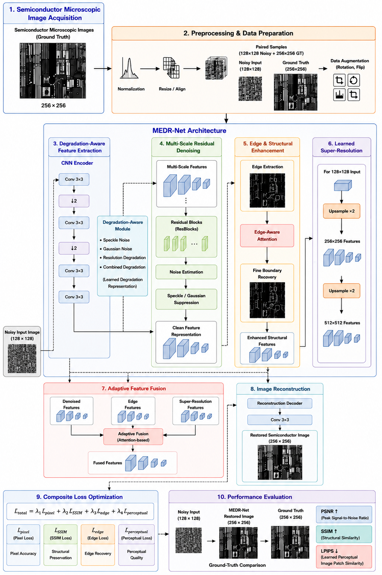

1. Project Overview
MEDR-Net (Multi-scale Edge-aware Denoising and Restoration Network) is a deep learning pipeline built in TensorFlow/Keras for restoring semiconductor microscopic images. It takes a low-resolution, noisy input image and produces a denoised, sharpened, and 2x super-resolved output. The project covers the full applied deep learning lifecycle: dataset preparation and augmentation, model training with a multi-term loss function, quantitative and qualitative evaluation, and standalone inference.
Semiconductor microscopy images are frequently affected by sensor noise, low resolution, and blur introduced during acquisition. Restoring these images accurately matters because downstream tasks defect detection, measurement, and classification — depend on structural detail (edges, boundaries, fine features) that naive denoising tends to destroy. MEDR-Net's architecture is specifically designed around preserving that structural detail while still removing noise, rather than treating restoration as a single generic image-to-image translation problem.

1.1 What Makes MEDR-Net's Approach Distinctive
- It separates the restoration problem into three explicit, purpose-built branches — denoised content, structural/edge content, and high-frequency detail — instead of using one monolithic decoder for everything.
- Feature extraction is degradation-aware: the network adapts which learned filters to emphasize based on the actual input, via a squeeze-and-excitation gating mechanism, rather than applying the same fixed processing to every image.
- Multi-scale context is captured using dilated convolutions in parallel (rather than pooling/downsampling), so the low-resolution input's spatial detail is never discarded before upsampling.
- Super-resolution uses learned pixel-shuffle upsampling (sub-pixel convolution) instead of fixed interpolation, so new pixels are synthesized by learned weights rather than smoothed from neighbors.
- The three branches are recombined using a per-pixel, softmax-weighted adaptive fusion, so the ideal blend of smooth-vs-sharp content is decided locally, not globally.
- Training uses a four-term composite loss (pixel, structural similarity, edge, and perceptual) so the optimization target reflects multiple notions of image quality at once, not just per-pixel error.

2. Step-by-Step Process
The project is organized as four sequential stages, each implemented as an independent, standalone script. The output of each stage feeds the next.

Stage 1 — Preprocessing & Augmentation (preprocess.py)
- Load paired Ground Truth (GT) and Noisy Low-Resolution (NoisyLR) .npy arrays from matching filenames.
- Squeeze array dimensions and transpose channel-first arrays to channel-last, if needed.
- Normalize each image to the [0, 1] range (divide by 255 if the array is in 8-bit range, then clip).
- Generate augmented copies of each pair: horizontal flip, vertical flip, and 90°/180°/270° rotations — applied identically to both GT and NoisyLR so the pairs stay spatially aligned.
- Save each augmented pair to a Preprocessed Augmented output directory, and optionally save a preview grid of sample pairs for visual sanity-checking.

Stage 2 — Training (train.py)
- Split the preprocessed pairs into train / validation / test sets (80% / 10% / 10%, seeded for reproducibility).
- Build a tf.data pipeline that loads, normalizes, and batches .npy pairs on the fly, with optional on-disk caching for speed.
- Construct the MEDR-Net model (see Section 3) and, if resuming, load existing checkpoint weights.
- Load a frozen, ImageNet-pretrained VGG16 network as a fixed feature extractor for the perceptual loss term.
- For each epoch: run gradient-descent training steps over the training set, then evaluation-only steps over the validation set, tracking composite loss, PSNR, and SSIM for both.
- After each epoch, save the model if validation loss improved; otherwise increment a patience counter. If validation loss plateaus for a set number of epochs, decay the learning rate; if it plateaus for longer (default 10 epochs), stop training early.
- Append results to a persistent training log (CSV) and save loss/PSNR/SSIM curves as a plot image.

Stage 3 — Evaluation (evaluate.py)
- Rebuild the MEDR-Net architecture and load the best saved checkpoint weights.
- Reconstruct the same held-out test split used during training (same seed) so evaluation is on genuinely unseen data.
- Run inference over the entire test set and compute aggregate PSNR, SSIM, and a VGG-feature-space perceptual distance (used as an LPIPS-style proxy).
- Select a sample of test images and generate a side-by-side comparison grid (input / ground truth / restored) annotated with per-sample PSNR and SSIM.

Stage 4 — Inference (infer.py)
- Rebuild the architecture and load the trained checkpoint weights.
- Load each input file from a target directory (.npy or standard image formats), normalize it, and resize to the model's expected 128×128 input size using bicubic interpolation if needed.
- Run the model forward pass to produce a restored, super-resolved output.
- Save each result as both a .npy array (for further numerical analysis) and a .png image (for visual inspection).
- Optionally generate a comparison preview grid of degraded-vs-restored samples.

3. Model Architecture
MEDR-Net maps a 128×128×1 low-resolution, noisy input to a 256×256×1 restored output through five stages, described in detail below: Degradation-Aware Feature Extraction (DAFE), Multi-Scale Residual Learning (MSRL), Edge-Aware Structural Enhancement (EASE), Learned Super-Resolution / Reconstruction (LSRR), and Adaptive Feature Fusion (AFF).
Pipeline: Input (128×128×1) → DAFE → MSRL (×6 blocks) → EASE → [LSRR × 3 branches] → AFF → Refinement → Output (256×256×1)

3.1 DAFE — Degradation-Aware Feature Extraction
Purpose: extract initial features while adapting the response per channel to the type and severity of degradation present in the specific input image, rather than applying a fixed filter response to every image identically.
Process:
- A 3×3 convolution followed by LeakyReLU (α = 0.2) extracts initial local features.
- A squeeze-and-excitation (SE) gate summarizes each feature channel with global average pooling, passes that summary through a two-layer bottleneck (reduction ratio 4), and produces a per-channel weight in [0,1] via a sigmoid.
- The original features are rescaled by that per-channel gate, then passed through a second 3×3 convolution and LeakyReLU.

3.2 MSRL — Multi-Scale Residual Learning
Purpose: denoise the feature maps while preserving both fine texture and coarse structure, by examining each location's neighborhood at multiple receptive-field sizes simultaneously. Six of these blocks are stacked in sequence.
Process (per block):
- Three parallel 3×3 convolutions are applied to the same input with dilation rates 1, 2, and 4 respectively, giving each branch a different effective receptive field without any change in parameter count or spatial resolution.
- The three branch outputs are concatenated and passed through a 1×1 convolution that learns how to fuse the three scales, followed by LeakyReLU.
- A residual (skip) connection adds the block's input back to the fused output, so each block only needs to learn a correction rather than reconstruct the signal from scratch.

3.3 EASE — Edge-Aware Structural Enhancement
Purpose: explicitly reinforce structural boundaries that a generic denoiser tends to blur away, since per-pixel losses alone favor smooth, low-detail solutions.
Process:
- A Sobel gradient-magnitude map is computed directly on the incoming feature maps, highlighting where intensity changes sharply (i.e., edges).
- The edge map is passed through a 3×3 convolution and LeakyReLU to learn which edge patterns are relevant to this domain.
- A 1×1 convolution with sigmoid activation converts the edge features into a spatial attention mask in [0,1] per pixel.
- The original input is multiplied by this attention mask and added back to itself (a residual attention gate), so structural regions are selectively boosted while other regions pass through largely unchanged.

3.4 LSRR — Learned Super-Resolution / Reconstruction
Purpose: upsample from 128×128 to 256×256 (2×) using a learned upsampling operator instead of fixed interpolation such as bicubic or bilinear resizing, since interpolation can only smooth existing values and cannot synthesize new detail. This module is applied independently to each of the three branches (denoised, structural, edge).
Process:
- A 3×3 convolution expands the channel count by a factor of scale² (= 4 for 2× upsampling), preparing four channel-groups of content for each output 2×2 pixel block.
- A pixel-shuffle operation (depth-to-space) rearranges the expanded channel dimension into new spatial positions, doubling height and width while quartering the channel count back to the original.
- A final 3×3 convolution and LeakyReLU refine the newly created pixels and reduce pixel-shuffle checkerboard artifacts.

3.5 AFF — Adaptive Feature Fusion
Purpose: combine the three upsampled branches denoised content, structurally-enhanced content, and edge/high-frequency content using per-pixel learned weights, since the ideal blend of smooth versus sharp content varies by location in the image (flat regions benefit from the denoised branch; boundaries benefit from the edge/structural branches).
Process:
- The three branches are concatenated along the channel dimension.
- A 1×1 convolution outputs exactly three channels per pixel, normalized with a softmax so the three fusion weights at every spatial location sum to 1.
- Each branch is multiplied by its corresponding weight map and the three weighted branches are summed.
- A final 3×3 convolution and LeakyReLU refine the fused result before it proceeds to the output head.
Formulas:
[w₁, w₂, w₃] = Softmax( Conv₁×₁( Concat(F_denoised, F_structural, F_edge) ) )
F_fused = w₁·F_denoised + w₂·F_structural + w₃·F_edge
Y = LeakyReLU( Conv₃×₃(F_fused) )
Because the weights w₁, w₂, w₃ are computed per pixel from the branch content itself, the network learns to rely on different branches at different spatial locations automatically, without any manual rule for when to prefer sharpness over smoothness.

3.6 Output Head
After AFF, two refinement convolutions progressively reduce channel depth (filters → filters/2), followed by a final 3×3 convolution with sigmoid activation that maps to the single-channel output image, constraining pixel values to [0, 1] to match the normalized ground-truth range.
Ŷ = σ( Conv₃×₃( LeakyReLU( Conv₃×₃( LeakyReLU( Conv₃×₃(F_fused) ) ) ) ) )

4. Composite Loss Function
MEDR-Net is trained with a weighted sum of four loss terms, so the optimization target captures pixel-level fidelity, structural similarity, edge sharpness, and perceptual quality simultaneously, rather than optimizing a single narrow objective that could favor blurry, low-detail outputs.
Total loss:
L_total = λ₁·L_pixel + λ₂·L_ssim + λ₃·L_edge + λ₄·L_perceptual
with default weights λ₁ = 1.0 (pixel), λ₂ = 0.6 (SSIM), λ₃ = 0.3 (edge), λ₄ = 0.1 (perceptual).

4.1 Pixel Loss (L1)
Mean absolute difference between the restored output and ground truth, computed per pixel. L1 is used instead of L2/MSE because it is less prone to encouraging over-smoothed, blurry predictions.
L_pixel = (1/N) Σ | Y_true − Y_pred |

4.2 SSIM Loss
Structural Similarity Index (SSIM) compares local luminance, contrast, and structural patterns between two images rather than raw pixel differences, better reflecting perceived visual similarity.
SSIM(x,y) = [ (2μₓμᵧ + C₁)(2σₓᵧ + C₂) ] / [ (μₓ² + μᵧ² + C₁)(σₓ² + σᵧ² + C₂) ]
L_ssim = 1 − mean( SSIM(Y_true, Y_pred) )
Where μₓ, μᵧ are local means, σₓ², σᵧ² are local variances, σₓᵧ is the local covariance, and C₁, C₂ are small stabilizing constants.

4.3 Edge Loss
The L1 distance between Sobel gradient-magnitude maps of the ground truth and prediction, directly penalizing blurred or missing edges and reinforcing what the EASE module is architecturally designed to preserve.
L_edge = (1/N) Σ | Sobel(Y_true) − Sobel(Y_pred) |

4.4 Perceptual Loss
The L2 distance between L2-normalized VGG16 features (extracted from the block3_conv3 layer of an ImageNet-pretrained, frozen VGG16 network) of the ground truth and prediction. This term captures texture and detail similarity in a learned feature space correlated with human visual perception, which pixel-wise and structural losses alone can miss.
φ̂(I) = φ(I) / ‖φ(I)‖₂ (L2-normalized VGG16 block3_conv3 features)
L_perceptual = (1/N) Σ ‖ φ̂(Y_true) − φ̂(Y_pred) ‖²
The feature vectors are explicitly L2-normalized before comparison because raw VGG activations have a much larger and layer-dependent magnitude than the other three loss terms (which are bounded to roughly [0,1]); without normalizing, this term would dominate and destabilize the composite loss.

5. Evaluation Metrics

5.1 PSNR (Peak Signal-to-Noise Ratio)
Standard pixel-fidelity metric expressed in decibels; higher values indicate lower reconstruction error.
PSNR = 10 · log₁₀( MAX² / MSE ), MSE = (1/N) Σ (Y_true − Y_pred)²
With images normalized to [0,1], MAX = 1.

5.2 SSIM
The same structural similarity measure used in the SSIM loss term (Section 4.2), reported directly as a quality metric; values closer to 1 indicate greater structural similarity to the ground truth.

5.3 LPIPS-Style Perceptual Distance
The perceptual loss term (Section 4.4) is also reported as a monitoring metric during evaluation. It is a VGG-feature-space distance used as an LPIPS-style proxy — it is not the official calibrated LPIPS metric, which uses a linear-calibrated VGG stack trained on human similarity judgments (typically via the lpips Python package). This proxy is suitable for tracking relative training progress but should not be reported as a citeable, published LPIPS number.

6. Default Configuration
Parameter | Value | Description
LR_SIZE | 128 | Input (low-resolution) spatial dimension
HR_SIZE | 256 | Output (restored) spatial dimension
CHANNELS | 1 | Grayscale image channels
Base filters | 64 | Feature channel width through most of the network
MSRL blocks | 6 | Number of stacked multi-scale residual blocks
Batch size | 4 | Training batch size
Learning rate | 1×10⁻⁴ | Adam optimizer initial learning rate
Early stopping patience | 40 epochs | Epochs without validation improvement before stopping
LR decay patience | 3 epochs | Epochs without improvement before halving the learning rate
Train / Val / Test split | 80% / 10% / 10% | Seeded, reproducible split

7. Summary
MEDR-Net's core contribution is architectural: rather than using a single generic encoder-decoder for restoration, it splits the problem into degradation-adaptive feature extraction, multi-scale residual denoising, explicit edge reinforcement, learned super-resolution, and per-pixel adaptive fusion of the resulting branches. Each stage targets a specific failure mode of naive restoration approaches fixed filtering that ignores input-specific degradation, single-scale context that misses either fine texture or broad structure, denoising that blurs edges, interpolation-based upsampling that cannot add detail, and static fusion rules that cannot adapt to local image content. The composite training loss reinforces the same priorities at the optimization level, combining pixel fidelity, structural similarity, edge sharpness, and perceptual quality into a single, weighted objective.

