**COMPHY_112G**

**TX Align90 DCC Calibration**

**R1.0**

**Macro Architecture Specification**

For Internal Use Only

Design Version V1.0

**Revision History**

|  |  |  |  |
| --- | --- | --- | --- |
| **Revision** | **Author** | **Change List** | **Date** |
| V1.0 |  |  |  |
|  |  |  |  |
|  |  |  |  |
|  |  |  |  |
|  |  |  |  |
|  |  |  |  |
|  |  |  |  |
|  |  |  |  |

**Table of Contents**

**1.** **Introduction** 2

**2. Interafces** 2

**2.1 Firmware Interface Signal** 2

**2.2 Digital Interface Signal** 2

**2.3 Analog Interface Signal** 3

**2.4 Time Flow** 3

**3** **Block Diagram** 4

**4** **FW Handling** 4

**4.1** **Flow Chart** 4

**4.2 Code Size** 5

**5** **Features** 5

**6** **Test Plan** 5

# **Introduction**

This document describes the firmware of TX Align90 DCC calibration.

# **2. Interafces**

## **2.1 Firmware Interface Signal**

|  |  |  |
| --- | --- | --- |
| **Port Name** | **Dir** | **Description** |
| cmx_TXDCC_CAL_EXT_EN | O | External enable. |
| cmx_EXT_FORCE_CAL_DONE | I/O | Force to skip calibration. |
| lnx_TXDCC_CAL_DONE_LANE | I/O | TXDCC Calibration done. |
| lnx_TXDCC_CAL_PASS_LANE | I/O | TXDCC Calibration pass. |

## 

## **2.2 Digital Interface Signal**

|  |  |  |
| --- | --- | --- |
| **Port Name** | **Dir** | **Description** |
| PHY_STATUS | O | The running status of PHY. |
| TXDCC_EN_LANE | I/O | TXDCC enable. |
| TX_BYPASS_ALIGN90 | I/O | TX bypass align90. |
| TX_BYPASS_DCC3 | I/O | TX bypass DCC3. |
| TX_SPEED_DIV_LOCAL | I/O | TX speed DIV local. |
| TX_ALIGN90_DCC_CAL_TOP_START | I/O | TX ALIGN90 DCC CAL start. |
| TX_ALIGN90_DCC_CAL_TOP_DONE | I/O | TX ALIGN90 DCC CAL done. |
| TXDCC_PDIV_EN_LANE | I/O | TXDCC PDIV Enable. |
| TX_BYPASS_DCC2 | I/O | TX bypass DCC2. |
|  |  |  |

## **2.3 Analog Interface Signal**

|  |  |  |
| --- | --- | --- |
| **Port Name** | **Dir** | **Description** |
|  |  |  |
|  |  |  |
|  |  |  |
|  |  |  |
|  |  |  |
|  |  |  |
|  |  |  |
|  |  |  |
|  |  |  |
|  |  |  |
|  |  |  |
|  |  |  |
|  |  |  |
|  |  |  |
|  |  |  |
|  |  |  |

## **2.4 Time Flow**

# **Block Diagram**

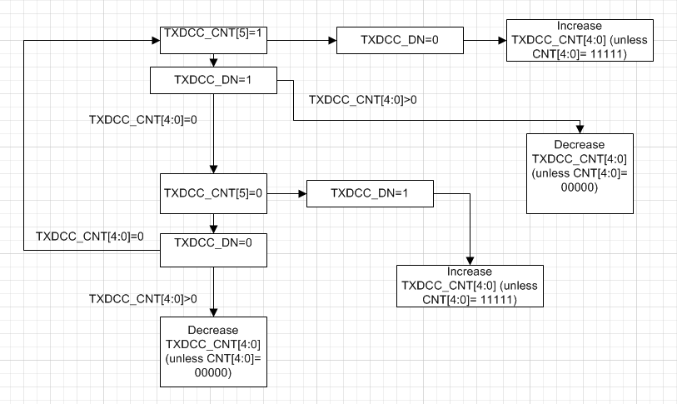

# **FW Handling**

The firmware first initializes for the calibration, next starts the unicore and wait for the calibration to finish. After the calibration, the FW saves the calibration result.

## **4.1** **Flow Chart**



## **4.2 Code Size**

# **Features**

The calibration function has the following features.

1. Initialize registers;
2. Start the unicore;
3. Wait for the calibration to finish;
4. Save the calibration result.

# **Test Plan**

| **No** | **Description** |
| --- | --- |
| **1** | **Initialization** |
|  | **Verify the initialization.**  Check the registers needed to be initialized. Covered by local test. |
| **2** | **Calibration starts.** |
|  | **Verify the calibration starts.**  Check the TX_ALIGN90_DCC_CAL_TOP_START. Covered by local test. |
| **3** | **Calibration done.** |
|  | **Verify the calibration done.**  Check the cmx_CAL_DONE. Covered by local test. |