**COMPHY_112G**

**TX IMP Calibration**

**R1.0**

**Macro Architecture Specification**

For Internal Use Only

Design Version V1.0

**Revision History**

|  |  |  |  |
| --- | --- | --- | --- |
| **Revision** | **Author** | **Change List** | **Date** |
| V1.0 |  |  |  |
|  |  |  |  |
|  |  |  |  |
|  |  |  |  |
|  |  |  |  |
|  |  |  |  |
|  |  |  |  |
|  |  |  |  |

**Table of Contents**

**1.** **Introduction** 2

**2. Interafces** 2

**2.1 Firmware Interface Signal** 2

**2.2 Digital Interface Signal** 2

**2.3 Analog Interface Signal** 3

**2.4 Time Flow** 4

**3** **Block Diagram** 5

**4** **FW Handling** 5

**4.1** **Flow Chart** 5

**4.2 Code Size** 5

**5** **Features** 5

**6** **Test Plan** 5

# **Introduction**

This document describes the firmware of RXCLK calibration.

# **2. Interafces**

## **2.1 Firmware Interface Signal**

|  |  |  |
| --- | --- | --- |
| **Port Name** | **Dir** | **Description** |
| cmx_TXIMP_CAL_EXT_EN | O | External enable. |
| cmx_EXT_FORCE_CAL_DONE | I/O | Force to skip calibration. |
| lnx_TXIMP_CAL_DONE_LANE | I/O | TX IMP Calibration done. |
| lnx_TXIMP_CAL_PASS_LANE | I/O | TX IMP Calibration pass. |

## 

## **2.2 Digital Interface Signal**

|  |  |  |
| --- | --- | --- |
| **Port Name** | **Dir** | **Description** |
| PHY_STATUS | O | The running status of PHY. |
| TX_IMP_CAL_TOP_START | I/O | TX IMP Calibration Top Start. |
| TX_IMP_CAL_TOP_DONE | I/O | TX IMP Calibration Top Done. |
|  |  |  |

## **2.3 Analog Interface Signal**

|  |  |  |
| --- | --- | --- |
| **Port Name** | **Dir** | **Description** |
| PU_DRVREG_LANE | IR | Previous description: TX output driver power down control signal. 0=power down 1=power up |
| PU_TX_LANE | IR | TX power control 0=power down 1=active |
| TXIMPCAL_EN | IR | TX Impedance calibration enable signal for CMN  1= enable TX impedance cali. 0= disable TX impedance cali. |
| TX_IMPCAL_EN_LANE | IR | TX Impedance calibration enable signal. 1= enable impedance cali for corresponding lane 0= disable impedance cali for corresponding lane |
| TX_IMPCAL_BOT_LANE | IR | Control Signal in TX impedance calibration.  0=Calibrate the impedance of PMOS (top) branches  1=calibrate the impedance of NMOS (bottom) branches. |
| TX_IMPCAL_SIDE_LANE | IR | Switch the side during impedance calibration, either for PMOS (top) or NMOS (bottom). Because each time, only half of the PMOS branches (or NMOS branches) will be used during calibration.  0=Calibrate the first half of PMOS or NMOS branches  1=Calibrate the other half of PMOS or NMOS branches. |
| RCAL_2ND_EN_LANE | IR | Perform impedance calibration for PMOS side twice, switch main branch and mirrored current in between. |
| TXIMP_PTUNE_LANE[5:0] | IR | Binary code. TX impedance setting for PMOS side, default ~42ohm without Tcoil. TXIMP_PTUNE_LANE[0] is 1LSB. |
| TXIMP_NTUNE_LANE[5:0] | IR | Binary code. TX impedance setting for NMOS side, default ~42ohm without Tcoil. TXIMP_NTUNE_LANE[0] is 1LSB. |
| TRX_IMPCAL_CLK | IR | Tx & Rx impedance calibration input clock |
| VREF_TXDRV_SEL[2:0] | IR | TX amplitude setting, which are sent to Ivref. [2:1] are used to adjust common mode voltage for hiz common mode voltage holding.  For each lane, there is separate VREF_TXDRV_SEL[2:0]  000: TX amp=0.88V  001: 0.9V  010: 0.92V  011: 0.94V  100: 0.96V (default)  101: 0.98V  110: 1.00V  111: 1.02V |
| TXIMPCAL_DRVAMP[2:0] | IR | Control the value of tx impedance calibration current, which should match tx amplitude setting.  TXIMPCAL_DRVAMP[2:0] is sent to Ivref and shared for all the lanes.  During each lane’s tx impedance calibration,  TXIMPCAL_DRVAMP[2:0] follow the setting of VREF_TXDRV_SEL[2:0] of the lane.  For example, during tx impedance calibration of lane0,  TXIMPCAL_DRVAMP[2:0]= VREF_TXDRV_SEL[2:0]_CH0 |
| VTH_TXIMPCAL[2:0] | IR | Impedance target setting for TX Impedance calibration, with T-coil excluded. With T-coil included, 2~3 ohm will be added.  000: Reserved  001: Reserved  010: Reserved  011: 42.3 ohm (default)  100: 44.7 ohm  101: 46.2 ohm  110: Reserved  111: Reserved |
| CMN_IMPCAL_OUT | O | Impedance calibration comparator output. |

## **2.4 Time Flow**

# **Block Diagram**

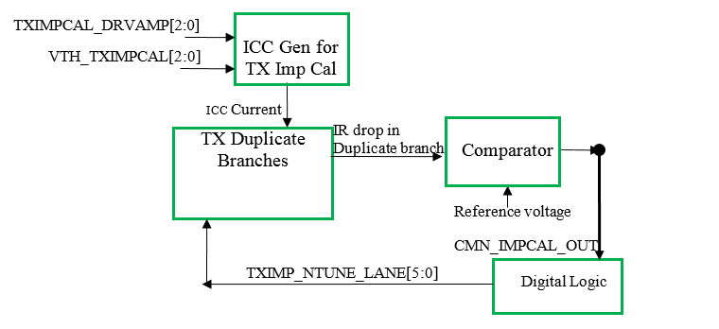

# **FW Handling**

The firmware first initializes for the calibration, next starts the unicore and wait for the calibration to finish. After the calibration, the FW saves the calibration result.

## **Flow Chart**

The FW does the TXIMP_N_1, TXIMP_N_2 and TXIMP_P_1, TXIMP_P_2, TXIMP_P_3 and TXIMP_P_4 calibration. The flow chart of each stage is similar. The flow chart is plotted below.



## **4.2 Code Size**

# **Features**

The calibration function has the following features.

1. Initialize registers;
2. Start the unicore;
3. Wait for the calibration to finish;
4. Save the calibration result.

# **Test Plan**

| **No** | **Description** |
| --- | --- |
| **1** | **Initialization** |
|  | **Verify the initialization.**  Check the registers needed to be initialized. Covered by local test. |
| **2** | **Calibration starts.** |
|  | **Verify the calibration starts for each stage.**  Check the TX_IMP_CAL_TOP_START. Covered by local test. |
| **3** | **Calibration done.** |
|  | **Verify the calibration done.**  Check the lnx_TXIMP_CAL_DONE_LANE. Covered by local test. |