Introduction

This “soft_reset” function are in all 28nm PHY IPs. So SoCs who used our 28nm PHY before may still need this function.

The basic idea is

1. PIN_RESET : Reset all hardware state machine and all PHY control registers.
2. PIN_RESET_CORE : Reset all hardware state machine, but does NOT reset PHY control registers.

If we apply this to MCU-based PHY,

1. PIN_RESET: Reset all hardware and Software state machine and all PHY control registers.
2. PIN_RESET_CORE#: Reset all hardware and software state machine, but does NOT reset PHY control registers.

So for item 2, MCU needs to know it starts from “soft-reset” and MCU needs to clear all status registers and xdata, then start over.

The below table list different ways to reset the MCU/PHY.

|  |  |  |  |  |
| --- | --- | --- | --- | --- |
|  | xdata | Registers | MCU SFR | Bus Logic |
| PIN_RESET | No | Yes | 0 | Yes |
| PIN_RESET_CORE# | No | No | Yes | Yes |
| MCU restart | No | No | Yes | No |
| Soft Reset No Reg | No | No | Yes | Yes |

Definitions:

PIN_RESET: Reset all hardware and Software state machine and all PHY control registers.

PIN_RESET_CORE#: Reset all hardware and software state machine, but does NOT reset PHY control registers.

MCU restart: Restart firmware with PHY New State. ISR uses this feature to enter new PHY state.

Soft Reset No Reg: Similar to PIN_RESET_CORE#.

Since the resets PIN_RESET_CORE# and Soft Reset No Reg are similar, FW will consider these two resets as the same reset type.

To determine which reset has occurred, FW will look at the mcu_status and phy_reset registers.

The below table list the registers values and what action FW will take.

|  |  |  |  |
| --- | --- | --- | --- |
| Register_mcu_status | Register_phy_reset | Description | Action |
| 0 | 1 | OOR | PowerUp_Seq |
| !0 | 1 | OO-SW-RST | Clear registers + PowerUp_Seq |
| !0 | 0 | SELF | PHY_NS |

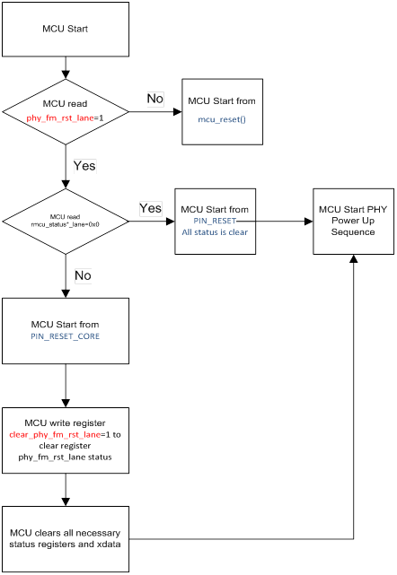

Firmware flowchart

