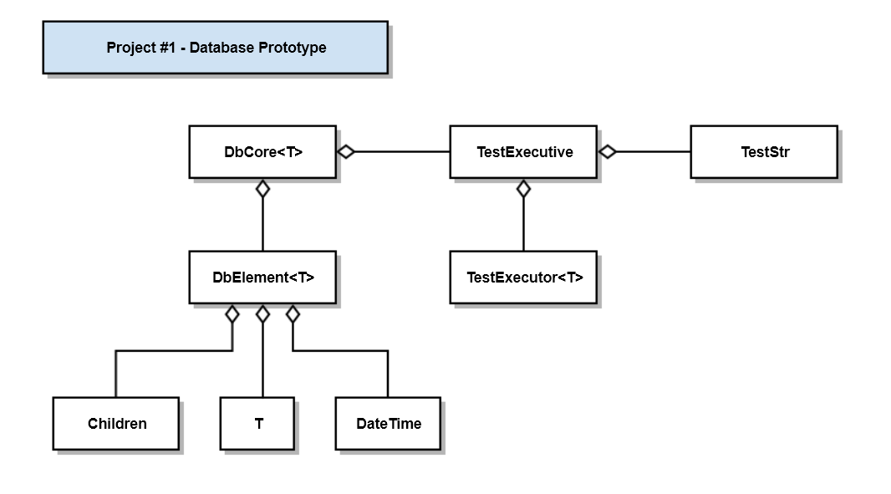

|  |  |
| --- | --- |
| Class | Responsibility |
| DbCore<T> | Implements core database functionality |
| DbElement<T> | Value part of a { key, value } db record |
| T | Payload type |
| Children | std::vector<std::string>, holds a collection of keys, e.g., dependencies |
| DateTime | Manages date-time stamps, creates current time strings |
| TestExecutive | Holds a collection of TestStr instances, executes them using TestExecutor<T> |
| TestExecutor<T> | Executes a single test in the context of a try-catch block |
| TestStr | Struct { name, test (callable object) } |