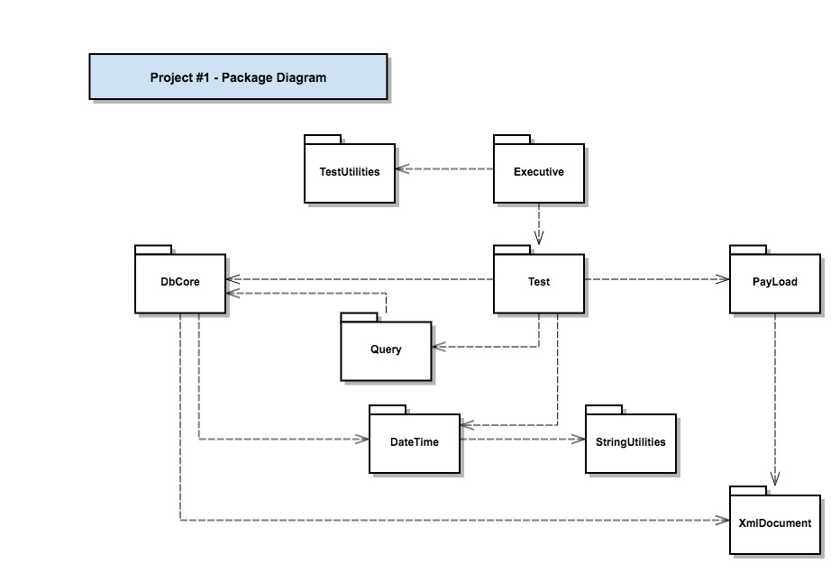

|  |  |
| --- | --- |
| Package | Responsibility |
| DbCore | Implements core database functionality |
| Query | Query for keys, Mata text, datetime, children relationship, payload |
| Test | Supply all test functions |
| Executive | Register all test functions in Test and executive them with TestUtilities |
| DateTime | Manages date-time stamps, creates current time strings |
| TestUtilities | Holds a collection of TestStr instances, executes them using TestExecutor<T> |
| Payload | User defined payload, now with a filepath and a vector of categories |
| XmlDocument | Deal with XML file, parser and make |
| StringUtilities | Supply functions for manipulating strings |