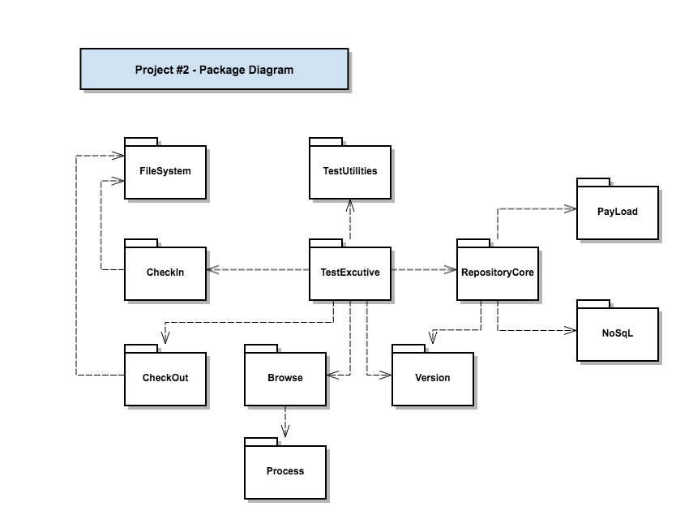

|  |  |
| --- | --- |
| Package | Responsibility |
| RepositoryCore | Implements core repository functionality |
| CheckIn | Accept file, add information, save to database and destination |
| CheckOut | Get all files with dependencies optionally |
| Executive | Register all test functions in Test and executive them with TestUtilities |
| Version | Manages versions and package status |
| TestUtilities | Holds a collection of TestStr instances, executes them using TestExecutor<T> |
| Payload | User defined payload, now with a filepath and a vector of categories, author, and version number |
| Browse | Display queried files |
| NoSql | Database implemented in project1 |
| Process | Pop up windows using process |
| FileSystem | Used in this project to copy files and get file information |