Domain Model

Acies - The A Team

Domain Model:

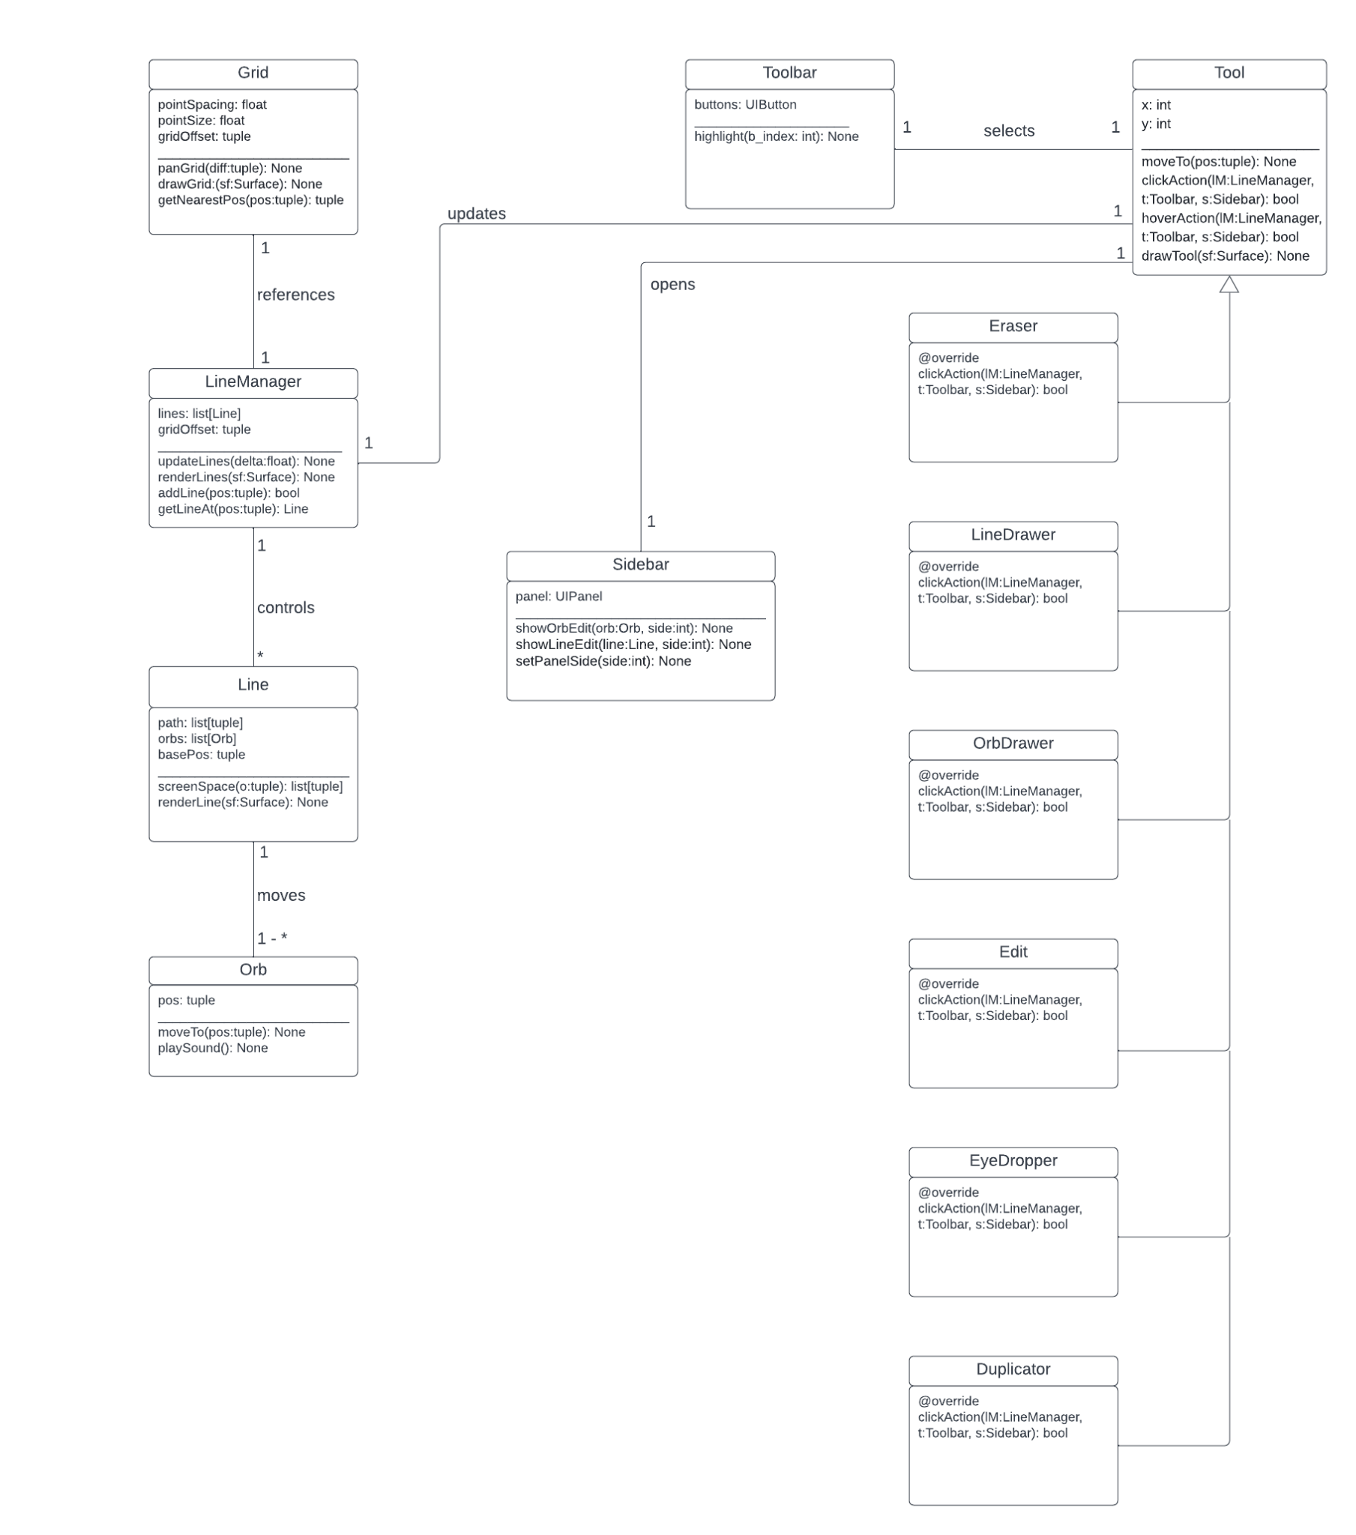

\*Because the model would look too complex if the method and variable names were exactly as seen in the code, they have been simplified for ease of reading.

Description:

The app is primarily controlled by the LineManager class. The Linemanager class contains a list of all of the Line instances and methods to place, update, render, and remove lines. The LineManager class references the Grid class in a one to one relationship in order to make sure that lines are snapping to the grid when placed. The LineManager class also controls all of the lines in a one to many relationship. Each Line contains a list of the Orb class instances that are attached to it, and updates them in a one to many relationship. Each Orb class contains a method to play sound when it reaches a corner on its line, and an attribute storing its position.

The Tool class contains functionality to handle mouse clicks, mouse drags, and mouse hovers. It holds its position in two attributes, x and y. Since there is only one Tool class instance at a time, the Tool class references the Toolbar class in a one to one relationship. When the Tool class type is changed, it tells the Toolbar to highlight the button of the type of the tool. The Tool class references the Sidebar class in a one to one relationship. When an action the tool takes involves the sidebar, it opens the Sidebar. The Eraser, LineDrawer, OrbDrawer, Edit, Eyedropper, and Duplicator classes all inherit from the Tool class. They override the Tool class's functions that handle mouse clicks, mouse drags, and mouse hovers with functionality relevant to their class name.