Title page

todo:

figures - various
create numbered checklists
graphs, rotated
standard equipment
radios and electronics general usage
propeller usage
reference section

PILOT’S OPERATING HANDBOOK

Kitfox Series 7 STi

MODEL SERIES 7 STi

SERIAL NO. ________________________________________

REGISTRATION NO. __________________________________

CONGRATULATIONS.....

Welcome to the ranks of Kitfox owners! Your Kitfox has been designed to give you the most in performance, economy, and comfort. It is a pleasant experience!

This Pilot’s Operating Handbook has been prepared as a guide to help you get the most pleasure and utility from your airplane. It contains information about this Kitfox’s equipment, operating procedures, and performance; and suggestions for its servicing and care. We urge you to read it from cover to cover, and to refer to it frequently.

TABLE OF CONTENTS
SECTION 1 INTRODUCTION 7
SECTION 2 GENERAL 8
SECTION 3 LIMITATIONS 15
SECTION 4 EMERGENCY PROCEDURES 22
SECTION 5 NORMAL PROCEDURES 36
SECTION 6 PERFORMANCE 66
SECTION 7 WEIGHT & BALANCE / EQUIPMENT LIST 71
SECTION 8 AIRPLANE & SYSTEMS DESCRIPTIONS 81
SECTION 9 HANDLING, SERVICE & MAINTENANCE 109
SECTION 10 SUPPLEMENTS 118

This handbook can be kept current by regularly checking for Service Letters published by Kitfox Aircraft Company. These are distributed to Kitfox Owners on the following Kitfox Aircraft web page: https://kitfoxaircraft.com/serviceletters/. Service Letters are made available in the form of pdf downloads. These should be examined and included with this Handbook.

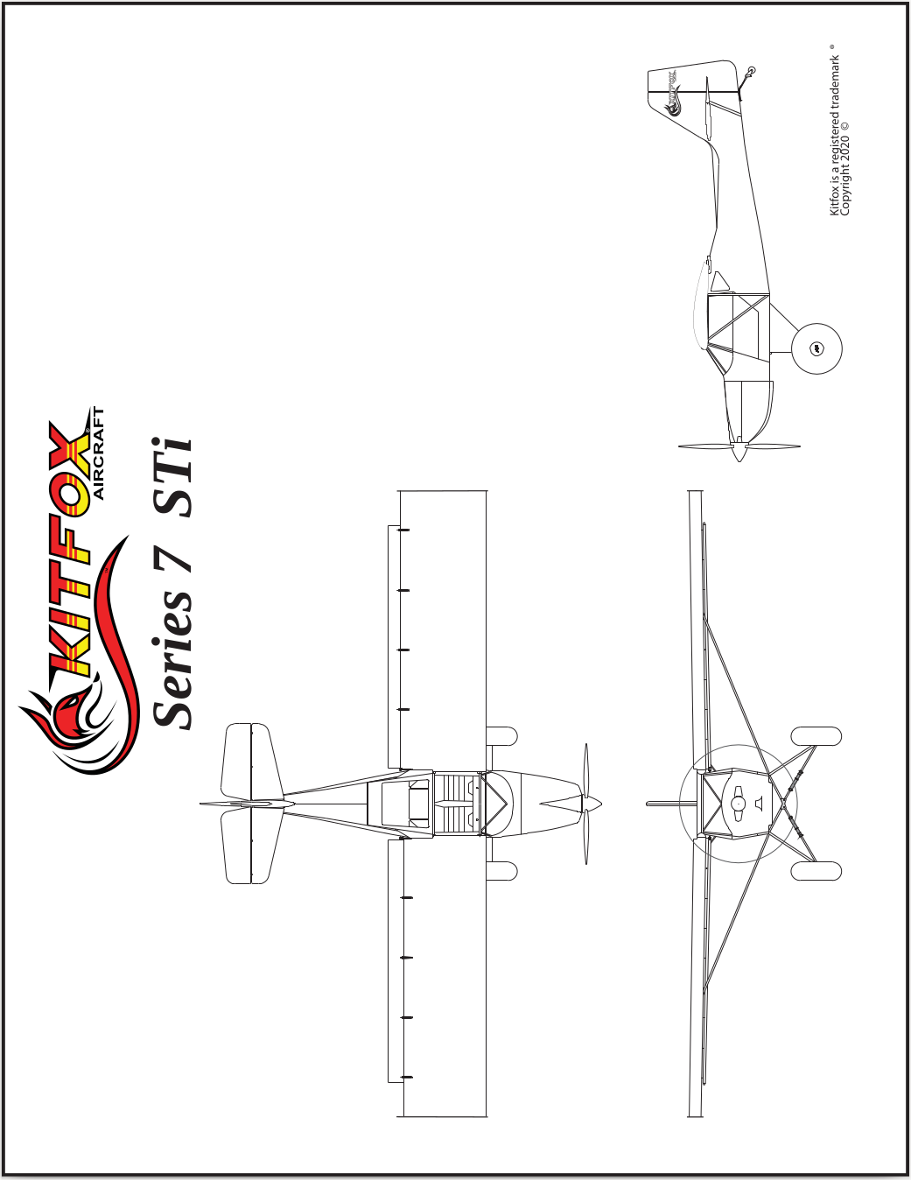
Figure 1-1. Three View

INTRODUCTION
This handbook contains 10 sections, and includes the material required to be furnished to the pilot by CFR 91.319. It may also contain supplemental data supplied by Kitfox Aircraft Company.

Section 1 provides basic data and information of general interest. It also contains definitions or explanations of symbols, abbreviations, and terminology commonly used.

GENERAL
TABLE OF CONTENTS
Section 2 GENERAL 10
ENGINE 10
PROPELLER 11
FUEL 11
FUEL LIMITATIONS 11
OIL 11
MAXIMUM CERTIFICATED WEIGHTS 12
STANDARD AIRPLANE WEIGHTS 12
SPECIFIC LOADINGS 12
SYMBOLS, ABBREVIATIONS AND TERMINOLOGY 12
GENERAL AIRSPEED TERMINOLOGY AND SYMBOLS 12
METEOROLOGICAL TERMINOLOGY 13
ENGINE POWER TERMINOLOGY 13
AIRPLANE PERFORMANCE AND FLIGHT PLANNING TERMINOLOGY 14
WEIGHT AND BALANCE TERMINOLOGY 14
CENTER OF GRAVITY LIMITS 15
WEIGHT LIMITS 15

ENGINE
Number of Engines: 1
Engine Manufacturer: BRP-Rotax
Engine Model Number: 915 iS A
Engine Type: Turbo-aspirated, geared-drive, air and water cooled, horizontally opposed, EFI equipped, four-cylinder engine with 1352 cu. cm displacement
Horsepower Rating and Engine Speed: 141 rated BHP at 5800 RPM for no more than 5 minutes
Horsepower Rating and Engine Speed: 135 rated BHP at 5500 RPM continuous

PROPELLER
Propeller Manufacturer: Airmaster
Propeller Model Number: AP430CTF-WWR72B-RSPB2.0-200F1.5-RS
Number of Blades: 3
Propeller Diameter: 72 inches
Propeller Type: Variable Pitch

FUEL
Approved Fuel Grades:
ASTM D4814 (min. AKI 91) aka 91 Octane MOGAS (Yellow)
100LL Grade Aviation Fuel (Blue)

FUEL LIMITATIONS
Total Capacity: 27 gallons.
Total Capacity Each Tank: 13 gallons
Capacity Header Tank: 1 gallon
Total Usable: 26 gallons

OIL
Oil Grade (Specification):
XPS 5W-50 Full Synthetic Aviation Engine
SHELL AeroShell Oil Sport Plus 4
Oil Capacity:
Total: 3 Liters

MAXIMUM CERTIFICATED WEIGHTS
Takeoff: 1550 lbs
Landing: 1550 lbs
Weight in Baggage Compartment: 160lb

STANDARD AIRPLANE WEIGHTS
Standard Empty Weight: 968 lbs
Maximum Useful Load: 582 lbs

SPECIFIC LOADINGS
Wing Loading: 10.47 lbs/sq ft
Power Loading: 11.00 lbs/hp

SYMBOLS, ABBREVIATIONS AND TERMINOLOGY

GENERAL AIRSPEED TERMINOLOGY AND SYMBOLS
CAS MPH Calibrated Airspeed is indicated airspeed corrected for position and instrument error and expressed in mph. MPH calibrated airspeed is equal to KTAS in standard atmosphere at sea level.

MPH MPH Indicated Airspeed is the speed show on the airspeed indicator and expressed in mph.

KTAS MPH True Airspeed is the airspeed expressed in mph relative to undisturbed air which is CAS corrected for altitude and temperature.

VA Maneuvering Speed is the maximum speed at which you may use abrupt control travel.

VFE Maximum Flap Extended Speed is the highest speed permissible with wing flaps in a prescribed extended position.

VNO Maximum Structural Cruising Speed is the speed that should not be exceeded except in smooth air, then only with caution.

VNE Never Exceed Speed is the speed limit that may not be exceeded at any time.

VS Stalling Speed or the minimum steady flight speed at which the airplane is controllable.

VS0 Stalling Speed or minimum steady flight speed at which the airplane is controllable in the landing configuration at the most forward center of gravity.

VX Best Angle-of-Climb Speed is the speed which results in the greatest gain of altitude in a given horizontal distance.

VY Best Rate-of-Climb Speed is the speed which results in the greatest gain in altitude in a given time.

METEOROLOGICAL TERMINOLOGY
OAT Outside Air Temperature is the free air static temperature. It is expressed in either degrees Celsius (formerly Centigrade) or degrees Fahrenheit.

Standard Temperature Standard Temperature is 15°C at sea level pressure altitude and decreases by 2°C for each 1000 feet of altitude.

Pressure Altitude Pressure Altitude is the altitude read from an altimeter when the altimeter’s barometric scale has been set to 29.92 inches of mercury (1013 mb).

ENGINE POWER TERMINOLOGY
BHP Brake Horsepower is the power developed by the engine.

RPM Revolutions Per Minute is engine speed.

Static RPM Static RPM is engine speed attained during a full-throttle engine runup when the airplane is on the ground and stationary.

AIRPLANE PERFORMANCE AND FLIGHT PLANNING TERMINOLOGY
Demonstrated Crosswind Velocity Demonstrated Crosswind Velocity is the velocity of the crosswind component for which adequate control of the airplane during takeoff and landing was actually demonstrated during certification tests. The value
shown is not considered to be limiting.

Usable Fuel Usable Fuel is the fuel available for flight planning.

Unusable Fuel Unusable Fuel is the quantity of fuel that cannot be safely used in flight.

GPH Gallons Per Hour is the amount of fuel (in gallons) consumed per hour.
NMPG Nautical Miles Per Gallon is the distance (in nautical miles) which can be expected per gallon of fuel consumed at a specific engine power setting and/or flight configuration.

WEIGHT AND BALANCE TERMINOLOGY
Reference Datum Reference Datum is an imaginary vertical plane from which all horizontal distances are measured for balance purposes.

Station Station is a location along the airplane fuselage given in terms of the distance from the reference datum.

Arm Arm is the horizontal distance from the reference datum to the center of gravity (C.G.) of an item.

Moment Moment is the product of the weight of an item multiplied by its arm. (Moment divided by the constant 1000 is used in this handbook to simplify balance calculations by reducing the number of digits.)

CENTER OF GRAVITY LIMITS
C.G. Center of Gravity is the point at which an airplane, or equipment, would balance if suspended. Its distance from the reference datum is found by dividing the total moment by the total weight of the airplane.

C.G. Arm Center of Gravity Arm is the arm obtained by adding the airplane’s individual moments and dividing the sum by the total weight.

C.G. Limits Center of Gravity Limits are the extreme center of gravity locations within which the airplane must be operated at a given weight.

WEIGHT LIMITS
Standard Empty Weight Standard Empty Weight is the weight of a standard airplane, including unusable fuel, full operating fluids and full engine oil.

Basic Empty Weight Basic Empty Weight is the standard empty weight plus the weight of optional equipment.

Useful Load Useful Load is the difference between takeoff weight and the basic empty weight.

Gross (Loaded) Weight Gross (Loaded) Weight is the loaded weight of the airplane.

Maximum Takeoff Weight Maximum Takeoff Weight is the maximum weight approved for the start of the takeoff run.

Maximum Landing Weight Maximum Landing Weight is the maximum weight approved for the landing touchdown.

Tare Tare is the weight of chocks, blocks, stands, etc. used when weighing an airplane, and is included in the scale readings. Tare is deducted from the scale reading to obtain the actual (net) airplane weight.

LIMITATIONS
TABLE OF CONTENTS
Section 3 LIMITATIONS 17
INTRODUCTION 17
AIRSPEED LIMITATIONS 18
AIRSPEED INDICATOR MARKINGS 18
POWER PLANT LIMITATIONS 19
POWER PLANT LIMITATIONS 20
INSTRUMENT 20
WEIGHT LIMITS 20
CENTER OF GRAVITY LIMITS 21
MANEUVERING LIMITS 21
MANEUVER MAXIMUM ENTRY SPEED* 21
FLIGHT LOAD FACTOR LIMITS 21
FLIGHT LOAD FACTOR LIMITS 21
KINDS OF OPERATION LIMITS 22
FUEL LIMITATIONS 22
PLACARDS 23

INTRODUCTION
Section 2 includes operating limitations, instrument markings, and basic placards necessary for the safe operation of the airplane, its engine, standard systems and standard equipment. The limitations
included in this section have been approved by the Federal Aviation Administration. When applicable, limitations associated with optional systems or equipment are included in Section 9.

AIRSPEED LIMITATIONS
Airspeed limitations and their operational significance are shown in Figure 2-1.

 | SPEED | MPH | REMARKS
VNE | Never Exceed Speed | 140 | Do not exceed this speed in any operation
VNO | Maximum Structural Cruising Speed | 111 | Do no exceed this speed except in smooth air, and then only with caution.
VA | Maneuvering Speed: 1550 lbs | 104 | Do not make full or abrupt control movements above this speed
VFE | Maximum Flap Extend Speed | 80 | Do not exceed this speed with flaps down.
 | Maximum Door Open Speed | 75 | Do not exceed this speed with doors open.

Figure 2-1 Airspeed Limitations

AIRSPEED INDICATOR MARKINGS
Airspeed indicator markings and their color code significance are shown in Figure 2-2.

MARKING | MPH VALUE OR RANGE | SIGNIFICANCE
White Arc | 35-80 | Full Flap Operating Range. Lower limit is maximum weight VS0 in landing configuration. Upper limit is maximum speed permissible with flaps extended.
Green Arc | 40-111 | Normal Operating Range. Lower limit is maximum weight VS at most forward C.G. with flaps retracted. Upper limit is maximum structural cruising speed.
Yellow Arc | 111-140 | Operations must be conducted with caution and only in smooth air.
Red Line | 140 | Maximum speed for all operations.

Figure 2-2 Airspeed Indicator Markings

POWER PLANT LIMITATIONS
Engine Manufacturer: Rotax
Engine Model Number: 915iS A
Engine Operating Limits for Takeoff and Continuous Operations:
Maximum Power: 141 BHP
Maximum Engine Speed: 5800 RPM

NOTE

The static RPM range at full throttle is 5800 for a maximum of 5 minutes

Maximum Oil Temperature: 266°F
Oil Pressure
Minimum: 11.6 psi
Maximum: 101.5 psi
Propeller Manufacturer: Airmaster
Propeller Model Number: AP430CTF-WWR72B-RSPB2.0-200F1.5-RS
Number of Blades: 3
Propeller Diameter: 72 inches
Propeller Type: Variable Pitch

POWER PLANT LIMITATIONS
Power plant instrument markings and their color code significance are show in Figure 2-3.

INSTRUMENT
 | RED LINE | GREEN ARC | RED LINE
 | MINIMUM LIMIT | NORMAL OPERATING | MAXIMUM LIMIT
Tachometer | --- | 1800 - 5500 RPM | 5800 RPM (max. 5 minutes
Oil Temp | -4F | 122° - 266° F | 266° F
Oil Press | 11.6 PSI | 29-72.5 PSI | 101.5 PSI

Figure 2-3. Power Plant Instrument Markings

WEIGHT LIMITS
Maximum Takeoff Weight: 1550 lbs.
Maximum Landing Weight: 1550 lbs.
Maximum Weight in Baggage Compartment:
Baggage Area - Station 49: 120 lbs.
See note below.

NOTE

The maximum weight capacity for the baggage area is 160 lbs. with one 180 lb pilot.

CENTER OF GRAVITY LIMITS
Center of Gravity Range:
Forward: 9.5 inches aft of datum at all weights.
Aft: 16.0 inches aft of datum at all weights.
Reference Datum: Leading edge of wing.

MANEUVERING LIMITS
This airplane is certificated in the normal category and is not designed for aerobatic flight.

No aerobatic maneuvers are approved except those listed below:

MANEUVER MAXIMUM ENTRY SPEED*
Chandelles .........................................................…………...... 95 mph
Lazy Eights .................................................………….............. 95 mph
Steep Turns ..................................................…………............ 95 mph
Stalls (Except Whip Stalls) ..............................Use Slow Deceleration

* Higher speeds can be used if abrupt use of the controls is avoided.

Aerobatics that may impose high loads should not be attempted. The important thing to bear in mind in flight maneuvers is that the airplane is clean in aerodynamic design and will build up speed quickly with the nose down. Proper speed control is an essential requirement for execution of any maneuver, and care should always be exercised to avoid excessive speed which in turn can impose excessive loads. In the execution of all maneuvers, avoid abrupt use of controls.

FLIGHT LOAD FACTOR LIMITS

FLIGHT LOAD FACTOR LIMITS
* +6g, -3g

KINDS OF OPERATION LIMITS
The airplane is equipped for day VFR and may be equipped for night VFR and/or IFR operations. FAR Part 91 establishes the minimum required instrumentation and equipment for these operations. The
reference to types of flight operations on the operating limitations placard reflects equipment installed at the time of Airworthiness Certificate issuance.

Flight into known icing conditions is prohibited.

FUEL LIMITATIONS
2 Standard Tanks: 13 U.S. gallons each
1 Header Tank: 1 U.S. gallon
Total Fuel: 27 U.S. gallons
Usable Fuel (all flight conditions): 25.5 U.S. gallons
Unusable Fuel: 1.5 U.S. gallons

NOTE

Takeoffs have not been demonstrated with less than 5 gallons total fuel (2.5 gallon per wing tank).

Approved Fuel Grades (and Colors):
ASTM D4814 (min. AKI 91) aka 91 Octane MOGAS (Yellow)
100LL Grade Aviation Fuel (Blue)

NOTE

AVGAS fuel additives

Additives under the names of Decalin® and Alcor®, which aid the scavenging of lead deposits have not been tested by BRP-Rotax. Field experience shows that these products significantly reduce lead deposits in the combustion chamber and piston/ring assemblies and have no detrimental effect on the engine, when used in the recommended manner.

Always follow the additive manufacturers instructions especially with regard to health and safety precautions. BRP-Rotax only has field experience with Decalin Runup® and Alcor TCP® brands. Other similar additives are not recommended as BRP-Rotax cannot comment on their suitability for the 916 i Series, 915 i Series, 912 i Series, 912 and 914 Series engine types.

PLACARDS
The following information is displayed in the form of composite or individual placards.

1. In full view of the pilot: (The “DAY-NIGHT-VFR-IFR” entry, shown on the example below, will vary as the airplane is equipped.)
2. In the baggage compartment:
3. Near fuel shutoff valve (standard tanks):
5. Near fuel tank filler cap (standard tanks):

EMERGENCY PROCEDURES
TABLE OF CONTENTS
Section 4 EMERGENCY PROCEDURES 24
INTRODUCTION 25
AIRSPEEDS FOR EMERGENCY OPERATION 25
OPERATIONAL CHECKLISTS 25
ENGINE FAILURES 25
FORCED LANDINGS 26
FIRES 27
ICING 29
LANDING WITH A FLAT MAIN TIRE 30
ELECTRICAL POWER SUPPLY SYSTEM MALFUNCTIONS 30
AMPLIFIED PROCEDURES 30
ENGINE FAILURE 30
FORCED LANDINGS 31
EMERGENCY OPERATION IN CLOUDS 32
RECOVERY FROM A SPIRAL DIVE 34
FLIGHT IN ICING CONDITIONS 34
SPINS 34
ROUGH ENGINE OPERATION OR LOSS OF POWER 35

INTRODUCTION
Section 3 provides checklist and amplified procedures for coping with emergencies that may occur. Emergencies caused by airplane or engine malfunctions are extremely rare if proper preflight inspections and maintenance are practiced. Enroute weather emergencies can be minimized or eliminated by careful flight planning and good judgment when unexpected weather is encountered. However, should an emergency arise, the basic guidelines described in this section should be considered and applied as necessary to correct the problem. Emergency procedures associated with ELT and other
optional systems can be found in Section 9.

AIRSPEEDS FOR EMERGENCY OPERATION
Engine Failure After Takeoff ...................................……........ 60 MPH
Maneuver Speed:
1550 Lbs .................................................………….…....... 98 MPH
Maximum Glide ........................................................………... 60 MPH
Precautionary Landing With Engine Power ........................... 55 MPH
Landing Without Engine Power:
Wing Flaps Up ..................................................………...... 65 MPH
Wing Flaps Down ..................................................……..... 60 MPH

OPERATIONAL CHECKLISTS

ENGINE FAILURES

ENGINE FAILURE DURING TAKEOFF RUN
1. Throttle - IDLE.
2. Brakes - APPLY.
3. Wing Flaps - RETRACT.
4. Master Switch - OFF.

ENGINE FAILURE IMMEDIATELY AFTER TAKEOFF
1. Airspeed - 60 MPH.
2. Fuel Shutoff Valve - OFF.
3. Wing Flaps - AS REQUIRED.
4. Master Switch - OFF.

ENGINE FAILURE DURING FLIGHT
1. Airspeed - 60 MPH.
2. Fuel Shutoff Valve - ON.
3. Power Switch - EMS BACKUP.
4. Start Button - Press START if propeller is stopped.

FORCED LANDINGS

EMERGENCY LANDING WITHOUT ENGINE POWER
1. Airspeed - 65 MPH (flaps UP),
60 MPH (flaps DOWN).
2. Fuel Shutoff Valve - OFF.
3. Wing Flaps - AS REQUIRED (Full recommended).
4. Master Switch - OFF.
5. Doors - UNLATCH PRIOR TO TOUCHDOWN.
6. Touchdown - SLIGHTLY TAIL LOW.
7. Brakes - APPLY HEAVILY.

PRECAUTIONARY LANDING WITH ENGINE POWER
1. Airspeed - 60 MPH.
2. Wing Flaps - Half.
3. Selected Field - FLY OVER, noting terrain and obstructions, Wind Wires Surface Slope (WWSS)
4. Radio and Electrical Switches - OFF.
5. Wing Flaps - Full (on final approach).
6. Airspeed - 55 MPH.
7. Master Switch - OFF.
8. Doors - UNLATCH PRIOR TO TOUCHDOWN.
9. Ignition Switch - OFF.
10. Brakes - APPLY HEAVILY.

DITCHING
1. Radio - TRANSMIT MAYDAY on 121.5 MHz, giving location and intentions.
2. Heavy Objects (in baggage area) - SECURE OR JETTISON.
3. Approach - High Winds, Heavy Seas - INTO THE WIND.
Light Winds, Heavy Swells - PARALLEL TO SWELLS.
4. Wing Flaps - Full.
5. Power - ESTABLISH 300 FT/MIN DESCENT AT 55 MPH.
6. Cabin Doors - UNLATCH.
7. Touchdown - LEVEL ATTITUDE AT 300 FT/MIN DESCENT.
8. Face - CUSHION at touchdown with folded coat.
9. Airplane - EVACUATE through cabin doors.
10. Life Vests and Raft - INFLATE.

FIRES

DURING START ON GROUND
If engine starts:

1. Power - 3300 RPM for a few minutes.
2. Engine - SHUTDOWN and inspect for damage.

If engine fails to start:

1. Cranking - CONTINUE in an effort to obtain a start.
2. Fire Extinguisher - OBTAIN (have ground attendants obtain if not installed).
3. Engine - SECURE.
a. Master Switch - OFF.
b. Fuel Shutoff Valve - OFF.
4. Fire - EXTINGUISH using fire extinguisher, wool blanket, or dirt.
5. Fire Damage - INSPECT, repair damage or replace damaged components or wiring before conducting another flight.

ENGINE FIRE IN FLIGHT
1. Fuel Pumps - OFF.
2. Fuel Shutoff Valve - OFF.
3. Master Switch - OFF.
4. Cabin Air - OFF.
5. Airspeed - 85 MPH in a side slip to the left (If fire is not extinguished, increase glide speed to find an airspeed which will
provide an incombustible mixture).
6. Forced Landing - EXECUTE (as described in Emergency Landing Without Engine Power).

ELECTRICAL FIRE IN FLIGHT
1. Master Switch - OFF.
2. All Other Switches - OFF.
3. Vents/Cabin Air/Heat - CLOSED.
4. Fire Extinguisher - ACTIVATE (if available).

WARNING
After discharging an extinguisher within a closed cabin, ventilate the cabin.

If fire appears out and electrical power is necessary for continuance of flight:

5. Master Switch - ON.
6. Circuit Breakers - CHECK for faulty circuit, do not reset.
7. Radio/Electrical Switches - ON one at a time, with delay after each until short circuit is localized.
8. Vents/Cabin Air/Heat - OPEN when it is ascertained that fire is completely extinguished.

CABIN FIRE
1. Master Switch - OFF.
2. Vents/Cabin Air - CLOSED (to avoid drafts).
3. Fire Extinguisher - ACTIVATE (if available)

WARNING
After discharging an extinguisher within a closed cabin, ventilate the cabin.

4. Land the airplane as soon as possible to inspect for damage.

WING FIRE
1. Navigation Light Switch - OFF.
2. Strobe Light Switch (if installed) - OFF.
3. Landing/Wig-wag (if installed) - OFF.
4. Pitot Heat Switch (if installed) - OFF.

NOTE
Perform a left side slip to keep the flames away from the fuel tank and cabin, and land as soon as possible, with flaps retracted.

ICING

INADVERTENT ICING ENCOUNTER
1. Turn pitot heat switch ON (if installed).
2. Turn back or change altitude to obtain an outside air temperature that is less conducive to icing.
3. Set cabin heat control to high to obtain maximum defroster air temperature. For greater air flow at reduced temperatures, adjust the cabin air control as required.
4. Open the throttle to increase engine speed and minimize ice build-up on propeller blades.
5. Plan a landing at the nearest airport. With an extremely rapid ice build-up, select a suitable “off airport” landing site.
6. With an ice accumulation of 1/4 inch or more on the wing leading edges, be prepared for significantly higher stall speed.
7. Leave wing flaps retracted. With a severe ice build-up on the horizontal tail, the change in wing wake airflow direction caused by wing flap extension could result in a loss of elevator effectiveness.
8. Perform a landing approach using a forward slip, if necessary, for improved visibility.
9. Approach at 65 to 75 MPH depending upon the amount of ice accumulation.
10. Perform a landing in level attitude.

LANDING WITH A FLAT MAIN TIRE
1. Wing Flaps - AS DESIRED.
2. Approach - NORMAL.
3. Touchdown - GOOD TIRE FIRST, hold airplane off flat tire as long as possible with aileron control.

ELECTRICAL POWER SUPPLY SYSTEM MALFUNCTIONS

OVER-VOLTAGE WARNING ILLUMINATES
1. Master Switch - OFF.
2. Master Switch - ON.
3. Over-Voltage Light - OFF.

If over-voltage light illuminates again:

4. Flight - TERMINATE as soon as practical.

AMMETER SHOWS DISCHARGE
1. Nonessential Electrical Equipment - OFF.
2. Flight - TERMINATE as soon as practical.

AMPLIFIED PROCEDURES

ENGINE FAILURE
If an engine failure occurs during the takeoff run, the most important thing to do is stop the airplane on the remaining runway. Those extra items on the checklist will provide added safety after a failure of this type.

PROMPTLY LOWERING THE NOSE TO MAINTAIN AIRSPEED and establish a glide attitude is the first response to an engine failure after takeoff. In most cases, the landing should be planned straight ahead with only small changes in direction to avoid obstructions. Altitude and airspeed are seldom sufficient to execute a 180° gliding turn necessary to return to the runway. The checklist procedures assume that adequate time exists to secure the fuel and ignition systems prior to touchdown.

After engine failure in flight, the best glide speed as shown in Figure 3-1 should be established as quickly as possible. While gliding toward a suitable landing area, an effort should be made to identify the cause of the failure. If time permits, an engine restart should be attempted as shown in the checklist. If the engine cannot be restarted, a forced landing without power must be completed.

HEIGHT AGL | 1000 | 2000 | 3000 | 4000 | 5000 | 6000 | 7000 | 8000
GLIDE DISTANCE (SM) | 1.6 | 3.2 | 4.8 | 6.4 | 8.0 | 9.6 | 11.2 | 12.8

Figure 3-1. Maximum Glide

SPEED 60 MPH
PROPELLER FEATHERED
FLAPS UP

FORCED LANDINGS
If all attempts to restart the engine fail and a forced landing is imminent, select a suitable field and prepare for the landing as discussed under the Emergency Landing Without Engine Power checklist.

Before attempting an “off airport” landing with engine power available, one should fly over the landing area at a safe but low altitude to inspect the terrain for obstructions and surface conditions, proceeding as discussed under the Precautionary Landing With Engine Power checklist.

Prepare for ditching by securing or jettisoning heavy objects located in the baggage area and collect folded coats for protection of occupants’ face at touchdown. Transmit Mayday message on 121.5 MHz giving location and intentions.

LANDING WITHOUT ELEVATOR CONTROL
Trim for horizontal flight (with an airspeed of approximately 55 MPH and flaps lowered to 1/2) by using throttle and elevator trim controls. Then do not change the elevator trim control setting ; control the glide angle by adjusting power exclusively.

At flareout, the nose-down moment resulting from power reduction is an adverse factor and the airplane may hit nose low. Consequently, at flareout, the trim control should be set at the full nose-up position and the power adjusted so that the airplane will rotate to the horizontal attitude for touchdown. Retract the flaps and close the throttle at touchdown.

FIRES
Although engine fires are extremely rare in flight, the steps of the appropriate checklist should be followed if one is encountered. After completion of this procedure, execute a forced landing. Do not attempt to restart the engine.

The initial indication of an electrical fire is usually the odor of burning insulation. The checklist for this problem should result in elimination of the fire.

EMERGENCY OPERATION IN CLOUDS

EXECUTING A 180° TURN IN CLOUDS
Upon inadvertently entering the clouds, an immediate plan should be made to turn back as follows:

1. Note the time of the minute hand and observe the position of the sweep second hand on the clock.
2. When the sweep second hand indicates the nearest half-minute, initiate a standard rate left turn, holding the turn coordinator symbolic airplane wing opposite the lower left index mark for 60 seconds. Then roll back to level flight by leveling the miniature airplane.
3. Check accuracy of the turn by observing the compass heading which should be the reciprocal of the original heading.
4. If necessary, adjust heading primarily with skidding motions rather than rolling motions so that the compass will read more accurately.
5. Maintain altitude and airspeed by cautious application of elevator control. Avoid over controlling by keeping the hands off the control wheel as much as possible and steering only with rudder.

EMERGENCY DESCENT THROUGH CLOUDS
If conditions preclude reestablishment of VFR flight by a 180° turn, a descent through a cloud deck to VFR conditions may be appropriate. If possible, obtain radio clearance for an emergency descent through clouds. To guard against a spiral dive, choose an easterly or westerly heading to minimize compass card swings due to changing bank angles. In addition, keep hands off the control wheel and steer a straight course with rudder control by monitoring the turn coordinator. Occasionally check the compass heading and make minor corrections to hold an approximate course. Before descending into the clouds, set up a stabilized let-down condition as follows:

1. Reduce power to set up a 500 to 800 ft/min rate of descent.
2. Adjust the elevator trim for a stabilized descent at 70 MPH.
3. Keep hands off control stick.
4. Monitor turn coordinator and make corrections by rudder alone.
5. Check trend of compass card movement and make cautious corrections with rudder to stop turn.
6. Upon breaking out of clouds, resume normal cruising flight.

RECOVERY FROM A SPIRAL DIVE
If a spiral is encountered, proceed as follows:

1. Close the throttle.
2. Stop the turn by using coordinated aileron and rudder control to align the symbolic airplane in the turn coordinator with the horizon reference line.
3. Cautiously apply elevator back pressure to slowly reduce the airspeed to 70 MPH.
4. Adjust the elevator trim control to maintain a 70 MPH glide.
5. Keep hands off the control stick, using rudder control to hold a straight heading.
6. Upon breaking out of clouds, resume normal cruising flight.

FLIGHT IN ICING CONDITIONS
Flight into icing conditions is prohibited. An inadvertent encounter with these conditions can best be
handled using the checklist procedures. The best procedure, of course, is to turn back or change altitude to escape icing conditions.

SPINS
Should an inadvertent spin occur, the following recovery procedure should be used:

1. PLACE AILERONS IN NEUTRAL POSITION.
2. RETARD THROTTLE TO IDLE POSITION.
3. APPLY AND HOLD FULL RUDDER OPPOSITE TO THE DIRECTION OF ROTATION.
4. JUST AFTER THE RUDDER REACHES THE STOP, MOVE THE CONTROL STICK BRISKLY FORWARD FAR ENOUGH TO BREAK THE STALL. Full down elevator may be required at aft center of gravity loadings to assure optimum recoveries.

5. HOLD THESE CONTROL INPUTS UNTIL ROTATION STOPS. Premature relaxation of the control inputs may extend the recovery.
6. AS ROTATION STOPS, NEUTRALIZE RUDDER, AND MAKE A SMOOTH RECOVERY FROM THE RESULTING DIVE.

NOTE

If disorientation precludes a visual determination of the direction of rotation, the symbolic airplane in the turn coordinator may be referred to for this information.

For additional information on spins and spin recovery, see the discussion under SPINS in Normal Procedures (Section 4).

ROUGH ENGINE OPERATION OR LOSS OF POWER

SPARK PLUG FOULING
A slight engine roughness in flight may be caused by one or more spark plugs becoming fouled by carbon or lead deposits. This may be verified by turning Lane A off briefly, turning Lane A back on and waiting for the light to turn back on and then repeating the same procedure with Lane B. An obvious power loss in single ignition operation is evidence of spark plug problem. Proceed to the nearest airport for repairs.

IGNITION MALFUNCTION
A sudden engine roughness or misfiring is usually evidence of ignition system or ECU problems. Switching from BOTH to either Lane A or Lane B position will identify which lane is malfunctioning. Select different power settings to determine if continued operation on BOTH lanes is practicable. If not, switch to the good lane and proceed to the nearest airport for repairs.

LOW OIL PRESSURE
If low oil pressure is accompanied by normal oil temperature, there is a possibility the oil pressure gauge or relief valve is malfunctioning. Landing at the nearest airport would be advisable to inspect the source of trouble.

If a total loss of oil pressure is accompanied by a rise in oil temperature, there is good reason to suspect an engine failure is imminent. Reduce engine power immediately and select a suitable forced landing field. Use only the minimum power required to reach the desired touchdown spot.

ELECTRICAL POWER SUPPLY SYSTEM MALFUNCTIONS
Malfunctions in the electrical power supply system can be detected by periodic monitoring of the ammeter and over-voltage warning light; however, the cause of these malfunctions is usually difficult to determine. A failing alternator or wiring is most likely the cause of alternator failures, although other factors could cause the problem. A damaged or improperly adjusted voltage regulator can also cause malfunctions. Problems of this nature constitute an electrical emergency and should be dealt with immediately. Electrical power malfunctions usually fall into two categories: excessive rate of charge and insufficient rate of charge. The paragraphs below describe the recommended remedy for each situation.

EXCESSIVE RATE OF CHARGE
After engine starting and heavy electrical usage at low engine speeds (such as extended taxiing) the battery condition will be low enough to accept above normal charging during the initial part of a flight. However, after thirty minutes of cruising flight, the ammeter should be indicating less than two needle
widths of charging current. If the charging rate were to remain above this value on a long flight, the battery would overheat and evaporate the electrolyte at an excessive rate. Electronic components in the electrical system could be adversely affected by higher than normal voltage if a faulty voltage regulator setting is causing the overcharging. To preclude these possibilities, [an over-voltage sensor will automatically shut down the alternator and the over-voltage warning light will illuminate if the charge voltage reaches approximately 14.2 volts.] Assuming that the malfunction was only momentary, an attempt should be made to reactivate the alternator system. To do this, turn both lanes off and then on again. If the problem no longer exists, normal alternator charging will resume and the warning light will go off. If the light illuminates again, a malfunction is confirmed. In this event, the flight should be terminated and/or the current drain on the battery minimized because the battery can supply the electrical system for only a limited period of time. If the emergency occurs at night, power must be conserved for later use of the landing light and flaps during landing.

INSUFFICIENT RATE OF CHARGE
If the ammeter indicates a continuous discharge rate in flight, the alternator is not supplying power to the system and should be shut down since the alternator field circuit may be placing an unnecessary load on the system. All nonessential equipment should be turned off and the flight terminated as soon as practical.

NORMAL PROCEDURES
TABLE OF CONTENTS
SECTION 5 NORMAL PROCEDURES 36
INTRODUCTION 37
GENERAL HANDLING OF THE AIRMASTER PROPELLER 37
AUTOMATIC OPERATION 38
MANUAL OVER-RIDE 39
SPEEDS FOR NORMAL OPERATION 40
CHECKLIST PROCEDURES 42
PREFLIGHT INSPECTION 42
BEFORE STARTING ENGINE 44
STARTING ENGINE (Temperatures above -4F°) 44
BEFORE TAKEOFF 44
TAKEOFF 45
LANDING 46
AFTER LANDING 47
AMPLIFIED PROCEDURES 48
STARTING ENGINE (Temperatures Above -4F°) 48
TAXIING 48
BEFORE TAKEOFF 50
TAKEOFF 51
LANDING 62
SHORT FIELD LANDING 62
CROSSWIND LANDING 62
BALKED LANDING 63
COLD WEATHER OPERATION 63
NOISE ABATEMENT 64

INTRODUCTION
Section 4 provides checklist and amplified procedures for the conduct of normal operation. Normal procedures associated with optional systems can be found in Section 9.

GENERAL OPERATION OF THE AIRMASTER PROPELLER
This aircraft is equipped with a variable pitch propeller and it must be handled differently to a conventional fixed pitch propeller. If used incorrectly the propeller can lead to engine limitations of manifold air pressure and speed to be exceeded in flight.

Full documentation regarding the Airmaster Propeller can be found at https://www.propellor.com/technical-publications:


WARNING

The propeller pitch is able to move to settings considerably coarser than typical fixed pitch propellers. Therefore the propeller may provide such a load on the engine that manifold air pressure (MAP) limits are exceeded. On aircraft with MAP limits, the pilot must ensure that the throttle is set so that MAP is kept within limits at the set engine speed.

The propeller is designed so that normal operation is automatic operation using the AC200 SmartPitch Controller. This operation provides constant speed governing of engine/propeller speed.

AUTOMATIC OPERATION
Automatic operation is when the automatic/manual selector is set to AUTO. The propeller system then functions as a constant speed propeller, where the propeller pitch changes automatically to keep the engine/propeller speed at a set value. This operation greatly reduces the workload of the pilot. The pilot effectively sets the desired power setting with the throttle and is then able to fly the aircraft, while having confidence that the engine/propeller speed, and therefore the power output, will remain constant.

Engine power is usually set by adjusting the throttle to achieve the desired performance. On aircraft with a MAP gauge, the MAP indication may be used to set the desired power.

The pilot must remain aware of the governing capabilities of the propeller system. The controller and pitch change mechanism have a finite response time and a finite rate of pitch change. The system is able to respond to normal changes in airspeed or throttle settings so that the speed remains within the governing limits of the set speed. However rapid change in airspeed or throttle setting will result in temporary deviations outside the governing limits until the propeller pitch is able to change sufficiently. Therefore throttle changes should be made in a slow and smooth manner.

Note

The governing limits (i.e., normal deviation from set speed) are detailed in the Airmaster AP3-4 Series Operators Manual, Chapter 9, Operation of AC200 SmartPitch Controller.

At all times the engine speed should be monitored to ensure that limits are not exceeded. Should the engine speed be observed to increase above the maximum, the throttle should be reduced immediately to keep the engine speed within limits. The following events may result in such an over-speed:

- Failure of the controller.
- Sudden increase in airspeed such as would be experienced in a dive.
- Rapid increase in throttle while in flight.

MANUAL OVERRIDE
If required the propeller may be operated in manual over-ride during any phase of flight. This is enabled by setting the automatic/manual selector to MAN. Manual over-ride is normally enabled in response to a failure of the automatic control system.

Note

See Airmaster AP3-4 Series Operators Manual, Part 9.3, Failure Modes, for a description of possible failure scenarios.

In manual over-ride the pilot has complete and direct control over the propeller pitch using the manual control switch. The pilot must control the propeller pitch and engine throttle to give the desired combination of power and engine speed, and to achieve the desired performance.

WARNING

An over-speed situation must be avoided. Selection of too fine a propeller pitch for the power setting will result in an over-speed.

WARNING

Excessively low engine speed must be avoided. Selection of too coarse a propeller pitch may result in the engine being unable to maintain the desired engine speed even at full throttle.

SPEEDS FOR NORMAL OPERATION
Unless otherwise noted, the following speeds are based on a maximum weight of 1550 pounds and may be used for any lesser weight.

Takeoff:
Normal Climb Out …………………………..…………… 65-75 MPH
Short Field Takeoff, Flaps 1/2, Speed at 50 Feet ............. 54 MPH
Climb, Flaps Up:
Normal .......................................................…...………...... 70 MPH
Best Rate of Climb, Sea Level ........................…......…..... 70 MPH
Best Rate of Climb, 10,000 Feet ....................................... 64 MPH
Best Angle of Climb, Sea Level thru 10,000 Feet .…........ 55 MPH
Landing Approach:
Normal Approach, Flaps Up ........................................ 60-70 MPH
Normal Approach, Flaps Full ...................….........….... 55-65 MPH
Short Field Approach, Flaps Full ..............…..................... 55 MPH
Balked Landing:
Maximum Power, Flaps Half ............................................. 55 MPH
Maximum Recommended Turbulent Air Penetration Speed:
1550 Lbs .................................................……………...... 104 MPH
1500 Lbs ..............................….............................…..…… 98 MPH
1350 Lbs .........................................................………....... 93 MPH
Maximum Demonstrated Crosswind Velocity ........................ 12 MPH

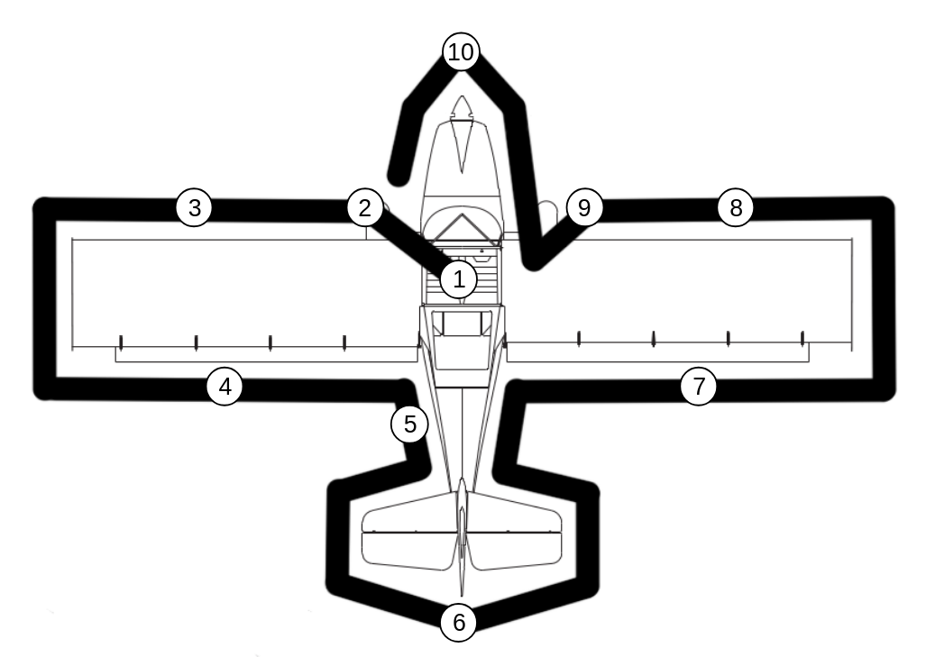
Figure 4-1. Preflight Inspection

NOTE

Visually check airplane for general condition during walk-around inspection. In cold weather, remove even small accumulation of frost, ice or snow from wing, tail and control surfaces. Also, make sure that control surfaces contain no internal accumulation of ice or debris. Prior to flight, check that pitot heater (if installed) is warm to touch within 30 seconds with battery and pitot heat switches on. If a night flight is planned, check operation of all lights, and make sure a flashlight is available.

CHECKLIST PROCEDURES

PREFLIGHT INSPECTION

1 - CABIN
- Lane A and B Switches - OFF.
- Master Switch - ON.
- Nav lights - ON.
- Strobe lights - ON.
- Landing or Wig Wag lights - ON.
- PropellEr - Switch to FEATHER and toggle “feather” to verify functionality. Switch to CRUISE when complete.
- Fuel Quantity Indicators - CHECK QUANTITY.
- All lights - OFF.
- Master Switch - OFF.
- Fuel Shutoff Valve - ON.
- Fuel levels - More than 1/8 tank, each.
- Control pins - In and secure.
- Spar pins - In and secure.

2- LEFT WING
- Main Wheel Tire - CHECK for proper inflation.
- Before first flight of day and after each refueling, use sampler cup and drain small quantity of fuel from fuel tank sump quick drain valve to check for water, sediment and proper fuel grade.
- Fuel Quantity - CHECK VISUALLY for desired level.
- Fuel Filler Cap - SECURE.

3 - LEFT WING Leading Edge
- Pitot Tube Cover - REMOVE and check opening for stoppage.
- Fuel Tank Vent Opening - CHECK for stoppage.
- Wing Tie-Down - DISCONNECT.

4 - LEFT WING Trailing Edge
- Flaperon - CHECK freedom of movement and security.

5 - EMPENNAGE
- Static Source Opening (left side of fuselage) - CHECK for stoppage.

6 - TAIL
- Tail Tie-Down - DISCONNECT.
- Control Surfaces - CHECK freedom of movement and security.
- Tailwheel - CHECK springs are connected to tail and safety wires are in place. CHECK that all bolts are secure and spring is properly tensioned.
- Access covers - CHECK all screws are in place.

7 - RIGHT WING Trailing Edge
- Flaperon - CHECK freedom of movement and security.

8 - RIGHT WING Leading edge
- Landing Light(s) - CHECK for condition and cleanliness.

9 - RIGHT WING
- Wing Tie-Down - DISCONNECT.
- Main Wheel Tire - CHECK for proper inflation.
- Before first flight of the day and after each refueling, use sampler cup and drain small quantity of fuel from fuel tank sump quick drain valve as well as header tank on bottom of fuselage to check for water, sediment, and proper fuel grade.
- Fuel Quantity - CHECK VISUALLY for desired level.
- Fuel Filler Cap - SECURE.

10 - NOSE
- Engine Oil Level - CHECK, do not operate with less than 3 liters (3.2 quarts). Level must be between minimum and maximum lines on dipstick.
- Engine Coolant - CHECK, that coolant level is visible through coolant window.
- Propeller and Spinner - CHECK for nicks and security.
- Air Filter - CHECK for restrictions by dust or other foreign matter.
- Cowling - CHECK for security.

BEFORE STARTING ENGINE
- Preflight Inspection – COMPLETE.
- Seats, Belts, Shoulder Harnesses - ADJUST and LOCK.
- Fuel Shutoff Valve - ON.
- Radios, Electrical Equipment - OFF.
- Brakes - TEST and SET.
- Circuit Breakers - CHECK IN.

STARTING ENGINE (Temperatures above -4F°)
- Master - ON.
- Propeller - SET to MAN and drive to fine pitch limit
- Lane A and B - ON.
- Start Power - Toggle ON.
- Lane A and B warning lights - CHECK OFF.
- Throttle - 50-60%.
- Fuel Pump (1) - ON.
- Propeller Area – CALL CLEAR.
- Ignition Switch - START (release when engine starts).
- Throttle - ADJUST for 2000 RPM or less.
- Oil Pressure – CHECK.
- Throttle – ADJUST for >2400 RPM and hold for 8 seconds.
- Throttle – ADJUST for ~2000 RPM for 2 minutes
- Throttle – ADJUST for ~2500 until oil temperature reaches 120° F.

BEFORE TAKEOFF
- Oil Temperature – 120° F
- All engine gauges - GREEN.
- Parking Brake - OFF.
- Cabin Doors - CLOSED and LATCHED.
- Flight Controls - FREE and CORRECT.
- Flight Instruments - SET.
- Radios - SET.
- Fuel Shutoff Valve - ON.
- Flaps - SET.
- Elevator Trim - TAKEOFF.
- Propellor - SET to AUTO and T.O.
- Throttle - 3000 RPM.
  - Lanes - CHECK (RPM drop should not exceed 125 RPM on either lane or 50 RPM differential between Lanes).
  - Engine Instruments and Ammeter – CHECK.
  - Propeller
    - Set to MAN.
    - Drive pitch toward COARSE. Ensure coarse indicator shows orange and engine RPM decreases.
    - Drive pitch toward FINE. Ensure fine indicator shows orange and RPM increases.
    - Set to AUTO and CRUISE. Ensure the no speed signal (i.e., fine indicator flashing orange) is not illuminated.
- Flashing Beacon, Navigation Lights and/or Strobe Lights - ON as required.
- Throttle Friction Lock - ADJUST.
- Brakes - RELEASE.

TAKEOFF

NORMAL TAKEOFF
- Wing Flaps - 1/2.
- Throttle - FULL OPEN.
- Elevator - LIFT TAIL at 40 MPH.
- Climb Speed - 65-75 MPH.
- Wing Flaps - RETRACT slowly after reaching 60 MPH.
- Propeller - SET to AUTO and CLIMB

SHORT FIELD TAKEOFF
- Wing Flaps - 1/2.
- Brakes - APPLY.
- Throttle - FULL OPEN.
- Brakes - RELEASE.
- Elevator - LIFT TAIL at 40 MPH.
- Climb Speed - 54 MPH (until all obstacles are cleared).
- Wing Flaps - RETRACT slowly after reaching 60 MPH.
- Prop - SET to AUTO and CLIMB

ENROUTE CLIMB
- Airspeed - 70 MPH.

NOTE
If a maximum performance climb is necessary, use speeds shown in the Rate of Climb chart in Section 5.

- Throttle - FULL OPEN.
- Prop - SET to AUTO and CLIMB.

CRUISE
- Prop – Set to AUTO and CRUISE.
- Power - 5350 RPM (no more than 100%).
- Elevator Trim - ADJUST.

BEFORE LANDING
- Seats, Belts, Harnesses - ADJUST and LOCK.
- Prop - Set to AUTO and T.O.

LANDING

NORMAL LANDING
- Airspeed - 60-70 MPH (flaps UP).
- Wing Flaps - AS DESIRED (below 80 MPH).
- Airspeed - 55-65 MPH (flaps DOWN).
- Touchdown - TAIL LOW.
- Landing Roll - RETRACT FLAPS (if deployed).
- Braking - MINIMUM REQUIRED.

SHORT FIELD LANDING
- Airspeed - 60-70 MPH (flaps UP).
- Wing Flaps - FULL (below 80 MPH).
- Airspeed - MAINTAIN 54 MPH.
- Power - REDUCE to idle as obstacle is cleared.
- Touchdown - TAIL LOW.
- Landing Roll - RETRACT FLAPS.
- Brakes - APPLY HEAVILY, CAREFULLY.

BALKED LANDING
- Throttle - FULL OPEN.
- Wing Flaps - RETRACT to half.
- Airspeed - 55 MPH.
- Wing Flaps - RETRACT (slowly).

AFTER LANDING
- Wing Flaps - RETRACT.

SECURING AIRPLANE
- Brake - ON.
- Power - ~3000 RPM
- Lane A and B - OFF
- Throttle - Pull OFF.
- Radios, Electrical Equipment - OFF.
- Master Switch - OFF.
- Parking Brake - SET.

AMPLIFIED PROCEDURES

STARTING ENGINE (Temperatures Above -4F°)
After starting, if the oil gauge does not begin to show pressure within 30 seconds in the summertime and about twice that long in very cold weather, stop the engine and investigate. Lack of oil pressure can cause serious engine damage.

NOTE

Details concerning cold weather starting and operation at temperatures below freezing may be found under Cold Weather Operation paragraphs in this section.

TAXIING
When taxiing, it is important that speed and use of brakes be held to a minimum and that all controls be utilized (see Taxiing Diagram, Figure 4-2) to maintain directional control and balance.

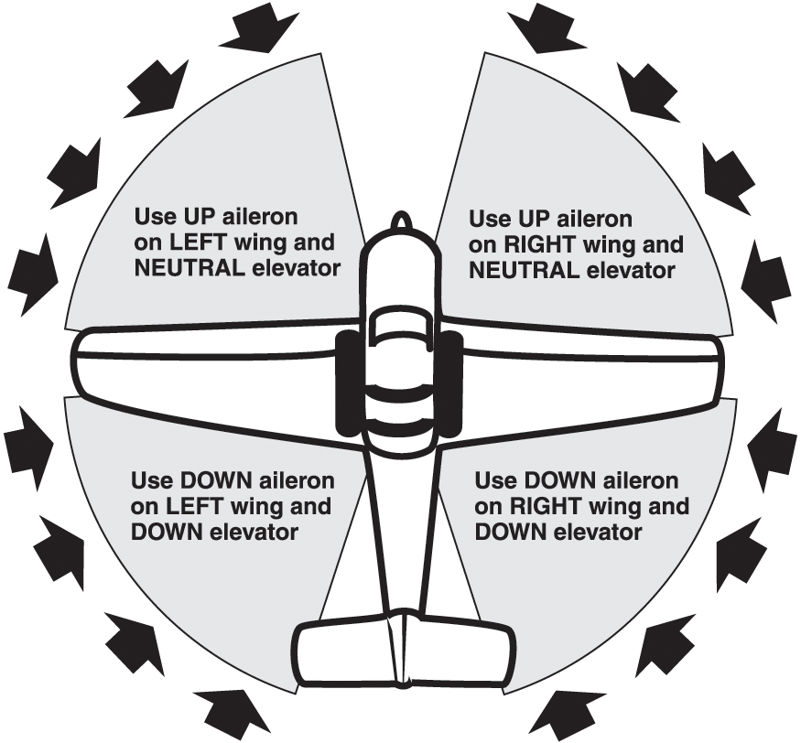

Figure 4-2. Taxiing Diagram

NOTE

Strong quartering tail winds require caution. Avoid sudden bursts of the throttle and sharp braking when the airplane is in this attitude. Use the steerable tail wheel and rudder to maintain direction.

Taxiing over loose gravel or cinders should be done at low engine speed to avoid abrasion and stone damage to the propeller tips.

BEFORE TAKEOFF

WARM-UP
Most of the warm-up will have been conducted during taxi, and additional warm-up before takeoff should be restricted to the checklist procedures. Since the engine is closely cowled for efficient in-flight cooling, precautions should be taken to avoid overheating on the ground.

LANE CHECK
The lane check should be made at 3000 RPM as follows. Turn off Lane A and note RPM. Next turn on BOTH to clear the other set of plugs. Then turn off Lane B note RPM and return the switch to the ON position. RPM drop should not exceed 125 RPM on either Lane or show greater than 50 RPM differential between magnetos. If there is a doubt concerning operation of the ignition system, RPM checks at higher engine speeds will usually confirm whether a deficiency exists. An absence of RPM drop may be an indication of faulty grounding of one side of the ignition system or should be cause for suspicion that the ignition timing is set in advance of the setting specified.

ALTERNATOR CHECK
Prior to flight where verification of proper alternator and voltage regulator operation is essential (such as night or instrument flights), a positive verification can be made by viewing the volts and amps on the Eng page of the Garmin G3X and by loading the electrical system momentarily (3 to 5 seconds) with the landing light. The ammeter will remain within the minimum and maximum range if the alternator and voltage regulator are operating properly.

TAKEOFF

POWER CHECK
It is important to check full-throttle engine operation early in the takeoff run. Any sign of rough engine operation or sluggish engine acceleration is good cause for discontinuing the takeoff. If this occurs, you are justified in making a thorough full-throttle static run-up before another takeoff is attempted. The engine should run smoothly and turn approximately 5500 to 5750 under full power and prop set to T.O. setting.

Full throttle run-ups over loose gravel are especially harmful to propeller tips. When takeoffs must be made over a gravel surface, it is very important that the throttle be advanced slowly. This allows the airplane to start rolling before high RPM is developed, and the gravel will be blown back of the propeller rather than pulled into it. When unavoidable small dents appear in the propeller blades, they should be immediately corrected as described in the Airmaster manuals.

After full throttle is applied, adjust the throttle friction lock clockwise to prevent the throttle from creeping back from a maximum power position. Similar friction lock adjustment should be made as required in other flight conditions to maintain a fixed throttle setting.

WING FLAP SETTING
Normal takeoffs are accomplished with wing flaps 0 to 1/2. Using 1/2 wing flaps reduces the total distance over an obstacle by approximately 10%. Flap deflections greater than 1/2 are not recommended or required for takeoff. If 1/2 wing flaps are used for takeoff, they should be left down until all obstacles are cleared and a safe flap retraction speed of 60 MPH is reached.

On a short field, 1/2 wing flaps and an obstacle clearance speed of 60 MPH should be used. This speed provides the best overall climb speed to clear obstacles when taking into account turbulence often found near ground level.

Soft or rough field takeoffs are performed with 1/2 wing flaps by lifting the airplane off the ground as soon as practical in a slightly tail-low attitude. If no obstacles are ahead, the airplane should be leveled off immediately to accelerate to a higher climb speed.

Takeoffs into strong crosswinds normally are performed with the minimum flap setting necessary for the field length, to minimize the drift angle immediately after takeoff. The airplane is accelerated to a speed slightly higher than normal, then pulled off abruptly to prevent possible settling back to the runway while drifting. When clear of the ground, make a coordinated turn into the wind to correct for drift.

ENROUTE CLIMB
Normal climbs are performed with flaps up, prop set to CRUISE, full throttle, and at speeds 5 to 10 mph higher than best rate-of-climb speeds for the best combination of performance, visibility and engine cooling. For maximum rate of climb, use the best rate-of-climb speeds shown in the Rate Of Climb chart in Section 5. If an obstruction dictates the use of a steep climb angle, the best angle-of-climb speed should be used with flaps 1/2, prop set to T.O., and maximum power. Climbs at speeds lower than the best angle-of-climb speed should be of short duration to improve engine cooling.

CRUISE
Normal cruising is performed between 60% and 65% power. The engine RPM and corresponding fuel consumption for various altitudes can be determined by using the Garmin G3X, Foreflight, or Section 5.

NOTE

Cruising should be done at 65% to 75% power until a total of 50 hours has accumulated or oil consumption has stabilized. This is to ensure proper seating of the rings and is applicable to new engines, and engines in service following cylinder replacement or top overhaul of one or more cylinders.

The data in Section 5 shows the increased range and improved fuel economy that is obtainable when operating at lower power settings. The use of lower power settings and the selection of cruise altitude on the basis of the most favorable wind conditions are significant factors that should be considered on every trip to reduce fuel consumption.

The Cruise Performance Table, Figure 4-3, shows the true airspeed and nautical mile per gallon during cruise for various altitudes and percent powers. This table should be used as a guide, along with the available winds aloft information, to determine the most favorable altitude and power setting for a given trip.
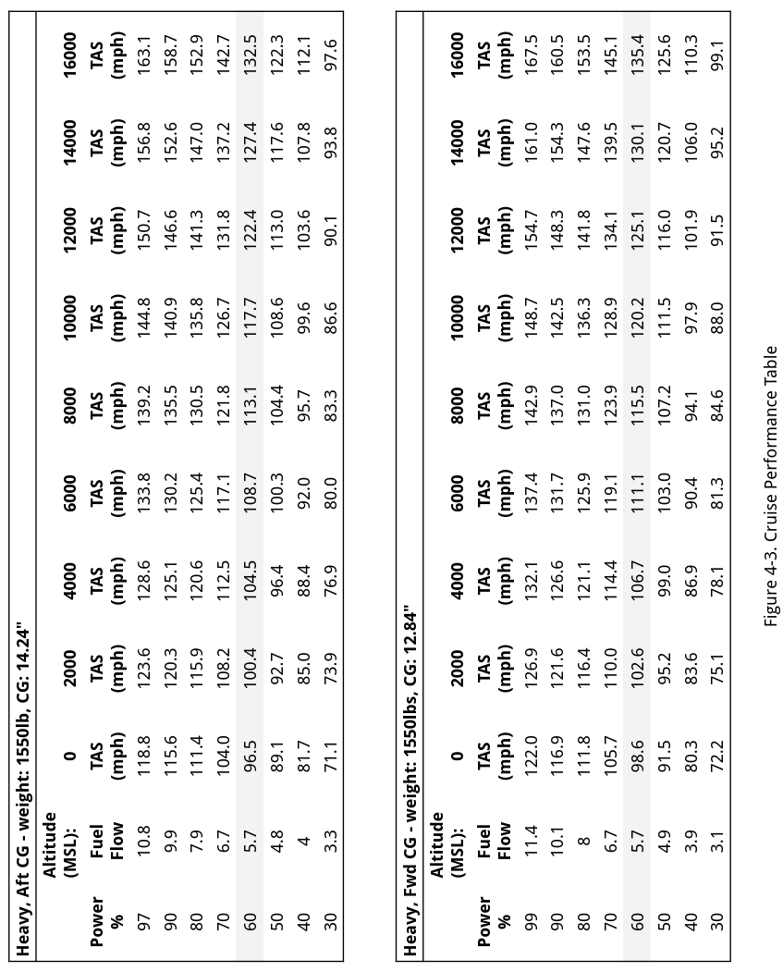
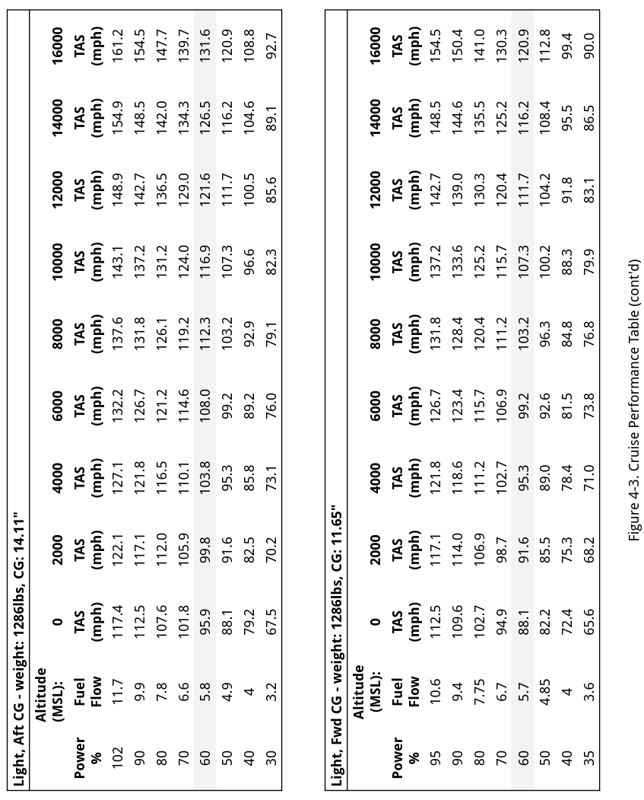

Heavy, Aft CG - weight: 1550lb, CG: 14.24"
Power % | MPG | Range (miles) | Endurance (hrs) | Time to Travel 1,200 mi (hrs) | Num of stops
97 | 12.4 | 234 | 1.8 | 11.5 | 5
90 | 13.2 | 257 | 2.0 | 11.2 | 4
80 | 15.9 | 335 | 2.7 | 11.1 | 3
70 | 17.5 | 384 | 3.3 | 11.8 | 3
60 | 19.1 | 433 | 4.0 | 12.0 | 2
50 | 20.9 | 489 | 4.9 | 13.0 | 2
40 | 23.0 | 552 | 6.0 | 14.0 | 2
30 | 24.3 | 595 | 7.4 | 16.0 | 2
Heavy, Fwd CG - weight: 1550lbs, CG: 12.84"
Power % | MPG | Range (miles) | Endurance (hrs) | Time to Travel 1,200 mi (hrs) | Num of stops
99 | 12.1 | 222 | 1.6 | 11.2 | 5
90 | 13.0 | 253 | 1.9 | 11.1 | 4
80 | 15.7 | 331 | 2.6 | 11.0 | 3
70 | 17.8 | 391 | 3.3 | 11.6 | 3
60 | 19.5 | 443 | 4.0 | 11.8 | 2
50 | 21.0 | 491 | 4.8 | 12.6 | 2
40 | 23.2 | 558 | 6.2 | 14.3 | 2
30 | 26.2 | 647 | 8.0 | 15.3 | 1
Figure 4-4 Sample Endurance Table
The Sample Endurance Table, Figure 4-4, shows the expected fuel flow, MPG, range, and endurance for given power settings at 6000’ MSL and no wind in a fully loaded aircraft. The table also includes columns for the number of stops and the time to travel 1,200 miles in hours, assuming 30 minutes per stop.
Note: Range and Endurance do not include 45 minute fuel reserve.
Light, Aft CG - weight: 1286lbs, 14.11"
Power % | MPG | Range (miles) | Endurance (hrs) | Time to Travel 1,200 mi (hrs) | Num of stops
102 | 11.3 | 206 | 1.6 | 11.6 | 5
90 | 12.8 | 251 | 2.0 | 11.5 | 4
80 | 15.5 | 329 | 2.7 | 11.4 | 3
70 | 17.4 | 383 | 3.3 | 12.0 | 3
60 | 18.6 | 422 | 3.9 | 12.1 | 2
50 | 20.2 | 472 | 4.8 | 13.1 | 2
40 | 22.3 | 535 | 6.0 | 14.4 | 2
30 | 23.8 | 584 | 7.7 | 16.8 | 2
Light, Fwd CG - weight: 1286lbs, 11.65"
Power % | MPG | Range (miles) | Endurance (hrs) | Time to Travel 1,200 mi (hrs) | Num of stops
95 | 12.0 | 228 | 1.8 | 12.0 | 5
90 | 13.1 | 262 | 2.1 | 11.7 | 4
80 | 14.9 | 316 | 2.7 | 11.9 | 3
70 | 16.0 | 351 | 3.3 | 12.7 | 3
60 | 17.4 | 395 | 4.0 | 13.6 | 3
50 | 19.1 | 446 | 4.8 | 14.0 | 2
40 | 20.4 | 489 | 6.0 | 15.7 | 2
35 | 20.5 | 498 | 6.8 | 17.3 | 2
Figure 4-4 Sample Endurance Table (cont'd)
The Sample Endurance Table, Figure 4-4, shows the expected fuel flow, MPG, range, and endurance for given power settings at 6000’ MSL and no wind in a fully loaded aircraft. The table also includes columns for the number of stops and the time to travel 1,200 miles in hours, assuming 30 minutes per stop.
Note: Range and Endurance do not include 45 minute fuel reserve.

STALLS
The stall characteristics are conventional for the flaps up and flaps down condition. The Angle of Attack audible indicator produces an intermittent beep 5 to 10 mph before the actual stall is reached and remains on until the airplane flight attitude is changed. Stall speeds for various combinations of flap setting and bank angle are summarized in Section 5.

SPINS
Intentional spins are not approved in this airplane (see Section 2).

Before attempting to perform spins several items should be carefully considered to assure a safe flight. No spins should be attempted without first having received dual instruction in both spin entries and spin recoveries from a qualified instructor who is familiar with the spin characteristics of the Kitfox S7.

The cabin should be clean and all loose equipment (including the microphone) should be stowed. For a solo flight in which spins will be conducted, the copilot’s seat belt and shoulder harness should be secured. **Spins with baggage loadings are not approved.**

The seat belts and shoulder harnesses should be adjusted to provide proper restraint during all anticipated flight conditions. However, care should be taken to ensure that the pilot can easily reach the flight controls and produce maximum control travel.

It is recommended that, where feasible, entries be accomplished at high enough altitude that recoveries are completed 4000 feet or more above ground level. At least 1000 feet of altitude loss should be allowed for a 1-turn spin and recovery, while a 6-turn spin and recovery may require somewhat more than twice that amount. For example, the recommended entry altitude for a 6-turn spin would be 6000 feet above ground level. In any case, entries should be planned so that recoveries are completed **well above** the minimum 1500 feet above ground level required by FAR 91.71. Another reason for using high altitudes for practicing spins is that a greater field of view is provided which will assist in maintaining pilot orientation.

The normal entry is made from a power-off stall. As the stall is approached, the elevator control should be smoothly pulled to the full aft position. Just prior to reaching the stall “break”, rudder control in the desired direction of the spin rotation should be applied so that full rudder deflection is reached almost simultaneously with reaching full aft elevator. A slightly greater rate of deceleration than for normal stall entries or the use of partial power at the entry will assure more consistent and positive entries to the spin. Both elevator and rudder controls should be held full with the spin until the spin recovery is initiated. An inadvertent relaxation of either of these controls could result in the development of a nose-down spiral.

NOTE

Careful attention should be taken to assure that the aileron control is neutral during all phases of the spin since any aileron deflection in the direction of the spin may alter the spin characteristics by increasing the rotation rate and changing the pitch attitude.

For the purpose of training in spins and spin recoveries, a 1 to 2 turn spin is adequate and should be used. Up to 2 turns, the spin will progress to a fairly rapid rate of rotation and a steep attitude. Application of recovery controls will produce prompt recoveries of from 1/4 to 1/2 of a turn.

If the spin is continued beyond the 2 to 3-turn range, some change in character of the spin may be noted. Rotation rates may vary and some additional sideslip may be felt. Normal recoveries from such extended spins may take up to a full turn or more.

Regardless of how many turns the spin is held or how it is entered, the following recovery technique should be used:

- VERIFY THAT AILERONS ARE NEUTRAL AND THROTTLE IS IN IDLE POSITION.

- APPLY AND HOLD FULL RUDDER OPPOSITE TO THE DIRECTION OF ROTATION.

- JUST AFTER THE RUDDER REACHES THE STOP, MOVE THE CONTROL STICK BRISKLY FORWARD FAR ENOUGH TO BREAK THE STALL. Full down elevator may be required at aft enter of gravity loadings to assure optimum recoveries.

- HOLD THESE CONTROL INPUTS UNTIL ROTATION STOPS. Premature relaxation of the control inputs may extend the recovery.

- AS ROTATION STOPS, NEUTRALIZE RUDDER, AND MAKE A SMOOTH RECOVERY FROM THE RESULTING DIVE.

NOTE

If disorientation precludes a visual determination of the direction of rotation, the symbolic airplane in the turn coordinator may be referred to for this information.

Variations in basic airplane rigging or in weight and balance due to installed equipment or cockpit occupancy can cause differences in behavior, particularly in extended spins. These differences are normal and will result in variations in the spin characteristics and in the recovery procedure should always be used and will result in the most expeditious recovery from any spin.

Intentional spins with flaps extended are prohibited, since the high speed which may occur during recovery are potentially damaging to the flap/wing structure.

LANDING
Normal landing approaches can be made with power-on or power-off at speeds of 60 to 70 MPH with flaps up, and 55 to 65 MPH with flaps down. Surface winds and air turbulence are usually the primary factors in determining the most comfortable approach speeds.

Actual touchdown should be made with power-off in a three-point stance.

SHORT FIELD LANDING
For a short field landing in smooth air conditions, make an approach at 54 MPH with full flaps using enough power to control the glide path. After all approach obstacles are cleared, progressively reduce power and maintain 54 MPH by lowering the nose of the airplane. Touchdown should be made with power-off. Immediately after touchdown, retract the flaps and carefully apply heavy braking as required. For maximum brake effectiveness hold full nose-up elevator, and apply maximum brake pressure without sliding the tires.

Slightly higher approach speeds should be used under turbulent air conditions. The rule of thumb is increase landing speed by 1/2 the predicted gust speed.

CROSSWIND LANDING
When landing in a strong crosswind, use the minimum flap setting required for the field length. Use a wing low, crab, or a combination method of drift correction and land in a nearly level attitude.

BALKED LANDING
In a balked landing (go-around) climb, the wing flap setting should be reduced to 1/2 immediately after full power is applied. Upon reaching a safe airspeed, the flaps should be slowly retracted to the full up position.

COLD WEATHER OPERATION
Prior to starting with temperatures below freezing, it is advisable to pull the propeller through several times by hand to “break loose” or “limber” the oil, thus conserving battery energy.

NOTE

When pulling the propeller through by hand, treat it as if the ignition switch is turned on.

Preheat is generally required with outside air temperatures below -20°C (-4°F) and is recommended when temperatures are below -7° (20°F).

Cold weather starting procedures are as follows:

With Preheat:

- Master Switch - OFF.
- Throttle - CLOSED.
- Parking Brake - SET.
- Propeller - PULL through by hand several revolutions.

NOTE

Caution should be used to ensure the brakes are set or a qualified person is at the controls.

- Throttle - OPEN to 50-60%.
- Propeller Area - CLEAR.
- Master Switch - ON.
- Lane A and B - ON.
- Power switch - ON.
- Pump A or B (not both) - ON.
- Ignition Switch - PRESS (release when engine starts).
- Throttle - ADJUST for 2000 to 2200 RPM for approximately one minute after which the RPM can be lowered to 2000 or less.
- Oil Pressure - CHECK.

Without Preheat:

The procedure for starting without preheat is the same as with preheat.

NOTE

If the engine fires but does not start or continue running, repeat the above starting procedure beginning with step 6. If the engine does not start during the first few attempts, or if engine firing diminishes in strength, it is possible that the spark plugs have been frosted over, in which case preheat must be used before another start is attempted.

NOISE ABATEMENT
Increased emphasis on improving the quality of our environment requires renewed effort on the part of all pilots to minimize the effect of airplane noise on the public.

We, as pilots, can demonstrate our concern for environmental improvement, by application of the following suggested procedures, and thereby tend to build public support for aviation:

- Pilots operating aircraft under VFR over outdoor assemblies of persons, recreational and park areas, and other noise-sensitive areas should make every effort to fly not less than 2000 feet above the surface, weather permitting, even though flight at a lower level may be consistent with the provisions of government regulations.

- During departure from or approach to an airport, climb after takeoff and descent for landing should be made so as to avoid prolonged flight at low altitude near noise-sensitive areas.

NOTE

The above recommended procedures do not apply where they would conflict with Air Traffic Control clearances or instructions, or where, in the pilot’s judgment, an altitude of less than 2000 feet is necessary for the pilot to adequately exercise their duty to see and avoid other aircraft.

PERFORMANCE
TABLE OF CONTENTS
PERFORMANCE 41
INTRODUCTION 41
USE OF PERFORMANCE CHARTS 41
TAKEOFF 42
CRUISE 42
STALL SPEEDS 44
CONDITIONS: 44
CRUISE PERFORMANCE 50
CONDITIONS: 50

INTRODUCTION
Performance data charts on the following pages are presented so that you may know what to expect from the airplane under various conditions, and also, to facilitate the planning of flights in detail and with reasonable accuracy. The data in the charts has been computed from actual flight tests with the airplane and engine in good condition and using average piloting techniques.

It should be noted that the performance information presented in the range and endurance profile charts allows for 45 minutes reserve fuel based on 45% power. Some indeterminate variables such as engine and propeller condition and air turbulence may account for
variations of 10% or more in range and endurance. Therefore, it is important to utilize all available information to estimate the fuel required for the particular flight.

USE OF PERFORMANCE CHARTS
Performance data is presented in tabular or graphical form to illustrate the effect of different variables. Sufficiently detailed information is provided in the tables so that conservative values can be selected and used to determine the particular performance figure with reasonable accuracy.

STALL SPEEDS
CONDITIONS:

Power Off

NOTE:

MPH values are approximate and are based on airspeed calibration data with power off.

MOST REARWARD CENTER OF GRAVITY

WEIGHT LBS | FLAP DEFLECTION | ANGLE OF BANK
WEIGHT LBS | FLAP DEFLECTION | 0° | 30° | 45° | 60°
WEIGHT LBS | FLAP DEFLECTION | IAS | IAS | IAS | IAS
1550 | UP | 43 | 48 | 52 | 60
1550 | 1/2 | 40 | 45 | 48 | 56
1550 | FULL | 39 | 42 | 47 | 55

MOST FORWARD CENTER OF GRAVITY

WEIGHT LBS | FLAP DEFLECTION | ANGLE OF BANK
WEIGHT LBS | FLAP DEFLECTION | 0° | 30° | 45° | 60°
WEIGHT LBS | FLAP DEFLECTION | IAS | IAS | IAS | IAS
1550 | UP | 50 | 53 | 60 | 70
1550 | 1/2 | 45 | 51 | 54 | 63
1550 | FULL | 43 | 50 | 52 | 60

Figure 5-3. Stall Speeds

TAKEOFF DISTANCE
SHORT FIELD

Kitfox N137DF at max gross weight of 1550lbs, equipped with a Rotax 915iS engine and Airmaster AP430 constant speed propeller has been demonstrated to achieve the following performance values at sea level under International Standard Atmosphere (ISA) pressure and temperature conditions of 29.92 inHg (1013.25 hPa) and 15°C (59°F), respectively:

Takeoff roll: 175 feet
Climb rate: 2450 feet per minute

Use the Koch Chart in Figure 5-4 to determine the takeoff roll and climb rate at for other pressure altitudes and temperatures.

CONDITIONS:
Flaps 1/2
Full Throttle Prior to Brake Release
Paved, Level, Dry Runway
Zero Wind

NOTES:
- Short field technique as specified in Section 4.
- Decrease distances 10% for each 9 mph headwind. For operation with tailwinds up to 10 mph, increase distance by 10% for each 2 mph.
- For operation on a dry, grass runway, increase distances by 15% of the “ground roll” figure.

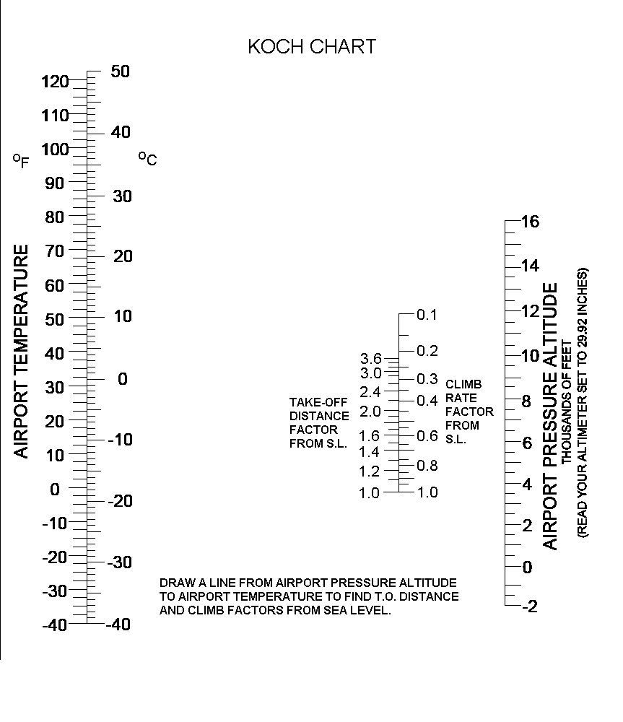
Figure 5-4. Koch Chart

Take-off Distance Factor (feet) |  |  | Climb Rate Factor (feet/min)
1.0 | 175 |  | 1.0 | 2450
1.2 | 210 |  | 0.8 | 1960
1.4 | 245 |  | 0.6 | 1470
1.8 | 315 |  | 0.4 | 980
2.0 | 350 |  | 0.3 | 735
2.4 | 420 |  | 0.2 | 490
3.0 | 525 |  | 0.1 | 245
3.6 | 630

Figure 5-5. Conversion Table

WEIGHT & BALANCE / EQUIPMENT LIST
TABLE OF CONTENTS
WEIGHT & BALANCE / EQUIPMENT LIST 57
INTRODUCTION 57
AIRPLANE WEIGHING PROCEDURES 57
WEIGHT AND BALANCE 58

INTRODUCTION
This section describes the procedure for establishing the basic empty weight and moment of the airplane. Sample forms are provided for reference. Procedures for calculating the weight and moment for various operations are also provided. A comprehensive list of all Kitfox equipment available for this airplane is included at the back of this section.

It should be noted that specific information regarding the weight, arm, moment and installed equipment list for this airplane can only be found in the appropriate weight and balance records carried in the
airplane.

AIRPLANE WEIGHING PROCEDURES
Careful attention to weight and balance is essential to the safe operation of your Kitfox. The forms and examples provided here will help you determine your aircraft’s empty weight and empty weight center of gravity. These calculations are necessary to determine
your useful load and the loading schedule to ensure that you operate your aircraft within its center of gravity envelope.

Staying within the CG range and gross weight limitations is essential to safe flight. Exceeding the aircraft's gross weight means that you are reducing the margins of safety which are included in the aircraft design to allow for factors such as gust loads, material variations, and differences in construction techniques. Reducing the margin of safety opens the door for in-flight structural failure under conditions
that an aircraft at, or below, gross weight would handle safely. Exceeding the center of gravity range will alter the stability of the aircraft and may change its controlability. If the CG is too far forward there may not be sufficient elevator authority to flare when landing. If the CG is too far aft, the aircraft may become unstable in pitch, may be unrecoverable from a stall, and is more prone to spinning. Obviously, a prudent builder and pilot will manage his weight and
balance carefully.

The basic process involves leveling and weighing the aircraft and doing some simple math to find the empty weight center of gravity. From there, the useful load and loading schedule can be determined.

Weigh the aircraft in its final, ready-to-fly state, complete with final paint, all instruments, radios and antennas, ELT, wheel pants, fire extinguisher, full engine oil, unusable fuel, upholstery, seat belts, etc.
Include everything that will be going aloft that isn't people, baggage, or usable fuel.

The aircraft is leveled by means of an accurate bubble level held on the lower fuselage fore and aft tubing in the area below the cabin. The datum (the reference point from which all measurements will be taken) is the leading edge of the wing at the root.

Useful Terms and Definitions
Center of Gravity (CG): The center of gravity may be defined, for the purpose of balance computations, as the point on the airplane about which the nose heavy (-) moments and the tail heavy (+) moments are exactly equal. If the aircraft were suspended from
this point it would have no tendency to rotate in either direction (nose up or nose down). The weight of the aircraft can be assumed to be concentrated at its CG.

CG Range: The allowable variation of the CG location is called the "CG Range". Since CG limits constitute the range of movement that the flight can have without making the aircraft unstable or un-safe to fly, the CG of the loaded airplane must remain within these limits for all phases of flight. These limits are defined on the weight and balance sheet at the end of this section.

Forward and Aft CG: The most forward and most rearward allowable CG limits for the aircraft. These limits are determined by design and have been verified through .it’s flight test programs.

Weighing Points: The weighing points of an airplane are the points at which the airplane is supported at the time it is weighed. In the case of the Super Sport, the main landing gear and nose or tail wheel are the weighing points.

Maximum Gross Weight (MGW): Maximum allowable weight of the aircraft and its contents authorized for takeoff as determined by design limits.

The maximum gross weight of the Kitfox Super Sport 7 STi with the Rotax 915iS (141 hp) engine installed is 1,550 pounds.

Empty Weight (EW): The empty weight of an aircraft includes all operating eTuipment that has a filed location and is normally carried in the aircraft and any other parts or equipment which are required for flight and are installed in the aircraft. )ull oil and unusable fuel (that remains in the lines and tanks but is not available to the engine) are included in the empty weight.

Useful Load (UL): Useful load is the empty weight subtracted from the maximum allowable gross weight of the aircraft. This load consists of the pilot, passengers, fuel, and baggage.

Datum: An imaginary vertical plane from which all horizontal measurements are taken for balance purposes with the aircraft in a level attitude. The datum for the Kitfox Super Sport is the wing leading edge at the root.

Arm (or Moment Arm): The horizontal distance, ininches, from the datum to the center of gravity of an item. A positive (+) arm indicates the item is located aft of the datum. A negative (-) arm indicates the item is located forward of the datum.

Moment: Moment is the product of a weight (in pounds) multiplied by its arm (in inches). Mean Aerodynamic Chord (MAC): The mean
chord of the wing. For weight and balance purposes, it is used to determine the CG range of the aircraft. The mean aerodynamic chord of the Super Sport is 1.1 inches.

Tare: The weight of the equipment necessary for weighing the airplane (such as chocks, blocks, etc.) which is included in the scale readings but is not a part of the actual weight of the airplane. Tare must be subtracted from the scale readings in order to obtain
the actual weight of the airplane.

Flight CG Limits:
Super Sport 7 STi Aircraft, No Wing Sweep
Forward station: 9.5”
Rearward: Station: 16.0”

- Ensure that the aircraft has everything on board that should be in place for finding the empty weight and CG. Move the aircraft inside a closed building to conduct the weight and balance measurements - even slight winds may yield inaccurate results if it is done outside. Place the aircraft on three scales (one under each wheel). The scales under the main wheels must be capable of accurately weighing up to 500 pounds each. Many EAA chapters have low platform scales which may be borrowed for weighing your aircraft. The main wheel scales should be level with one another so that the aircraft will be level laterally. If the aircraft is not level laterally, place shims under the main wheel on the low side until it is. For the conventional landing gear configuration, position a sturdy stand under the tailwheel with a scale between the stand and the wheel. Adjust the height of the stand until the airplane is level fore and aft. For the tricycle gear configuration, place the scale under the nose wheel. Use an accurate bubble level or electronic digital level on the fuselage floor tubing to verify that the aircraft is level.
- With the aircraft level and all fixed equipment installed, record the scale readings and tare weights:
 | Total (lbs) | Tare (lbs) | Net (lbs)
Right Main | - | =
Left Main | - | =
Nose/Tail | - | =

Total the three Net weights and record below:

Aircraft empty weight _________________ lbs

- With the aircraft still level, drop a plumb line from the leading edge of the wing at the root (just outboard of the wing root fairing) and mark the floor at this point. A piece a masking tape and a fine-point marking pen work well for making the marks on the floor. Repeat this on the other side. Similarly, mark the floor at the points directly below the center of the axles of the three wheels. Roll the aircraft out of the way. Using a chalk line, make a line on the floor between the two datum points. With the aid of a carpenters square, make a perpendicular chalk line from the nose/tailwheel axle mark to the datum line and perpendicular lines from the main gear axle marks to the datum line. Measure as accurately as possible along the perpendicular lines between the axle marks and the datum line and record the dimensions below (in decimals, not fractions).
Right Main Arm +/- (in.)
Left Main Arm +/- (in.)
Tailwheel/Nose Wheel Arm +/- (in.)

Note: The measurement for a nosewheel aircraft will be a negative number as it is in front of the datum point. Likewise, a tailwheel measurement will be positive.

- Compute the aircraft moments by multiplying each scale reading by its arm.

Location | Net Weight (lb) | Arm (in) | Moment (in.lbs)
Right Main | x | =
Left Main | x | =
Nose/Tail | x | =
Total Weight: |  | Total Moment:

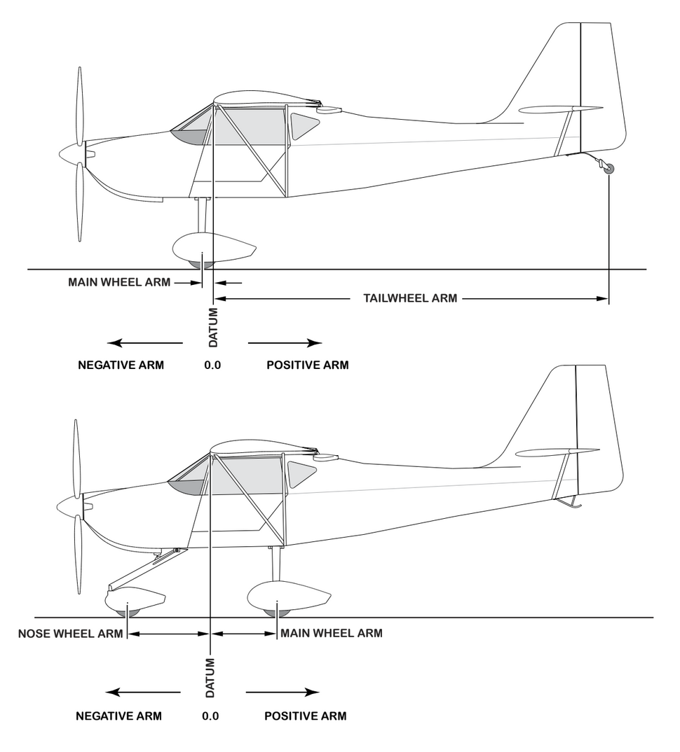

Figure 6-1 Weight and Balance

WEIGHT AND BALANCE
The following information will enable you to operate your Kitfox within the prescribed weight and center of gravity limitations. To figure weight and balance, use the Sample Problem and Center of Gravity Moment Envelope as follows:

The basic empty weight and moment from appropriate weight and balance records carried in your airplane have already been entered. Continue by entering the weight for the fuel, pilot + passenger, and baggage. Next multiply the weight by arm at each station and divide by 1000 and enter the number in the last column. For example, (27gal * 6lb/gal * 16.5) / 1000 = 2.7

Repeat this for the pilot + passenger and baggage.

Sum up the weights and moments and plot these values on the Center of Gravity Moment Envelope graph to determine whether the point falls within the envelope, and if the loading is acceptable.
Sample Loading Problem | Weight (lbs) | Arm (in) | Moment  (lb-ins/1000)
Empty Weight | 968 | 10.2 | 9.9
Usable Fuel |  | 16.5
Pilot and Passenger |  | 18.3
Baggage |  | 46.9
TOTAL WEIGHT AND MOMENT
Locate this point on Center of Gravity Moment Envelope Graph.
Figure 6-6. Sample Loading Problem

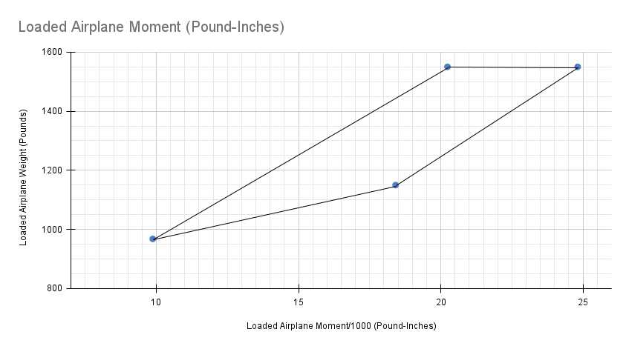
Figure 6-8. Center of Gravity Moment Envelope

AIRPLANE & SYSTEMS DESCRIPTIONS
TABLE OF CONTENTS
Section 7 AIRPLANE & SYSTEMS DESCRIPTIONS 82
INTRODUCTION 84
AIRFRAME 84
FLIGHT CONTROLS 88
TRIM SYSTEM 88
INSTRUMENT PANEL 88
GROUND CONTROL 89
WING FLAP SYSTEM 90
LANDING GEAR SYSTEM 90
BAGGAGE COMPARTMENT 90
SEATS 91
SEAT BELT AND SHOULDER HARNESSES 91
SEAT BELTS 91
SHOULDER HARNESSES 91
ENTRANCE DOORS AND CABIN WINDOWS 93
ENGINE 94
ENGINE CONTROLS 94
ENGINE INSTRUMENTS 95
ENGINE OIL SYSTEM 96
IGNITION-STARTER SYSTEM 97
AIR INTAKE SYSTEM AND BOOST PRESSURE CONTROL 97
EXHAUST SYSTEM 98
COOLING SYSTEM 98
PROPELLER 98
FUEL SYSTEM 98
BRAKE SYSTEM 100
ELECTRICAL SYSTEM 100
MASTER SWITCH 101
AMMETER 101
OVER-VOLTAGE SENSOR AND WARNING LIGHT 101
CIRCUIT BREAKERS AND FUSES 102
GROUND SERVICE PLUG RECEPTACLE 102
LIGHTING SYSTEM 103
EXTERIOR LIGHTING 103
INTERIOR LIGHTING 103
CABIN HEATING, VENTILATING AND DEFROSTING SYSTEM 103
PITOT-STATIC SYSTEM AND INSTRUMENTS 104
AIRSPEED INDICATOR 104
RATE-OF-CLIMB INDICATOR 104
ALTIMETER 104
ATTITUDE INDICATOR 105
DIRECTIONAL INDICATOR 105
AOA STALL WARNING SYSTEM 105
AVIONICS SUPPORT EQUIPMENT 105
AUDIO CONTROL PANEL 105
STATIC DISCHARGERS 107

INTRODUCTION
This section provides description and operation of the airplane and its systems.

AIRFRAME
The airplane is an rag and tube, two-place, high-wing, single-engine airplane equipped with conventioanl tailwheel landing gear, and is designed for general utility purposes.

The construction of the fuselage is a conventional tube 4130 chromoly steel frame covered in fabric. Major items of structure are the front and rear carry-through spars to which the wings are attached, a bulkhead and forgings for main landing gear attachment at the base of the rear door posts, and a bulkhead with attaching plates at the base of the forward door posts for the lower attachment of the wing struts. Four engine mount stringers are also attached to the forward door posts and extend forward to the firewall.

The externally braced wings, containing the fuel tanks, are constructed of a front and rear spar with cut plywood ribs with birch plywood sparcaps, doublers, and stringers. The entire structure is covered with fabric skin. The front spars are equipped with wing-to-fuselage and wing-to-strut attach fittings. The aft spars are
equipped with wing-to-fuselage attach fittings, and are full-span spars. Conventional hinged flaperon are attached to the trailing edge of the wings. The flaperons are constructed of a forward spar containing balance weights, formed sheet foam ribs and smooth aluminum skin joined together at the trailing edge.

The empennage (tail assembly) consists of a conventional vertical stabilizer, rudder, horizontal stabilizer, and elevator. The vertical stabilizer consists of a steel frame, cut plywood wood ribs and reinforcements, covered in a fabric skin panel. The rudder is constructed of a formed leading fiberglass edge skin containing hinge halves, a fabric skin panels and ribs, with a ground adjustable trim tab at its base. The horizontal stabilizer is constructed of a steel frame, plywood ribs and stiffeners, and fabric skin panels. The the front of the horizontal stabilizer attach point acts as the elevator trim. Construction of the elevator consists of a steel frame and bellcrank, left and right wrap-around fabric skin panels.
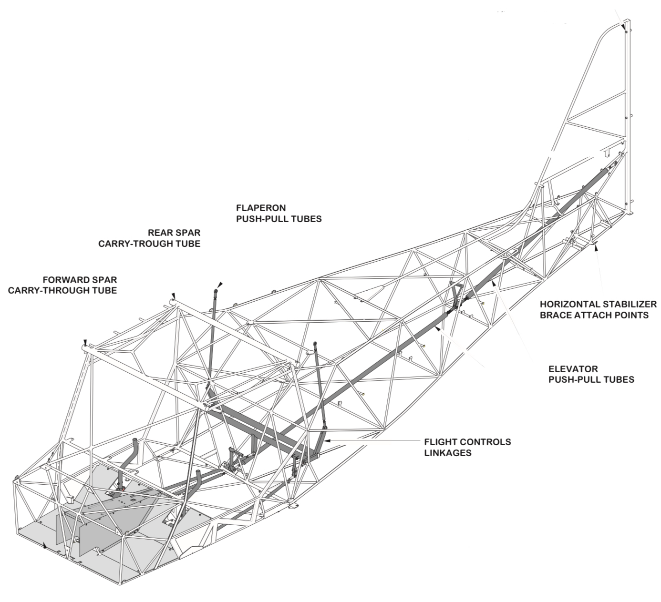
AILERON AND ELEVATOR CONTROL SYSTEM
Figure 7-1. Flight Control and Trim Systems (Sheet 1 of 2)
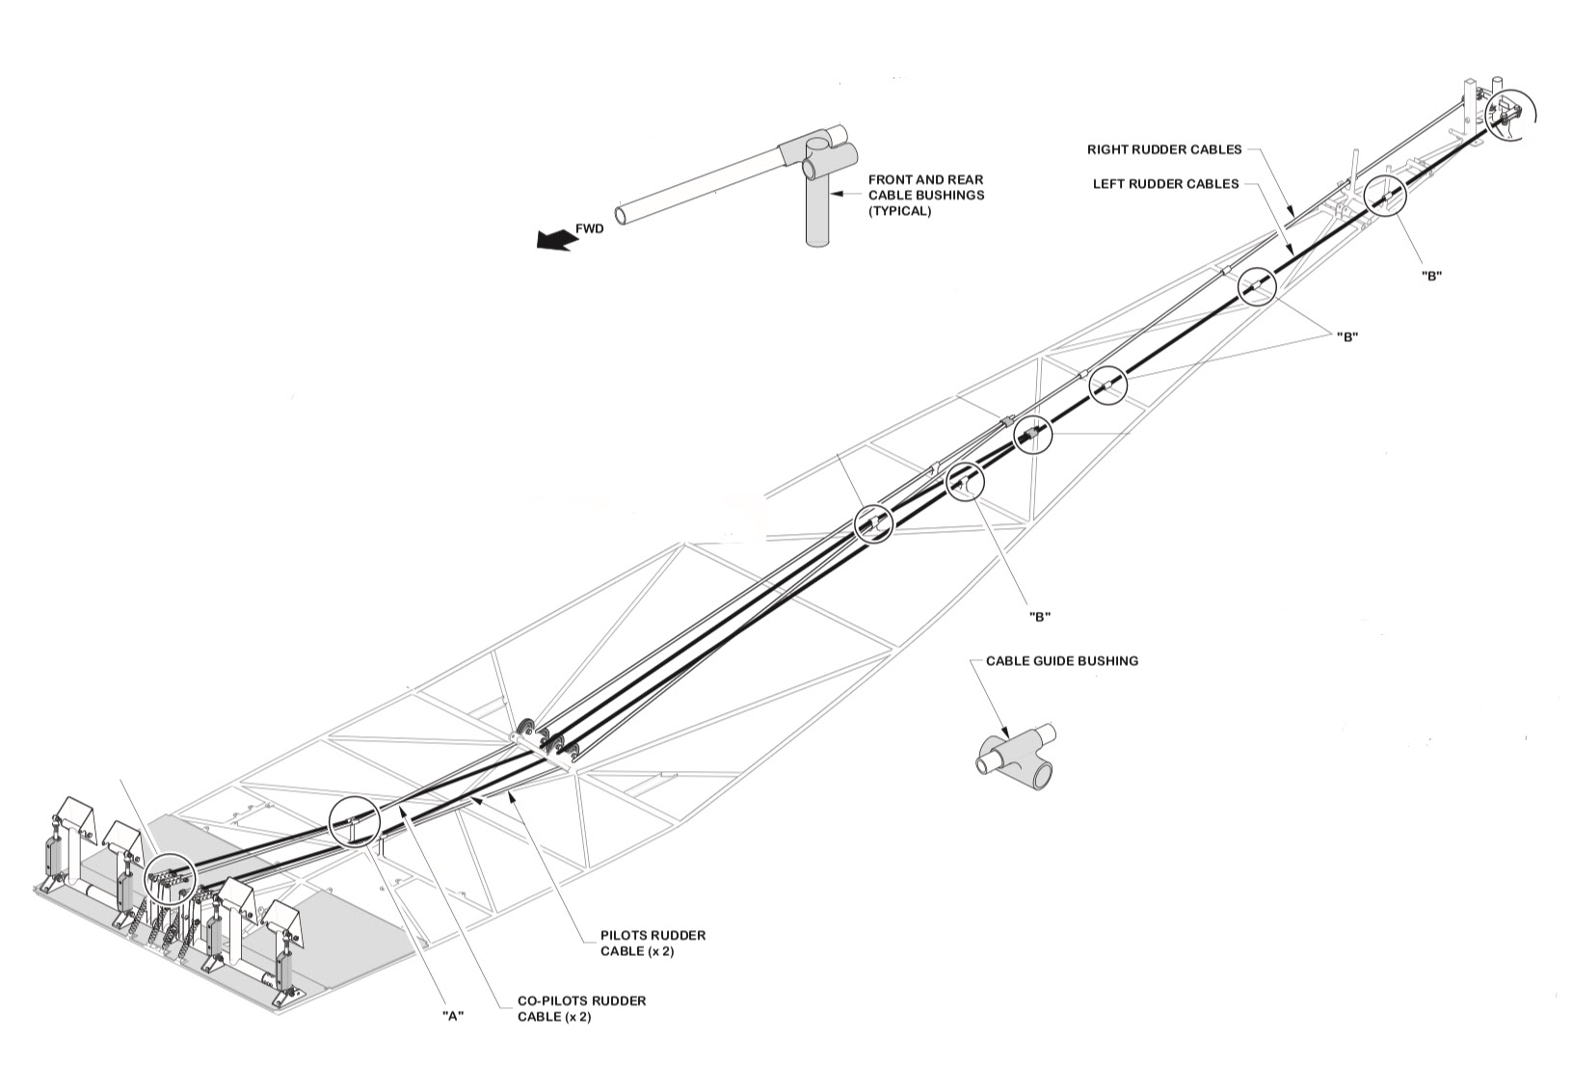
RUDDER CONTROL SYSTEM
Figure 7-1. Flight Control and Trim Systems (Sheet 2 of 2)

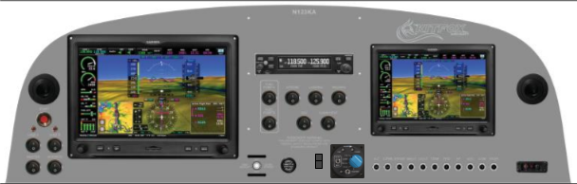
Figure 7-2. Instrument Panel (Sheet 1 of 2)

- Start Button
- Air Vent
- Engine Instruments
- Tachometer
- Manifold Pressure
- Trim Indicator
- Airspeed Indicator
- Compass
- Turn Indicator
- Bank Indicator
- Artificial Horizon
- Altimeter and Vertical Speed Indicator
- Programable Data Bar
- Multifunction Display
- Fuel Pumps
- Radio
- Strobe Lights
- Landing Lights
- Wigwag Lights
- Multifunction Flight Display (MFD)
- Air Vent
- ECU Lane Switches
- Master Switch
- Avionics Switch
- GDU Control Knobs
- Exhaust Gas Temperatures
- NRST
- Direct To
- SD Card Slot
- Menu
- Back
- GDU Control Knobs
- Start Power/Emergency Power Switch
- Throttle (With Friction Lock)
- Propeller Fine/Coarse Manual Switch
- Propeller Controller
- Circuit Breakers
- ELT Test

FLIGHT CONTROLS
The airplane’s flight control system (see Figure 7-1) consists of conventional aileron, rudder, and elevator control surfaces. The control surfaces are manually operated through mechanical linkage using a control wheel for the ailerons and elevator, and rudder/brake pedals for the rudder.

The rudder/brake pedals are adjustable for both the pilot and passenger using the levers in the center console.

TRIM SYSTEM
The trim system consists of a wormgear driven by a motor attached to the front of the horizontal stabilizer. This motor is controlled by rocker switch on the center console to adjust the incident angle of the stabilizer. The position of the trim is indicated on the Garmin G3X GDU.

INSTRUMENT PANEL
The main component of the instrument panel (see figure 7-2) is the 10” Garmin G3X Touch GDU 460 PFD (primary flight display) directly in front of the pilot. A secondary 7” Garmin G3X Touch GDU 450 MFD (multi-function display) is placed directly in front of the passenger. In addition to the displays are the Garmin GTR200B communications radio, the Airmaster Controller unit, and various switches and fuses. For full details refer to Figure 7-2 sheets 1 and 2.

For details concerning the instruments, switches, circuit breakers, and controls on this panel, refer in this section to the description of the systems to which these items are related.

GROUND CONTROL
Effective ground control while taxiing is accomplished through tail wheel steering by using the rudder pedals; left rudder pedal to steer left and right rudder pedal to steer right. When a rudder pedal is
depressed, a cable attached to a steering spring and chain (which is connected to the tailwheel gear and to the rudder bars) will turn the tail wheel through an arc to each side of center. By applying either left or right brake, the degree of turn may be increased enough to pivot the aircraft around the wheel on the inside of the turn.

Moving the airplane by hand is most easily accomplished by attaching a tow bar to the tail wheel. If a tow bar is not available, or pushing is required, use the wing struts as push points. Do not use the vertical or horizontal surfaces to move the airplane.

The minimum turning radius of the airplane, using differential braking and nose wheel steering during taxi, is approximately 30 feet. To obtain a minimum radius turn during ground handling, the
airplane may be rotated around the main landing gear by pushing or pulling the handle on the empennage near the tail.

WING FLAPERON SYSTEM
The wing flaps are integrated with the ailerons, creating a so-called flaperon, and are extended or retracted by positioning the flap handle on the center console to the desired deflection position.

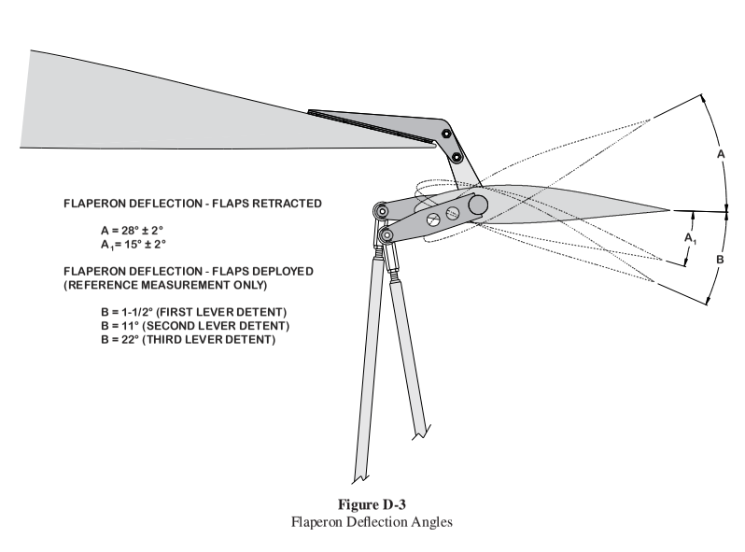
Figure 7-3. Wing Flaperon System

LANDING GEAR SYSTEM
The landing gear is of the conventional type with a steerable tailwheel and two main wheels. The landing gear may be equipped with wheel fairings. Shock absorption is provided by shock absorbers on the main landing gear struts and the air/oil tail gear shock strut. Each main gear wheel is equipped with a hydraulically actuated disc-type brake on the inboard side of each wheel. When wheel fairings are installed an aerodynamic fairing covers each brake.

BAGGAGE COMPARTMENT
The baggage compartment consists of the area from the back of the pilot and passenger’s seats to the aft cabin bulkhead. Access to the baggage compartment is gained from within the airplane cabin as well as by lifting the plexiglass turtledeck. A baggage net with six tie-down straps is provided for securing baggage and is attached by tying the straps to tie-down rings provided in the airplane. When loading the airplane, children should not be placed or permitted in the baggage compartment, unless a child’s seat is installed, and any material that might be hazardous to the airplane or occupants should not be placed anywhere in the airplane.

SEATS
The seats arrangement consists of two separate seats for the pilot and passenger. These are not adjustable.

SEAT BELT AND SHOULDER HARNESSES
All seat positions are equipped with 4-point seat belts (see Figure 7-4). The pilot’s and passenger’s seats are also equipped with separate shoulder harnesses.

SEAT BELTS
The seat belts used with the pilot’s seat, passenger’s seat, and the child’s seat (if installed) are attached to fittings on the floorboard.

To use the seat belts for the pilot’s and passenger’s seats
lengthen each half of the belt as needed by grasping the sides of the links and pulling against the belt. Insert and lock the belt link into the buckle. Tighten the belt to a snug fit by pulling the free end of the
belt. To release these seat belts, grasp the top of the buckle and pull upward.

SHOULDER HARNESSES
Each shoulder harness is attached to a hard point on the airframe directly behind each occupant.

The shoulder harnesses are used by fastening and adjusting the seat belt first. Then, lengthen the harnesses as required by pulling on the connecting link on the end of the harness and the narrow release strap. Removing the harness is accomplished by pulling upward on the narrow release strap. In an emergency, the shoulder harness may be removed by releasing the seat belt first and allowing the harness to drop to the side of the seat.

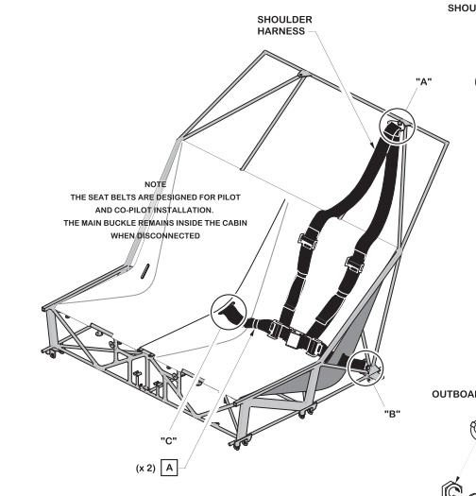
Figure 7-4. Seat Belts and Shoulder Harnesses

Adjustment of the shoulder harness is important. A properly adjusted harness will permit the occupant to lean forward enough to sit completely erect, but prevent excessive forward movement and contact with objects during sudden deceleration. Also, the pilot will want the freedom to reach all controls easily.

ENTRANCE DOORS AND CABIN WINDOWS
Entry to, and exit from the airplane is accomplished through either of two entry doors, one on each side of the cabin.

To open the doors from outside the airplane, place fingertips at the front edge of each door and pull straight out. Both cabin doors should be checked for security prior to flight, and should not be opened intentionally during flight.

NOTE

Accidental opening of a cabin door in flight due to improper closing does not constitute a need to land the airplane. The best procedure is to set up the airplane in a trimmed condition at approximately 65 mph, momentarily shove the door outward slightly, and forcefully close the door.

Exit from the airplane is accomplished by rotating the door latch. To lock the airplane, lock the right cabin door from the inside then use a hex key to lock the left door from the outside.

ENGINE
The airplane is powered by a Rotax model 915iS horizontally-opposed, four-cylinder, overhead-valve, air and water cooled, fuel injected engine with a wet sump oil system. The engine is rated at 141 horsepower at 5800 RPM for 5 minutes and 135 horsepower at 5700 RPM continuously. Major engine accessories include a starter, an internally mounted direct drive alternator, and an oil cooler, and a water radiator. Dual electronic ignitions are mounted on the rear of the engine.

ENGINE CONTROLS
Engine power is controlled by a throttle located on the lower center portion of the instrument panel. The throttle operates in a conventional manner; in the full forward position, the throttle is open, and in the full aft position, it is closed. A friction lock, which is a round knurled disk, is located at the base of the throttle and is operated by rotating the lock clockwise to increase friction or counterclockwise to
decrease it.

The engine is fuel injected and has no mixture control like other, antiquated engines you might have flown behind.

ENGINE INSTRUMENTS
Engine operation is monitored by the following instruments presented on the Garmin G3X Touch screens: manifold pressure gauge, tachometer, gallons per hour, oil pressure gauge, oil temperature gauge, coolant temperature gauge fuel pressure gauge, and EGT gauges. See Figure 7-2 sheet 2 for locations of these gauges.

All gauges report data from the Rotax FADEC (Full Authority Digital Engine Control) mounted within the engine compartment.

MANIFOLD AIR PRESSURE
The manifold pressure reports PSI in inches of mercury with a green arc range of 1.77 in. HG to 51 in. HG.

TACHOMETER
The tachometer gauge is calibrated in increments of 10 RPM and indicates engine speed, only. The gear reduction ratio is 2.54:1 which equates to a propeller RPM of 2300 at 5800 RPM indicated engine RPM. Instrument markings include a normal operating range (green arc) of 1800 to 5700 RPM, and a maximum (red line) of 5800 RPM.

FUEL FLOW
The gallons per hour gauge reports a calculated value obtained from various input data sources including the fuel pressure gauge, the manifold pressure gauge, outside air temperature and pressure.

OIL PRESSURE
The oil pressure gauge markings indicate that minimum idling pressure (below 3500 RPM) is 11.6 PSI (red line), the normal operating range is 29 to 72.5 PSI (green arc), and maximum pressure is 101.5 PSI (red line) observed during cold start and during warm up period.

OIL TEMPERATURE
The oil temperature is indicated by a gauge located on the Garmin G3X Touch screens. Oil temperature limitations are the normal operating range (green arc) which is 50°C (122°F) to 130°C (266°F), and the maximum (red line) which is 130°C (266°F).

COOLANT TEMPERATURE
The coolant temperature gauge markings indicate the minimum temperature of -20°C (-4°F) to 120°C (248°F).

FUEL PRESSURE
The fuel pressure gauge reads the pressure at an mechanical gauge mounted in the fuel line on the front side of the firewall. The normal, green-arc, range is 42 PSI to 46 PSI though these may be exceeded to 36 PSI and 51 PSI for a max of 3 seconds during throttle position changes.

EXHAUST GAS TEMPERATURE
The EGT, exhaust gas temperature, gauges report the temperature of the exhaust as it exits each cylinder. The red line for the EGT is 950°C (1742°F).

ENGINE OIL SYSTEM
Oil for engine lubrication is supplied from a tank mounted behind the engine. The capacity of the tank is 3 liters (3.2 quarts).

The oil pump (driven by the camshaft) sucks the motor oil from the oil tank and forces it through the oil filter and, depending on the engine installation, through the oil cooler, to the points of lubrication in the engine and the turbocharger.

The escaping oil emerging from the points of lubrication accumulates on the bottom of crankcase and is forced back to the oil tank by the piston blow-by gases. The ventilation of the oil system is done by the vent socket on the oil tank.

The turbocharger is lubricated via a separate oil line (from the main oil pump). The oil emerging from the turbocharger oil sump and is sucked back to the secondary oil pump and then pumped back to the
main oil tank via an oil hose.

An oil filler cap/oil dipstick is located at the rear of the engine on the left side. The filler cap/dipstick is accessible through an access door in the engine cowling. The engine should not be operated on less than 2.5 quarts of oil. To minimize loss of oil through the breather, fill to 3 quarts for normal flights of less than three hours. For extended flight, fill to 3.2 quarts (dipstick indication only). For engine oil grade and specifications, refer to Section 8 of this handbook.

IGNITION-STARTER SYSTEM
The 915 iS is equipped with 4 double ignition coils and two spark plugs in each cylinder. The ignition system is almost entirely wear-free, as the ECU generates and processes the ignition signal electronically.

Below approximate 97% throttle position the ECU will operate the engine in ECO mode. In ECO mode the injection and ignition system are controlled for best economy and best fuel efficiency. Above 97% throttle position the ECU hands over to POWER mode. POWER mode uses fuel enrichment for maximum performance, especially for take-off and climb.

Note

ECO mode is only available with dual Lane operation. In single Lane operation only POWER mode is always active for best engine performance in case of emergency.

AIR INTAKE SYSTEM AND BOOST PRESSURE CONTROL
The compressor side of the turbocharger sucks air through the air filter and pushes it through the Intercooler into the airbox. The pressure in the airbox is controlled by the Throttle. From the airbox the compressed air moves through the intake manifolds into the four cylinders.

The compression rate of air depends on the amount of exhaust gases passing the compression side of the turbocharger. For controlling this compression rate the wastegate has an important role. If the wastegate is fully closed the complete flow of exhaust gases must pass the turbine. The more the wastegate is opened, the less exhaust gases have to pass the turbine. The waste gate is powered by the boost pressure from the compressor. Pneumatic valves actuated by the ECU control the amount of the boost pressure necessary to adjust the waste gate to reach the requested boost pressure. The PCV, as well as Wastegate, are normally closed.

For more details refer to the Rotax Operators Manual for Rotax Engine Type 915i A/C24 Series, https://rotax.my.salesforce-sites.com/DocumentsSearch/sfc/servlet.shepherd/version/download/068Mm00000JDCwpIAH?asPdf=false :



EXHAUST SYSTEM
Exhaust gas from each cylinder passes through riser assemblies to a muffler and tailpipe on the left side of the engine.

COOLING SYSTEM
Ram air for engine cooling enters through two intake openings in the front of the engine cowling. The cooling air is directed around the cylinders and other areas of the engine by baffling, and is then
exhausted through an opening at the bottom aft edge of the cowling. No manual cooling system control is provided.

PROPELLER
The airplane is equipped with a three-bladed, variable-pitch, constant speed carbon fiber. The propeller is 72 inches in diameter.

For more details refer to Section the Airmaster AP3, 4 AND 5 Series Constant Speed Propellor Operator’s Manual at https://www.propellor.com/technical-publications:

FUEL SYSTEM
The fuel systems consist of two vented fuel tanks (one in each wing), a fuel shutoff valve, dual redundant fuel pumps, a coarse particle fuel strainer and a fine particle fuel strainer.

Fuel flows by gravity from the two wing tanks to a fuel header tank behind the passenger seat. The fuel then flows to a shutoff valve in the center console. With the valve in the ON position, fuel flows through a strainer to the fuel pumps. From the pumps the fuel is injected directly into the intake ports.

Fuel system venting is essential to system operation. Blockage of the venting system will result in a decreased fuel flow and eventual engine stoppage. Venting is accomplished by an interconnecting line
from the header fuel tank to the right tank. Both tanks are vented to the outside by vented fuel caps.

Fuel quantity is measured by two sight gauges visible in the wings from the cockpit.

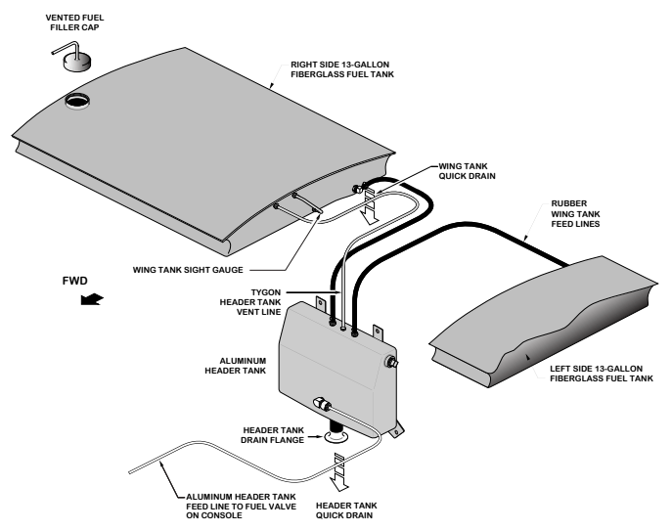
Figure 7-6. Fuel System

An empty tank is indicated by viewing the fuel level in the sight gauges in the wing tanks. The indicators cannot be relied upon for accurate readings during skids, slips, or unusual attitudes.

The amount of unusable fuel is relatively small due to the dual outlets at each tank. The maximum unusable fuel quantity, as determined from the most critical flight condition, is about 1.5 gallons total.
This quantity was not exceeded by any other reasonable flight condition, including prolonged 30 second full-rudder sideslips in the landing configuration. Takeoffs have not been demonstrated with less than 6 gallons total fuel (2.5 gallon per tank and 1 gallon in the header tank).

The fuel system is equipped with drain valves in both wing tanks and the header tank to provide a means for the examination of fuel in the system for contamination and grade. The system should be examine before the first flight of every day and after each refueling, by using the sampler cup provided to drain fuel from the wing tank sumps, and by utilizing the fuel strainer drain under the passenger side of the fuselage. The fuel tanks should be filled after each flight to prevent condensation.

BRAKE SYSTEM
The airplane has a single-disc, hydraulically-actuated brake on each main landing gear wheel. Each brake is connected, by a hydraulic line, to a master cylinder attached to each of the pilot’s rudder
pedals. The brakes are operated by applying pressure to the top of either the left (pilot’s) or right (copilot’s) set of rudder pedals, which are interconnected. When the airplane is parked, both main
wheel brakes may be set by utilizing the parking brake which is operated by a handle on the center console.

For maximum brake life, keep the brake system properly maintained, and minimize brake usage during taxi operations and landings.

Some of the symptoms of impending brake failure are: gradual decrease in braking action after brake application, noisy or dragging brakes, soft or spongy pedals, and excessive travel and weak braking action. If any of these symptoms appear, the brake system is in need if immediate attention. If, during taxi or landing roll, braking action decreases, let up on the pedals and then re-apply the brakes with heavy pressure. If the brakes become spongy or pedal travel increases, pumping the pedals should build braking pressure. If one brake becomes weak or fails, use the other brake sparingly while using opposite rudder, as required, to offset the good brake.

ELECTRICAL SYSTEM
Electrical energy (see Figure 7-7) is primarily supplied by a 12-volt, direct-current system powered by an engine-driven, 60-amp alternator and a 12-volt, 15-amp hour battery located behind the baggage compartment. Power is supplied through a single bus bar; a master switch controls this power to all circuits, except the engine ignition system.

A secondary, emergency backup battery is located behind the panel above the pilot’s pedals.

MASTER SWITCH
The master switch is a split-rocker type switch labeled MASTER, and is ON in the up position and OFF in the down position. To the right of the MASTER switch, labeled NAV, controls all electrical power to the airplane avionics.

Normally, both sides of the master switch should be used simultaneously; however, the NAV side of the switch could be turned ON separately to check equipment while on the ground.

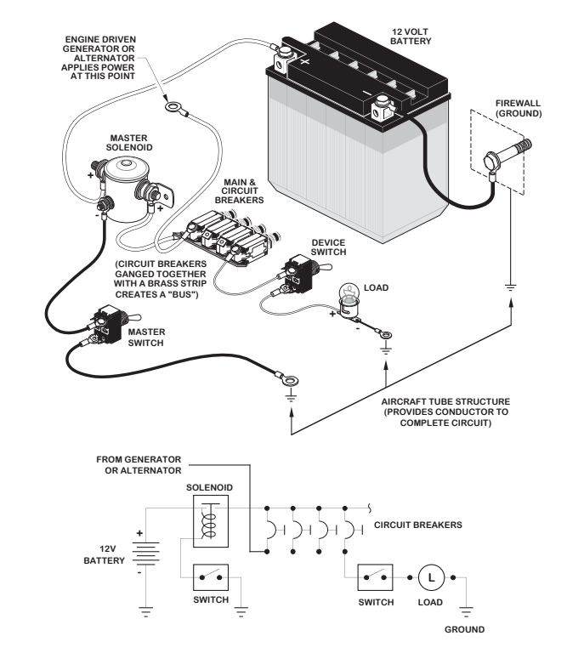
Figure 7-7. Example Electrical System

CIRCUIT BREAKERS AND FUSES
Most of the electrical circuits in the airplane are protect by “push-to-reset” circuit breakers mounted under the MFD on the right side of the instrument panel. The USB ports are equipped with a fuse behind the instrument panel on the pilot side.

GROUND SERVICE PLUG RECEPTACLE
A ground service plug receptacle is installed to permit the use of an external power source for cold weather starting and during lengthy maintenance work on the electrical and electronic equipment. The
receptacle is located behind the baggage compartment on the right side of the fuselage near the aft edge of the turtledeck. The velco holding the rear baggage wall over the fuselage tubing must be released to access the plug.

PRIMARY FLIGHT DISPLAY

AMMETER
The ammeter, visible within the Garmin G3X Touch under the Engine tab, indicates the flow of current, in amperes, from the alternator to the battery or from the battery to the airplane electrical system. When the engine is operating and the master switch is turned on, the ammeter indicates the charging rate applied to the battery. In the event the alternator is not functioning or the electrical load exceeds the output of the alternator, the ammeter indicates the battery discharge rate.

OVER-VOLTAGE SENSOR AND WARNING LIGHT
The airplane is equipped with an automatic over-voltage protection system consisting of an over-voltage sensor behind the instrument panel and a red warning light, labeled HIGH VOLTAGE, under the
ammeter.

In the event an over-voltage condition occurs, the over-voltage sensor automatically removes alternator field current and shuts down the alternator. The red warning light will then turn on, indicating to the pilot that the alternator is not operating and the battery is supplying all electrical power.

The over-voltage sensor may be reset by turning the master switch off and back on again. If the warning light does not illuminate, normal alternator charging has resumed; however, if the light does illuminate
again, a malfunction has occurred, and the flight should be terminated as soon as practical.

The warning light may be tested by momentarily turning off the ALT portion of the master switch and leaving the BAT portion turned on.

EXTERIOR LIGHTING
Conventional navigation lights, flashing beacons, and strobe lights are located on the wing tips as are dual landing lights. All exterior lights are controlled by rocker type switches in the center of the instrument panel. The switches are ON in the up position and OFF in the down position.

The flashing beacon should not be used when flying through clouds or overcast; the flashing light reflected from water droplets or particles in the atmosphere, particularly at night, can produce vertigo
and loss of orientation.

The high intensity strobe lights will enhance anti-collision protection. However, the lights should be turned off when taxiing in the vicinity of other airplanes, or during night flight through clouds, fog or haze.

INTERIOR LIGHTING
Instrument and control panel lighting is provided by integral lighting. To control the intensity of the integral lighting enter the Garmin G3X Touch configuration screen and adjust accordingly.

The Garmin GTR200B communication radio also has an integrated light.

PITOT-STATIC SYSTEM AND INSTRUMENTS
The pitot-static system supplies ram air pressure to the airspeed indicator and static pressure to the airspeed indicator, rate-of-climb indicator and altimeter. These are integrated into the ADHRS system attached to the rear of the Garmin G3X Touch PFD. The system is composed of either an unheated or heated pitot tube mounted on the lower surface of the left wing, an external static port on the lower left side of the rear fuselage, and the associated plumbing necessary to connect the instruments to the sources.

AIRSPEED INDICATOR
The airspeed indicator is calibrated in miles per hour. Limitation and range markings include the white arc (35 to 80 mph), green arc (40 to 111 mph), yellow arc (120 to 140 mph), and a red line (140 mph).

True airspeed is automatically calculated by the Garmin G3X Touch system and is visible on the display screens at the top of indicated airspeed tape.

RATE-OF-CLIMB INDICATOR
The rate-of-climb indicator depicts airplane rate of climb or descent in feet per minute. The pointer is actuated by atmospheric pressure changes resulting from changes of altitude as supplied by the static
source.

ALTIMETER
Airplane altitude is depicted by a barometric type altimeter. Pressing the box below the altitude tape allows the pilot to set the barometric pressure using a number touchpad.

ATTITUDE INDICATOR
An attitude indicator is available on both the Garmin PFD and MFD displays and gives a visual indication of flight attitude. Bank attitude is presented by a pointer at the top of the indicator relative to the bank scale which has index marks at 10°, 20°, 30°, 45° and 60° either side of the center mark. Pitch and roll attitudes are presented by a horizontal bar in relation to the horizon.

DIRECTIONAL INDICATOR
A directional indicator is available and displays airplane heading on a compass card in relation to a fixed simulated airplane image and index.

AOA STALL WARNING SYSTEM
The airplane is equipped with a Garmin AOA stall warning system in the pitot tube. As the airplane approaches a stall a beeping will occur in the headsets becoming more persistent until it becomes a steady beep at the stall speed.

AVIONICS SUPPORT EQUIPMENT
The airplane may, at the owner’s discretion, be equipped with various types of avionics support equipment such as an audio control panel and static dischargers. The following paragraphs discuss
these items.

AUDIO CONTROL PANEL
Operation of radio equipment is covered in Section 9 of this handbook. When one or more radios is installed, a transmitter/audio switching system is provided (see figure 7-10). The operation of this
switching system is described in the following paragraphs.

The transmitter selector switch is labeled TRANS, and has two positions. When two transmitters are installed, it is necessary to switch the microphone to the radio unit the pilot desires to use for transmission. This is accomplished by placing the transmitter selector switch in the position corresponding to the radio unit which is to be used. The up position selects the upper transmitter and the down position selects the lower transmitter.

The installation of Kitfox radio equipment provides certain audio back-up capabilities and transmitter selector switch functions that the pilot should be familiar with. The audio amplifier in the NAV/COM radio is required for speaker and transmitter operation. The amplifier is automatically selected, along with the transmitter, by the transmitter selector switch. As an example, if the number 1 transmitter is selected, the audio amplifier in the associated NAV/COM receiver is also selected, and functions as the amplified for ALL speaker audio. In the event the audio amplifier in use fails, as evidenced by loss of all speaker audio and transmitting capability of the selected transmitter, select the other transmitter. This should re-establish speaker audio and transmitter operation. Since headset audio is not affected by audio amplifier operation, the pilot should be aware that, while utilizing a headset, the only indication of audio amplifier failure is loss of the selected transmitter. This can be verified by switching to the speaker function.

The speaker-phone switches determine whether the output of the receiver in use is fed to the headphones or through the audio amplifier to the speaker. Place the switch for the desired receiving
system either in the up position for speaker operation or in the down position for headphones. The center OFF position will remove receiver output to either headphones or the speaker.

Figure 7-10. Audio Control Panel

Airplanes equipped with any radio other than the Kitfox 300 Nav/Com (Type RT-385A) will not have sidetone capability (monitoring of the operator’s own voice transmission). If the airplane is equipped
with a Kitfox 300 Nav/Com (Type RT-385A), the radio will have sidetone capabilities and the audio control panel will include a speaker sidetone volume control knob as illustrated in figure 7-10. Sidetone will be heard on either the airplane speaker or a headset as selected with the speaker-phone selector switches. When the speaker position is selected, sidetone audio volume may be controlled by rotating the SIDETONE VOL control knob clockwise to increase audio volume and counterclockwise to decrease it. When headphones are in use, sidetone volume cannot be adjusted.

STATIC DISCHARGERS
If frequent IFR flights are planned, installation of wick-type static dischargers is recommended to improve radio communications during flight through dust or various forms of precipitation (rain, snow
or ice crystals). Under these conditions, the build-up and discharge of static electricity from the trailing edge of the wings, rudder, elevator, propeller tips, and radio antennas can result in loss of usable radio signals on all communications and navigation radio equipment. Usually the ADF is first to be affected and VFH communication equipment is the last to be affected.

Installation of static dischargers reduces interference from precipitation static, but it is possible to encounter severe precipitation static conditions which might cause the loss of radio signals, even with static dischargers installed. Whenever possible, avoid known severe precipitation areas to prevent loss of dependable radio signals. If avoidance is impractical, minimize airspeed and anticipate temporary loss of radio signals while in these areas.

CABIN HEATING, VENTILATING AND DEFROSTING SYSTEM
The temperature and volume of airflow into the cabin can be regulated to any degree desired by manipulation of the 3-way rocker switch labeled CABIN HEAT as well as the cabin air eyeball ventilator ports located on each side of the panel.

Heated air is created by passing cabin air over a radiator located behind the panel and is directed over the pilot and passenger’s feet.

Panel:
Garmin display units, GDU 460 10” PFD and GDU 450 7” MFD:


Garmin GTR 200B communication radio:


Garmin Sensors Kit, including the GSU 25C ADAHRS - air data attitude heading reference system, GMU 11 magnetometer, and
GTP 59 temperature probe:


Garmin GEA 24 engine indication system (EIS)

Garmin GA 26C low profile remote antenna

TCW Technologies Integrated Backup Battery System IBBS-12V-3AH


Left side of baggage compartment:
GPS 20A ADS-B WAAS and GPS

GTX 45R Transponder, ADS-B in&out

GA 35 WAAS GPS teardrop footprint antenna

TCW Technologies Safety Trim Booster ST1-12V-10A-BSTR


Right side of baggage compartment:
ACK ELT


Left wing:
In fuselage behind seats and baggage compartment:
GSA 28 servo - pitch
GSA 28 servo – roll


Behind the baggage compartment, EarthX ETX900 Battery:



HANDLING, SERVICE & MAINTENANCE
TABLE OF CONTENTS
Section 8 HANDLING, SERVICE & MAINTENANCE 108
INTRODUCTION 108
AIRPLANE FILE 109
AIRPLANE INSPECTION PERIODS 109
FAA REQUIRED INSPECTIONS 109
PILOT CONDUCTED PREVENTIVE MAINTENANCE 110
GROUND HANDLING 111
TOWING 111
PARKING 111
TIE-DOWN 111
FLYABLE STORAGE 111
ENGINE OIL 112
OIL AND OIL FILTER CHANGE – 112
FUEL 113
LANDING GEAR 113
CLEANING AND CARE 113
WINDSHIELD-WINDOWS 113
PAINTED SURFACES 114
PROPELLER CARE 115
INTERIOR CARE 115

INTRODUCTION
This section contains recommended procedures for proper ground handling and routine care and servicing of your Kitfox. It also identifies certain inspection and maintenance requirements which
must be followed if your airplane is to retain performance and dependability. It is wise to follow a planned schedule of lubrication and preventive maintenance based on climatic and flying conditions encountered in your locality.

AIRPLANE FILE
There are miscellaneous data, information and licenses that are a part of the airplane file. The following is a checklist for that file. In addition, a periodic check should be made of the latest Federal Aviation Regulations to ensure that all data requirements are met.

A. To be displayed in the airplane at all times:

- Aircraft Airworthiness Certificate (FAA Form 8100-2)
- Mark “EXPERIMENTAL” on aircraft in letters at least 2” and no more than 6” tall near the entrances to the cockpit.
- Passenger warning placard
“PASSENGER WARNING – THIS AIRCRAFT DOES NO COMPLY WITH FEDERAL SAFETY REGULATIONS FOR STANDARD AIRCRAFT” displaced in full view of all occupants.
- Fireproof data plate securely attached to aircraft near tail with Builder, Model, and Serial number marked on it by etching, stamping, or engraving.

B. To be carried in the airplane at all times:
- Aircraft Registration Certificate (FAA Form 8050-3)
- Operating Handbook
- Weight and Balance

C. To be made available upon request:
- Airplane Log Book
- Engine Log Book
- Propeller Log Book

Most of the items listed are required by the United States Federal Aviation Regulations. Since the Regulations of other nations may require other documents and data, i.e., a Radio Operators License, owners of airplanes not registered in the United States should check with their own aviation officials to determine their individual requirements.

AIRPLANE INSPECTION PERIODS

FAA REQUIRED INSPECTIONS
As required by Federal Aviation Regulations, all civil aircraft of U.S. registry must undergo a complete inspection each twelve calendar months. In addition to the required ANNUAL CONDITION inspection, aircraft operated commercially (for hire) must have a complete inspection every 100 hours of operation.

The FAA may require other inspections by the issuance of airworthiness directives applicable to the airplane, engine, propeller and components. It is the responsibility of the owner/operator to ensure compliance with all applicable airworthiness directives and, when the inspections are repetitive, to take appropriate steps to prevent inadvertent noncompliance.

In lieu of the 100 HOUR and ANNUAL inspection requirements, an airplane may be inspected in accordance with a progressive inspection schedule, which allows the work load to be divided into
smaller operations that can be accomplished in shorter time periods.

PILOT CONDUCTED PREVENTIVE MAINTENANCE
A certified pilot who owns or operates an airplane not used as an air carrier is authorized by FAR Part 43 to perform limited maintenance on his airplane. Refer to FAR Part 43 for a list of the specific maintenance operations which are allowed.

NOTE

Pilots operating airplanes of other than U.S. registry should refer to the regulations of the country of certification for information on preventive maintenance that may be performed by pilots.

AC 43.13-1B - Acceptable Methods, Techniques, and Practices - Aircraft Inspection and Repair should be obtained prior to performing any preventive maintenance to ensure that proper procedures are followed.

GROUND HANDLING

TOWING
The airplane is most easily and safely maneuvered by hand with the tow-bar attached to the tailwheel.

PARKING
When parking the airplane, head into the wind and set the parking brakes. Do not set the parking brakes during cold weather when accumulated moisture may freeze the brakes, or when the brakes are overheated. Loop the seat belt over the control stick and chock the wheels. In severe weather and high wind conditions, tie the airplane down as outlined in the following paragraph.

TIE-DOWN
Proper tie-down procedure is the best precaution against damage to the parked airplane by gusty or strong wings. To tie-down the airplane securely, proceed as follows:

1. Set the parking brake and loop the seatbelt over the control stick.
2. Tie sufficiently strong ropes or chains (700 pounds tensile strength) to the wing and tail tie-down fittings and secure each rope to a ramp tie-down.
3. Install a surface control lock over the fin and rudder.
4. Install a pitot tube cover.

FLYABLE STORAGE
Airplanes placed in non-operational storage for a maximum of 30 days or those which receive only intermittent operational use for the first 25 hours are considered in flyable storage status. Every
seventh day during these periods, the propeller should be rotated by hand through five revolutions. This action “limbers” the oil and prevents any accumulation of corrosion on engine cylinder walls.

WARNING

For maximum safety, check that the ignition switch is OFF, the throttle is closed, and the airplane is secured before rotating the propeller by hand. Do not stand within the arc of the propeller blades while turning the propeller.

After 30 days, the airplane should be flown for 30 minutes or a ground runup should be made just long enough to produce an oil temperature within the lower green arc range. Excessive ground runup should be avoided.

Engine run-up also helps to eliminate excessive accumulations of water in the fuel system and other air spaces in the engine. Keep fuel tanks full to minimize condensation in the tanks. Keep the battery fully charged to prevent electrolyte from freezing in cold weather.

ENGINE OIL
GRADE AND VISCOSITY FOR TEMPERATURE RANGE –
SHELL AeroShell Oil Sport Plus 4
XPS 5W-50 Full Synthetic Aviation Engine oil.

CAPACITY OF OIL TANK - 3 liters (3.2 quarts)
Do not operate on less than 2.2 quarts. To minimize loss of oil through breather, fill to 3 quart level for normal flights of less than 3 hours. For extended flight, fill to 3.2 quarts. These quantities refer to oil dipstick level readings.

OIL AND OIL FILTER CHANGE –
For complete oil and oil filter change procedure, refer to the Rotax Maintenance Manual Line, section 12-20-00, Oil Change, available by searching the documentation at the following URL:

https://www.flyrotax.com/p/service/technical-documentation

FUEL
APPROVED FUEL GRADES
ASTM D4814 (min. AKI 91) aka 91 Octane MOGAS (Yellow)
100LL Grade Aviation Fuel (Blue)

CAPACITY EACH STANDARD TANK - 13 Gallons
CAPACITY HEADER TANK - 1 Gallon

NOTE

Due to cross-feeding between fuel tanks, the tanks should be re-topped after each refueling to assure maximum capacity.

LANDING GEAR
MAIN WHEEL TIRE PRESSURE - 8-11 PSI on 29.00-6
TAILWHEEL TIRE PRESSURE -
TAILWHEEL SHOCK STRUT - Keep filled with MIL-H-5606 hydraulic fluid and inflated with air to 20 PSI.
Do not over-inflate.

CLEANING AND CARE

WINDSHIELD-WINDOWS
The plastic windshield and windows should be cleaned with an aircraft windshield cleaner. Apply the cleaner sparingly with soft cloths, and rub with moderate pressure until all dirt, oil scum and bug stains are removed. Allow the cleaner to dry, then wipe it off with soft flannel cloths. If a windshield cleaner is not available, the plastic can be cleaned with soft cloths moistened with Stoddard solvent to remove oil and grease.

NOTE

Never use gasoline, benzine, alcohol, acetone, carbon tetrachloride, fire extinguisher or anti-ice fluid, lacquer thinner or glass cleaner to clean the plastic. These materials will attack the plastic and may cause it to craze.

Follow by carefully washing with a mild detergent and plenty of water. Rinse thoroughly, then dry with a clean moist chamois. Do not rub the plastic with a dry cloth since this builds up an electrostatic charge which attracts dust. Waxing with a good commercial wax will finish the cleaning job. A thin, even coat of wax, polished out by hand with clean soft flannel cloths, will fill in minor scratches and help prevent further scratching.

Do not use a canvas cover on the windshield unless freezing rain or sleet is anticipated since the cover may scratch the plastic surface.

PAINTED SURFACES
The painted exterior surfaces of your Kitfox have a durable, long lasting finish and, under normal conditions, require no polishing or buffing.

Generally, the painted surfaces can be kept bright by washing with water and mild soap, followed by a rinse with water and drying with cloths or a chamois. Harsh or abrasive soaps or detergents which cause corrosion or scratches should never be used. Remove stubborn oil and grease with a cloth moistened with Stoddard solvent.

Waxing is unnecessary to keep the paint surfaces bright. However, if desired, the airplane may be waxed with a good automotive wax. A heavier coating of wax on the leading edge of the wings and tail
and on the engine nose cap and propeller spinner will help reduce the abrasion encountered in these areas.

When the airplane is parked outside in cold climates and it is necessary to remove ice before flight, care should be taken to protect the painted surfaces during ice removal with chemical liquids. A 50-50 solution of isopropyl alcohol and water will satisfactorily remove ice accumulations without damaging the paint. A solution with more than 50% alcohol is harmful and should be avoided. While applying the de-icing solution, keep it away from the windshield and cabin windows since the alcohol will attack the plastic and may cause it to craze.

PROPELLER CARE
Preflight inspection of propeller blades for nicks, and wiping them occasionally with an oily cloth to clean off grass and bug stains will assure long, trouble-free service. Small nicks on the propeller,
particularly near the tips and on the leading edges, should be dressed out as soon as possible since these nicks produce stress concentrations, and if ignored, may result in cracks. Never use an alkaline cleaner on the blades; remove grease and dirt with carbon tetrachloride or Stoddard solvent.

INTERIOR CARE
To remove dust and loose dirt from the upholstery and carpet, clean the interior regularly with a vacuum cleaner.

Blot up any spilled liquid promptly with cleansing tissue or rags. Don’t pat the spot; press the blotting material firmly and hold it for several seconds. Continue blotting until no more liquid is taken up. Scrape off sticky materials with a dull knife, then spot-clean the area.

Oily spots may be cleaned with household spot removers, used sparingly. Before using any solvent, read the instructions on the container and test it on an obscure place on the fabric to be cleaned. Never saturate the fabric with a volatile solvent; it may damage the padding and backing materials.

Soiled upholstery and carpet may be cleaned with foam-type detergent, used according to the manufacturer’s instructions. To minimize wetting the fabric, keep the foam as dry as possible and
remove it with a vacuum cleaner.

The instrument panel and control switches need only be wiped off with a damp cloth. Oil and grease on the control stick and control knobs can be removed with a cloth moistened with Stoddard solvent. Volatile solvents, such as mentioned in paragraphs on care of the windshield, must never be used since they soften and craze the plastic.

SUPPLEMENTS
TABLE OF CONTENTS
SECTION 9 - SUPPLEMENTS 124
INTRODUCTION 125
EMERGENCY LOCATOR TRANSMITTER (ELT) 125
SECTION 1 – GENERAL 125
SECTION 2 – LIMITATIONS 126
SECTION 3 – EMERGENCY PROCEDURES 126
SECTION 4 – NORMAL PROCEDURES 127
SECTION 5 – PERFORMANCE 127
KITFOX 300 NAV/COM (720-Channel – Type RT-328T) 128
SECTION 1 – GENERAL 128
SECTION 2 – LIMITATIONS 131
SECTION 3 – EMERGENCY PROCEDURES 132
SECTION 4 – NORMAL PROCEDURES 132
SECTION 5 – PERFORMANCE 134
KITFOX 300 TRANSPONDER (Type RT-359A) AND OPTIONAL ENCODING ALTIMETER (Type EA-401A) 134
SECTION 1 – GENERAL 134
SECTION 2 – LIMITATIONS 137
SECTION 3 – EMERGENCY PROCEDURES 137
SECTION 4 – NORMAL PROCEDURES 138
KITFOX 400 TRANSPONDER (Type RT-459A) AND OPTIONAL ENCODING ALTIMETER (Type EA-401A) 140
SECTION 1 – GENERAL 140
SECTION 2 – LIMITATIONS 143
SECTION 3 – EMERGENCY PROCEDURES 143
SECTION 4 – NORMAL PROCEDURES 144
SECTION 5 – PERFORMANCE 145

INTRODUCTION
This section consists of a series of supplements, each covering a single optional system which may be
installed in the airplane. Each supplement contains a brief description, and when applicable, operating
limitations, emergency and normal procedures, and performance. Other routinely installed items of
optional equipment, whose function and operational procedures do not require detailed instructions,
are discussed in Section 7.

EMERGENCY LOCATOR TRANSMITTER (ELT)

SECTION 1 - GENERAL
The ELT consists of a self-contained dual-frequency radio transmitter and battery power supply, and is activated by an impact of 5G or more as may be experienced in a crash landing. The ELT emits an omni-directional signal on the international distress frequencies of 121.5 and 243.0 MHz. (Some ELT units in export aircraft transmit only on 121.5 MHz.) General aviation and commercial aircraft, the FAA, and CAP monitor 121.5 MHz, and 243.0 MHz is monitored by the military. Following a crash landing, the ELT will provide line-of-sight transmission up to 100 miles at 10,000 feet. The ELT supplied in domestic aircraft transmits on both distress frequencies simultaneously at 75 mw rated power output for 48 continuous
hours in the temperature range of -40°F to +131°F (-40°C to +55°C). The ELT unit in export aircraft transmits on 121.5 MHz at 25 mw rated power output for 100 continuous hours in the temperature
range of -40°F to +131°F (-40°C to +55°C).

The ELT is readily identified as a bright orange unit mounted on the right side of the baggage compartment wall. To gain access to the unit, remove the baggage compartment wall. The ELT is operated by
a control panel at the forward facing end of the unit (see figure 1.)

Figure 1. ELT Control Panel

1. FUNCTION SELECTOR SWITCH (3-position toggle switch):

ON Activates transmitter instantly. Used for test purposes and if “G” switch is
inoperative.

OFF Deactivates transmitter. Used during shipping, storage and following rescue.

AUTO Activates transmitter only when “G” switch receives 5G or more impact.

2. COVER - Removable for access to battery pack.
3. ANTENNA RECEPTACLE - Connects to antenna mounted on top of tailcone.

SECTION 2 - LIMITATIONS

There is no change to the airplane limitations when this equipment is installed.

SECTION 3 - EMERGENCY PROCEDURES

Immediately after a forced landing where emergency assistance is required, the ELT should be utilized as follows:

1. ENSURE ELT ACTIVATION - Turn a radio transceiver ON and select 121.5 MHz. If the ELT can be heard transmitting, it was activated by the “G” switch and is functioning properly. If no emergency tone is audible, gain access to the ELT and place the function selector switch in the ON position.
2. PRIOR TO SIGHTING RESCUE AIRCRAFT - Conserve airplane battery. Do not activate radio transceiver.
3. AFTER SIGHTING RESCUE AIRCRAFT - Place ELT function selector switch in the OFF position, preventing radio interference. Attempt contact with rescue aircraft with the radio transceiver
set to a frequency of 121.5 MHz. If no contact is established, return the function selector switch to ON immediately.
4. FOLLOWING RESCUE - Place ELT function selector switch in the OFF position, terminating emergency transmission.

SECTION 4 - NORMAL PROCEDURES
As long as the function selector switch remain in the AUTO position, the ELT automatically activates following an impact of 5G or more over a short period of time.

Following a lightning strike, or an exceptionally hard landing, the ELT may activate although no emergency exists. To check your ELT for inadvertent activation, select 121.5 MHz on your radio transceiver and listen for an emergency tone transmission. If the ELT can be heard transmitting, place the function selector switch in the OFF position and the tone should cease. Immediately place the function selector switch in the AUTO position to re-set the ELT for normal operation.

SECTION 5 - PERFORMANCE
There is no change to the airplane performance data when this equipment is installed.

KITFOX 300 NAV/COM (720-Channel - Type RT-328T)

SECTION 1 - GENERAL
The Kitfox 300 Nav/Com (Type RT-328T), shown in Figure 1, consists of a panel-mounted receiver-
transmitter and a single- or dual-pointer remote course deviation indicator (CDI). The set includes a
720-channel VHF communication receiver-transmitter and a 200-channel VHF navigation receiver, both
of which may be operated simultaneously.

The communication receiver-transmitter receives and transmits signals between 118.000 and 135.975
MHz in 25-k Hz steps. The navigation receiver receives and interprets VHF omnidirectional and localizer
signals between 108.00 and 117.95 MHz in 50-kHz steps. The communication receiver-transmitter and
the navigation receiver are synthesizer-controlled and are tuned automatically when the frequency is
selected.

A DME receiver-transmitter or a glide slope receiver, or both, may be interconnected with the Kitfox
300 Nav/Com set for automatic selection of the association DME or GS frequency. When a VOR
frequency is selected on the Nav/Com, the associated VORTAC or VOR-DME station frequency will also
be selected automatically; likewise, if a localizer frequency is selected, the associated glide slope
frequency will be selected automatically.

All controls of the Kitfox 300 Nav/Com, except the omni bearing selector knob (OBS), which is located
on the course indicator, are mounted on the front panel of the receiver-transmitter. The course
indicator includes either a single pointer and related OFF flag for VOR/LOC indication only, or dual
pointers and related OFF flags for both VOR/LOC and glide slope indications. The course indicator also
incorporates a back-course lamp (BC) which lights when optional back-course operation is selected.
Each control function is described in Figure 1, and the audio control panel supplied with this equipment
is shown and described in Section 7 of this handbook.

Figure 1. Kitfox 300 Nav/Com (Type RT-328T)

1. RECEIVER-TRANSMITTER FREQUENCY INDICATOR.

2. NAVIGATION RECEIVER FREQUENCY INDICATOR.

3. SQUELCH CONTROL - used to adjust signal threshold necessary to activate communication receiver
audio. Clockwise rotation increases background noise (decreases squelch action); counterclockwise
rotation decreases background noise.
4. COMMUNICATION RECEIVER-TRANSMITTER MEGAHERTZ SELECTOR - Selects communication
receiver-transmitter frequency in 1-MHz steps between 118 and 135 MHz.
5. OFF/ON VOLUME CONTROL - Turns set on and controls volume of audio from communications
receiver.
6. COMMUNICATION RECEIVER-TRANSMITTER FRACTIONAL MEGAHERTZ SELECTOR - Selects
communication receiver-transmitter fractional frequency in .05-MHz steps between .000 and .950
MHz or between .025 and .975 MHz depending on position of 50-25 MHz selector switch (7).
7. 50-25 FRACTIONAL MHz SELECTOR SWITCH - In “50” position, enables communication whole MHz
frequency readout to display and communication fractional MHz control to select fractional part of
frequency in .05-MHz steps between .000 and .950 MHz. In “25” position, frequency display and
coverage is in .05-MHz steps between .025 and .975.

NOTE

The third decimal-place digit is not shown on the receiver-transmitter
frequency readout. As shown in Figure 1, selected Com frequency is
118.000 MHz. With the switch in the other position, 118.02 is 118.025
MHz or 118.07 is 118.075 MHz.

8. NAVIGATION RECEIVER MEGA HERTZ SELECTOR - Selects navigation receiver frequency in 1-Mhz
steps between 108 and 117 MHz; simultaneously selects paired glide slope frequency or DME
channel.
9. NAVIGATION RECEIVER VOLUME CONTROL - Controls volume of audio from navigation receiver
only. Clockwise rotation increases audio level.
10. NAVIGATION RECEIVER FRACTIONAL MEGA HERTZ SELECTOR - Selects navigation receiver frequency
in .05-MHz steps between .00 and .95 MHz; simultaneously paired glide slope frequency or DME
channel.
11. COMBINED IDENTIFIER SIGNAL SELECTOR AND VOR SELF-TEST SELECTOR SWITCH (ID-T SWITCH) –
With VOR or LOC station selected, in ID position, station identifier is audible; in center (unmarked)
position, identifier is off; in T (momentary on) position, tests VOR navigation circuits.
12. COURSE DEVIATION POINTER - Indicates deviation from selected omni bearing or localizer
centerline.
13. OFF/TO-FROM INDICATOR - Operates only with VOR or localizer signal. “OFF” position (flag)
indicates unreliable signal. When “OFF” position disappears, indicator shows whether selected VOR
course is “TO” or “FROM” the station (if LOC frequency is selected, indicator will only show “TO”).
14. RECIPROCAL COURSE INDEX - Indicates reciprocal of selected VOR course.
15. OMNI BEARING SELECTOR (OBS) - Selects desired course to or from a VOR station.
16. BC - During LOC operation, when optional Back-Course operation is selected, amber lamp
illuminates to alert the pilot that CDI indication is reversed.
17. BEARING DIAL - Rotated by OBS to select course at index.
18. COURSE INDEX - indicates selected VOR course.
19. GLIDE SLOPE “OFF” FLAG - When visible, indicates unreliable glide slope signal or no glide slope
signal. The flag disappears when a reliable glide slope signal is being received.
20. GLIDE SLOPE DEVIATION POINTER - Indicates deviation from normal glide slope.

SECTION 2 - LIMITATIONS

There is no change to the airplane limitations when this avionics equipment is installed. However, the
pilot should be aware that on many Kitfox airplanes equipped with the windshield mounted glide slope
antenna, pilots should avoid use of 2700 ±100 RPM (or 1800 ±100 RPM with a three bladed propeller)
during ILS approaches to avoid oscillations of the glide slope deviation pointer caused by propeller
interference.

SECTION 3 - EMERGENCY PROCEDURES

There is no change to the airplane emergency procedures when this avionics equipment is installed.

SECTION 4 - NORMAL PROCEDURES

COMMUNICATION TRANSCEIVER OPERATION:

1. OFF/VOL Control - TURN ON and adjust to desired listening level.
2. XMTR SEL Switch - SET to desired transceiver.
3. SPEAKER PHONE (or AUTO) Switch - SET to desired mode.
4. 50-25 Fractional MHz Selector Switch - SELECT desired frequency (does not affect navigation
frequencies).
5. COM Frequency Selector Knob - SELECT desired operating frequency.
6. SQ Control - ROTATE counterclockwise to decrease background noise as required.
7. Mike Button:
a. To Transmit - DEPRESS and SPEAK into microphone.
b. To Receive - RELEASE.

NAVIGATION RECEIVER OPERATION:

1. COM/OFF VOL Control - TURN ON.
2. SPEAKER/PHONE (or AUTO) Switch - SET to desired mode.
3. NAV Frequency Selector Knob - SELECT desired operating frequency.
4. NAV VOL Control - ADJUST to desired audio level.
5. ID-T Switch:
a. To Identify Station - SET to ID to hear navigation station identifier (More Code) signal.
b. To Filter Out Station Identifier Signal - SET to CENTER (unmarked) position to include
filter in audio circuit.
6. OBS Knob - SELECT desired course.

TO SELF TEST VOR NAVIGATION CIRCUITS:

1. COM OFF/VOL Control - TURN ON.
2. NAV Frequency Selector Switches - SELECT usable VOR station signal.
3. OBS Knob - SET for 0° course at index; CDI pointer centers or deflects left or right, depending on
bearing of signal; OFF/TO-FROM indicator shows TO or FROM.
4. ID-T Switch - PRESS to T and HOLD at T; CDI pointer should center and OFF/TO-FROM indicator
should show FROM.
5. OBS Knob - TURN to displace course approximately 1/2 to either side of 0° (while holding ID-T
switch at T); CDI pointer should deflect full scale in direction corresponding to course
displacement. OFF/TO-FROM indicator should still show FROM.

NOTE

This test does not fulfill the requirements of FAR 91.25.

SECTION 5 - PERFORMANCE

There is no change to the airplane performance when this avionics equipment is installed. However, the
installation of an externally mounted antenna of several external antennas, will result in a minor
reduction in cruise performance.

KITFOX 300 TRANSPONDER (Type RT-359A) AND OPTIONAL ENCODING ALTIMETER (Type EA-401A)

SECTION 1 - GENERAL
The Kitfox 300 Transponder (Type RT-359A), shown in Figure 1, is the airborne component of an Air
Traffic Control Radar Beacon System (ATCRBS). The transponder enables the ATC ground controller to
“see” and identify the aircraft, while in flight, on the control center’s radarscope more readily.

The Kitfox 300 Transponder consists of a panel-mounted unit and an externally-mounted antenna. The
transponder receives interrogating pulse signals on 1030 MHz and transmits coded pulse-train reply
signals on 1090 MHz. It is capable of replying to Mode A (aircraft identification) and Mode C (altitude
reporting) interrogations on a selective reply basis on any of 4,096 information code selections. When
an optional panel-mounted EA-401A Encoding Altimeter (not part of a standard 300 Transponder
system) is included in the avionic configuration, the transponder can provide altitude reporting in 100-
foot increments between -1000 and +35,000 feet.

All Kitfox 300 Transponder operating controls, with the exception of the optional altitude encoder’s
altimeter setting knob, are located on the front panel of the unit. The altimeter setting knob is located
on the encoding altimeter. Functions of the operating controls are described in Figure 1.

Figure 1. Kitfox 300 Transponder and Encoding Altimeter

1. FUNCTION SWITCH - Controls application of power and selects transponder operating mode, as
follows:
OFF - Turns set off.
SBY - Turns set on for equipment warm-up.
ON - Turns set on and enables transponder to transmit Mode A (aircraft identification) reply
pulses.
ALT - Turns set on and enables transponder to transmit either Mode A (aircraft identification)
reply pulses or Mode C (altitude reporting) pulses selected automatically by the interrogating
signal.
2. REPLY LAMP - Lamp flashes to indicate transmission of reply pulses; glows steadily to indicate
transmission of IDENT pulse or satisfactory self-test operation. (Reply Lamp will also glow steadily
during initial warm-up period.)
3. IDENT (ID) SWITCH - When depressed, selects special pulse identifier to be transmitted with
transponder reply to effect immediate identification of aircraft on ground controller’s display.
(Reply Lamp will glow steadily during duration of IDENT pulse transmission.)
4. DIMMER (DIM) CONTROL - Allows pilot to control brilliance of reply lamp.
5. SELF-TEST (TST) SWITCH - When depressed, causes transponder to generate a self-interrogating
signal to provide a check of transponder operation. (Reply Lamp will glow steadily to verify self-test
operation.)
6. REPLY-CODE SELECTOR KNOBS (4) - Select assigned Mode A reply code.
7. REPLY-CODE INDICATORS (4) - Display selected Mode A reply code.

8. 1000-FOOT DRUM TYPE INDICATOR - Provides digital altitude readout in 1000-foot increments
between -1000 feet and +35,000 feet. When altitude is below 10,000 feet, a diagonally striped flag
appears in the 10,000 foot window.
9. OFF INDICATOR WARNING FLAG - Flag appears across altitude readout when power is removed
from the altimeter to indicate that readout is not reliable.
10. 100-FOOT DRUM TYPE INDICATOR - Provides digital altitude readout in 100-foot increments
between 0 feet and 1000 feet.
11. 20-FOOT INDICATOR NEEDLE - Indicates altitude in 20-foot increments between 0 feet and 1000
feet.
12. ALTIMETER SETTING SCALE - DRUM TYPE - Indicates selected altimeter setting in the range of 27.9
to 31.0 inches of mercury on the standard altimeter or 950 to 1050 millibars on the optional
altimeter.
13. ALTIMETER SETTING KNOB - Dials in desired altimeter setting in the range of 27.9 to 31.0 inches of
mercury on the standard altimeter or 950 to 1050 millibars on the optional altimeter.

SECTION 2 - LIMITATIONS

There is no change to the airplane limitations when this avionic equipment is installed.

SECTION 3 - EMERGENCY PROCEDURES

TO TRANSMIT AN EMERGENCY SIGNAL:

1. Function Switch - ON.
2. Reply-Code Selector Knobs - SELECT 7700 operating code.
3. ID Switch - DEPRESS then RELEASE to effect immediate identification of aircraft on ground
controller’s display.

TO TRANSMIT A SIGNAL REPRESENTING LOSS OF ALL COMMUNICATIONS (WHEN IN A CONTROLLED
ENVIRONMENT):

1. Function Switch - ON.
2. Reply-Code Selector Knobs - SELECT 7700 operating code for 1 minute; then SELECT 7600
operating code for 15 minutes and then REPEAT this procedure at same intervals for remainder
of flight.
3. ID Switch - DEPRESS then RELEASE to effect immediate identification of aircraft on ground
controller’s display.

SECTION 4 - NORMAL PROCEDURES

BEFORE TAKEOFF:

1. Function Switch - SBY.

TO TRANSMIT MODE A (AIRCRAFT IDENTIFICATION) CODES IN FLIGHT:

1. Reply-Code Selector Knobs - SELECT assigned code.
2. Function Switch - ON.
3. DIM Control - ADJUST light brilliance of reply lamp.

NOTE

During normal operation with function switch in ON position, display
lamp flashes indicating transponder relies to interrogations.

4. ID Button - DEPRESS momentarily when instructed by ground controller to “squawk IDENT”
(reply lamp will glow steadily, indicating IDENT operation).

TO TRANSMIT MODE C (ALTITUDE REPORTING) CODES IN FLIGHT:

1. Off Indicator Warning Flag - VERIFY that flag is out of view on encoding altimeter.
2. Altitude Encoder Altimeter Setting Knob - SET IN assigned local altimeter setting.
3. Reply-Code Selector Knobs - SELECT assigned code.
4. Function Switch - ALT.

NOTE

When directed by ground controller to “stop altitude squawk”, turn
Function Switch to ON for Mode A operation only.

NOTE

Pressure altitude is transmitted by the transponder for altitude squawk
and conversion to indicated altitude is done in ATC computers. Altitude
squawked will only agree with indicated altitude when the local
altimeter setting is used by the ground controller is set in the encoding
altimeter.

5. DIM Control - ADJUST light brilliance of reply lamp.

TO SELF-TEST TRANSPONDER OPERATION:

1. Function Switch - SBY and wait 30 seconds for equipment to warm-up.
2. Function Switch - ON or ALT.
3. TST Button - DEPRESS and HOLD (reply lamp should light with full brilliance regardless of DIM
control setting).
4. TST Button - Release for normal operation.

SECTION 5 - PERFORMANCE

There is no change to the airplane performance when this avionic equipment is installed. However, the
installation of an externally mounted antenna or several related external antennas, will result in a minor
reduction in cruise performance.

KITFOX 400 TRANSPONDER (Type RT-459A) AND OPTIONAL ENCODING ALTIMETER (Type EA-401A)

SECTION 1 - GENERAL
The Kitfox 400 Transponder (Type 459A), show in Figure 1, is the airborne component of an Air Traffic
Control Radar Beacon System (ATCRBS). The transponder enables the ATC ground controller to “see”
and identify the aircraft, while in flight, on the control center’s radarscope more readily.

The 400 Transponder consists of a panel-mounted unit and an externally-mounted antenna. The
transponder receives interrogating pulse signals on 1030 MHz and transmits coded pulse-train reply
signals on 1090 MHz. It is capable of replying to Mode A (aircraft identification) and Mode C (altitude
reporting) interrogations on a selective reply basis on any of 4,096 information code selections. When
an optional panel mounted EA-401A Encoding Altimeter (not part of 400 Transponder System) is
included in the avionic configuration, the transponder can provide altitude reporting in 100-foot
increments between -1000 and +35,000 feet.

All Kitfox 400 Transponder operating controls, with the exception of the optional altitude encoder’s
altimeter setting knob, are located on the front panel of the unit. The altimeter setting knob is located
on the encoding altimeter. Functions of the operating controls are described in Figure 1.

Figure 1. Kitfox 400 Transponder and Encoding Altimeter Operating Controls

1. FUNCTION SWITCH - Controls application of power and selects transponder operating mode as
follows:
OFF - Turns set off.
SBY - Turns set on for equipment warm-up or standby power.
ON - Turns set on and enables transponder to transmit Mode A (aircraft identification) reply
pulses.
ALT - Turns set on and enables transponder to transmit either Mode A (aircraft identification)
reply pulses or Mode C (altitude reporting) pulses selected automatically by the interrogating
signal.
2. REPLY LAMP - Lamp flashes to indicate transmission of reply pulses; glows steadily to indicate
transmission of IDENT pulse or satisfactory self-test operation. (Reply Lamp will also glow steadily
during initial warm-up period.)
3. IDENT (ID) SWITCH - When depressed, selects special pulse identifier to be transmitted with
transponder reply to effect immediate identification of aircraft on ground controller’s display.
(Reply Lamp will glow steadily during duration of IDENT pulse transmission.)
4. DIMMER (DIM) CONTROL - Allows pilot to control brilliance of Reply Lamp.
5. SELF-TEST (TST) SWITCH - When depressed, causes transponder to generate a self-interrogating
signal to provide a check of transponder operation. (Reply Lamp will glow steadily to verify self-test
operation.)

6. REPLY-CODE SELECTOR SWITCHES (4) - Select assigned Mode A Reply Code.
7. REPLY-CODE INDICATORS (4) - Display selected Mode A Reply Code.
8. 1000-FOOT DRUM TYPE INDICATOR - Provides digital altitude readout in 1000-foot increments
between -1000 feet and +35,000 feet. When altitude is below 10,000 feet, a diagonally striped flag
appears in the 10,000-foot window.
9. OFF INDICATOR WARNING FLAG - Flag appears across altitude readout when power is removed
from altimeter to indicate that readout is not reliable.
10. 100-FOOT DRUM TYPE INDICATOR - Provides digital altitude readout in 100-foot increments
between 0 feet and 1000 feet.
11. 20-FOOT INDICATOR NEEDLE - Indicates altitude in 20-foot increments between 0 feet and 1000
feet.
12. ALTIMETER SETTING SCALE - DRUM TYPE - Indicates selected altimeter setting in the range of 28.1
to 30.99 inches of mercury on the standard altimeter or 946 to 1049 millibars on the optional
altimeter.
13. ALTIMETER SETTING KNOB - Dials in desired altimeter setting in the range of 27.9 to 31.0 inches of
mercury on standard altimeter or 950 to 1050 millibars on the optional altimeter.

SECTION 2 - LIMITATIONS

There is no change to the airplane limitations when this avionic equipment is installed.

SECTION 3 - EMERGENCY PROCEDURES

TO TRANSMIT AN EMERGENCY SIGNAL:

1. Function Switch - ON.
2. Reply-Code Selector Switches - SELECT 7700 operating code.
3. ID Switch - DEPRESS then RELEASE to effect immediate identification of aircraft on ground
controller’s display.

TO TRANSMIT A SIGNAL REPRESENTING LOSS OF ALL COMMUNICATIONS (WHEN IN CONTROLLED

ENVIRONMENT):

1. Function Switch - ON.
2. Reply-Code Selector Switches - SELECT 7700 operating code for 1 minute; then SELECT 7600
operating code for 15 minutes and then REPEAT this procedure at same intervals for remainder
of flight.
3. ID Switch - DEPRESS then RELEASE at intervals to effect immediate identification of aircraft on
ground controller’s display.

SECTION 4 - NORMAL PROCEDURES

BEFORE TAKEOFF:

1. Function Switch - SBY.

TO TRANSMIT MODE A (AIRCRAFT IDENTIFICATION) CODES IN FLIGHT:

1. Reply-Code Selector Switches - SELECT assigned code.
2. Function Switch - ON.
3. DIM Control - ADJUST light brilliance of reply lamp.

NOTE

During normal operation with function switch in ON position, REPLY
lamp flashes indicating transponder replies to interrogations.

4. ID Button - DEPRESS momentarily when instructed by ground controller to “squawk IDENT”
(REPLY lamp will glow steadily, indicating IDENT operation).

TO TRANSMIT MODE C (ALTITUDE REPORTING) CODES IN FLIGHT:

1. Off Indicator Warning Flag - VERIFY that flag is out of view on encoding altimeter.
2. Altitude Encoder Altimeter Setting Knob - SET IN assigned local altimeter setting.
3. Reply-Code Selector Switches - SELECT assigned code.
4. Function Switch - ALT.

NOTE

When directed by ground controller to “stop altitude squawk”, turn
Function Switch to ON for Mode A operation only.

NOTE

Pressure altitude is transmitted by the transponder for altitude squawk and conversion to indicated altitude is done in ATC computers. Altitude squawked will only agree with indicated altitude when the local altimeter setting in use by the ground controller is set in the encoding altimeter.

5. DIM Control - ADJUST light brilliance of reply lamp.

TO SELF-TEST TRANSPONDER OPERATION:

1. Function Switch - SBY and wait 30 seconds for equipment to warm-up.
2. Function Switch - ON or ALT.
3. TST Button - DEPRESS and HOLD (Reply lamp should light with full brilliance regardless of DIM control setting).
4. TST Button - Release for normal operation.

SECTION 5 - PERFORMANCE

There is no change to the airplane performance when this avionic equipment is installed. However, the installation of an externally mounted antenna or several related external antennas, will result in a minor reduction in cruise performance.

