**ANSIBLE**

* **INSTALLATION**

**Installing WSL on Windows:**

**Step 1: On Windows cmd, run command**

**wsl --install**

**This will install both WSL and Ubuntu**

**In settings go to**

**Step 2: Reboot Your PC**

**Step 3: Create a new Ubuntu user. Enter Your Username and Password**

**Step 4: Run sudo apt update- to install all updates**



**Step 5: Run the sudo apt-get install software-properties-common, to get all common properties**

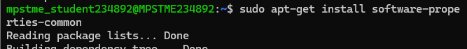

**Step 6: Run sudo apt-add-repository ppa:ansible/ansible to install repository**



**Step 7: Run sudo apt update again to update the repository**

**Step 8: Run sudo apt-get install ansible**

**Step 9: Run ansible --version**

* **Creating Remote Servers Using Docker and installing SSH**

**Install docker, from docker hub pull the image**

**Step 1: Pull Docker image of ubuntu from docker hub and run**

**docker pull ubuntu –on cmd**

1. **In Docker Desktop, you should be able to see the image of Ubuntu**

1. **Now spin up the container:**

**Code: docker run -it --name abc --hostname managed-node -p 2222:22 ubuntu bash**



1. **You should be able to see the container running in Docker Desktop**

1. **Now we’ve entered the bash (CMD) of the container. Now install SSH and Python3 on the container using this bash: apt update**

**apt install -y openssh-server python3**

1. **Now start SSH on the container**

**Code: service ssh start**



1. **Now setup password for SSH on the container**

1. **Now we install vim or vi on the container’s bash**

**apt update**

**apt install -y vim**

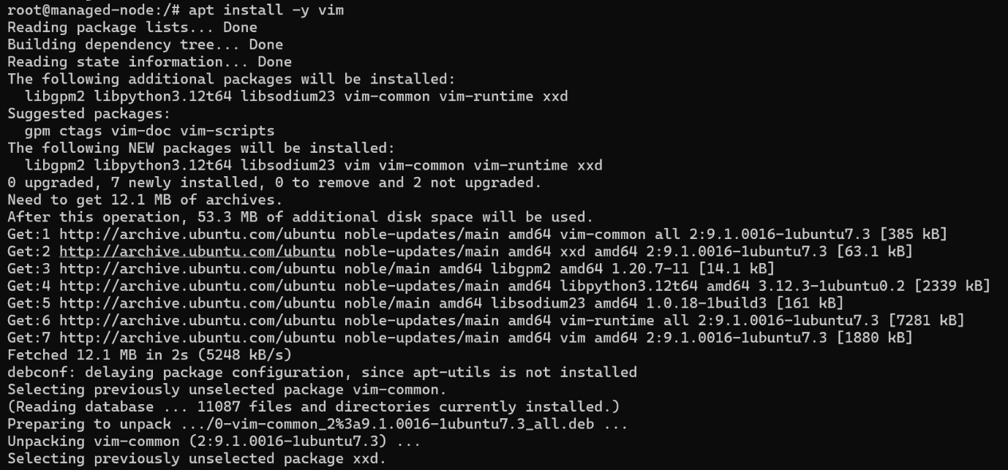

1. **Edit this file and save using :wq**

**Code: vim /etc/ssh/sshd_config**

**Change permission root login to yes**

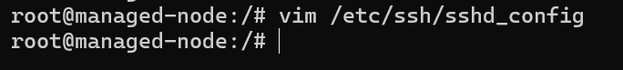

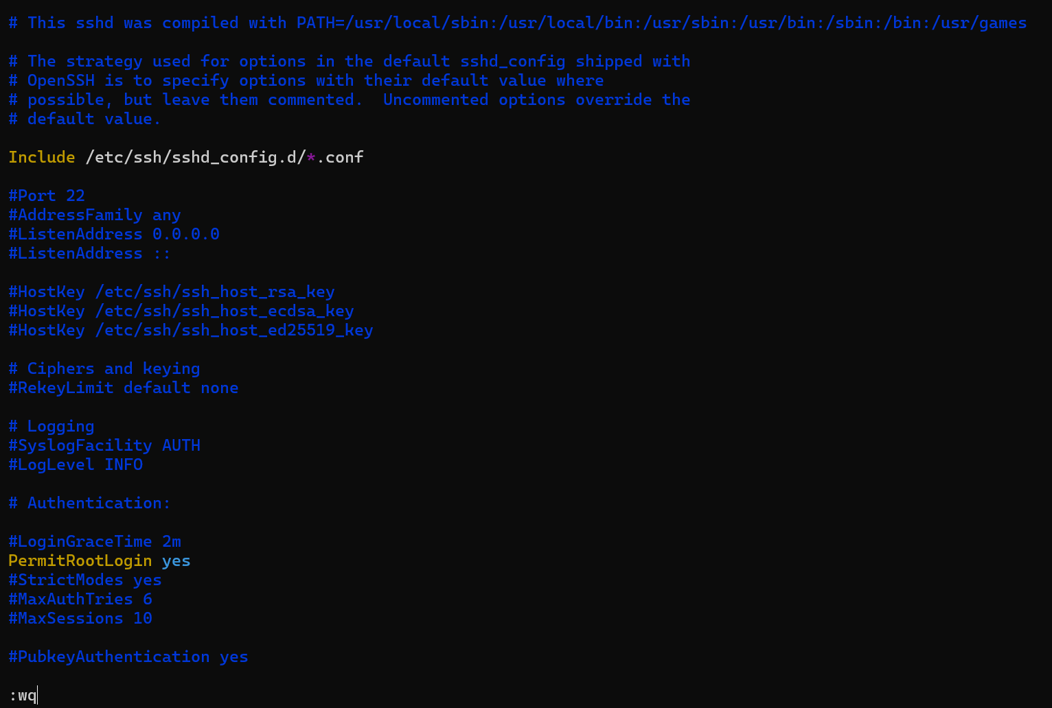

1. **Restart SSH on the container**

**Code: service ssh restart**



1. **On create SSH public key on WSL Ubuntu machine**

**Ssh-keygen -t rsa**

**In ubunto**

**Code: ssh-copy-id -p 2222 root@localhost**

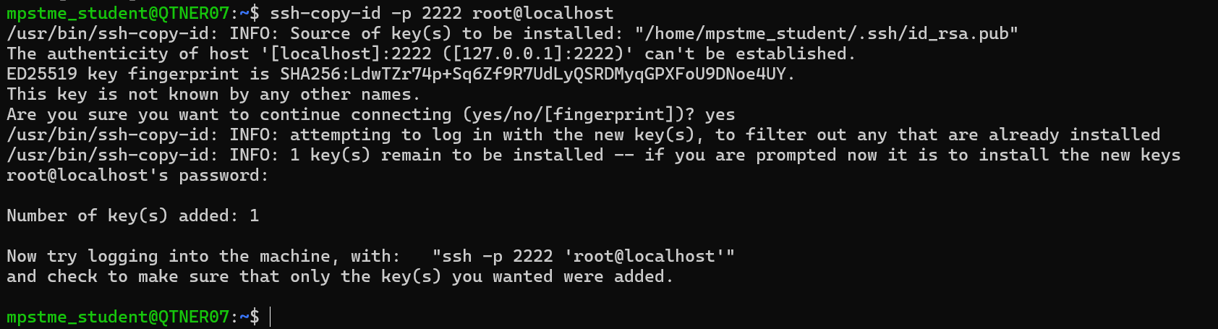

1. **Now add the manage nodes(docker codes) to the container**

**Code: sudo vi/etc/ansible/hosts**



1. **Open the hosts file and below the comments section add the two lines:**

**[managed_nodes]**

**managed-node ansible_host=localhost ansible_port=2222 ansible_user=root**

**:wq to save and exit**

1. **Test your connections**

**Command: ansible all -m ping**

* **Creating Playbooks**

**Step 1: Run mkdir playbooks, to create a new directory to store your playbooks**

**Step 2: Next run ls to verify**

**Code:ls**



**Step 3: Go inside the playbooks folder, run cd playbooks:**

**Cd playbooks**



**Step 4:Create your playbook using command:**

**Code:** **vi first_pb.yml**



**Step 5:Open vi editor and write your content**

* **Press “i” to start writing**

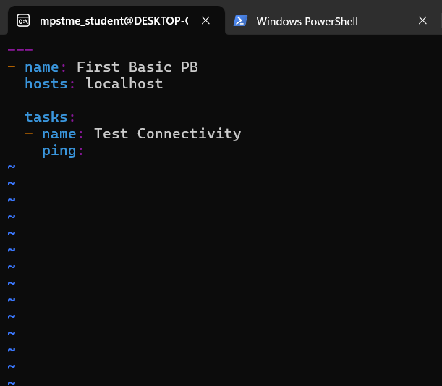

**Code:**

**---**

**- name: First Basic PB**

**hosts: localhost**

**tasks:**

**- name: Test Connectivity**

**ping:**

**To exit, press ESC and write :wq in the editor you will go back to your command shell**

**To see your file again, run**



**Step 6: To run your playbook, run command**

**Code: ansible-playbook first_pb.yml**

**Practice Tasks:**

**Task 1: Test Connectivity with localhost and printing a hello world**

**Vi File:**

---

- name: First Basic PB

hosts: localhost

tasks:

- name: Test Connectivity

ping:

- name: Print Output

debug: msg="Hello World"

**Running the task:**

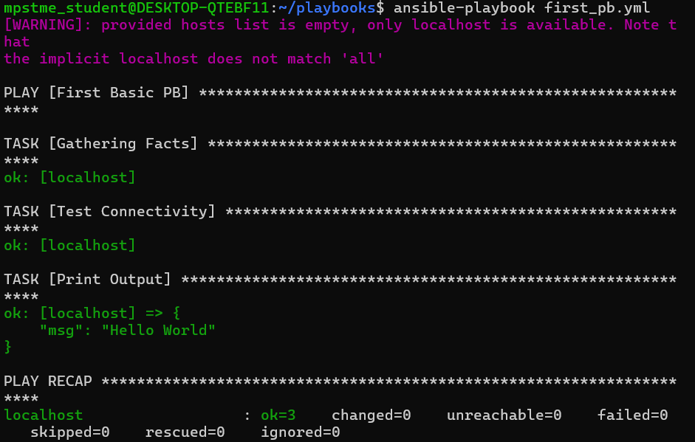

Task 2: Installing a package on localhost

**Create a new playbook:**



**Check if nginx Is installed successfully (TASK 1):**



**TASK 2: If nginx service is running successfully:**

**systemctl status nginx.service**

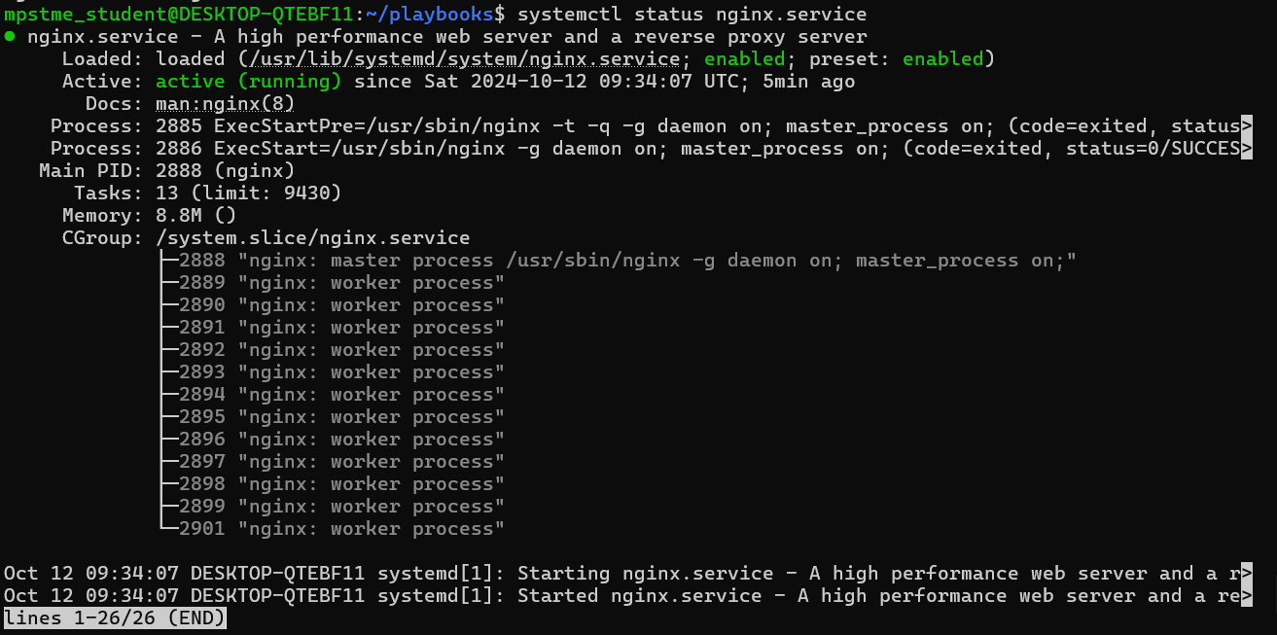

**Errors:**

**1.**

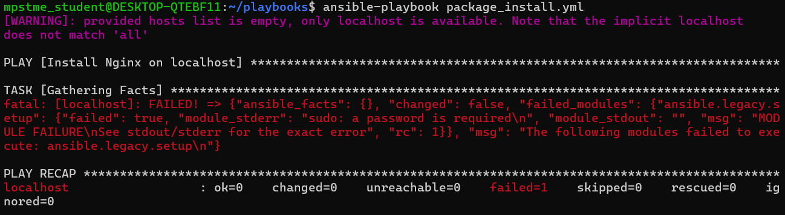

**Resolution: use –ask-become-pass with the run command**

Creating a Playbook to run tasks on remote server

---

- name: Simple playbook to manage the node

hosts: managed_nodes

become: yes # Escalate privilege to root

tasks:

- name: Ping the node

ansible.builtin.ping:

- name: Install nginx web server

ansible.builtin.apt:

name: nginx

state: present

update_cache: yes

- name: Start nginx service using command module

ansible.builtin.command:

cmd: /usr/sbin/nginx # Run nginx in the foreground

creates: /var/run/nginx.pid # Only run if nginx is not already running

- name: Create a test file

ansible.builtin.file:

path: /tmp/test_file.txt

state: touch

owner: root

group: root

mode: '0644'

Run the file:



**For Apache:**

**Playbook:**

---

- name: Install and ensure Apache is running

hosts: localhost

become: yes # Run tasks as sudo

tasks:

- name: Update the package repository

apt:

update_cache: yes

- name: Install Apache

apt:

name: apache2

state: present

- name: Ensure Apache service is started and enabled

service:

name: apache2

state: started

enabled: yes



