**GIT/GITHUB AND STREAMLIT**

1. **Installation**

**On Cmd: pip install streamlit**

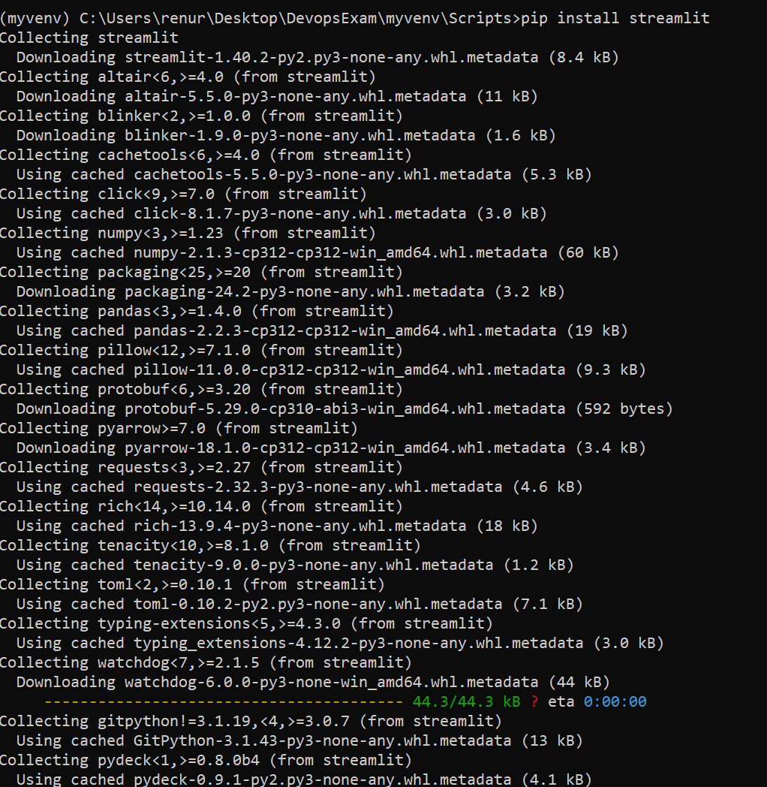

**Check if installed:**

**On Cmd: streamlit hello**

**On Cmd you shld se:**

Creating a venv in python : python -m venv myvenv

cd myvenv

cd Scripts

activate

Create a app.py in myvenv file

Code:

import streamlit as st

import pandas as pd

import numpy as np

st.title('Hello App!')

st.write(pd.DataFrame({

    'first column': [1, 2, 3, 4],

    'second column': [10, 20, 30, 40]

}))

df = pd.DataFrame({'Name': ['ALEX', 'MAX', 'Devin'], 'City': ['NEW YORK', 'TEXAS', 'CAMBRIDGE']})

st.table(df)

chart_data = pd.DataFrame(

     np.random.randn(20, 3),

     columns=['a', 'b', 'c'])

st.line_chart(chart_data)

Streamlit run app.py

Create a .env file in the project:

On cmd type : pip install python-dotenv

Create a new .gitignore in the project

Code :

#.gitignore

# Ignore the virtual environment folder

myenv/

env/

# Ignore Python cache files

_pycache_/

*.py[cod]

*.pyo

# Ignore system files

.DS_Store

Thumbs.db

# Ignore IDE/editor-specific files

.vscode/

.idea/

*.sublime-workspace

*.sublime-project

# Ignore logs and temporary files

*.log

*.tmp

# Ignore configuration files and secrets

.env

# Ignore Jupyter Notebook checkpoints (if applicable)

.ipynb_checkpoints/

# Ignore compiled Python files

*.pyc

Come out of the project

Code : Cd ..

Initiate git init

Shift this files out of the project file

Git add: git add .

Git status

Create a new repo in the github

git remote add origin https://github.com/yoda-code/Streamlit_devops.git



Check the version:

Code: git remote -v

Verify the branch

Code: git branch

**During pushing, Git might throw a Permissions Denied Error**

**git push -u origin master**



**Run: git credential-manager clear**

**Again :- git push -u origin master**

**Go To Control Panel>User Accounts>User Accounts>Manage Credentials**

**Remove your GitHub credentials**

**git push -u origin master**

**DEPLOYING YOUR APP ON STREAMLIT CLOUD**

1. **Go to Stramlit Community Cloud-> Login using GitHub**

**Deploy Your Streamlit App on Streamlit Cloud:**

