**Q2. Kubernetes**

1. Open cmd🡪run as administrator🡪ensure minikube,Kubernetes and docker desktop is installed
2. Start minikube using docker driver, command: **minikube start --driver=docker**

1. Run command: **docker ps** to verify that minikube has startedA computer code on a black background

   Description automatically generated
2. Run command: **minikube status**

1. Run command: **kubectl create deployment myy-nginx --image=nginx:latest** to pull the nginx image from docker hub

1. Run: **kubectl get deployments**

1. Run: **kubectl get pods**

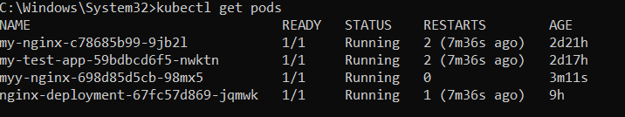

1. Expose these pods to minikube:

Command: **kubectl expose deployment my-nginx --port=80 --type=LoadBalancer**

1. Run: **kubectl get services**

1. Run: **minikube service myy-nginx**

1. **Output:**

1. For creating 2 replicas, run: **kubectl scale deployment my-test-app --replicas=3**

1. To scale it to 5 replicas, run: **kubectl scale deployment my-test-app --replicas=5**

1. **To verify, run: kubectl get pods**

