**GIT/GITHUB AND STREAMLIT**

1. **Installation**

**On Cmd: pip install streamlit**

1. **Check if installed:**

1. **On Cmd you shld se:**

1. **Streamlit Hello Page**

1. **Cmd to install venv: python -m venv myenv**



1. **Navigate to scripts: cd scripts**



1. **Check the directory**

**Command: dir**

1. **Activate the streamlit environment:**

**Command: activate**



1. **Run: activate**

1. **To verify, Run: streamlit hello**

1. **Go to VS code, Open folder which contains myenv**

1. **Create a new file app.py in the folder**

1. **Go to https://docs.streamlit.io/**

1. **Go to** [**https://docs.streamlit.io/get-started/tutorials/create-an-app**](https://docs.streamlit.io/get-started/tutorials/create-an-app)
2. **Create a title Page in Streamlit**

import streamlit as st

import pandas as pd

import numpy as np

st.title('Uber pickups in NYC')

1. **Go to cmd: streamlit run app.pyA screenshot of a computer

   Description automatically generated**
2. **Output**

1. **Using Magic Commands:**

import streamlit as st

import pandas as pd

st.write("Here's our first attempt at using data to create a table:")

st.write(pd.DataFrame({

    'first column': [1, 2, 3, 4],

    'second column': [10, 20, 30, 40]

}))

1. **Refresh/Rerun**

1. **Creating Plots Using magic commands**

import streamlit as st

import numpy as np

import pandas as pd

chart_data = pd.DataFrame(

     np.random.randn(20, 3),

     columns=['a', 'b', 'c'])

st.line_chart(chart_data)

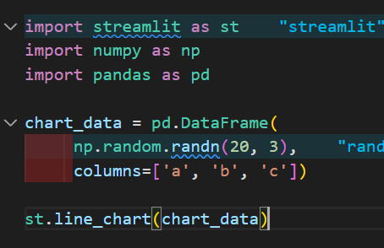

1. **Refresh/Rerun**

1. **Creating a Table Using Magic commands**

import streamlit as st

import numpy as np

import pandas as pd

dataframe = pd.DataFrame(

    np.random.randn(10, 20),

    columns=('col %d' % i for i in range(20)))

st.table(dataframe)

1. **Refresh/Rerun**

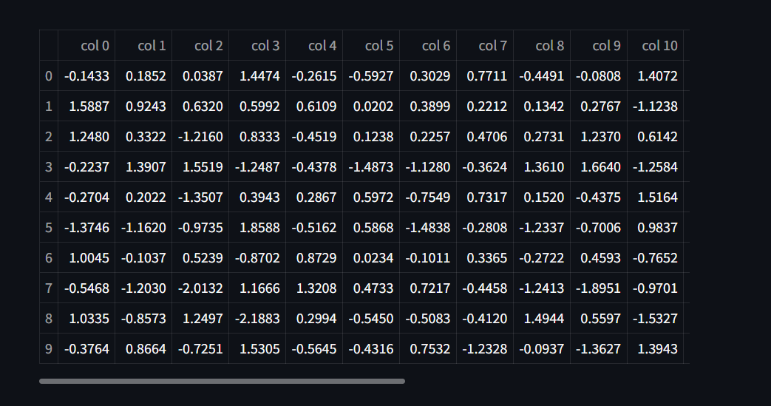

1. **Making a Text Input:**

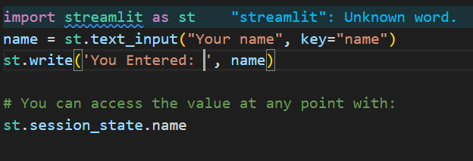

1. **Rerun/Refresh**

1. **Create a .evn file in your environment**

1. **On Cmd, run: pip install python-dotenv**

**Pushing Your Code to GitHub:**

1. **Create a .gitignore file**

1. **Contents of .gitignore file:**

#.gitignore

# Ignore the virtual environment folder

myenv/

env/

# Ignore Python cache files

_pycache_/

*.py[cod]

*.pyo

# Ignore system files

.DS_Store

Thumbs.db

# Ignore IDE/editor-specific files

.vscode/

.idea/

*.sublime-workspace

*.sublime-project

# Ignore logs and temporary files

*.log

*.tmp

# Ignore configuration files and secrets

.env

# Ignore Jupyter Notebook checkpoints (if applicable)

.ipynb_checkpoints/

# Ignore compiled Python files

*.pyc

1. **Initialize a repository:**
2. **Initialize a repository, Command: git init**

1. **Move the app.py,.gitignore,.env file outside the myenv folder**

1. **Git add, command: git add .**



1. **Check status: git status**

1. **Create a New Git Hub repo**

1. **Connect your repository: git remote add origin https://github.com/dakshita-thakkar/streamlit-github.git**



1. **Verify: git remote -v**



1. **Verify the branch, Command: git branch**



1. **During pushing, Git might throw a Permissions Denied Error**

**git push -u origin master**



**Run: git credential-manager clear**

**Go To Control Panel>User Accounts>User Accounts>Manage Credentials**

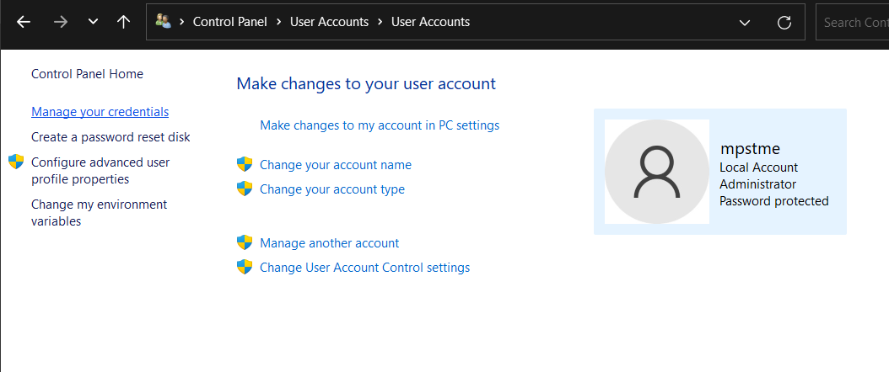

**Remove your GitHub credentials**

1. **Push your files again: git push -u origin master**

**DEPLOYING YOUR APP ON STREAMLIT CLOUD**

1. **Go to Stramlit Community Cloud-> Login using GitHub**

1. **Deploy App**

**Deploy Your Streamlit App on Streamlit Cloud:**

