**KUBERNETES**

* **Installation**

1. **First Install Chocolatey in Your Pc in Windows PowerShell-Run as Administrator**

**Command: Set-ExecutionPolicy Bypass -Scope Process -Force; [System.Net.ServicePointManager]::SecurityProtocol = [System.Net.ServicePointManager]::SecurityProtocol -bor 3072; iex ((New-Object System.Net.WebClient).DownloadString('https://community.chocolatey.org/install.ps1'))**

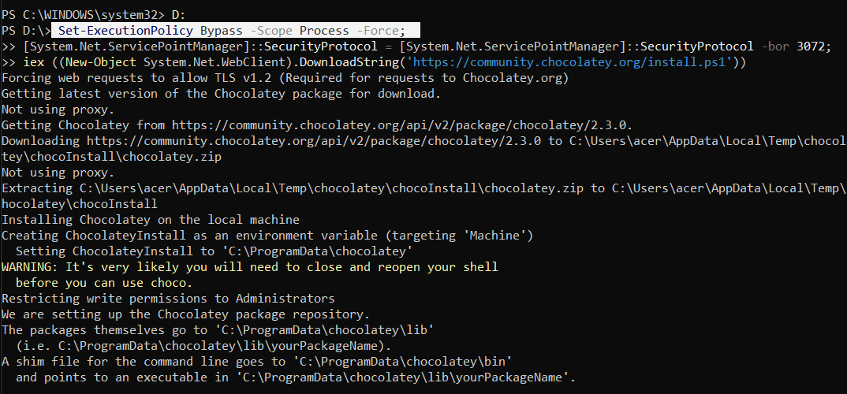

1. **Open CMD- Run as administrator and install kubectl. Run all the following commands on CMD**

**Command: choco install kubernetes-cli**

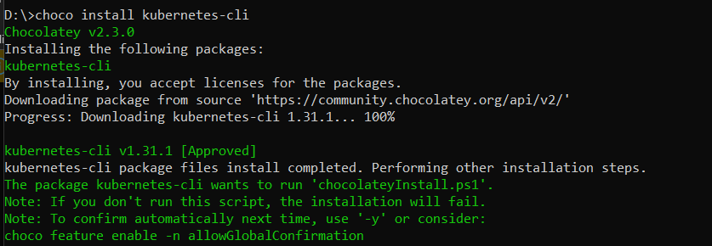

1. **Confirm if kubectl is installed:**

**Command: kubectl version –-client**

1. **Run cd %USERPROFILE%**



1. **Run mkdir .kube**



1. **Now go to D drive and to .kube folder. Inside the .kube folder create a Text file and name it config.txt**



1. **Next install Minikube**

**On CMD-Run as administrator:**

**Run command: choco install minikube**

1. **Now make a Kubernetes cluster using command**

**minikube start --driver=docker (ensure system has docker else install docker desktop)**

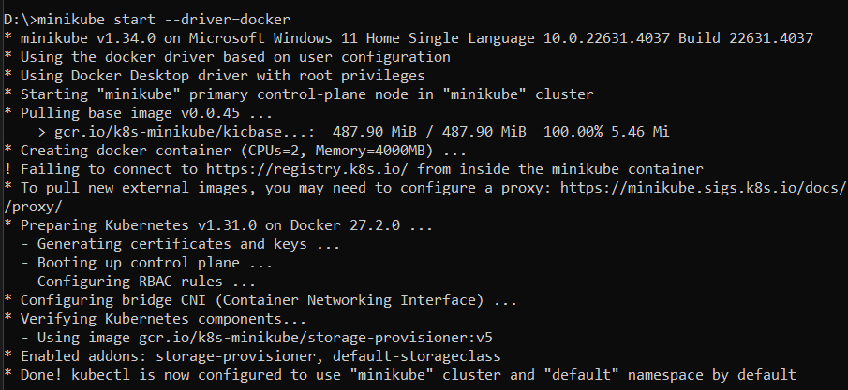

1. **Run command docker ps to verify if your containers are up**



1. **Run minikube status to verify**

1. **Running a pre-existing application (example nginx) on Kubernetes**

* **Go to Docker hub-search nginx**
* **On CMD run command: kubectl create deployment my-nginx --image=nginx:latest**



* **Check if my-ngnix was create: run kubectl get deployments**

* **Check If pod was created: run kubectl get pods**

* **Expose the pod to minikube:**

**Command: kubectl expose deployment my-nginx --port=80 --type=LoadBalancer**



* **Check if your service is exposed**

**Command: kubectl get services**

* **Link your service with minikube**

**Command: minikube service my-nginx**

In case of errors run following command and restart:

**To delete the existing pods and container:**

**minikube delete**

**Run this and repeat everything here(follow everything above):**

**minikube start --driver=docker**

* **RUNNING A CUSTOM APPLICATION IN KUBERNETES**

1. Open VS Code
2. In VS code Terminal run to check if node is installed

1. Create a new react app

1. Run the project

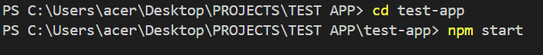

1. Make changes to App.js file

1. npm-start

1. Now delete node_modules
2. Right click on your project and create a new file-name it Dockerfile





1. Inside the docker file write:

FROM node:20

WORKDIR /myapp

COPY . .

RUN npm install

CMD ["npm" , "start"]

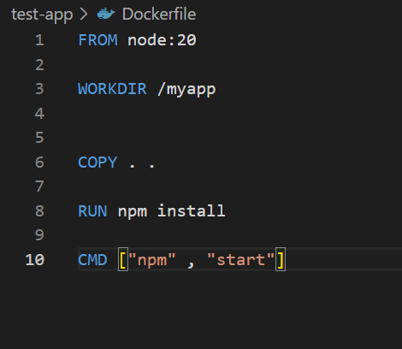

1. Now we want to create an image of this app

For this go to docker.com, sign up, and go to docker hub, create repository

Click on create

1. In VS Terminal run:

docker build -t dakshitathakkar/my-nginx:01 .

1. On VS code terminal run to verify:

docker iamges

1. Next Login to docker, On VS code terminal run:

docker login

1. Now push your image to repository, On VS code terminal run:

docker push dakshitathakkar/my-nginx:01

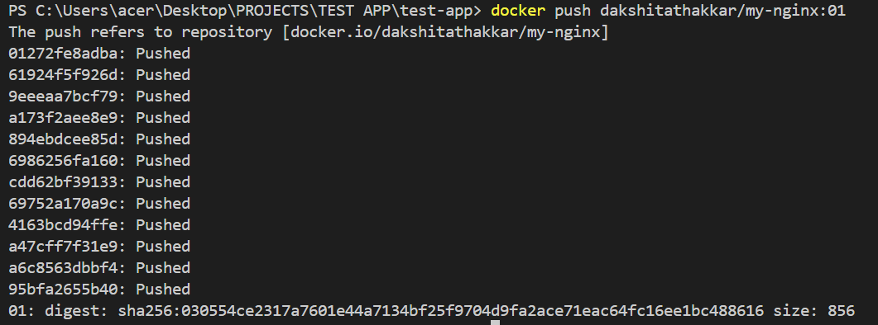

1. Refresh dockerhub- you should see your image

1. Go to CMD run minikube status

1. Create a deployment



1. Check if deployment created:

1. Check if pod is running:

1. Expose it to minikube



* **SCALING ON KUBERNETES (INCREASE OR DECREASE THE NUMBER OF PODS)**

1. **Scaling Up:**

**Command: kubectl scale deployment my-test-app --replicas=3**

**To verify, run: kubectl get pods**

1. **Scaling down:**

**Command: kubectl scale deployment my-test-app --replicas=3**

**To verify, run: kubectl get pods**

