



Token: Top of Form

**sqp_77b6c2d2aaad4fd28c00a36943917d66f668703c**

pipeline {

agent any // Use any available agent

stages {

stage('Create Python File') {

steps {

script {

// Write the Python code to hellllo.py

writeFile file: 'hello.py', text: '''\

print("hello world")

'''

}

}

}

stage('Run Python Script') {

steps {

echo 'Running Python script...'

// Execute the Python script

sh 'python3 hello.py'

}

}

stage('SonarQube Analysis') {

steps {

script {

// Define the SonarQube properties

def scannerHome = tool 'SonarQube Scanner' // Use the SonarQube Scanner installed in Jenkins

withSonarQubeEnv('SonarQube Server') { // Use the configuration name for your SonarQube server

sh "${scannerHome}/bin/sonar-scanner -Dsonar.projectKey=my-proj -Dsonar.sources=."

}

}

}

}

stage('Quality Gate') {

steps {

script {

// Wait for the quality gate to pass

waitForQualityGate abortPipeline: true

}

}

}

}

post {

always {

// This block runs after all stages, regardless of success or failure

echo 'Pipeline completed'

}

failure {

// Additional actions on failure

echo 'Pipeline failed, check the logs for more information.'

}

}

}

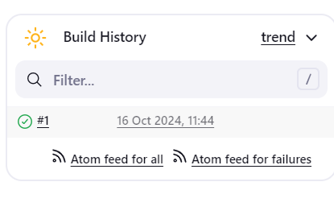

Bottom of Form