**Install Terraform**

1. Go to official site of Terraform by HashiCorp and install for Windows AMD64

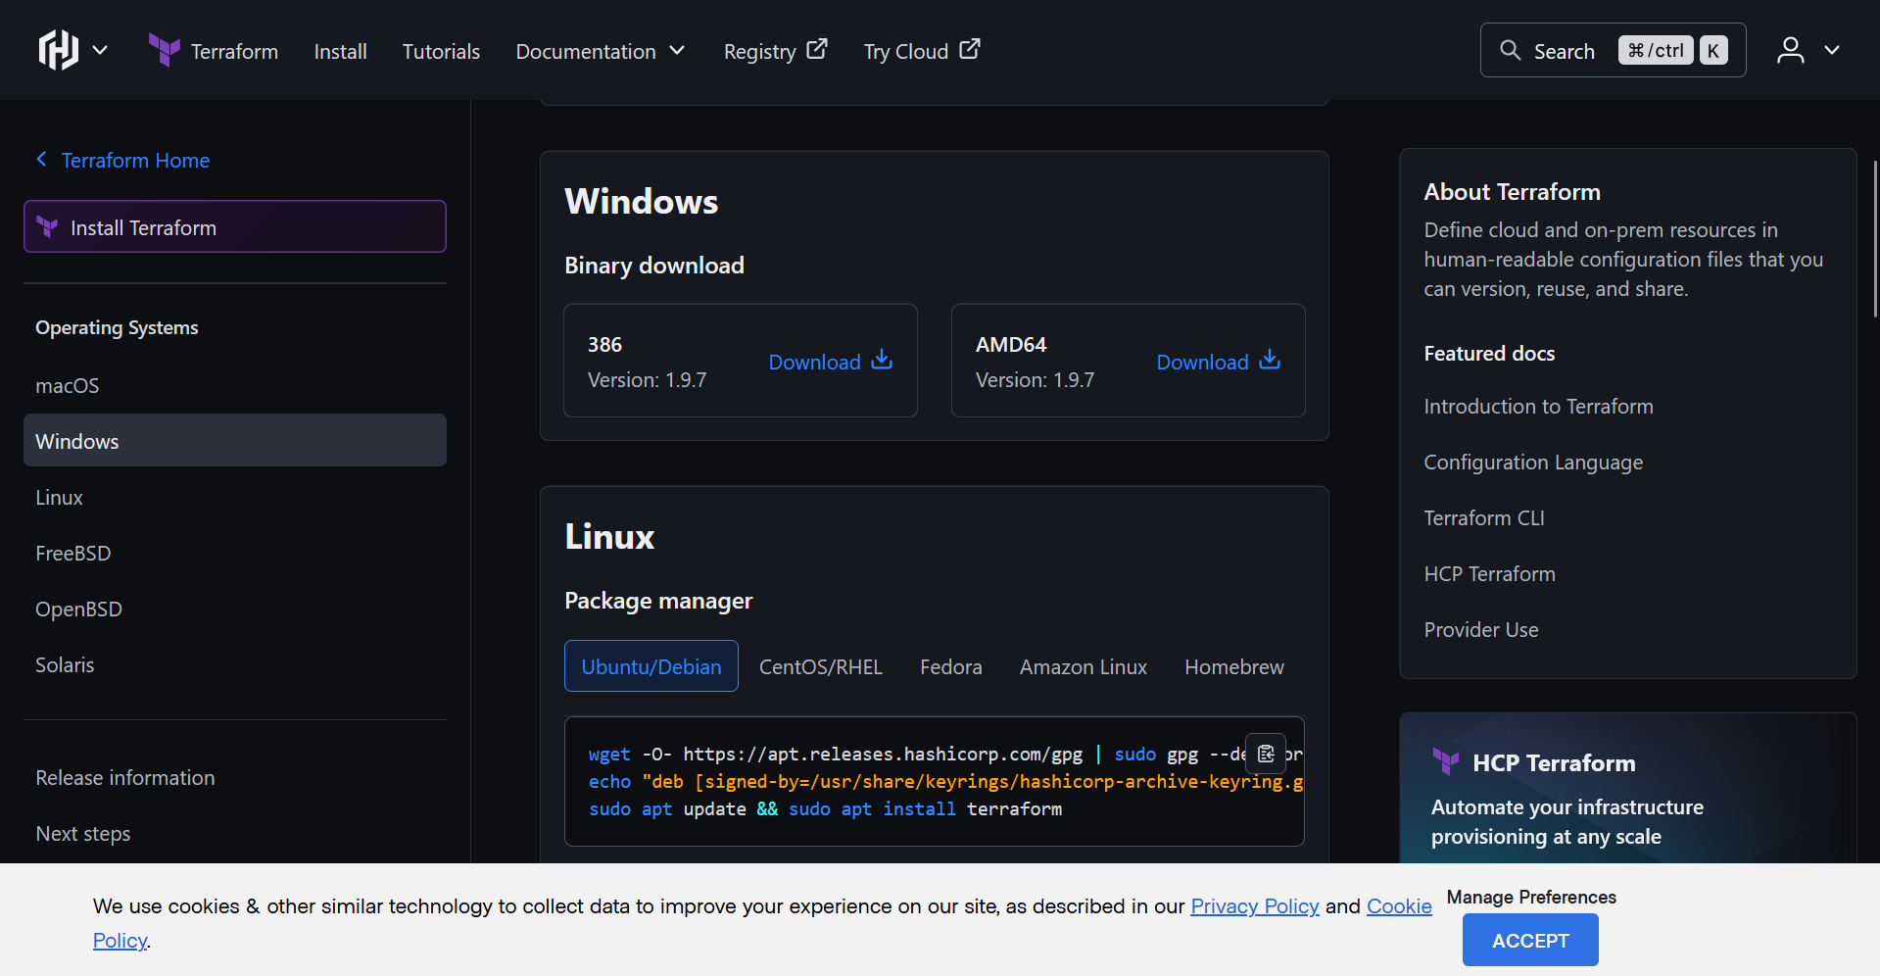

1. After the zip is downloaded, extract and save the folder in location of your choice
2. Copy the path of terraform.exe and add it to path environment variable

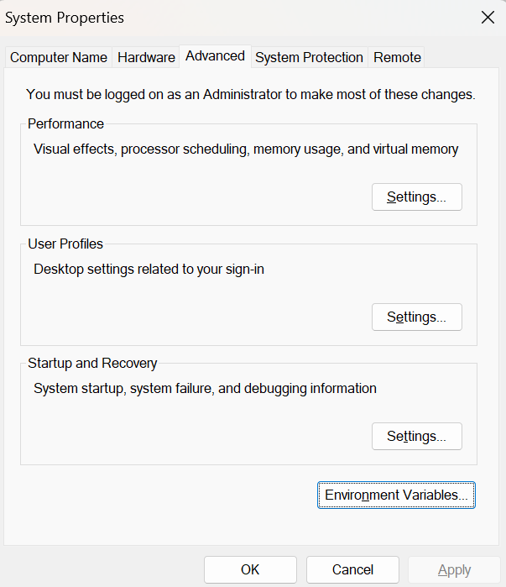

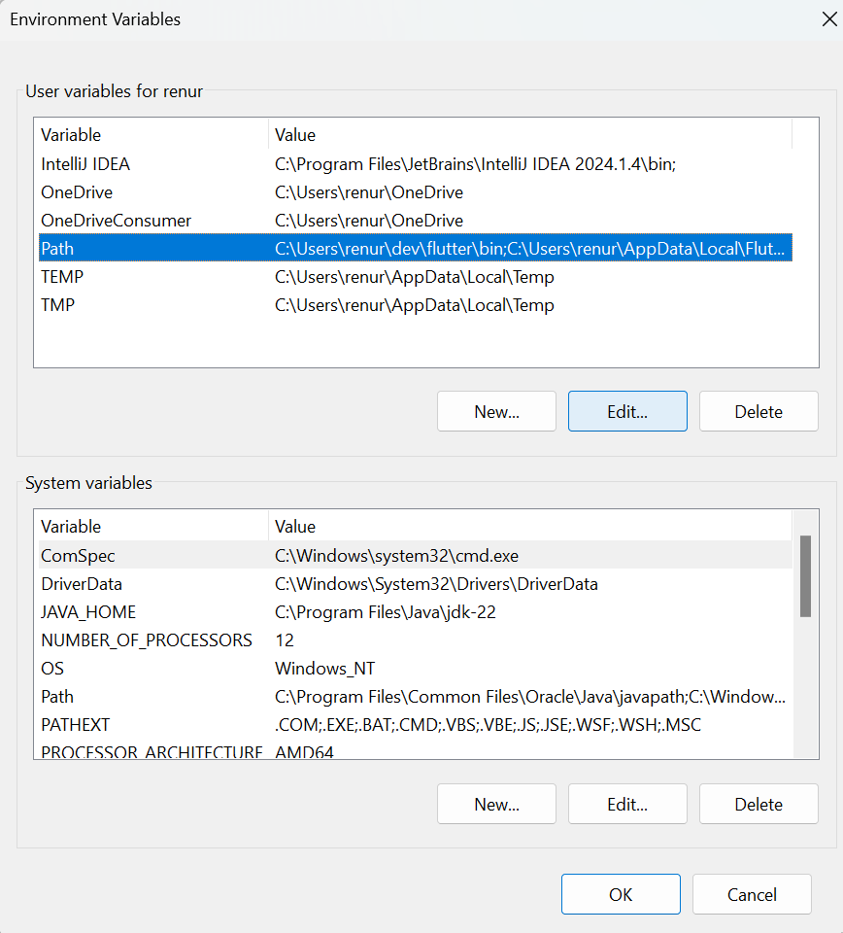

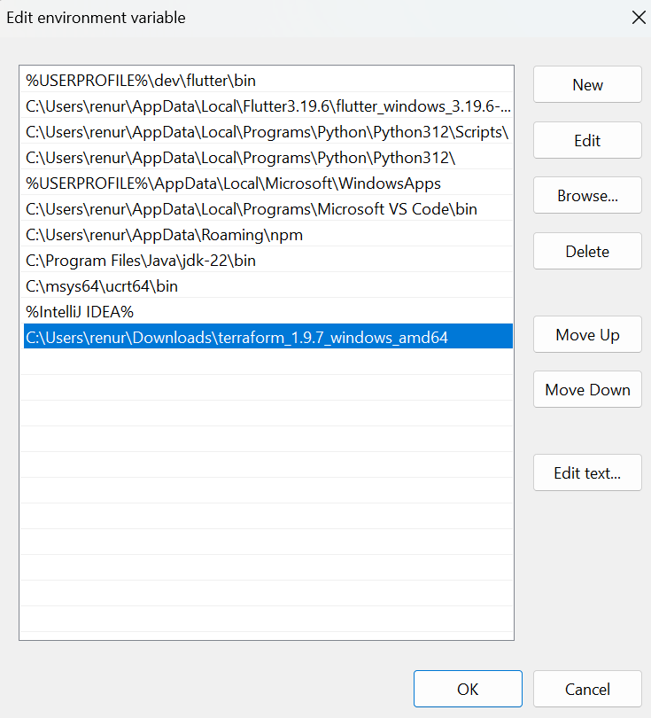

1. Check if terraform is installed

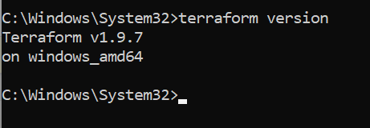

1. Start minikube

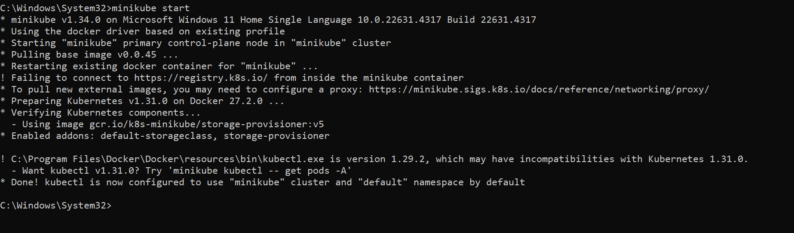

1. Create a folder in Downloads folder called TerraformProject. Create a main.tf file inside it. Copy paste this content inside it:

terraform {

required_providers {

kubernetes = {

source = "hashicorp/kubernetes"

version = "~> 2.0"

}

}

}

provider "kubernetes" {

config_path = "~/.kube/config" # Path to your kubeconfig file (default location)

}

# Basic NGINX Deployment

resource "kubernetes_deployment" "nginx" {

metadata {

name = "nginx-deployment"

}

spec {

replicas = 1 # Deploy 1 replica for simplicity

selector {

match_labels = {

app = "nginx"

}

}

template {

metadata {

labels = {

app = "nginx"

}

}

spec {

container {

name = "nginx"

image = "nginx:latest"

port {

container_port = 80

}

}

}

}

}

}

# Basic Kubernetes Service to Expose NGINX Deployment

resource "kubernetes_service" "nginx" {

metadata {

name = "nginx-service"

}

spec {

selector = {

app = "nginx"

}

port {

port = 80

target_port = 80

}

type = "NodePort" # Simpler than LoadBalancer, exposes a port on each node

}

}

1. Initialize terraform: terraform init

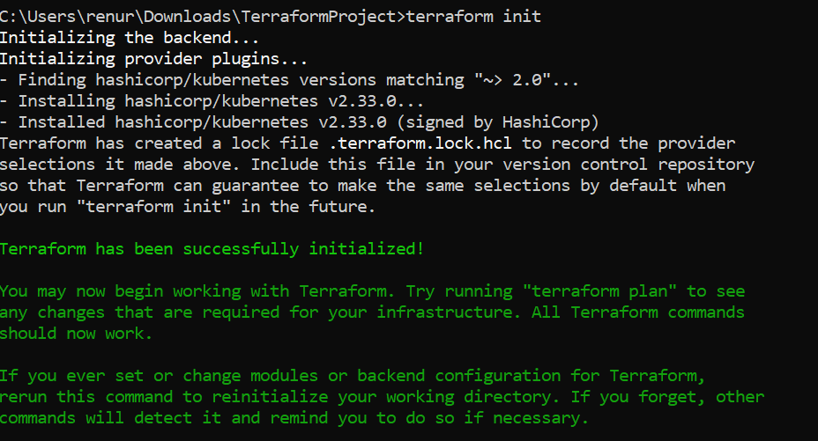

1. Apply the terraform file: terraform apply

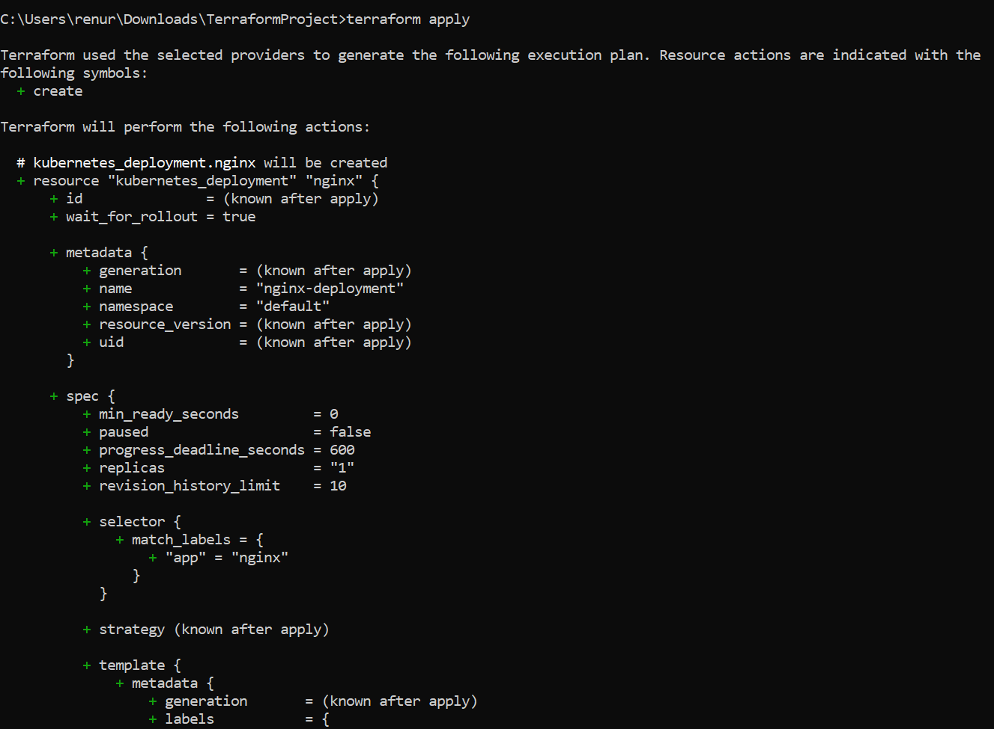

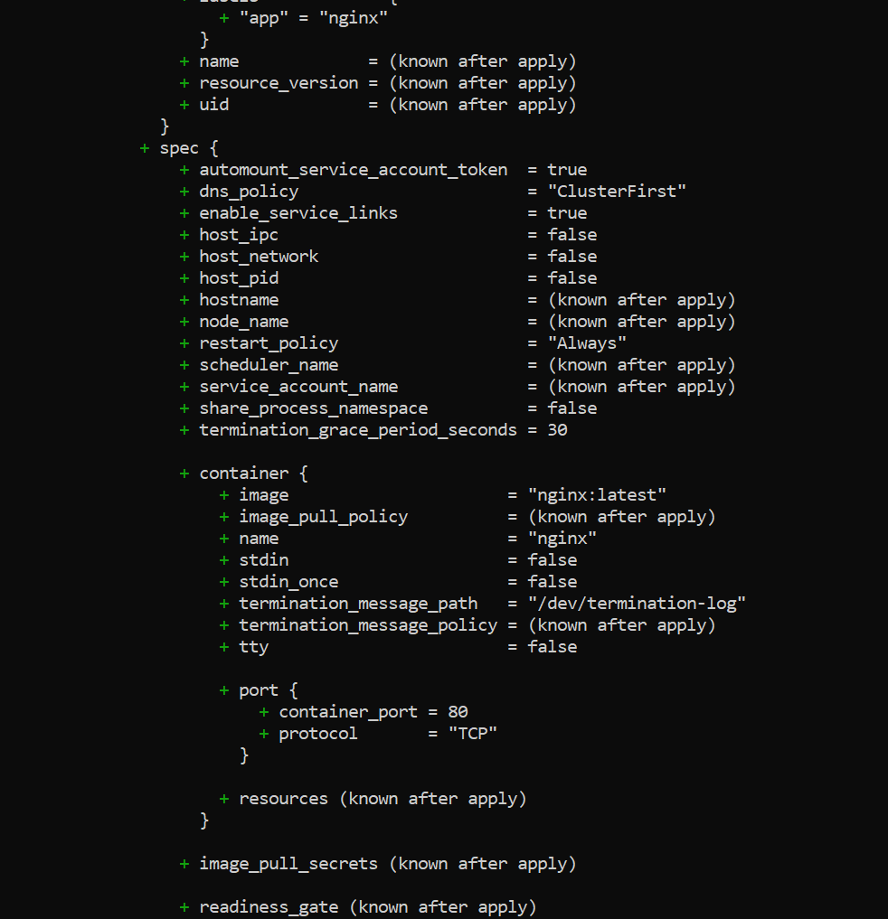

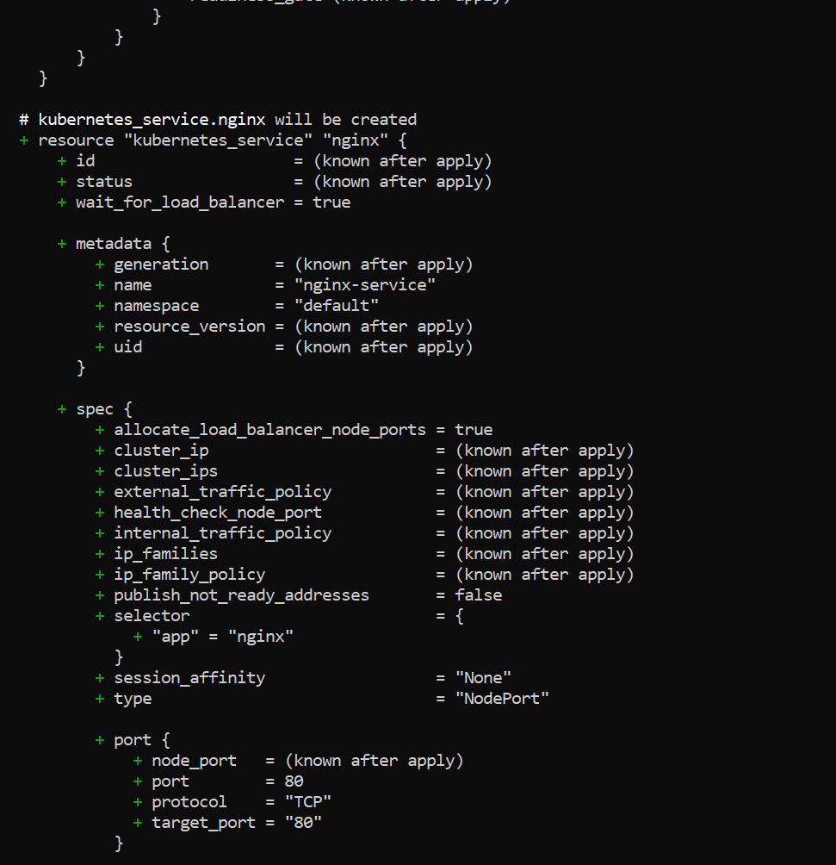

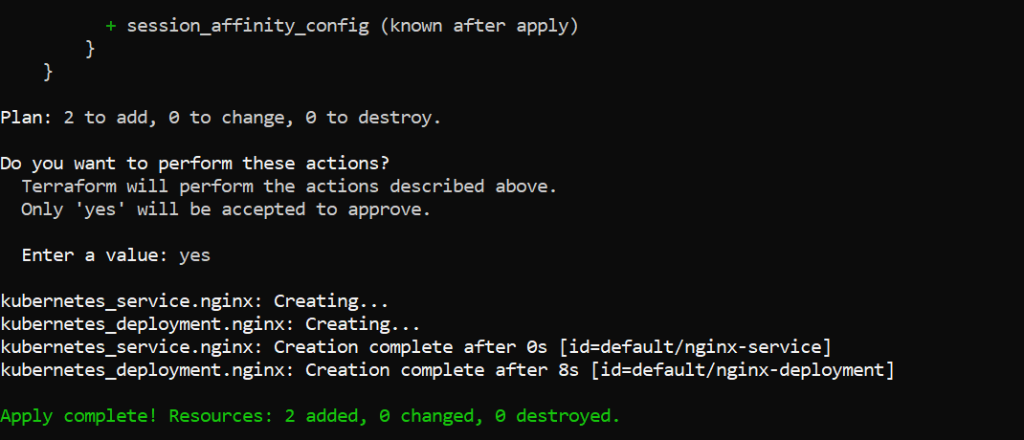

1. Once apply process is over, to access nginx we ca use: minikube service nginx-service

