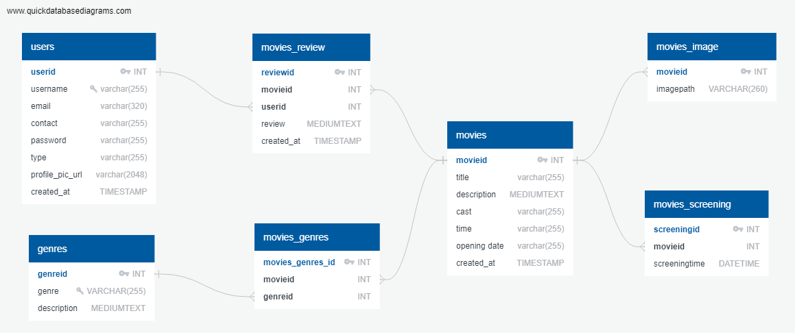

**Table name:** users

**Description:** Stores users and the user’s information

**Table name:** movies_review

**Description:** Stores user revies for movie

**Table name:** movies

**Description:** Stores movies and movie’s information

**Table name:** movies_image

**Description:** Stores path to movies’ image

**Table name:** movies_screening

**Description:** Stores screening times for movies

**Table name:** movies_genres

**Description:** Used to link movies and genres to establish many-to-many relationship

**Table name:** genres

**Description:** Stores genres and genres’ description