Aron Bauer

Nguyen

CIS-18A

5 February 2019

Course Project Pseudocode and Documentation

1. Business Type: School/Education.
2. Company: LearningGeo Inc.
3. main() pseudo code:

Display welcome message

Choose number of shapes to practice

Size calculation tracker and shape types tracker to number of shapes

For (integer i = 0 to number of shapes)

Display main menu

Choose 2-D or 3-D shape

If (2-D shape selected)

Display 2-D shapes menu

Choose shape (case Rectangle, case Parallelogram, case Trapezoid,

case Triangle, case Circle) all cases are same but diff. calc. formula

Enter shape’s required dimensions

Calculate and display shape’s area

Update calculations tracker and shape types tracker

Else (3-D shapes were selected)

Display 3-D shapes menu

Choose shape (case Right Circular Cone, case Pyramid, case

Sphere, case Right Circular Cylinder, case Right Prism) all cases

are same here as well, but diff. calc. formula

Choose whether to calculate volume or surface area

Enter shape’s general dimensions

If (volume selected)

Enter shape’s volume calculation specific dimensions

Calculate and display shape’s volume

Update calculations tracker and shape types tracker

Else (Surface area was selected)

Enter shape’s surface area calculation specific dimensions

Calculate and display shape’s surface area

Update calculations tracker and shape types tracker

Pause program till enter is pressed

For (integer i = 0 to size of calculations tracker)

Display shape types and calculations tracker

Package shapes hierarchy:

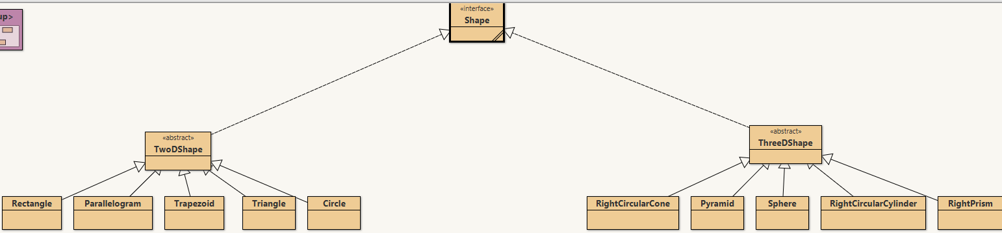

Program default package (GeoShapes class contains main()):

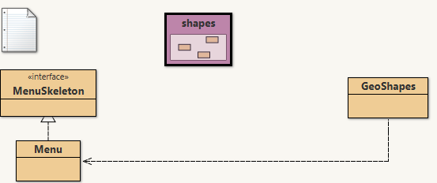

1. Documentation:

This program’s primary target users are those that are currently students in an introduction to geometry class, such as 8th graders or highschool freshman. However, this program can be used by any that may need to refresh on the fundamental calculaions of basic shapes.

This program’s purpose is to assist these intro-to-gemoetry students as they practice calculations of the various formulas for area of the different basic two-dimensional shapes and the formulas for volume and surface area for basic three-dimensional shapes. This program can assist the students in checking their answers on their practice assignments, and can help refresh their memories of the correct formula for each calculation for each shape, as the students are attempting to memorize these formulas--if that is what their course requires.

The buisness function for this program is to help students practice their basic geometry skills by working with basic shapes and basic calculations.

The technical function of this progrma is for it to be a java program, in which the user is prompted menu questions from an interface outside of main. Those questions involve how many shapes to practice, what type of shape to practice, and what specific shape to practice. The shapes themselves will be contained in a separate package; that package will contain a hierarchy, at the top is another interface named Shape. Branching from the top are two abstract classes, representing two dimsensional and three dimensional shapes. Under each of the two abstract classes are 5 classes, each representing a specific but basic shape. All 2-D shapes will inherit an abstract method from the 2-D shapes abstract class that will be implemented by each shape to calculate its repective area thus, each shape will have different data members and formulas for area. This process is similar with the 5 shape classes under the 3-D abstract class, but there will be two abstract methods implemented for each shape: one to calculate volume and one to calculate surface area, each sharing or using calculation specific data members.

In the main program itself, the user enters how many shapes to practice, to which the program enters a loop using that number as its maximum iteration value, and two arrays are created and sized to that same value; one will hold the calculation values, and the other will holed the shape name and calculation type. The user next chooses whether to practice a 2-D or 3-D shape. The user then chooses one of 5 shapes from either the 2-D or 3-D group; the two seperate groups of shapes are seperarted by a simple control statement, and all subsequent shapes within each control satement are themselves each seperated within their own “case” in a switch-case statement. If the shape selected is 2-D, the user enters the required, shape-specific data and is then shown the area formula along with the calculation using the user-inputted data. Then, the two arrays are updated: one with the name of the shape and calculation type, the other with the calculation value. If the user selected a 3-D shape, the user must further specify whether to calculate volume or or surface area, then enter the required shape-specific but also calculation specific data, which is determined by an inner control statement within that shape’s specific “case”. Once the specified number of shapes practiced has been reached, the program will wait for the user to continue the program. Once continued, using the two arrays, all the shapes and calculation results that the user had practiced since run-time will be displayed. Then the program terminates.