**Department of TPSW**

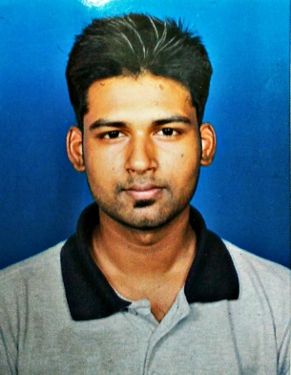

**NIT DURGAPUR**

**TPSW Database: (Final Year) UG students**

***To be filled by Student Write NA & put Tick wherever necessary***

1. Name: **Debapriya Das** 2. a) Roll No: **12/CS/14**

3. Department: **Computer Science Engineering** b) I Card No: **20120092**

4. a) Religion: **Hinduism** 4.b) AIEEE AIR/Year: **78056/2012**

5. OP/SC/ST/OBC/PWD: **SC**  6. Male/Female: **Male**

7. Urban/Rural: **Urban**

8. % Marks obtained (2 decimal places without any rounding) / Year of passing:

i) 10th (Best of …..Subjects, if any): **9.8 CGPA/2010**

ii) 12th (Best of …..Subjects, if any): **70.8%//2012**

9. UG—SGPA: (2 decimal places without any rounding) / Year of passing:

i) 1st Sem: **6.36** ii) 2nd Sem: **6.48** iii) 3rd Sem: **6.13** Iv) 4th Sem: **6.71**

v) 5th Sem : **6.32** vi) 6th Sem : **6.95** vii) 7th Sem : viii) 8th Sem :

10. Scholarship awarded, if any, give details separately:

11. Supplementary in each semester & Active backlog, if any, give details separately: **Yes, 3 Supplementary**

12. Disciplinary proceeding/ Action taken against, if any, give details separately: **None**

13. Address for communication & E-Mail: **at & PO – Talbagicha, Kharagpur – 6**

**West Bengal – 721306**

**yodebu@gmail.com/debapriya.nitd@gmail.com**

14. Contact Phone No: **+91-9614986376**

15. If you are interested in Entrepreneurship then give details separately:

16. Extra-curricular activities, give details separately: **YES**

17. a) Internship after 6th semester : **Yes** b)Name of the Organization : **Dezyre** (<www.dezyre.com>)

c) Duration: **2 months**

**Additional Information**

*Sl. No.-10.* Scholarship awarded, if any, give details :

*Sl. No.- 11.* Supplementary in each semester & Active backlog, if any, give details:

**NO ACTIVE BACKLOG OR SUPPLEMENTARY**

**Engineering Physics – 1st Semester**

**Electrical Engineering – 2nd Semester**

**Digital Logic Design – 3rd Semester**

*Sl. No.- 12.* Disciplinary proceeding / Action taken against, if any, give details:

**NONE**

*Sl. No.- 15.* If you are interested in Entrepreneurship then give details:

*Sl. No.- 16.* Extra-curricular activities, give details:

**Singing**

**Painting**

**Quizzing**

I do hereby declare and certify that the above given information are true and correct.

I shall abide all the Policies/Rules/Decisions of TPSW as framed from time to time.

I will be penalized if I misbehave with any student after the results are declared by any company.

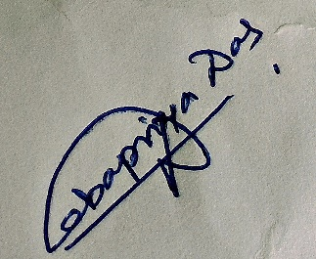

Date: **17-07-2015**  Signature of the Student

**Instructions**:- Fill the form & send mail it to [**biodata2015.2016@gmail.com**](mailto:biodata2015.2016@gmail.com) .

If a form is not received, he/she is not entitled for placement process.