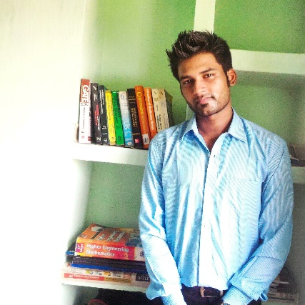CURRICULUM VITAE

3 Dec, 2015

# PERSONAL DETAILS

* **NAME:** Debapriya Das
* **FATHERS NAME :** Mr Tridib Kumar Das
* **CURRENT ADDRESS:** Room - 111, Hall - 4, NIT Durgapur, M G Avenue, Durgapur, West Bengal – 713209
* **PERMANENT ADDRESS:** s/o - Tridib Kumar Das, Talbagicha, Kharagpur, West Bengal – 721306
* MOBILE NO.: +91- 9614986376
* **EMAIL:** yodebu@gmail.com , [debapriya.nitd@gmail.com](mailto:debapriya.nitd@gmail.com)
* **GITHUB :** [github@yodebu](http://www.github.com/yodebu) – [www.github.com/yodebu](http://www.github.com/yodebu)

# RESEARCH SKILLS and EXPERIENCE

* **Worked as a Product – Course Quality Intern at Dezyre (www.dezyre.com), an online education training portal for two months and developed projects and Algorithms in Data Science using Python**
* **Worked as Summer Intern at IIT KHARAGPUR to develop a web interface for a project that takes a Phylogenetic Tree and creates a better tree, using complex genetic algorithms.**
* Dedication towards work and accuracy; Hardworking, Passionate towards my Work.
* *Programming ability in C++, JAVA, Python and C.*
* *Excellent understanding in Algorithms, Data Structures and OOPs.*
* *Excellent understanding in Networking Concepts.*
* *Well versed with Data Science, Analytics and Statistics, Data Mining, Big Data, Machine Learning. Can develop data science algorithms in Python as well as R.*
* *HackerEarth, HackerRank, Codechef and SPOJ practicing for solving problems on Algorithms and Data Structures.*
* *Excellent Understanding of Software Design, Modelling and Testing.*

­­­­­

# EDUCATIONAL QUALIFICATIONS

**Presently studying at NIT DURGAPUR in 7th semester in B. Tech in Computer Science and Engineering of 2016 batch.**

* Studying **B. Tech** in **COMPUTER SCIENCE ENGINEERING** at **NIT DURGAPUR**, batch of **2016**.
* Passed **AISSCE 2012** from KV AFS SALUA, affiliated to CBSE BOARD with 70.8%.
* Passed **AISSE 2010** from KV AFS SALUA, affiliated to CBSE BOARD with 9.8 CGPA.

|  |  |  |  |  |
| --- | --- | --- | --- | --- |
| **SCHOOL/UNIVERSITY**    **NATIONAL INSTITUTE OF**  **TECHNOLOGY, DURGAPUR** | **DEGREE** | **AFFILIATED TO**  **BOARD/UNIVERSITY** | **PERCENTAGE** | **PASSOUT YEAR** |
| B. TECH | NATIONAL  INSTITUTE OF  TECHNOLOGY | 6.49 CGPA (UPTO  6th SEMESTER) | 2016 |
| **KENDRIYA VIDYALAYA, AFS**  **SALUA** | 10+2  AISSCE | CBSE | 70.8% | 2012 |
| **KENDRIYA VIDYALAYA, AFS**  **SALUA** | 10  AISSE | CBSE | 9.8 CGPA | 2010 |

# AWARDS AND HONORS, ACADEMIC ACCOMPLISHMENTS

* Awarded 1st in Inter KV Regional Science Exhibition, Kolkata Region in Quiz and sent for representing National level twice, class 11th and class 12th.
* Awarded 1st in many School level and College level Quizzes.
* Awarded as The Best Five Students of the School consecutively from class 4 to class 11.
* Won prizes for painting and singing in numerous competitions.

# SKILLS AND QUALIFICATIONS TO LOOK OUT!

* **Software Development in C++, JAVA, Python and C using native APIs and Libraries as well as external libraries and Frameworks.**
* **Can operate and troubleshoot any type of OS – Windows or *nix OS.**
* Understanding of Algorithms, Data Structures, OOPs and Networking Concepts.
* Fluency in Microsoft Office, Internet applications and Linux Applications.
* AutoCAD, CORELDRAW and Photoshop fluency for design purposes.
* **Scripting and Automation ability in Bash, Python.**
* **Open Source Contribution on Github – tweaking with open source projects and bug fixing**.
* Data Analysis using Python and Open Source tools available on the Internet.
* ***Web Developer and Web Designer*,** Intermediate HTML, CSS, PHP, JavaScript, JSP/J2EE, Django understanding.
* **Operability and excellent understanding of Database management system, MySQL and Oracle Database.**
* **Tinkering with Linux - AWS – Servers – NodeJS and everything that is new and interesting!**
* Novice Ethical Hacking Skills.
* **Excellent Fluency in English, Hindi and Bengali.**

# CO- CURRICULAR ACTIVITES

* Quizzing is my Passion, loves taking part in Quizzes and is a passionate Quiz Master himself.
* Loves painting and goes for landscape painting in free time.
* Loves singing Classical Music and playing the Harmonium, Tanpura and KeyBoard.
* Loves reading story books.

# POSITIONS OF RESPONSIBILITY

* School Cultural Captain of our School for two consecutive year.

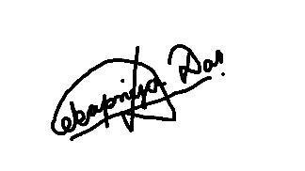

**SIGNA**

**TURE**

## DATED: 03 December, 2015