## Overview

In this activity, you will take your first steps toward becoming a front-end web developer. You will create a folder structure so that you can keep your HTML project organized and code your first website!

Read [Why “Hello, World?](https://en.wikipedia.org/wiki/%22Hello,_World!%22_program)” for background on the popular phrase in programming.

## Instructions

1. Create a folder named 00-MyCode in your document folder of your computer.
   * + Note: Use the same folder structure for all activities to avoid confusion later.
   * We’ll store all repositories and code activities in this folder for easy access, organized simply by the curriculum week. Use the same activity titles convention (i.e., 17.1-02-Hello-World).

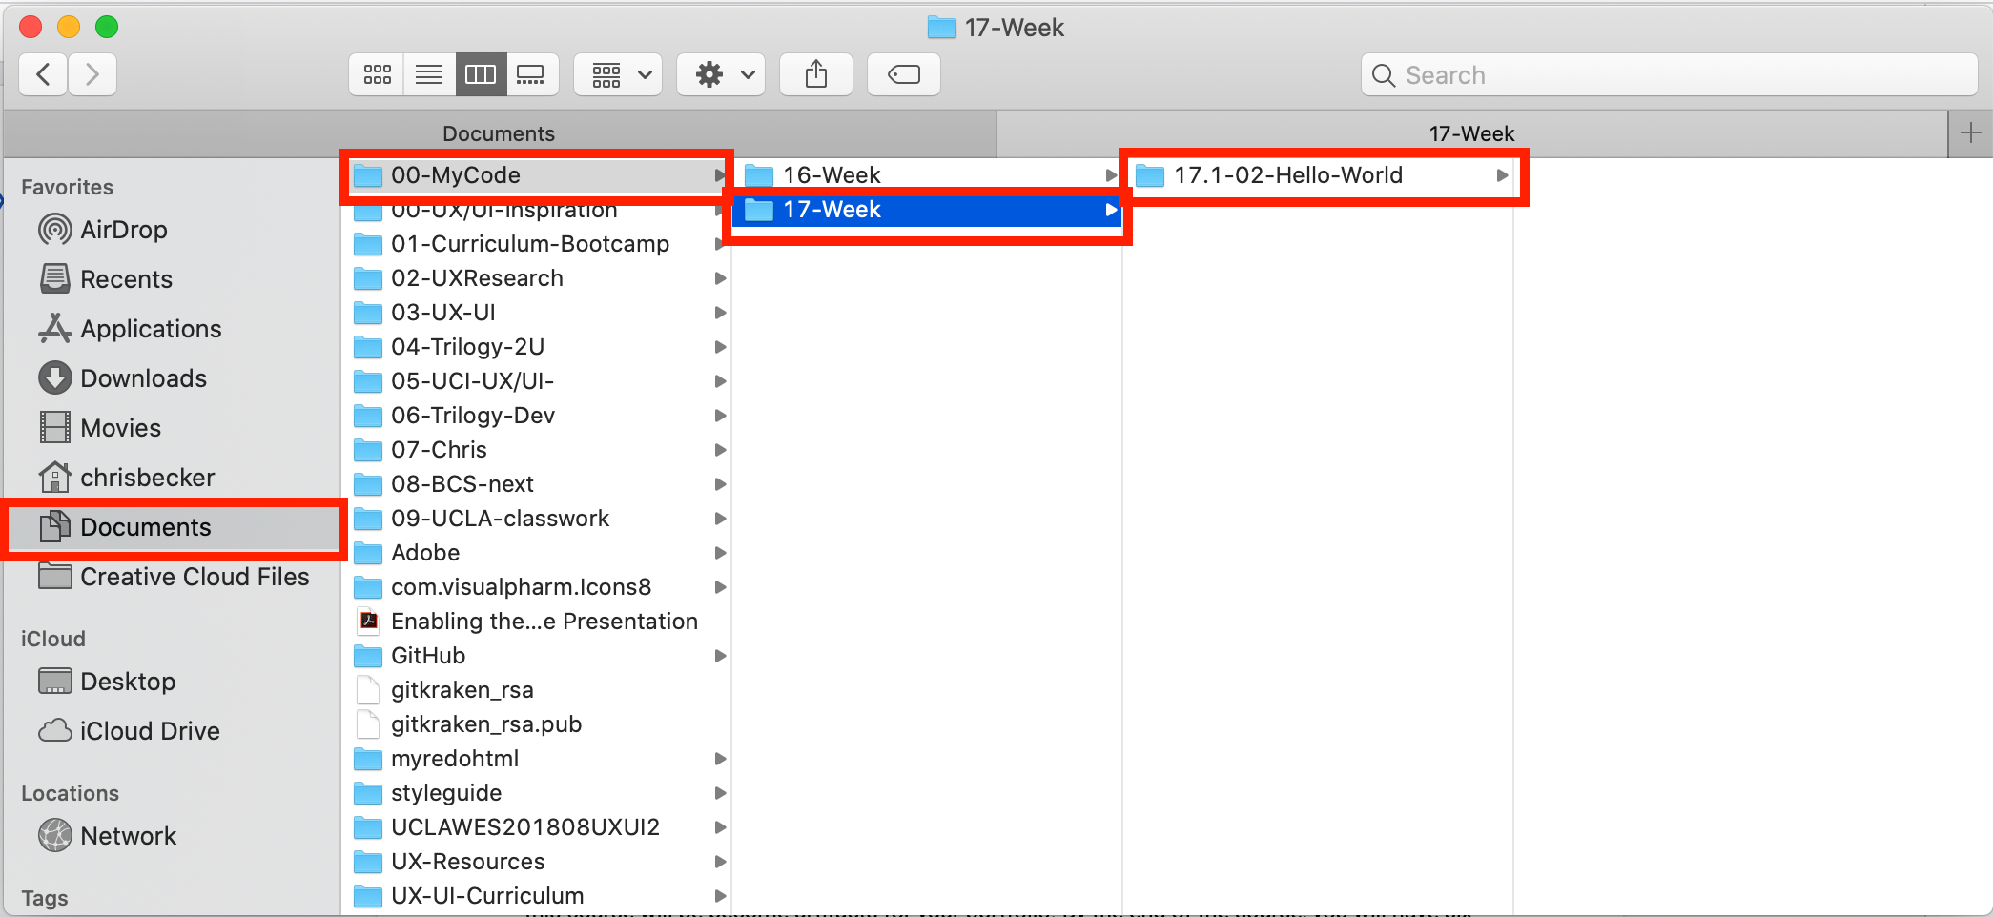

* + **You’ll save all your work during the coding units of the UX/UI Boot Camp within the MyCode folder in week folders to keep it organized.**

1. In Visual Studio Code, select File > Open workspace, and add the 00-MyCode folder you just created. (See illustration below.)
   * Once you’ve completed this step, you will have an organized file system set up for your work.

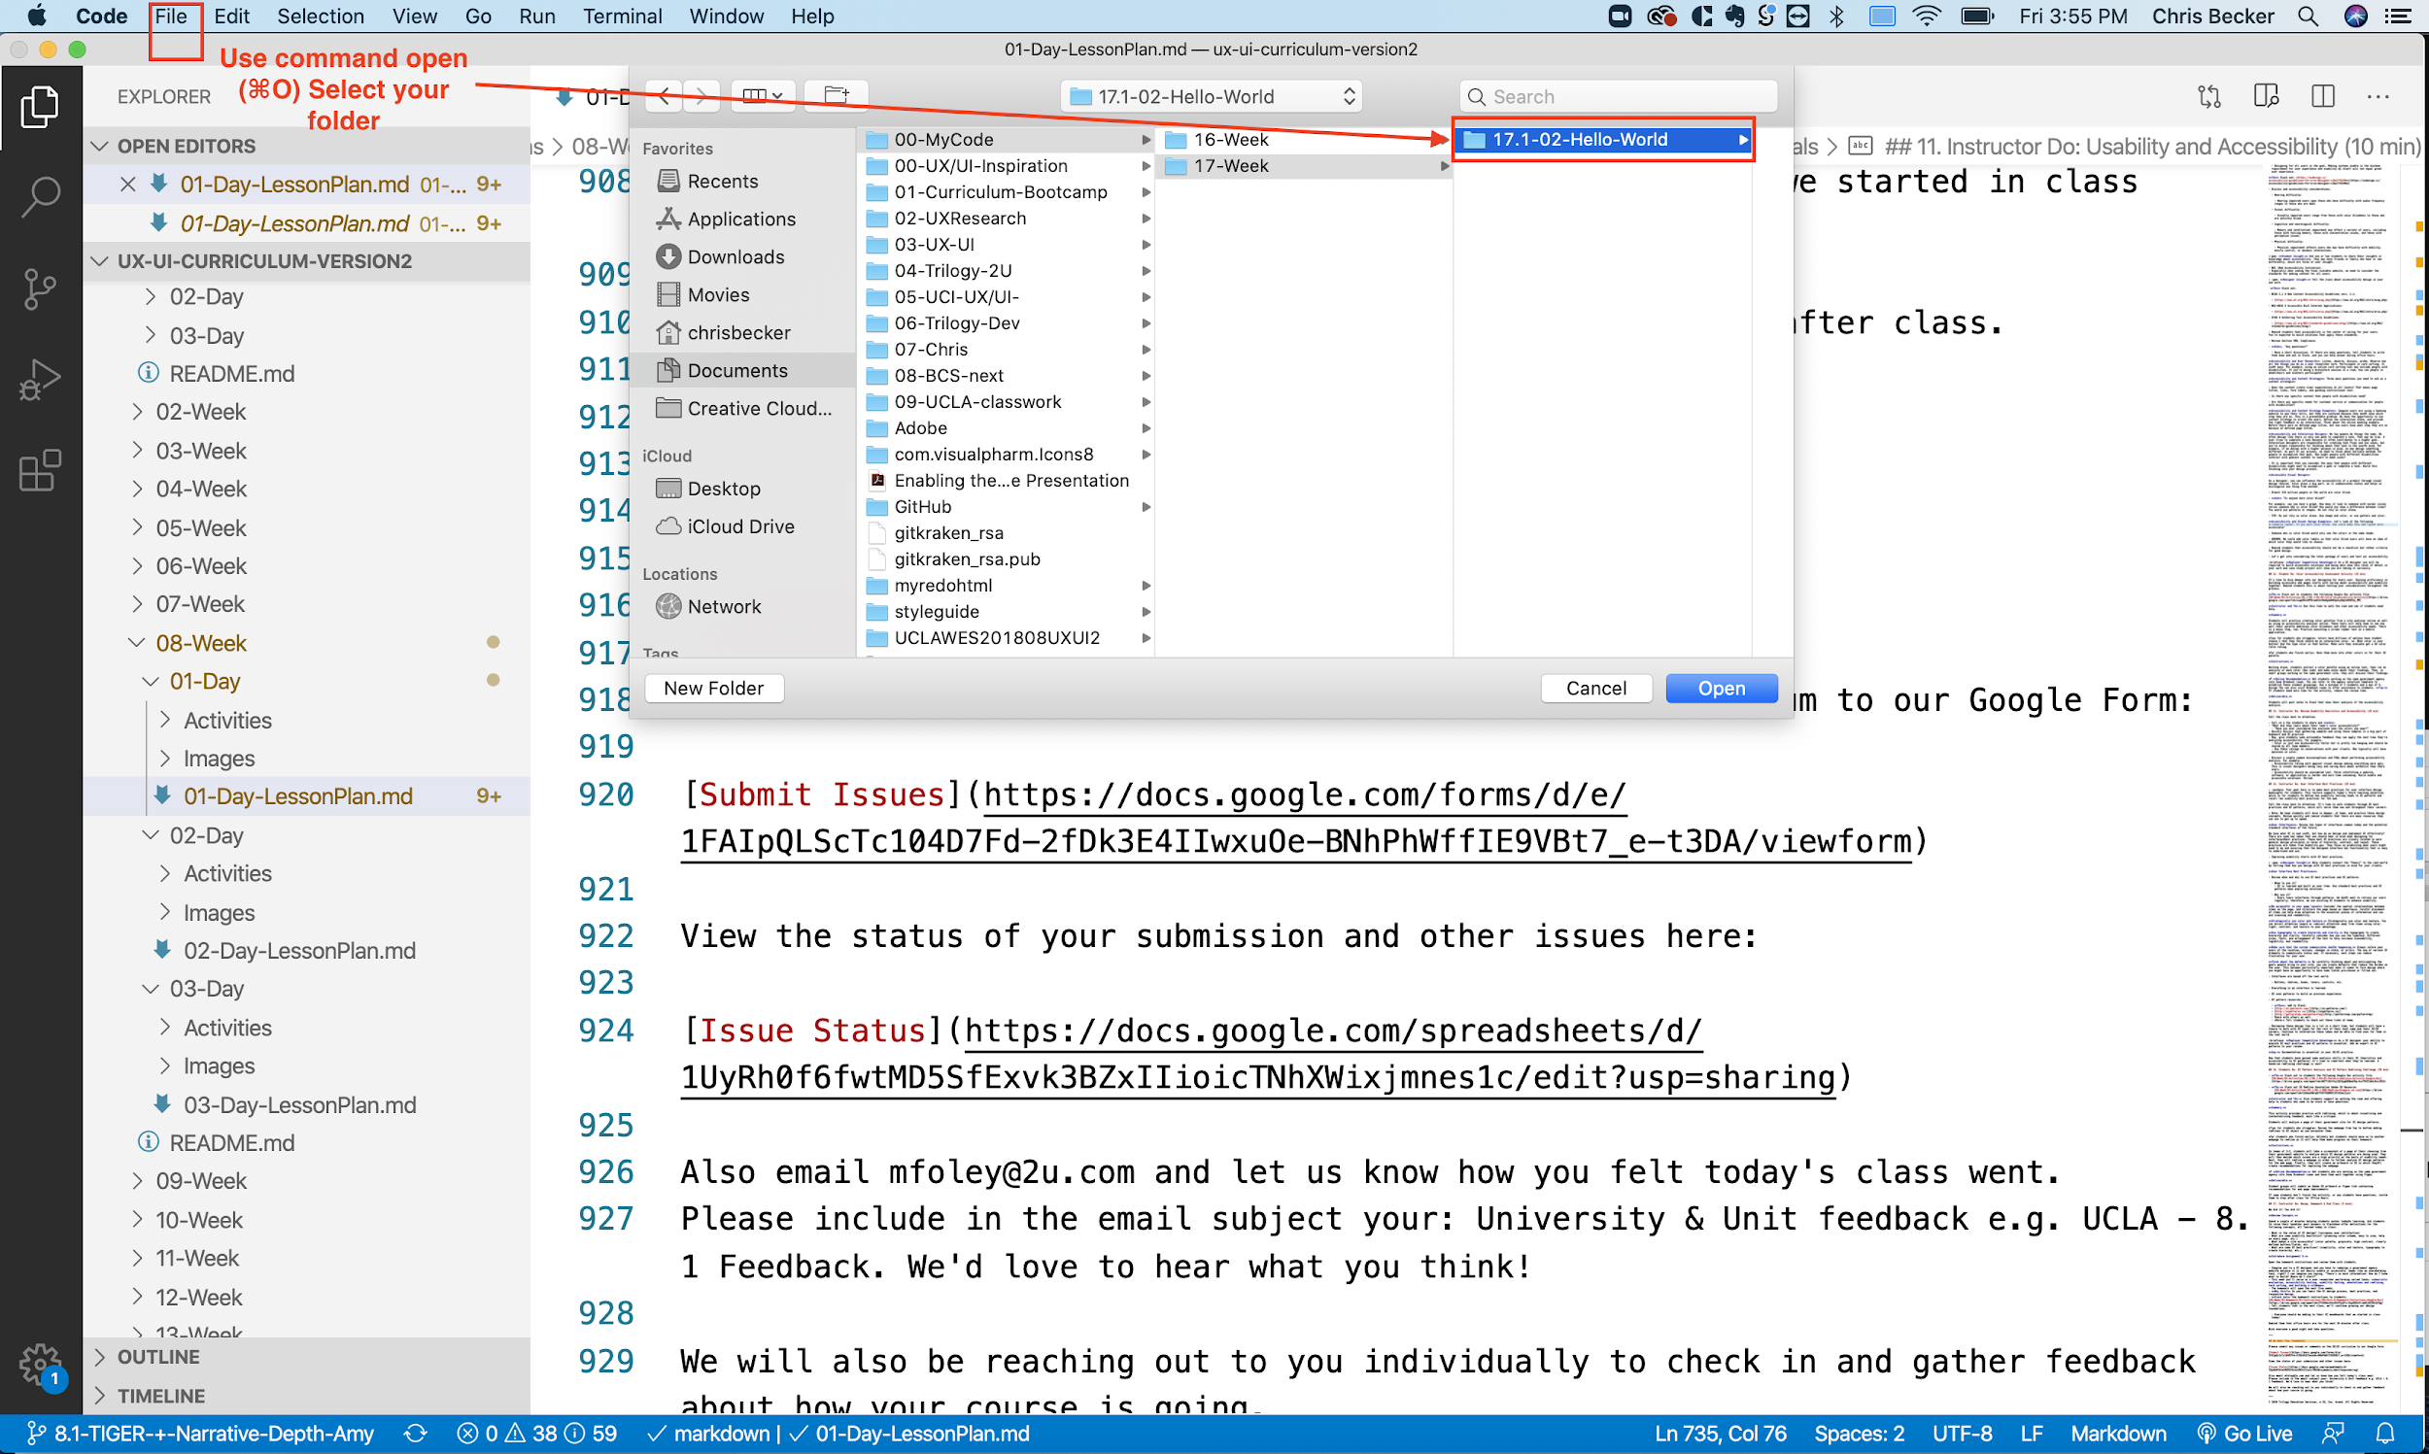

1. Add a folder named 17.1-02-Hello_World to your workspace if you haven’t done so already by clicking the new folder icon in the left panel of Visual Studio Code.

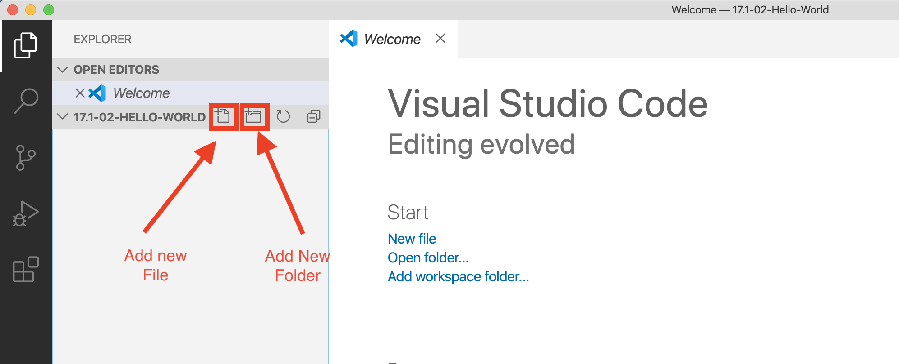

1. Create a file named file index.html and place it inside your 17.1-02-Hello_World folder.   
   **Tip:** Right-click on the 17.1-02-Hello_World folder to add the file.
2. You should now have an HTML file nested in a folder.

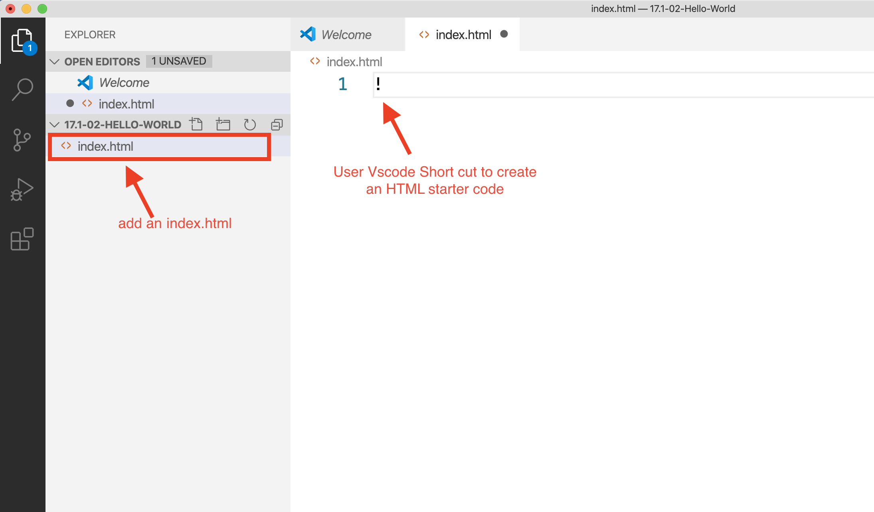

1. Type out the HTML structure below:

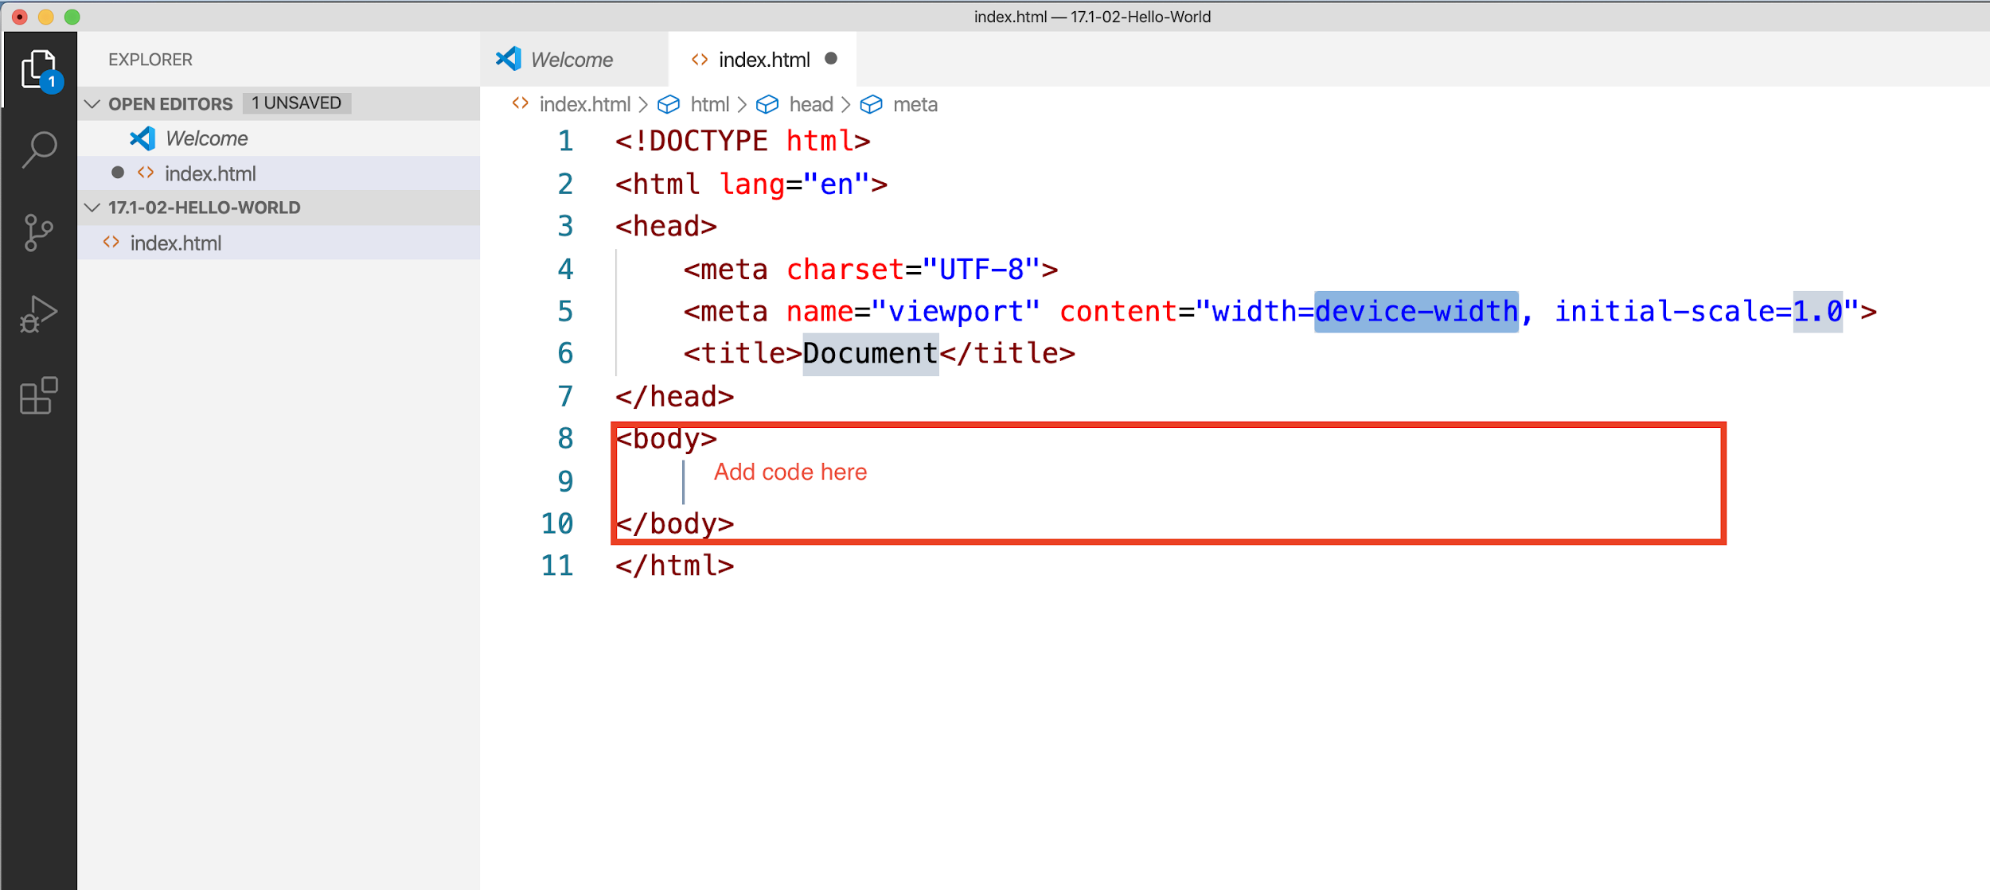

* + Add an <h1> tag with content: “Hello, World!”
  + Add a <p> tag with content: “My first paragraph.”
  + Add a <a href=”url”> with content: “Hi, I am a link! I take you to other places on the web.”

Sample:

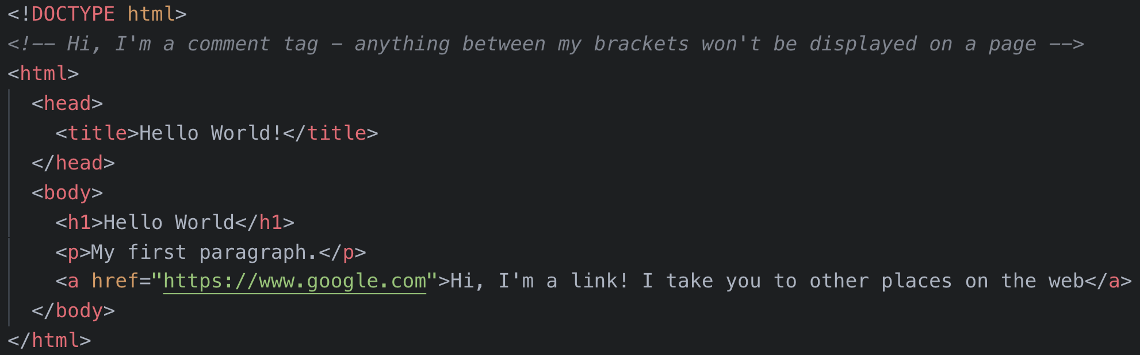

1. Save your file!
   * This is a valuable—and often overlooked—step. If you don’t save your file, you won’t see new changes when viewing a file in your browser.
2. Open index.html in your browser.
   * Install Visual Studio Code extension open in your browser.

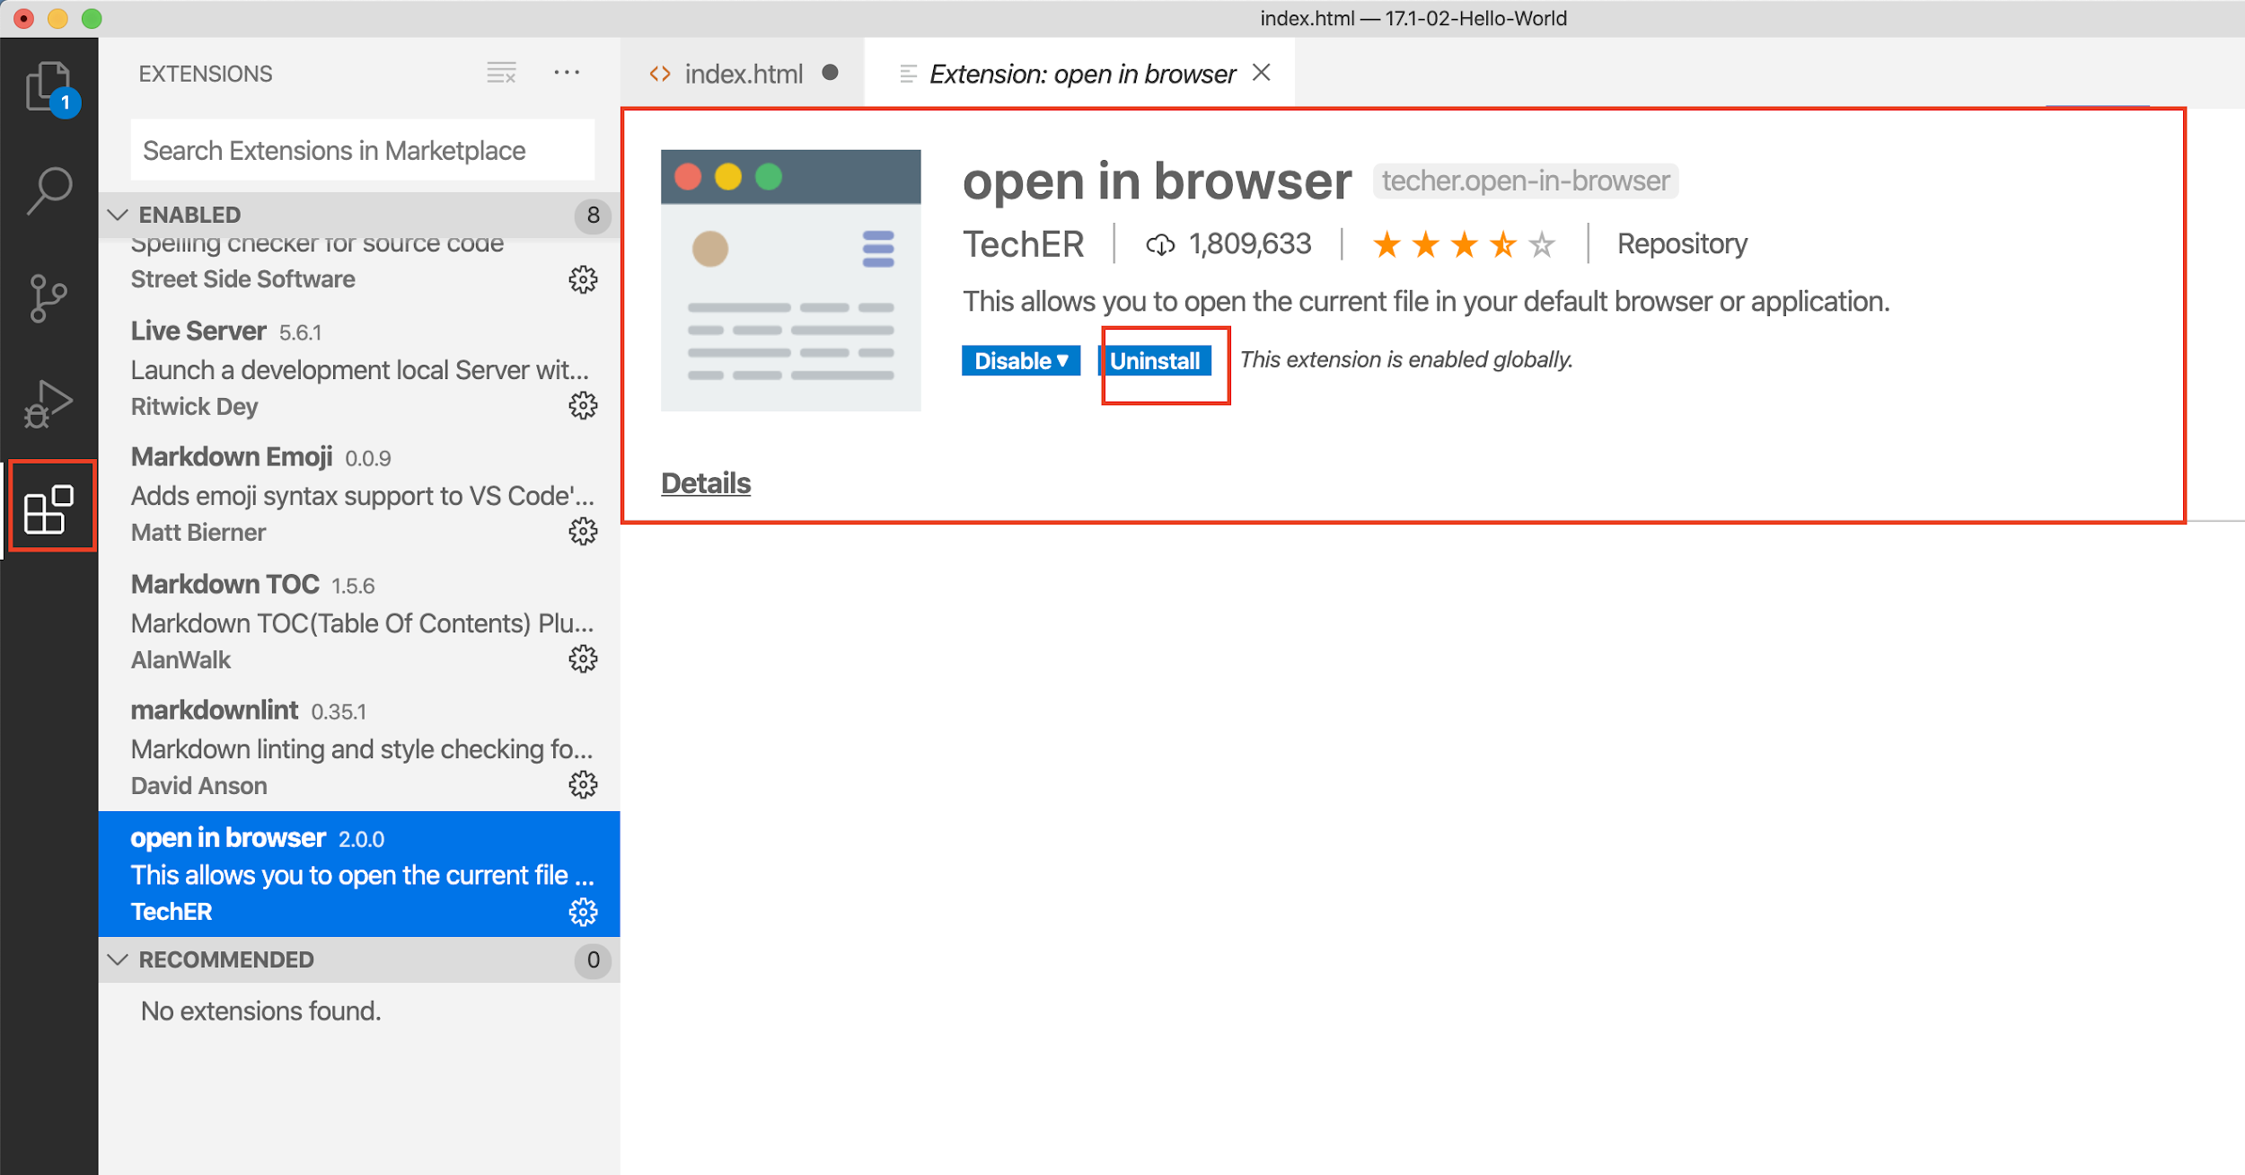

* + Right-click to open your browser.

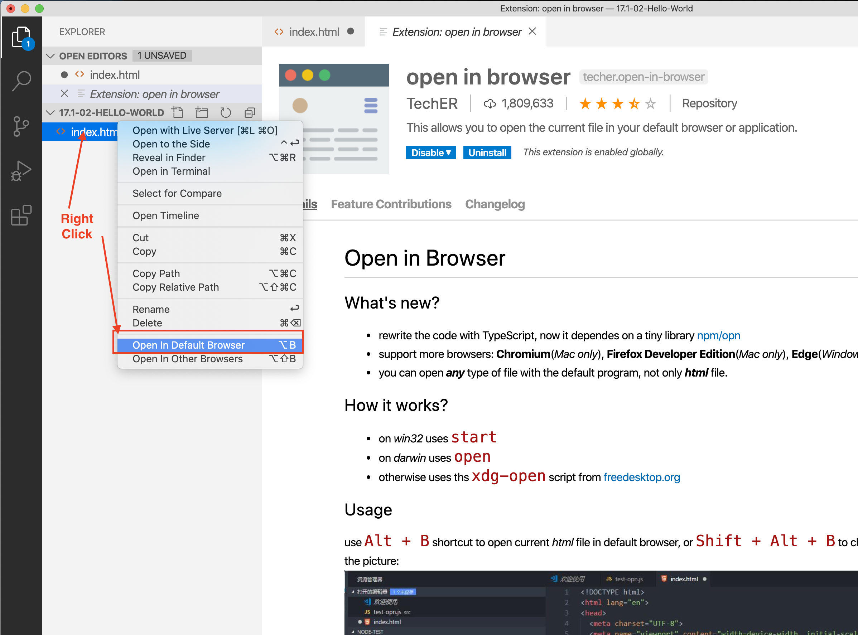

**In the Real World**

HTML is the root of all webpages. Over your career, you will make 1000s of webpages with a variety of complexity. Stay consistent with file names and folder structure of your coding files to show that you can work with teams and supply clarity to your work. Navigating and structuring your projects will make you more efficient overtime.