## Overview

In this activity, you will experiment with semantic elements and practice using documentation by implementing five unique elements.

## Instructions

### Part 1: Set Up Your Environment (3 min)

1. In Visual Studio Code, open the 00-MyCode folder, which you created in the [Hello, World! activity](https://docs.google.com/document/d/1HvEaE0jQ8L9coKzVJOxLtLiqvEn8moVc6LgMwPI1xUM/edit?usp=sharing).
2. Open a Chrome window and navigate to Google. While coding, you will use this to search for documentation on each element.
3. Resize and reposition Visual Studio Code and Chrome so that you can see both:

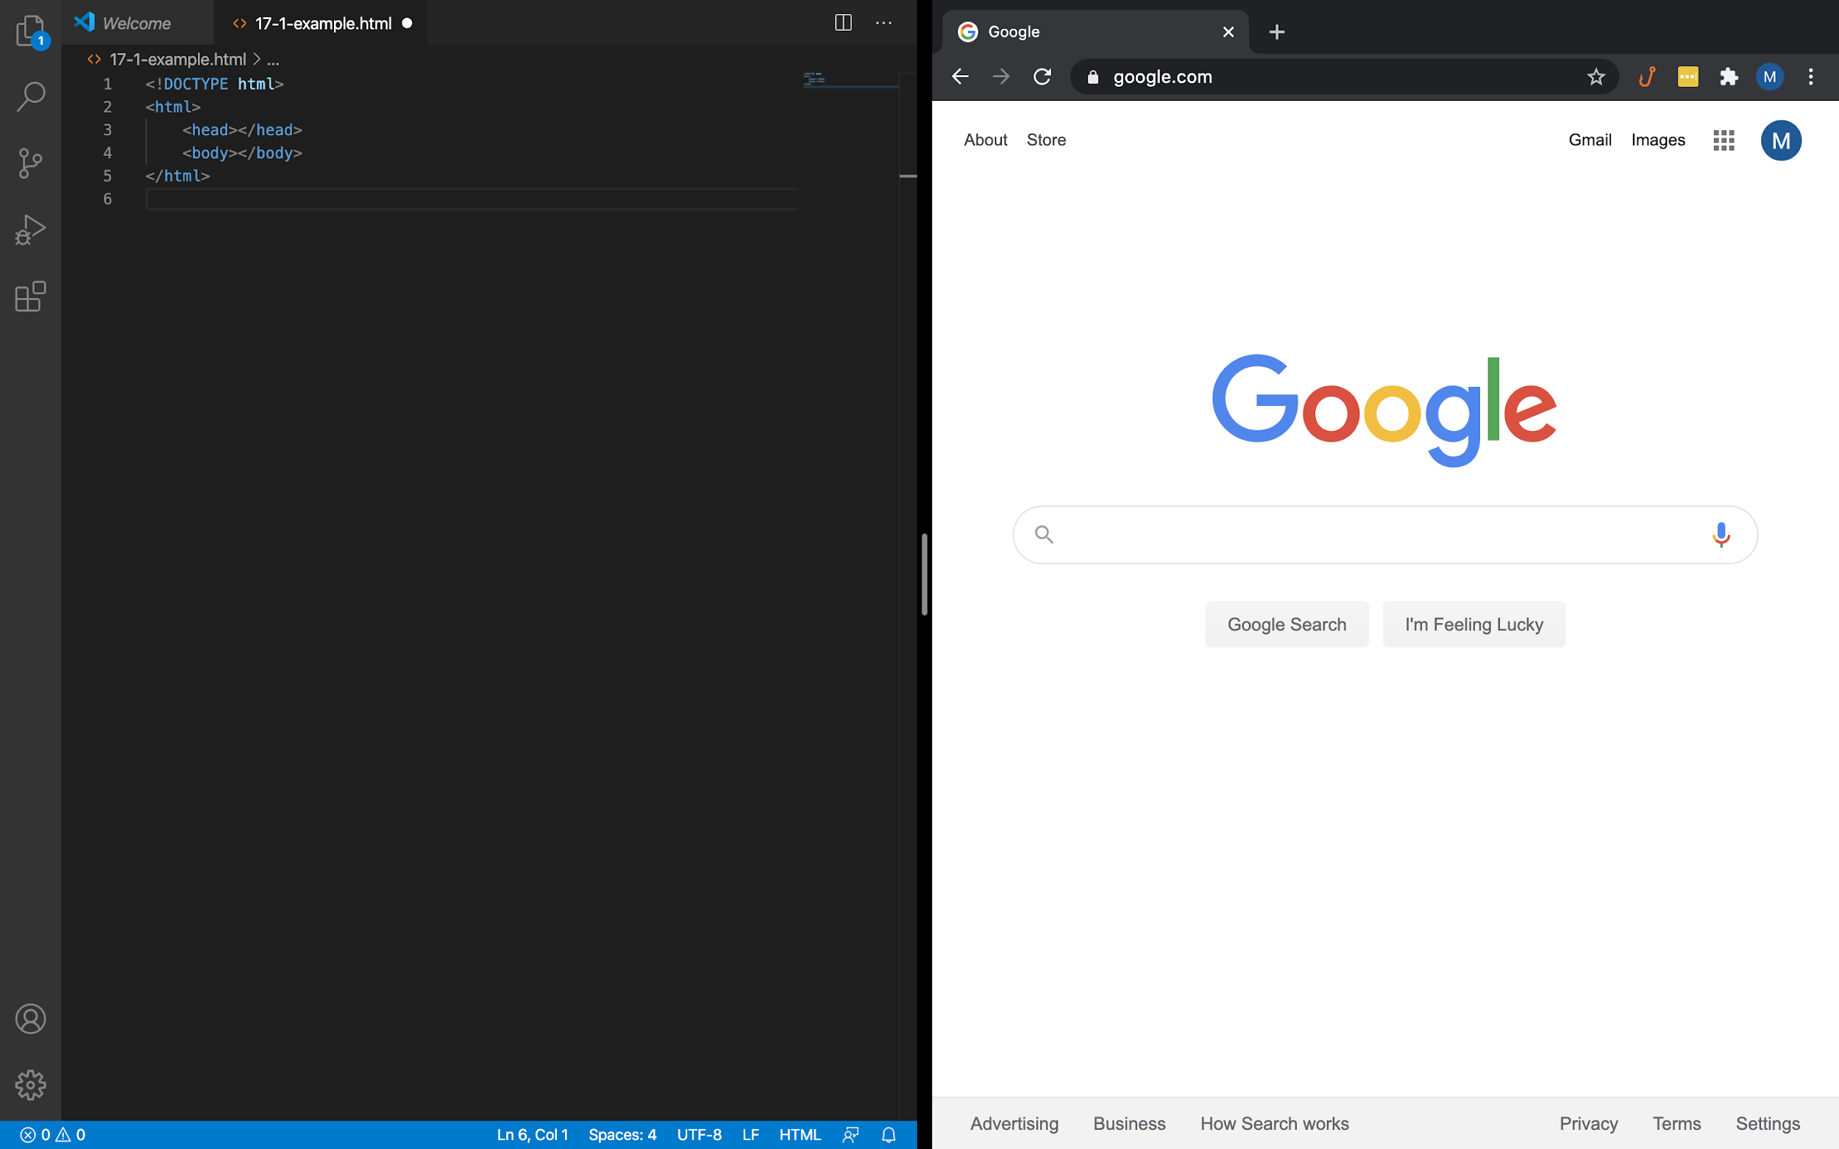

*Tip:* This side-by-side layout can be achieved quickly by using [Mac’s Split View](https://support.apple.com/en-us/HT204948) or [Window’s Snap](https://support.microsoft.com/en-us/help/4027324/windows-10-snap-your-windows).

### Part 2: Add Familiar Elements (6 min)

1. Within the body (where your header, paragraph, and anchor are), add three new paragraph elements.
   * Even if you feel confident creating paragraph elements, open the documentation for practice. To find the documentation, type “w3c paragraph” into Google.
   * For the content of the first paragraph, write your name. For the other two, write anything you want.
2. Below your paragraphs, create an image element.
   * Find the documentation for image elements in the same way as you did for paragraph elements.
   * Provide alternate text that displays if the user can’t view the image.
   * Provide a URL reference to any photo.

*Tip:* To copy the URL of a photo on the web, right click on it and select “Copy link address.”

* + Define a height and width for the image.

1. Below your image, create a multi-line text input.
   * You don’t need to know the name of an element to find its documentation. Type “w3c multi line text input” into Google.
   * The textarea element has many optional attributes. Use at least three attributes.
2. Check your work by comparing your code to [this solution on CodePen](https://codepen.io/matt-boisseau/pen/bGpYqzg).

### Part 3: Experiment With New Elements (5 min)

1. Add any two of these elements:
   * figure
   * input
   * table
   * nav
   * hr

Alternatively, pick any two elements from [W3C’s list of every element](https://www.w3schools.com/tags/ref_byfunc.asp).

*Tip:* Don’t worry about getting these two exactly right. Make a note of anything you find difficult for the review phase.

### Part 4: Share your work (1 min)

## In the Real World

Elements vary in purpose, attributes, and even syntax. Knowing how to quickly access documentation is one of the most essential skills for all programmers. No web developer has memorized every HTML element, but being familiar with the available options allows you to pick the best tool for the job.