## Overview

In this activity, you will add custom CSS to an existing website.

Using and adding custom CSS is a crucial building block to front-end development. It’s a skill you’ll be using more and more in the coming weeks, so let’s build your CSS foundation.

## Instructions

1. Open Fav_Musician.html.
   * It’s located in the Unit 17 Activities folder, inside **17.1_unsolved.zip**.
   * Remember to get in the habit of downloading the activities .zip folder each day before class.
2. Create a folder named css in the My_Favorite_Musician folder.
3. Inside the css folder, add a file named style.css.
4. Now it’s time to link your HTML and CSS files.
   * Add the following to your Fav_Musician.html file, **within** the <head> tag.

|  |
| --- |
| <link href="css/style.css" rel="stylesheet" type="text/css"> |

* + This tells our Fav_Musician.html file to use the CSS located in the style.css file. That way your Fav_Musician.html knows what CSS to use for styling the HTML elements.

1. Within style.css, write a **selector** that targets the <h1> HTML element in your HTML file.

|  |
| --- |
| h1 {   } |

* + Don’t remember what a **selector** is? Check out this illustration:

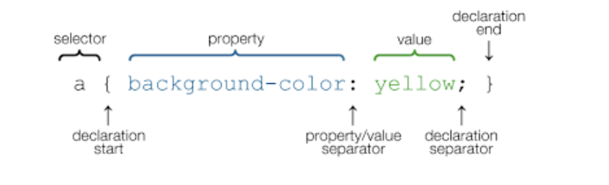

1. Within this selector, set the color property to a value of purple.

|  |
| --- |
| h1 {  color: purple; } |

* + This CSS specifies that all <h1> elements will be purple.

1. Next, add another selector that targets the <li> elements and sets the color to blue.
2. Lastly, write a selector that targets the <html> element and sets the background-color to orange.
3. Save your changes, then open Fav_Musician.html in your browser to see your work.
4. Take a screenshot and share it with your peers in the 01-class-activities channel in Slack.

## Resources

If you get stuck, refer to the following:

* [Documentation on CSS Selectors](https://www.w3schools.com/css/css_syntax.asp)

**In the Real World**

HTML on its own is not that great. HTML + CSS build a lot of the web. Start small and build up to more complex visual designs in code. Being able to practice and demonstrate your CSS code skills will help you design exactly what you want over time.