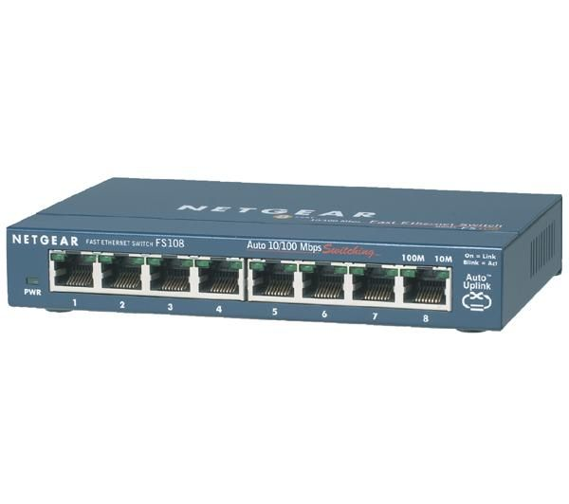
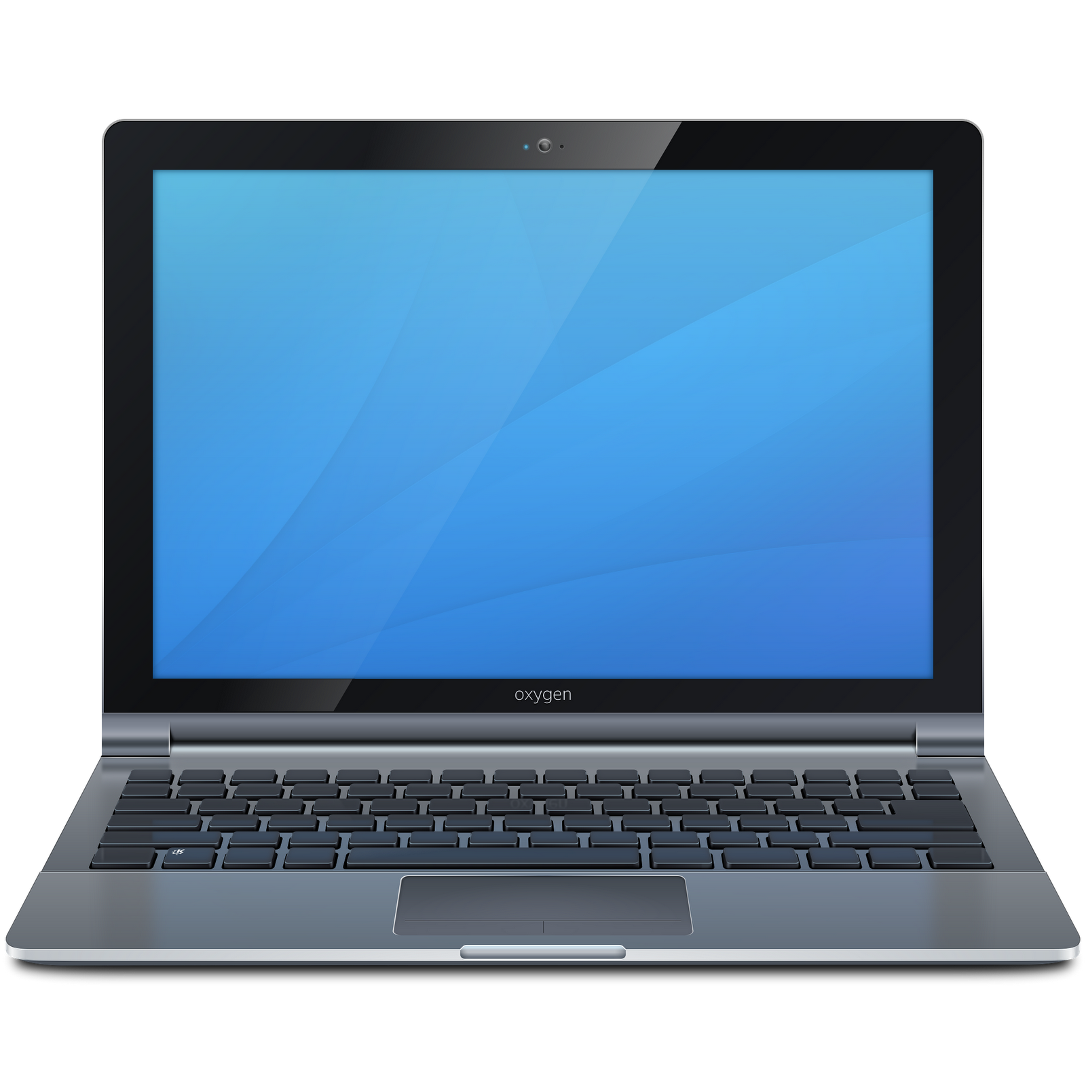
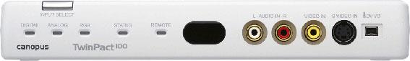
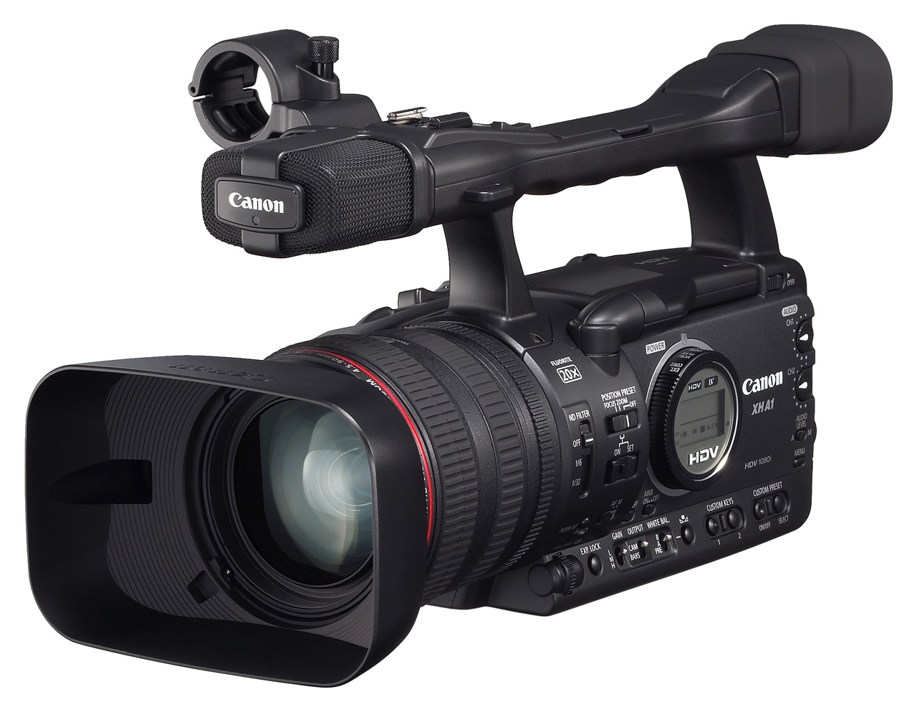
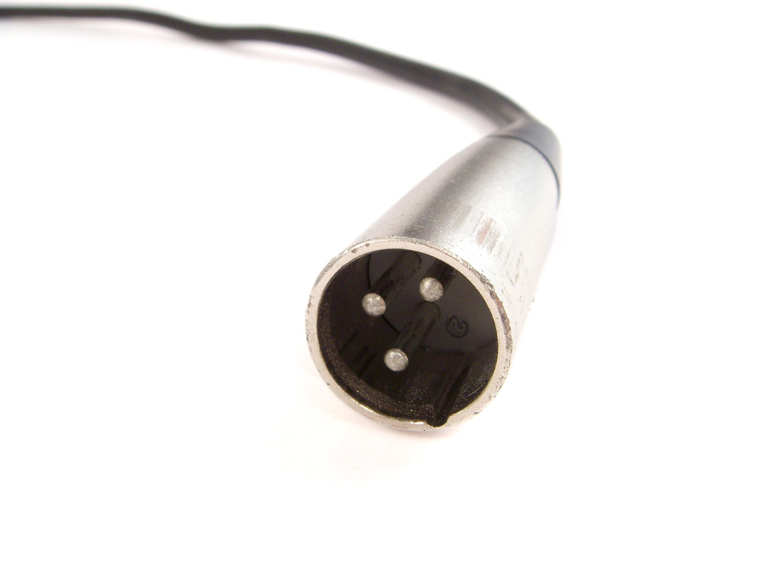
Input select switch
Presenter's laptop
6pin firewire to the VIDEO laptop
Audio input
plug it to L input
VGA from speaker's laptop
RGB/VGA indicator
VGA to the projector

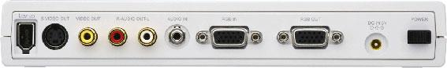
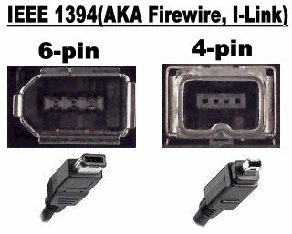
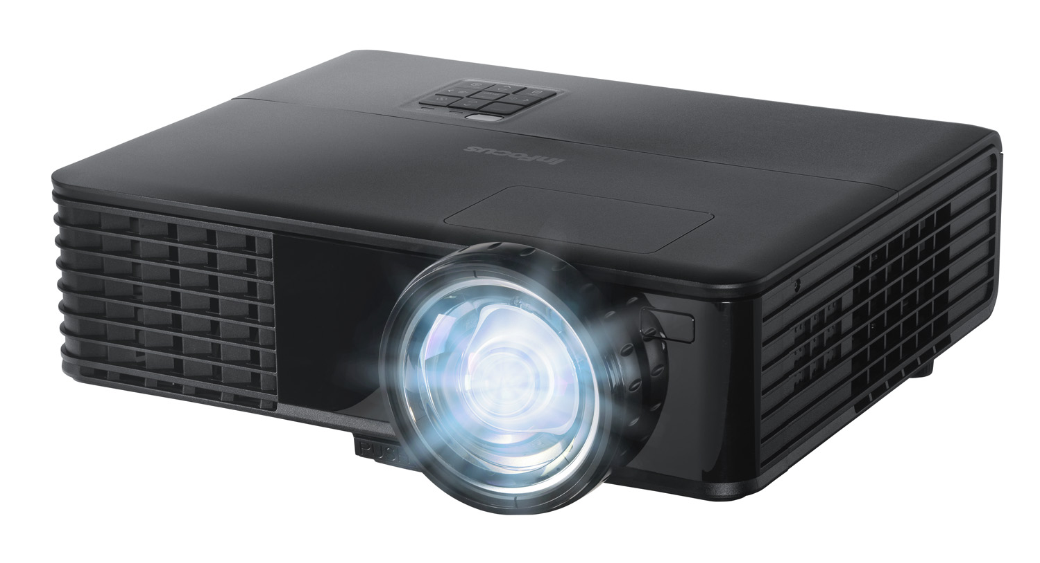

VIDEO laptop

dvswitch laptop

The TwinPact is the device we use to capture the image from a Presenter's laptop as it goes to the projector. The device is connected between the speaker's laptop and the projector and seamlessly captures the image being displayed without interfering with the projector and laptop communications.

Set up Procedure:
- Connect the VGA cable from the Presenter's laptop to the RGB IN on the back of the TwinPact.
- Connect the VGA cable from the Projector to the RGB OUT on the back of the TwinPact.
Note: This may vary slightly depending on the room. e.g. some rooms have fixed projectors with input at the speaker desk, others have a FOSDEM-provided projector which needs to be connected directly.
- Connect the Firewire cable from the 6pin Firewire port(on the back of the TwinPact) to the Slave/TwinPact Laptop.
- Have the speakers Resolution set to 1024x768 is possible.
- Connect the TwinPact Power and turn it on.
- Press the Input Select button until the RGB light is on.
- Make sure the Slave Laptop is running (the lid can be closed) or the Master laptop will not be able to connect to the TwinPact.
- Connect the Slave/TwinPact Laptop to the LAN.
- Connect the Firewire to the camera.
- Connect the Firewire from the camera to the Master/dvswitch Laptop.
- Connect the Audio cable to the L input of the camera.
- Connect the Master/dvswitch Laptop to the LAN.

Setup the speaker/presenter.
- Attach the VGA cable from the Twinpact to the laptop of the presenter.
- Press ctrl+alt+backspace on the Master/dvswitch Laptop.
- Go to the Master/dvswitch Laptop and verify that everything is ok.

How to get HELP?
- Open an IRC client and connect to irc.freenode.net ( /server irc.freenode.net ). The Master/dvswitch laptop has Xchat installed.
- Join channel #fosdem-video ( /j #freenode-video ).
- Ask for help in the channel.
- If no one replies or you need urgent help, send an SMS to Holger(+49 172 415 7304) or Wouter (+32 486 836 198).

