Stacked Rapid Sand Filter Theory, Fall 2015

Isha Chaknalwar, Theresa Chu, Michelle Lee

December 11, 2015

# Abstract

Modeling the physics of particle capture in stacked rapid sand filters allows for greater understanding and further innovation in filtration. A two-layer sand filter will be built to measure filtration performance parameters of effluent turbidity, head loss, and time until turbidity breakthrough or excessively high head loss. Sand filtration should be effective in removing small flocs, so flocculated influent water with coagulant and clay will enter the filter to simulate filtration and clogging.

# Table of Contents

Abstract

Table of Contents

Task List

Task Map

Task Details

Introduction

Literature Review

Gravity Exclusion

Previous Work

Spring 2015

Methods

Flocculator Design

StaRS Filter Experiment Design

Description of Experimental Apparatus Setup

Conclusions

Future Work

References

# Task List

### Task MapSlide2.JPG

### Task Details

1. Design the inlet system/ 9/18/15 - Theresa. Design inlet system using tubing that includes flow injection into the sand bed without slotted pipes.
2. Design the system for influent water/ 9/18/15 - Michelle. Design a flocculator and contact chamber. The effluent of the contact chamber will be used as the influent of the filter.
3. Design the the filter/ 9/18/15 - Isha. Design the filter with design flow rate and filtration. Create a schematic for flow through the filtration system.
4. Build the apparatus/ 9/30/15- Theresa. Acquire materials necessary for building the apparatus. Sieve sand between Sieve No. 30 and 40.
5. Build the flocculator/ 9/30/15 - Michelle. Acquire materials necessary for building the flocculator.
6. Design experiments/ 9/30/15 - Isha. Design experiments testing for head loss, effluent turbidity, and floc size.
7. Test the influent water/ 10/7/15 - Theresa. Measure the floc size distribution in the effluent of the tube settler to establish that it is stable. Adapt a floc imaging system to measure floc size.
8. Run experiments/ 11/24/15 - Michelle. Test the sand filter. Measure the floc size distribution, effluent turbidity, and the head loss as a function run time. Collect any other useful data.
9. Analyze the data/ 12/1/15 - Isha. Plot head loss and pC* curves over time, mass of coagulant accumulated, and mass of clay accumulated. Plot change in size in flocs from influent water and effluent water. Assess filter performance.
10. Create mathematical model/ 12/4/15 - Theresa. The model should predict head loss as a function of coagulant dosage and the mass of solids accumulated. The model should predict pore storage volume as a function of coagulant dosage.

### 

# Introduction

The stacked rapid sand (StaRS) filter is used to filter the particles that were too small to be removed by the previous methods by sedimentation.The StaRS Filter consists of a column of sand with six layers, with four inlet pipes and three outlet pipes on one side of the column. The filter is cleaned through a process called backwashing, in which water, sent up through the bottom of the sand filter, fluidizes the sand column and exits through the top of the filter column. Since the water flows at six times the flow rate and thus six times the velocity for all of the layers, the particles are loosened from the sand and exit the filter.

The StaRS Filter Theory Team has the goal of creating a mathematical model that can give more definitive data about the StaRS filter, given a set of design and operating parameters. The model should predict head loss as a function of coagulant dosage and the mass of solids accumulated in the filter, given a constant influent turbidity. From this model, one would then be able to compute the filter efficiency with respect to effluent turbidity and head loss until turbidity breakthrough or excessively high head loss.

The team plans to design a new inlet system for influent water into the filter and injection into the sand beds without using the slotted pipes. Last semester it was established that slotted pipes cause high head loss and also clogging of flocs in the slots leads to microbial growth. So a new inlet system has to be developed keeping the head loss to minimum, avoid clogging and prevent the sand entering the inlet system.

# Literature Review

## Gravity Exclusion

Stacked Rapid Sand (StaRS) Filters are responsible for filtering out all flocs and producing pure water for distribution. To ensure the filters can function properly, the filters cannot be clogged. However, the slotted pipes that were used by previous teams and current plants were found to clog easily when the dirty water with flocs go through the narrow gaps of the slotted pipes. As a result, a new design had to be adopted to avoid inlet system clogging. The StaRS FlnE team carried out various experiments last semester and tested whether gravity-based sand exclusion zones developed from the gravity sand exclusion theory was a viable alternative for preventing the send entering the inlet pipes (StaRS FlnE Report, 2015 Spring).

The gravity-based sand exclusion theory suggests sand would be prevented from entering these zones during backwash due to the downward pull of gravity. As a result, exclusion zones can be maintained in the filter, and they would exist below the inlet and outlet pipe orifices and contain only water. Because the velocity in all pipes other than the backwash inlet is essentially zero during backwash, there would be no flow of water into these zones to carry sand up into the pipes. It was hypothesized that if the inlet system was designed to be an inverted U-shaped channel, sand would not enter the inlet system during backwash.

Through a series of experiments, the StaRS FlnE team verified that the gravity-based sand exclusion zones could indeed prevent sand from entering an inverted U-shaped channel during backwash. The exclusion zone remained sand-free during the backwash of the small scale sand filter.

In order to further explore the possible implementation of the gravity-based sand exclusion zones in the StaRS Filter, the StaRS Theory team decided to build an apparatus that incorporates the gravity exclusion principle for inlet pipes clogging prevention. The team will build an inlet pipe that has a rectangular orifice drilled into it, which resembles an inverted U-shaped channel. The team will confirm if the gravity-based sand exclusion zones work well for injecting the dirty water into the filter and test whether the inlet pipe with rectangular orifice design experiences clogging during backwash. Eventually, a mathematical model of the filter will be designed based on the data collected.

# Previous Work

## Spring 2015

The team tested the head loss through slotted pipe. Experiments were carried out with different influent turbidity and coagulant dosages to determine which conditions led to clogging and head loss.

The results showed that head loss through the slotted pipes with just water was negligible but as coagulant and clay floc built up the head loss increased.The results also showed that only clay and water does not cause significant head loss. Also the head loss for experiments with just PACl was lower than clay and PACl experiments. Head loss values for PACl and clay experiments were around 30 cm at the end of a 6 hour run, whereas head loss values for PACl only experiments were around 15 cm.

The final plots showed that head loss was a function of the mass of PACl that entered the system, irrespective of presence of clay in water. Increase or decrease in clay amount alone did not exhibit significant amount of change in the head loss, possibly because it is the coagulant that makes the particles stick to the sand and decrease pore size and thus creates more head loss.

Finally, the team determined that slotted pipes clog and only have about 50 cm of head loss to work with before too much potential energy is lost and slotted pipes should be replaced.

# Methods

An experimental apparatus will be constructed to test the head loss influent water experiences during filtration with the new stacked rapid sand filter apparatus design. Moreover, experiments will be done to see if the apparatus is prone to clogging. If the apparatus is likely to clog, the causes will be investigated and the apparatus will be further modified. Finally, whether the sand will flow backward into the inlet pipe will also be explored.

**Stacked Rapid Sand Filter Apparatus**

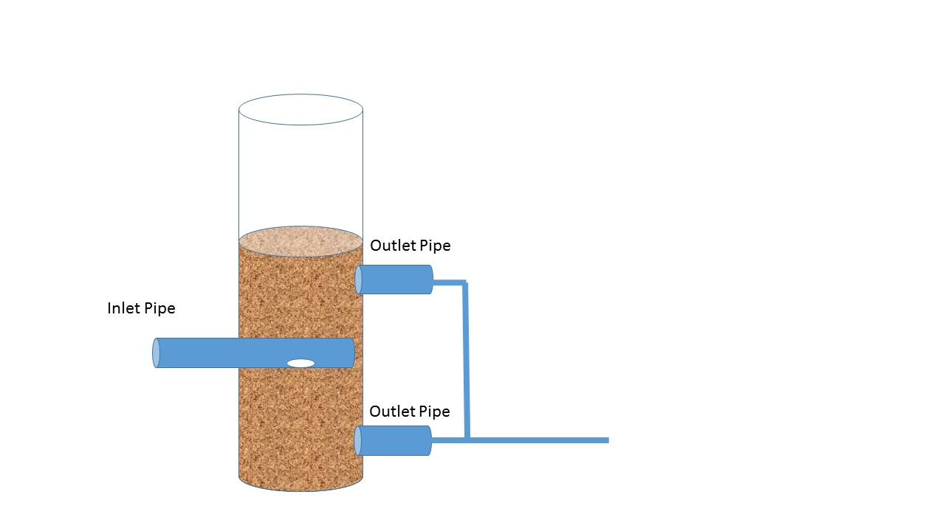

Figure 1. Experimental Design of Stacked Rapid Sand Filter

Instead of using slotted pipes, the team will assemble a stacked rapid sand filter with two sand layers and an inlet with a rectangular orifice for water infusing into the sand. Based on the experimental results from the StaRS FlnE subteam, the team hypothesized that the using a pipe with a rectangular orifice facing downward would avoid the problem of orifice clogging and sand flowing back to the inlet system. The team will run experiments to confirm the above assumptions.

The area of the orifice was calculated based on the relationship for the new filter injection system. The relationship is the following,

$\frac{Area of the hole}{Area of the column}$ = $\frac{Area of inlet system}{Area of filter}$

The area of the inlet system divided by the area of the filter was determined to be the same as the outer diameter of the inlet pipe of 1 inch/10 cm. Since the area of the filter depends on the inner diameter of the inlet pipe as shown below,

$A{{}_{Fi}=π\frac{ID{}_{Pipe}{}^{2}}{4}}_{}$

The inner diameter of the pipe we used was 1.029 inches and thus the area of the filter column was 1.792 cm2. On the other hand, the area of the orifice depends on the area of the filter and the outer diameter of the pipe as followed,

$A{{}_{Orifice}=\frac{A{}_{Fi}OD{}_{Pipe}}{10cm}}_{}$

Since the outer diameter of the inlet pipe is 1.3 inch and the area of the filter column was calculated to be 5.4cm2, the area of the orifice is thus 1.8 cm2.

The diameter of the hole is thus calculated to be 1.5 cm. Since the team uses a copper pipe with length of 5.35 cm and diameter of 0.83 cm, which cannot fit a hole this large, a rectangular orifice will be cut out instead with the dimension 0.80 cm wide and 2.24 cm long. These dimensions maintain the same area ratio with the filter while allowing the inlet system to be feasibly constructed. When experiments are run, observations will be made to check if the sand will flow back into the inlet pipe.

Moreover, the team will test for the head loss experienced by the influent water during the experiments. The pressure of the influent stream and the effluent stream will be measured and the head loss will be calculated based on the difference in the water’s pressure going into and coming out of the filter. If the head loss was significant, then the team would have to reassess the rectangular orifice inlet pipe design in the apparatus and come up with a new model.

For all the experiments, the influent turbidity will be set at a constant 5 NTU. The influent turbidity will be monitored after all the water mixes with the water-clay solution, and before the water enters the flocculator. Influent turbidity is measured before the water is mixed with the solution.

In terms of sand grain size, the sand is designed to have the same size as the sand in the actual plants in Honduras. It was then decided that the sand would need to be sieved using the 30 mesh, which will give the sand 0.5mm radius. Unfortunately, the 30 mesh is nowhere to be found in the lab. An alternative to get around this problem is to first run experiments with the commercially sieved sand with unknown grain size and determine the commercially sieved sand grain size by sieving it with sieves with different openings afterwards. However, the alternative method is less desired because it will be difficult to get an exact measurements of the sand size.

### Flocculator Design

The flocculator was designed with a target energy dissipation rate of 1 W/kg and residence time 2.67 seconds.

Aim Residence time:

$θ=\frac{{G{}_{θ}}_{}}{G{}_{1}}=2.671s$

It has been found that the energy dissipation rate depends on diameter of the floc tube and radius of curvature of the flocculator. Also, The rate is independent of length of the floc tube.

The target energy dissipation rate was 1 W/Kg. The target energy dissipation rate was set to be high to produce smaller flocs for filtration. This is done to replicate the actual filtration process, where as the water reaches the filter only small flocs are present in the water due to sedimentation and flocculation. The floc tube of inner diameter 0.0625 cm (1/16 in) and outer diameter 0.3175 cm (1/8 in), can achieve an energy dissipation rate of 3.505 W/Kg. This rate is higher than aimed for but the next big tubing with inner diameter 0.238 cm (3/32 in) and outer diameter 0.396 cm (5/32 in) gives dissipation rate of 0.611 W/Kg, which is too low compared to the required rate.

Selecting the closest value bigger than the required rate, the flocculator uses inner diameter 0.0625 cm (1/16 in) and outer diameter 0.3175 cm (1/8 in).

The length of the floc tube is dependant on the residence time. For calculating the length of the tube with the target residence time of 2.67 seconds and using the following equation, the length of the tube can be calculated as 1.321 m.

$θ_{Floctube }=\frac{{Length}_{Floctube}}{{V_{Floc}.Q_{Floc }}_{}}$

The head loss in the flocculator is a function of radius of curvature. The radius of curvature of the flocculator is 5.8 m and gives the head loss of 0.942 m.

### StaRS Filter Experiment Design

Experiments will be performed to investigate the head loss influent water experiences when it goes through the filter under different coagulant dosage conditions. A relationship between the amount of dosage used and the amount of head loss the water experience in the filter will also be derived based on the experimental results.

The experiments will be done with varying dosages of PACl. In the experiments, dosage of 0.2 mg, 0.65 mg, 1.55 mg, and 2 mg PACl/L will be used. Pressure sensors will be attached to the inlet pipes and outlet pipes of the filter so that the pressure of water entering and leaving the filter can be measured. By Darcy-Weisbach equation, $Δp=ρgh_{f}$, where $Δp$ represents change in pressure, $ρ$ represents the density of fluids, $g$ represents gravity and $h_{f}$ represents head loss due to friction losses when the water moves through the filter. The difference between the water pressure entering the filter and leaving the filter can therefore provide information on the head loss water experiences with the Darcy-Weisbach equation.

### Experimental Apparatus Setup

Water inlet pipe was connected to the water influent water pump and backwash pipe respectively. The influent water pump controls the flow rate of the water into the system and the water sent to the backwash pipe was solely used for the backwash purpose to keep the StaRS filter sand bed clean and reduce the chances of clogging with the filter due to flocs. The influent water pipe that goes through the influent water pump was connected with the clay-water solution pipe, which goes through the clay pump that controls the flow rate of the clay-water solution. The clay-water solution pipe and the influent water pipe were connected by a T- joint, such that the influent water can split into two flows which enters the flow accumulator and influent turbidimeter respectively. The pipe leaving the turbidimeter was then attached to the PACl solution pipe, which was controlled by the PACl pump. The mixture of the influent water-clay solution and PACl solution would leave the tee at one single pipe and enter the contact chamber through one single pipe. The contact chamber was connected to the flocculator, such that the the solution could enter flocculator for rapid flocculation. The pipe leaving the flocculator will be connected to the pressure sensor and filter. Three pipes leave the filter. One was a pipe that pass through the effluent turbidimeter and enter the sink. One was a pipe that left directly to the sink. The last one was the backwash pipe that was connected to the influent water pipe. The water left at different pipes depending on whether backwashed or the experiments were performed.

The backwash pipe and the influent pipe are controlled by the same pump. When the experiment runs in the filter state, the solenoid valve of the backwash pipe will be closed, such that the water only flows into the influent pipe and the pump it connects to will act as the influent pump at that point and runs in the rotation per minutes that correspond to the influent flow rate calculated. When the experiment runs in the backwash state, the solenoid valve of the influent pipe will be closed while the valve of the backwash pipe will be opened, such that the water only goes through the backwash pipe. The pump will be manually set up to run in a certain rotation per minutes that gives the desired backwash flow rate.

### Capacity Load Experiment Setup

The team collaborated with the Foam Filter team to run experiments on finding the loading capacity in foam filters and sand filters. The main goal of the experiment is to determine whether the foam filter, which has higher porosity, allows solid loading capacity than sand filter. Like the sand filter used in the StaRS Filter experiments to find the headloss across the filter system, the sand filter used in the capacity load experiment incorporates two sand layers of 20 cm and an inlet pipe with orifice. However, in the capacity load experiment, instead of merely integrating clay in the influent water, a mixture of 10 mg/L of HA sodium salt and 68.9 mg/L of clay was mixed with the influent water, which gave an influent turbidity of 70 NTU. The coagulant dosage was set to be 10.7 mg/L. Experiments were run to test how much solid, measured in NTU, was accumulated for 30 minutes of operations. The sand filter capacity load result was compared with that of the foam filter.

### Experimental Design Schematic

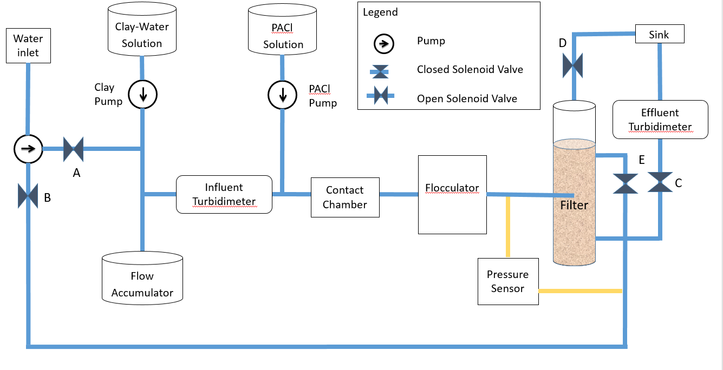

Figure 2. Schematic of Experimental Design in Filter State

* 1. Water will be mixed with clay and stored in a stock tank.
  2. A flow accumulator will be used to ensure a steady, smooth water flow from the pumps.
  3. The clay solution is constantly mixed with an electric mixer to keep the turbidity constant. The turbidity of the clay stock will be kept constant at 5 NTU.
  4. After the solution leaves the influent turbidimeter, it will be mixed with PACl solution. The concentration of PACl solution varies in different experiments. The experimental concentrations used include 0.2 mg PACl/L, 0.65 mg PACl/L, 1.55 mg PACl/L, and 2 mg PACl/L.
  5. The solution will mix thoroughly in the contact chamber.
  6. The solution will enter the flocculator at high flow rate. The flocs’ sizes are expected to be small as the the solution will flow at a high flow rate and big flocs have small opportunities to form.
  7. The solution will enter the filter through the new inlet model, which has the orifice facing downwards. The flow of the water will be enter the sand layer in downward direction instead of sideways.
  8. The filter contains two 20 cm sand beds that filter out flocs and reduce the turbidity of the influent water.
  9. A pressure sensor will be installed connecting the inlet pipes to the filter and the effluent pipes. The sensor measures the difference in head between the top and the bottom of the sand column. Before each test, there will be no water flowing through the pipe and the sensor will be set to zero.
  10. A solenoid valve will be used to control the flow out of the column.
  11. An effluent turbidimeter measures the turbidity of the water leaving the filter.
  12. A pump will be used to backwash the filter in between tests. Water is pumped through the sand beds to fluidize the beds and remove the deposited clay from the previous test. Another solenoid valve that controls the flow rate of water out of the filter during backwash. The valve closes during filtration and opens during backwash.

### Process Controller Method File

Several states are used to control the various pumps and valves for each mode of the filter

Filter: Solenoid valves A,C,E open; Clay pump, PACl pump, Influent pump on.

Backwash:The valve number B and D were combined into valve D such that only solenoid valve D is open during backwash; Influent pump on.

Calibrate Pumps: Sets pump speeds for calibration.

Toggle: Tests solenoid valves.

### Process Controller Setpoints

* On - This state corresponds to boolean 1 and is used to turn the pumps on.
* Off - This state corresponds to boolean 0 and is used to turn the pumps off.
* PID Control - The state calculates the fraction the pump should run with a given set of values for P, I, D, a target value, and a setpoint value in constant-time.
* Clay Pump Speed - The state includes the influent turbidity, Target influent turbidity and PID control.
* PACl Pump Speed - The state includes the influent flow rate, PACl Stock Concentration, PACl Dose Concentration, and PACl Pump Tubing Size.
* Runtime - The state corresponds to the amount of time a certain state is run transitioning into the next state (this setpoint is used in automatic mode)
* Turbidimeters - This state includes turbidimeter ID and readings
* Influent Flow Rate - This state corresponds to the target influent flow rate calculated.
* Target Influent Turbidity - This state is used for the clay pump to maintain a target turbidity.

### Cleaning Procedures

Experimental apparatus is cleaned every time before an experiment is run. The cleaning procedures are as follows:

1. Run Backwash Half Flow state on ProCoDA. The backwash pump will pump water at a rate of 41.9 rotations per minute. A one-half backwash flow rate has to be used before the full speed backwash flow rate because the inlet pump pipe will detach by itself if pressure suddenly builds up to generate flow rate at full back wash speed.
2. Run Backwash Full Flow state on ProCoDA. This will allow the sand layers in the sand filter column to be clean.
3. Run Backwash Ending state on ProCoDA, which is a state that allows the gradual change in pump speed until it reaches zero. This will also prevent the detachment of the influent pump water pipe due to abrupt pressure change.
4. Clean turbidimeter by running clean water through it.
5. Clean flow accumulator by running clean water inside the flow accumulator.
6. Zero pressure sensor.

# Issues Encountered

### High Energy Dissipation Across Flocculator

The flocculator was designed for high dissipation rate. However it was unable to achieve the exact target flow rate 1W/kg due to restraints, such as the sizes and material of the available tubings on market. The flow rate achieved pertains to a dissipation rate of more than 3W/kg and that results in very high headloss across the filter column. The flocculator was removed to verify the impact of its absence. It was confirmed that the removal of the flocculator can maintain an inlet flow rate that is close to our target flow rate. Therefore, it was decided that the flocculator would not be used.

### Solution Filling up the Flow Accumulator

When the filtration state is run, it was designed to have a portion of the influent flow would enter the flow accumulator. However, the amount of the flow that entered the flow accumulator was uncontrollable as of now. It was believed that the atmospheric pressure inside and outside of the container was not great enough to counteract the pressure of the influent flow. Consequently, the solution keeps entering the flow accumulator and overflows when it surpasses the container volume. Currently, the problem is tackled by manually removing the water in the accumulator before it overflows. Efforts would be made continuously to ensure that water pressure would not build up in the system and there would be no overflowing in the accumulator.

### Sand Flowing out of the Filter Column

During backwash, the backwash current forces the sand to move up the column. During the process, sand sometimes leaves through the inlet pipe orifice and enters the system. There are several reasons that led to the problem. First, when the column or the inlet pipe was slightly tilted, there would be a high chance for the sand to flow out of the inlet pipe. The column is often hit by a hammer during filtration state to get rid of the air in the system, and that results in the shifting of the column’s orientation and position. The problem was fixed by constant monitoring of the position of the column and reposition it immediately if it is not positioned straight. Second, the inlet solenoid valve has also been causing problems. When the Inlet solenoid valve was completely closed, the sand would not go past the valve and enter the earlier stages of the system. However, when the solenoid valve does not work properly, such as when it does not close completely and leaks, the sand may flow through the valve to different part of the system. Attempts to resolve this problem were made by replacing the solenoid valve with a manual valve, such that it could be ensured that the valve closed properly. However, another issue came up as the manual valve are not water tight when connected to our inlet system. Water kept leaking when going through the valve. The inlet current would not be able to enter the filter column at the desired flow rate as a result, and the alternative was rejected. It was decided that a solenoid valve for inlet would be used.

But the solenoid valve was failing again and therefore was removed. It was replaced by a longer tubing fitted in a way the sand does not enter the system through the inlet. But it was observed the tubing often fails in preventing the sand from coming out.

The issue also emerge again while cleaning the filter. The filter needs to be cleaned after every experiment. During backwash, the sand flows out of the filter column into the system through the tubing. Also, the turbidimeters need to be cleaned. If the turbidimeters are opened in normal condition the sand flows out into the system. To avoid that the filter is drained each time before opening the turbidimeters.

### PID Control

For the experiment, a target influent turbidity of 5 NTU is set. The Proportional Integral Derivative (PID) control keeps the constant influent turbidity while running the experiment. As clay water enters the system the inlet turbidimeter measures the influent water turbidity. To keep influent turbidity constant, the PID control restricts the clay pump speed. The PID controls the speed by given values of P, I and D.

For getting the 5 NTU target, the PID was first calibrated and by trial and error method various combinations of P and I values were tried keeping the D to be zero. The P value range from 0.5 to 1 and I value ranged from 0.4 to 0.8. The PID control unable to deliver a constant influent turbidity with these set of values. The PID had trouble keeping the 5 NTU constant for a longer period of time. The closest it reached to 5 NTU was in the range of 4.7 to 5.3 NTU with P=0.7 and I=0.5 for the first experiment. The same P and I values could not yield a constant turbidity for the next experiment. The filter theory team did not succeed with getting the correct PID numbers for 5 NTU to run the next experiment.

Analysis

An inlet system with pipe of diameter 0.83 cm will be used with an orifice of dimension 2.24 x 0.8 cm for infusing water in the sand bed.

The experiment was run at influent turbidity of 5 NTU with PACl dosage of 2 mg/L for 17 hours. The influent and effluent turbidity was monitored and head loss over time was measured, and pC* over time was calculated.

The target influent turbidity was 5 NTU but while running the experiment it was observed that the influent turbidity varies from 0 to 10 NTU as PID control was unable to to maintain the constant influent turbidity.

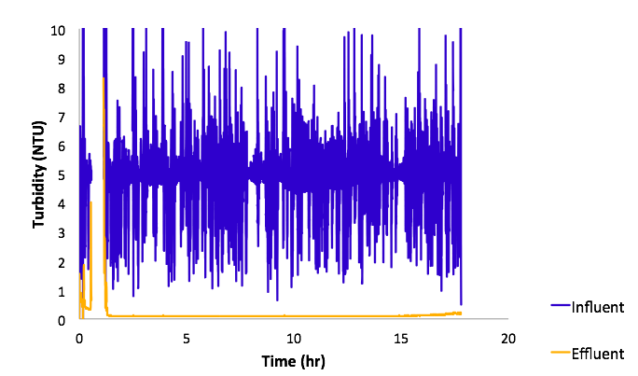

Figure 3 . Influent and effluent turbidity over time.

The effluent turbidity was plotted as as function of time. It was observed that effluent turbidity was high (about 2 NTU) in the initial period of filtration, but it decreased after the first hour of operation and remained constant till 15th hour. After 15th hour it starts to increase again approaching the breakthrough turbidity.

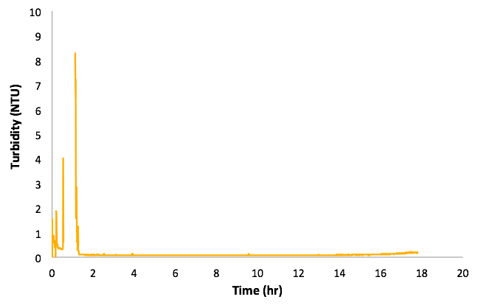

Figure 4 . Effluent turbidity over time

The head loss was plotted as a function time. From the plot it was observed that initially the head loss increased exponentially to about 25 cm and then showed a linear growth over time. Head loss per hour was observed to be 23.2 cm.

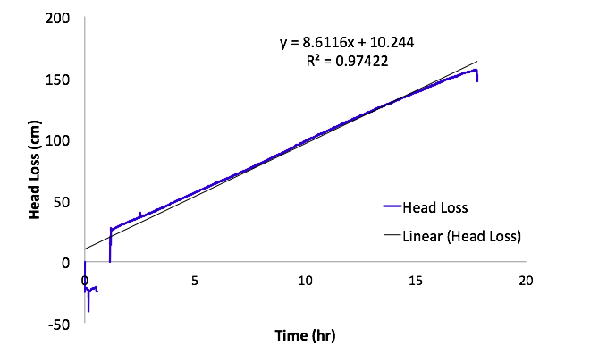

Figure 5 . Head loss in filter over time

The pC* was calculated and it was observed that pC* increased initially and was steady for most of the experiment but started decreasing after 15 hours of operation. From this it can be inferred that the filter started failing post that point.

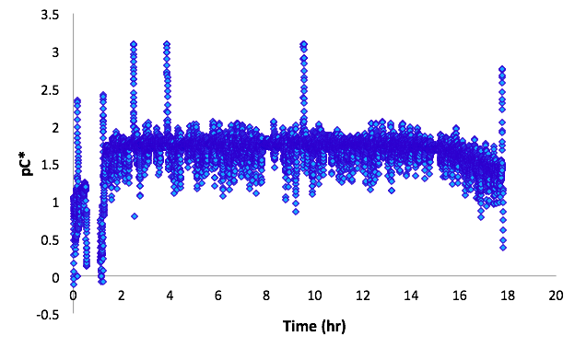

Figure 6 pC* over time

### Capacity Load Experiment

The capacity load experiments determines the NTUL per cm sand in the filter. The experiment was run for 30 minutes. In the experiment, the turbidity over time, pC* over time, and head loss over time are measured. The resulted pC*over time is small (as illustrated in figure 7 below) and the resulted head loss shows a steady, increasing trend (as illustrated in figure 8 below). Therefore, the experiment was determined to be effective and data on the NTUL per cm sand was analyzed.

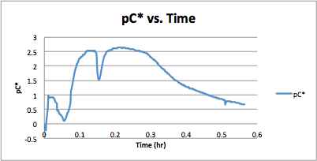

Figure 7. Experimental Result of pC* over Time across Sand Filter

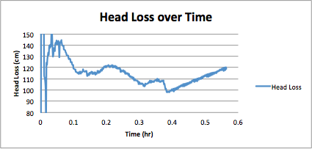

Figure 8. Experimental Result of Head Loss over Time across Sand Filter

As shown below in figure 9, the influent turbidity over time in the sand column shots up from 0 to our target turbidity 70 NTU after a few minutes of operation. This is expected because when the experiment is first started, the influent water is still mixing with the clay and organic matter. However, after a few minutes, the addition of the mixture will reach a steady state which is indicated by a steady turbidity at the target value. Similarly, in the first few minutes, the resulted effluent turbidity shows abnormality. However, after the first few minutes, the effluent turbidity goes back down to below 1 NTU. As the filtration continues, a steady increase in the effluent turbidity is observed. This is a consequence of the continuous loading of clay-organic mixture in the sand filter, causing cloggings in pores. As a result, not as much clay-organic solution can be filtered through the sand filter as it could in the beginning of the experiment.

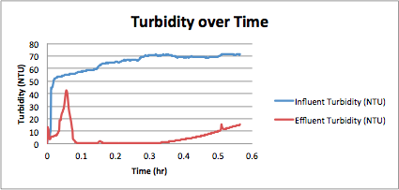

Figure 9. Experimental Result of Turbidity over Time across Sand Filter

For the foam filtration, the cumulative NTU is 3547 NTU. On the other hand, for the sand filtration, the cumulative NTU is 631 NTU. However, since the sand filter is supposed to perform less well under high turbidity, it is not entirely conclusive on whether the foam filter has a much better loading capacity. More data and analysis of the foam filter performance versus sand filter performance can be obtained from Foam Filter Team Fall 2015 Research Report.

# Conclusions

From the experiment run it was observed that the head loss in the filter showed a steady linear increase, rising 125 cm over 16.5 hours, disregarding the initial jump in head loss. The total head loss in filter is much higher than the allotted 40 cm of head loss for the filters.

Also, from the effluent turbidity data it can be inferred that the filter performs consistently even though the influent turbidity varies. The effluent turbidity remained relatively constant at 0.1 NTU for the first 15 hours of the filtration.

Unfortunately, the PID control is not working ideally. The experiment was run under P being 0.7, I being 0.5 and D being 0. Howent turbidity did not always stay in the accepted turbidity range, which is from 4.7 to 5.3. Once in a ten to fifteen minutes, the influent turbidity will experience a drastic change in values. Sometimes, the value changes to a small positive number, such as 2.6. Other times, the value may give -999 NTU influent turbidity. It is suspected that a discommunication between the ProCoDA and the Turbidity meter causes the problem. Similar problems have occurred in experiments in previous years. Nonetheless, the errors in the experiments done in previous years happened less frequently and thus can be overlooked. With such frequent turbidity measurement output errors occurring this semester, the turbidity analysis is greatly affected. Continuous efforts are being made to ensure the correct setup of the PID values, such that we can run our experiments with an accurate turbidity output and produce a more accurate model.

With the current data and issues pertaining it can be concluded that more experiments need to be run after solving the issues.

# Future Work

PID control will be used in order to maintain an influent turbidity of 5 NTU. The system will first be tested so that the optimal P, I, and D values are chosen. The backwash mode will be tested on the filter to ensure that sand does not exit the filter. The current P and I values should be reevaluated so that turbidity remains constant. A new calibration procedure for PID control that works consistently should also be formalized.

A control measure should be implemented in the filter so that sand does not exit the filter through the inlet. Valves, manual or solenoid, will break if sand gets into the valve, so another method should be considered. Otherwise, changes in ProCoDA states and changes in the experimental apparatus should be made carefully so that sand does not leave the filter. The current inlet system of a rectangular orifice should be reevaluated for effectiveness.

With a functional sand filter, experiments will be run to measure head loss and effluent turbidity over time. A collection of pC* curves based off of the effluent turbidity results will describe filter performance. Head loss over time will be analyzed for trends based on coagulant dosage and influent turbidity. These trends can contribute to the overall mathematical model of head loss due to coagulant dosage. The sand filter layer depth of 20 cm will also be reevaluated as the optimal filter depth.

# References

* Experimental Thermal and Fluid Science. (2006). *Science Direct,* *30*(4), 329-336. Retrieved September 30, 2014, from http://www.sciencedirect.com/science/article/pii/S0894177705000993
* Weber-Shirk, M. (2014, September 14). Flow Control and Measurement. Retrieved September 30, 2014, from https://confluence.cornell.edu/display/cee4540/Syllabus