期末報告

班級 : 四子三甲 學號 : C110152118 姓名 : 張宥富

4位元之全加器設計

1. 原理:

真值表

|  |  |  |  |  |  |  |
| --- | --- | --- | --- | --- | --- | --- |
| A | B | C | D | Co1 | S1 | S0 |
| 0 | 0 | 0 | 0 | 0 | 0 | 0 |
| 0 | 0 | 0 | 1 | 0 | 0 | 1 |
| 0 | 0 | 1 | 0 | 0 | 0 | 1 |
| 0 | 0 | 1 | 1 | 0 | 1 | 0 |
| 0 | 1 | 0 | 0 | 0 | 0 | 1 |
| 0 | 1 | 0 | 1 | 0 | 1 | 0 |
| 0 | 1 | 1 | 0 | 0 | 1 | 0 |
| 0 | 1 | 1 | 1 | 0 | 1 | 1 |
| 1 | 0 | 0 | 0 | 0 | 0 | 1 |
| 1 | 0 | 0 | 1 | 0 | 1 | 0 |
| 1 | 0 | 1 | 0 | 0 | 1 | 0 |
| 1 | 0 | 1 | 1 | 0 | 1 | 1 |
| 1 | 1 | 0 | 0 | 0 | 1 | 0 |
| 1 | 1 | 0 | 1 | 0 | 1 | 1 |
| 1 | 1 | 1 | 0 | 0 | 1 | 1 |
| 1 | 1 | 1 | 1 | 1 | 0 | 0 |

卡諾圖化簡

|  |  |  |  |  |
| --- | --- | --- | --- | --- |
| CD  AB | 00 | 01 | 11 | 10 |
| 00 | 0 | 0 | 0 | 0 |
| 01 | 0 | 0 | 0 | 0 |
| 11 | 0 | 0 | 1 | 0 |
| 10 | 0 | 0 | 0 | 0 |

S1= A'CD + A'BD + BCD' + AB'D + AB'C + ABC'

=((( A'CD)’ (A'BD)’ ( BCD')’) ((AB'D)’ (AB'C)’ (ABC')’))’

|  |  |  |  |  |
| --- | --- | --- | --- | --- |
| CD  AB | 00 | 01 | 11 | 10 |
| 00 | 0 | 0 | 1 | 0 |
| 01 | 0 | 1 | 1 | 1 |
| 11 | 1 | 1 | 0 | 1 |
| 10 | 0 | 1 | 1 | 1 |

S0=A⊕B⊕C⊕D

|  |  |  |  |  |
| --- | --- | --- | --- | --- |
| CD  AB | 00 | 01 | 11 | 10 |
| 00 | 0 | 1 | 0 | 1 |
| 01 | 1 | 0 | 1 | 0 |
| 11 | 0 | 1 | 0 | 1 |
| 10 | 1 | 0 | 1 | 0 |

1. 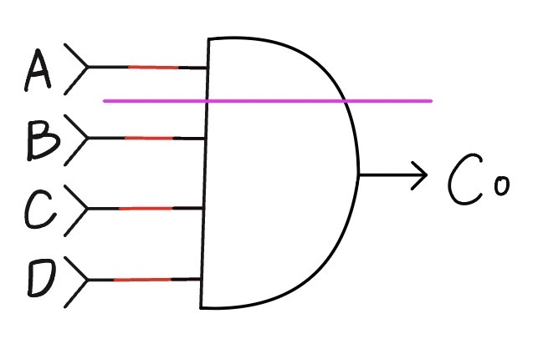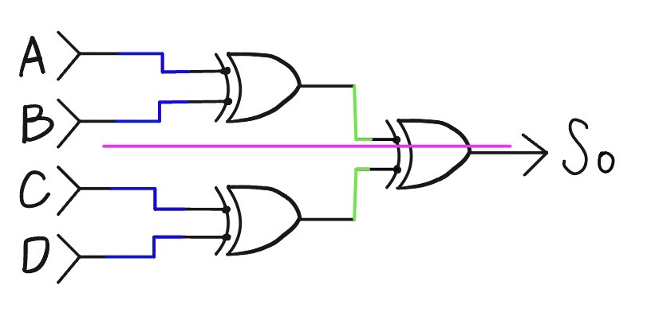邏輯閘電路方塊圖:

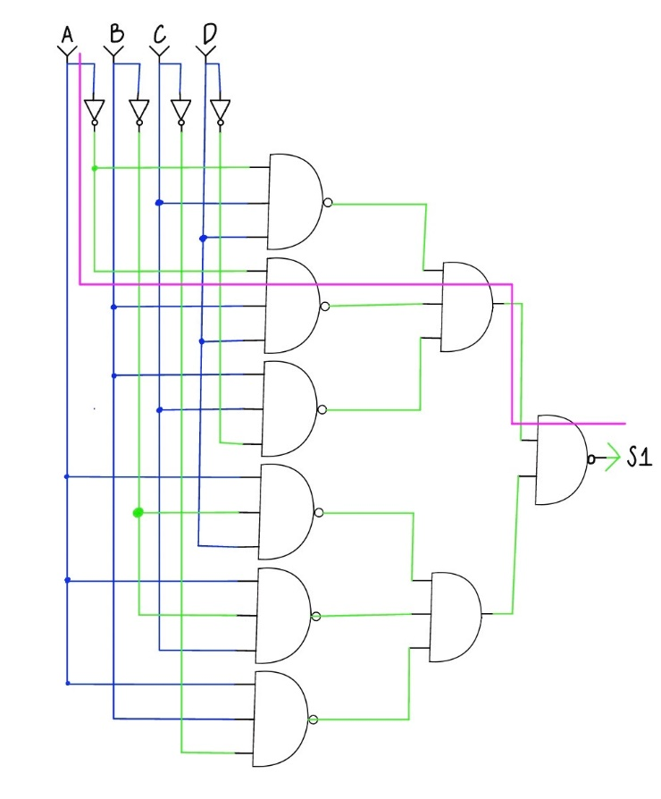

|  |  |
| --- | --- |
| INV | NAND2 |
|  |  |
| NAND3 | AND2 |
|  |  |
| AND3 | AND4 |
|  |  |
| OR2 | XOR |
|  |  |

1. 延遲分析:

Co=and4

S1=xor+xor

S0=inv*2 +and*2+or*2

Co延遲時間 = 164.2ps

S1 延遲時間 = 263.7ps

S0 延遲時間 = 212.1ps

1. 模擬結果:

