1. Creating and Renaming Files/Directories
Create a directory named test_dir using mkdir.
Inside test_dir, create an empty file called example.txt.
Rename example.txt to renamed_example.txt using mv
Ans: mkdir command used to create directory,
mv command used to rename file
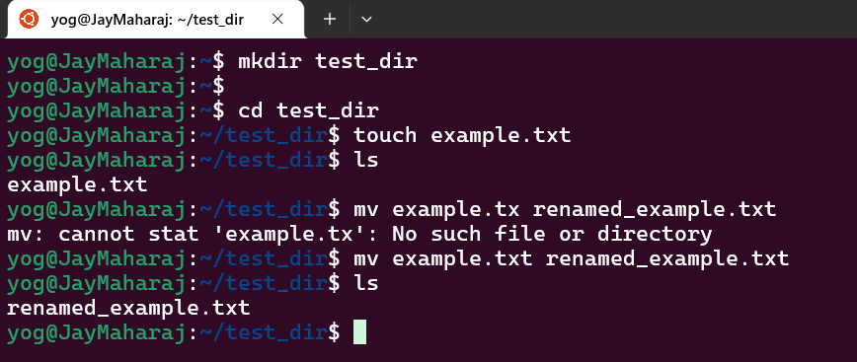
2. Viewing File Contents
Use cat to display the contents of /etc/passwd.
Display only the first 5 lines of /etc/passwd using head.
Display only the last 5 lines of /etc/passwd using tail.

Ans: cat command used to get data from file or use to read text from file. Head and Tail command give us facility to read lines of file either top or bottom.
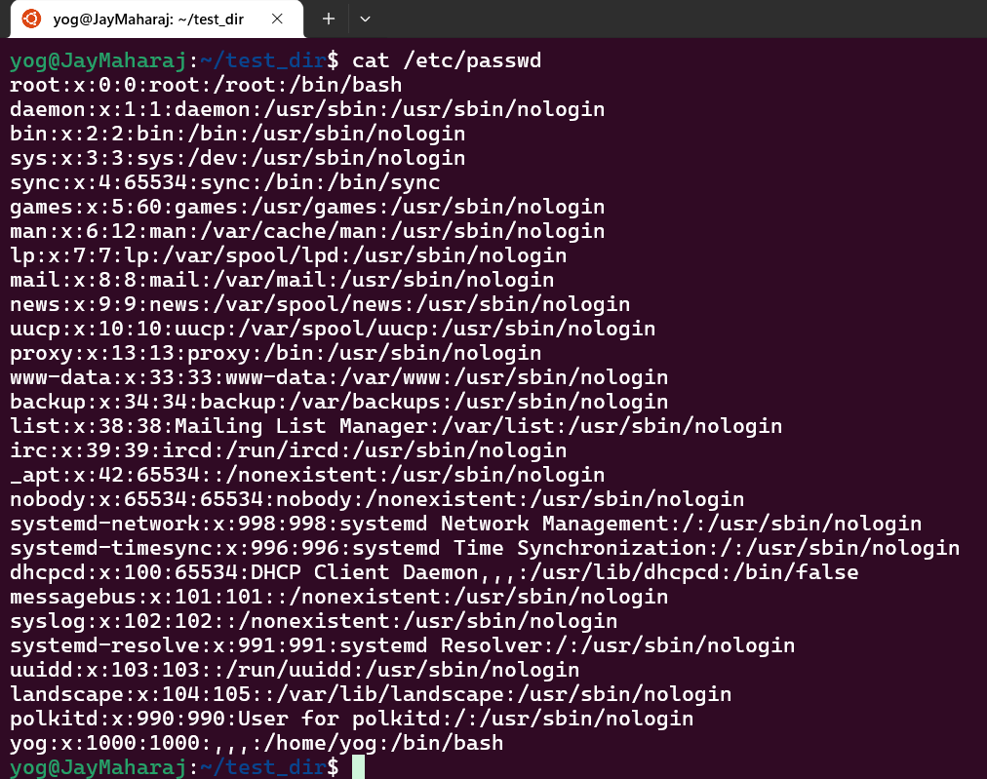
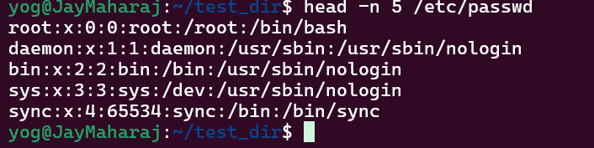
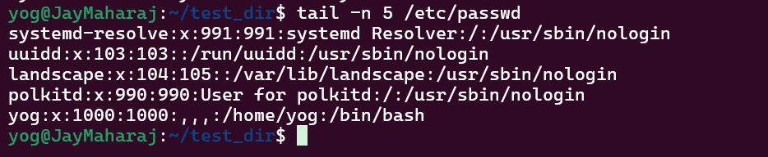

3.Searching for Patterns
Use grep to find all lines containing the word "root" in /etc/passwd.
Ans: grep command allows to filter out specific text (search specific text or pattern) from file.
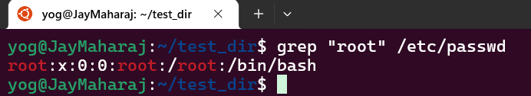

4. Zipping and Unzipping
Compress the test_dir directory into a file named test_dir.zip using zip.
Unzip test_dir.zip into a new directory named unzipped_dir.
Ans:
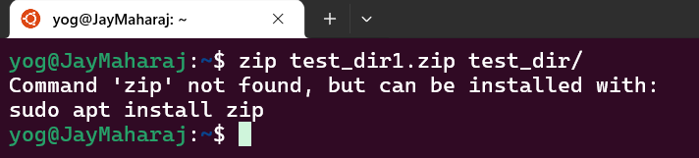
After running command sudo apt install zip unzip issue resolved.

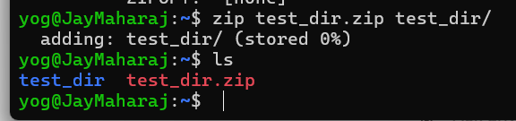
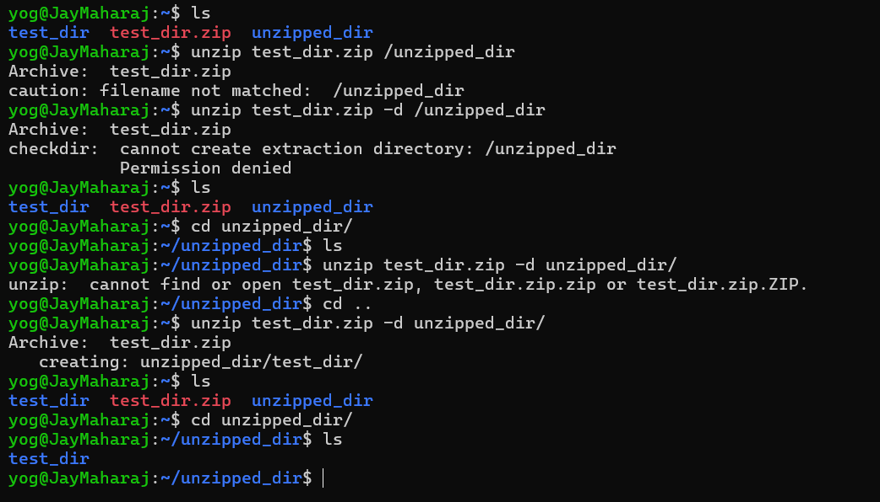
5. Downloading Files
Use wget to download a file from a URL (e.g., https://example.com/sample.txt).

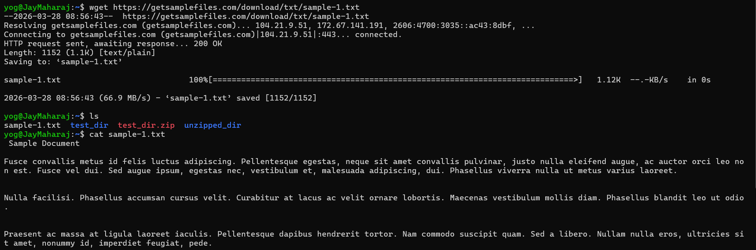

6. Changing Permissions
Create a file named secure.txt and change its permissions to read-only for everyone using chmod.
Ans: In numeric mode number 4 is used for read permission, and 444 is set Read permission for owner, group and others.
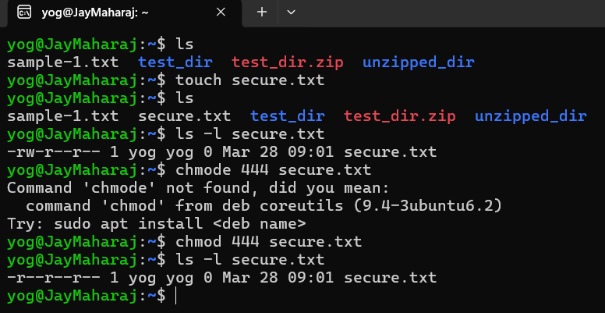

7. Working with Environment Variables
Use export to set a new environment variable called MY_VAR with the value "Hello, Linux!".
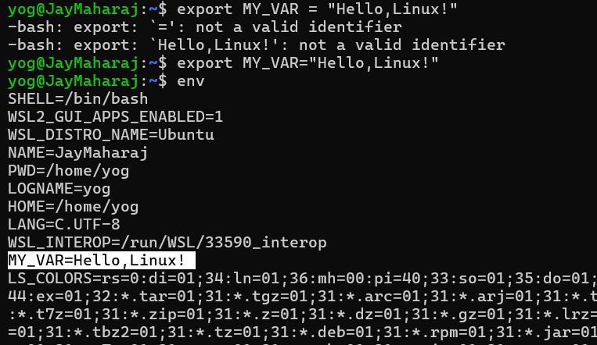

Submission Guidelines -: Attach Screenshots or command along with explanation and submit in doc(google doc or microsoft doc) format also attach github repo link

