Project: Implementing Public Key Infrastructure (PKI) using Active Directory Certificate Services (ADCS)
Overview
I implemented a complete Public Key Infrastructure (PKI) setup by installing and configuring Active Directory Certificate Services (ADCS) on Windows Server 2022.
This project demonstrates my ability to work with enterprise-level security infrastructure, certificate authorities, and server configurations.

Implementing Public Key Infrastructure (PKI) using ADCS
Objective:
To design, configure, and validate a fully functional PKI environment by deploying a Root Certification Authority (CA) using ADCS.
Environment / Tools Used
- Windows Server 2022
- Active Directory Certificate Services (ADCS)
- Server Manager

This project showcases in:
- Implementing PKI security
- Working with Windows Server roles
- Configuring enterprise security infrastructure
- Understanding certificate-based authentication and encryption

Steps I Performed
1️⃣ Installing Certificate Services
- Opened Server Manager and launched Add Roles and Features.
- Selected Role-based installation and the server from the pool.
- Chose Active Directory Certificate Services (ADCS) and enabled required management tools.
- Kept default features and continued with the installation.
- Selected Certification Authority (CA) as the role service.
- Allowed automatic server restart and completed installation.

2️⃣ Configuring Active Directory Certificate Services
- Completed post-deployment configuration using the yellow notification flag in Server Manager.
- Verified credentials and proceeded with configuration.
- Selected:
  - Certification Authority
  - Standalone CA
  - Root CA
- Created a new private key and selected the default cryptographic provider.
- Specified a custom CA name.
- Changed the default certificate validity period from 5 years to 1 year.
- Accepted default database locations.
- Completed and verified CA configuration.

Below are the PKI configuration steps with corresponding screenshots.

Step 1: Open Server Manager and start Add Roles and Features.


Step 2: Choose Role-based installation.
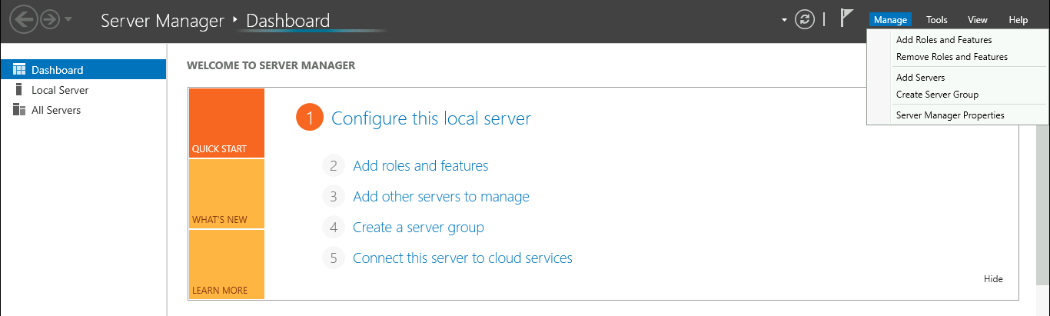

Step 3: Select server from pool.
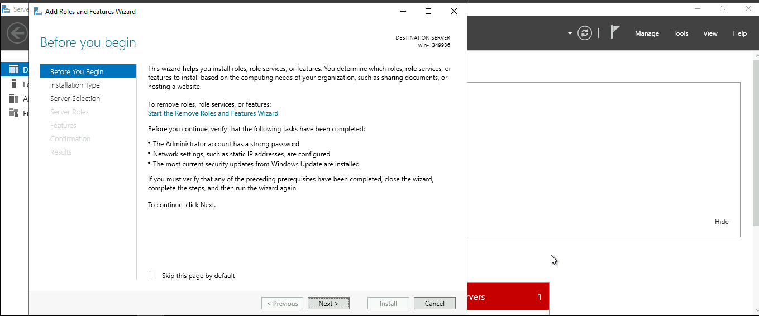

Step 4: Select Active Directory Certificate Services role.
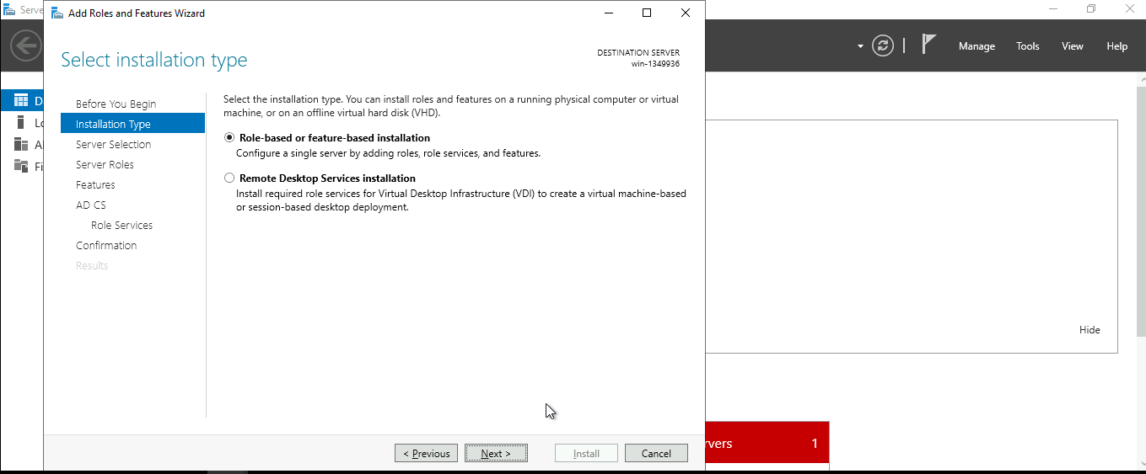

Step 5: Add required features for ADCS.
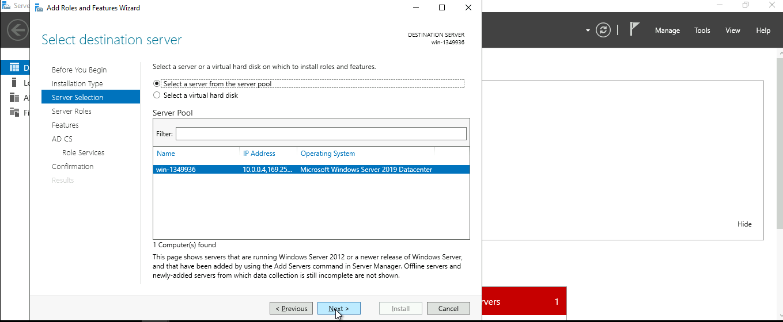

Step 6: Confirm role selection.
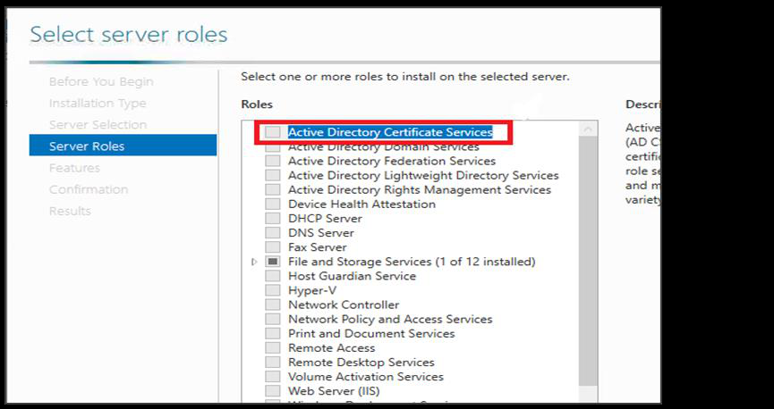

Step 7: Install Certification Authority role service.
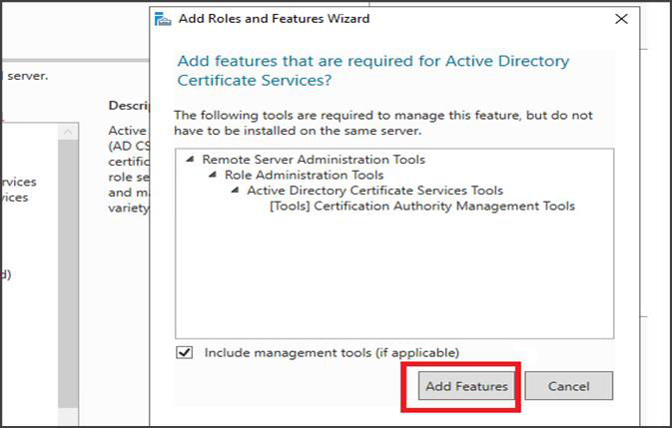

Step 8: Complete installation.
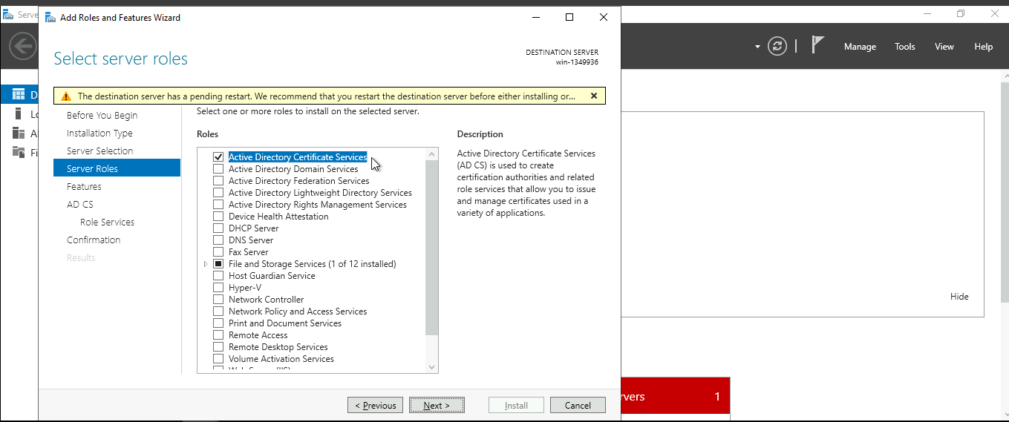

Step 9: Start ADCS post-deployment configuration.
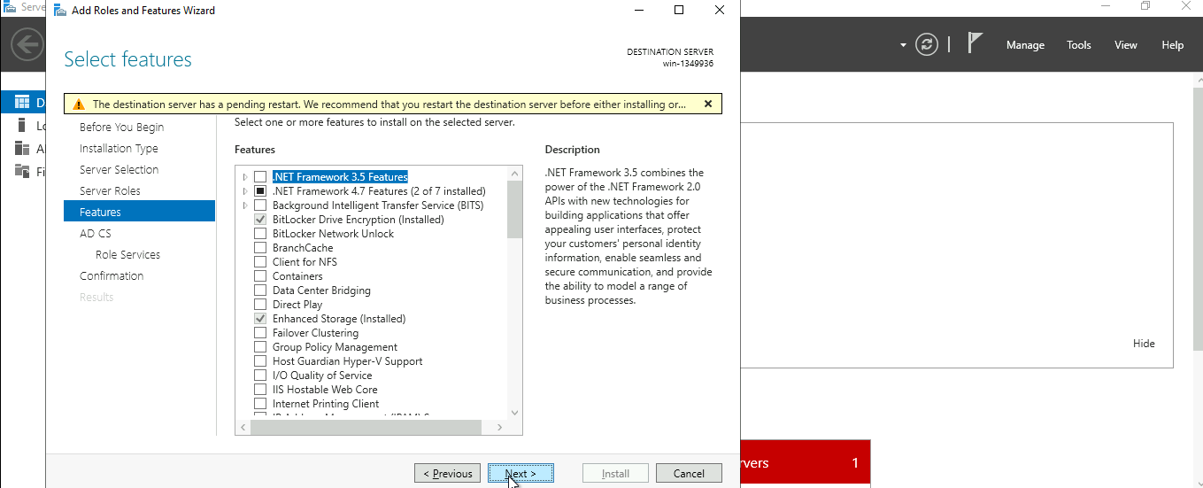

Step 10: Choose Certification Authority.
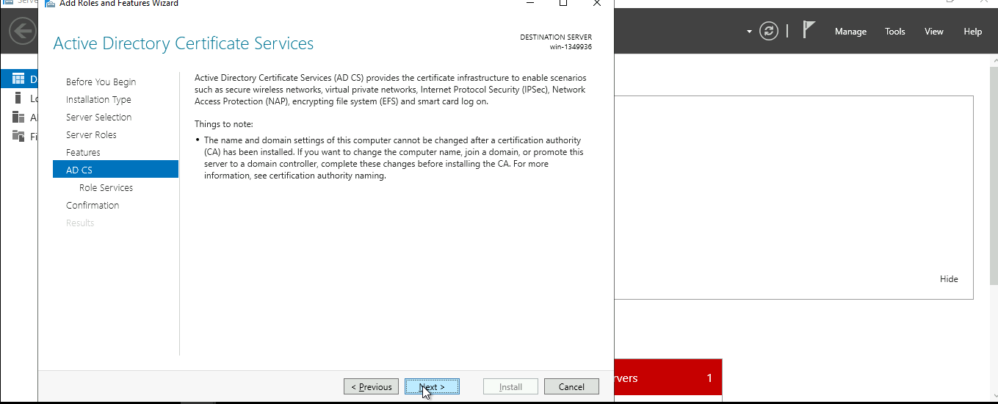

Step 11: Select Standalone CA.
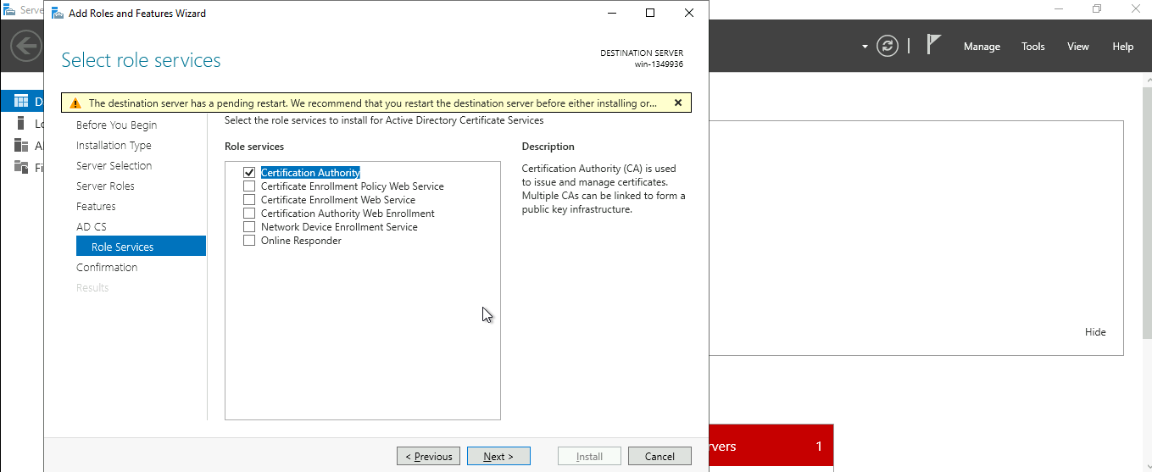

Step 12: Select Root CA.
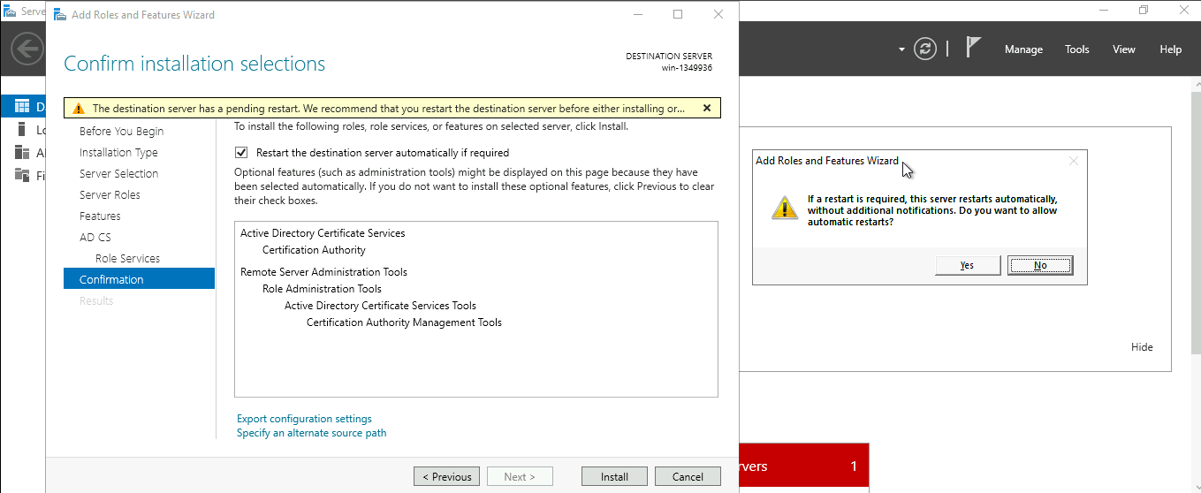

Step 13:Install the selected certificate
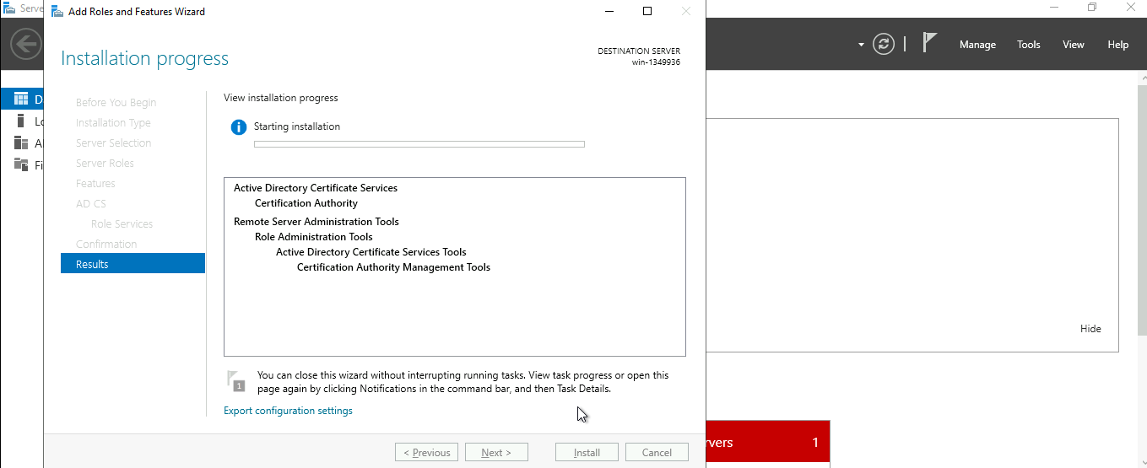

Step 14: install completed
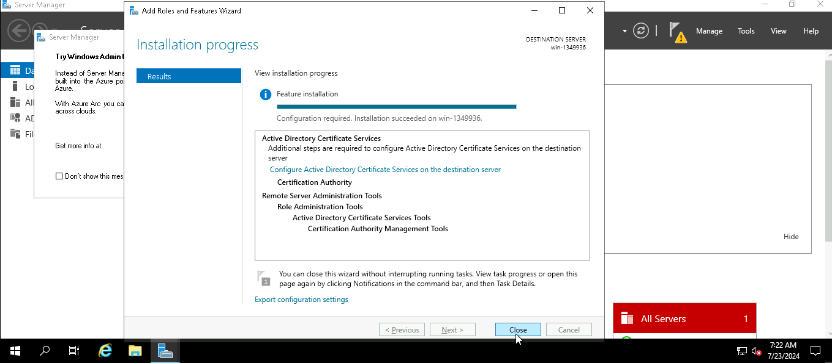

Step 15:
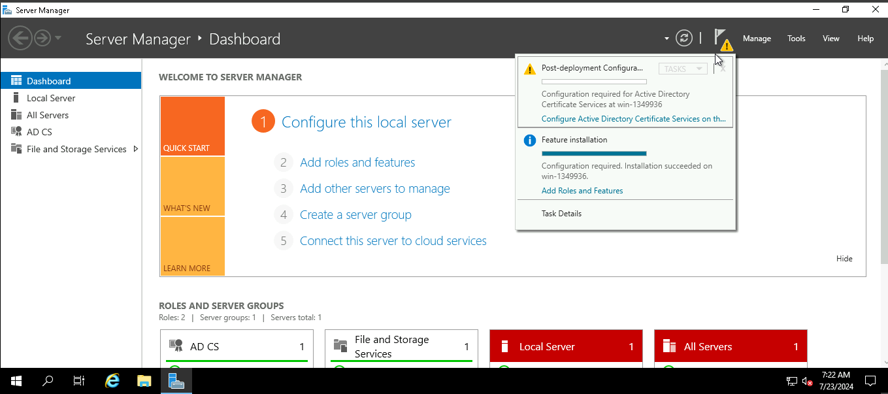

Step 16: Set validity period to 1 year.
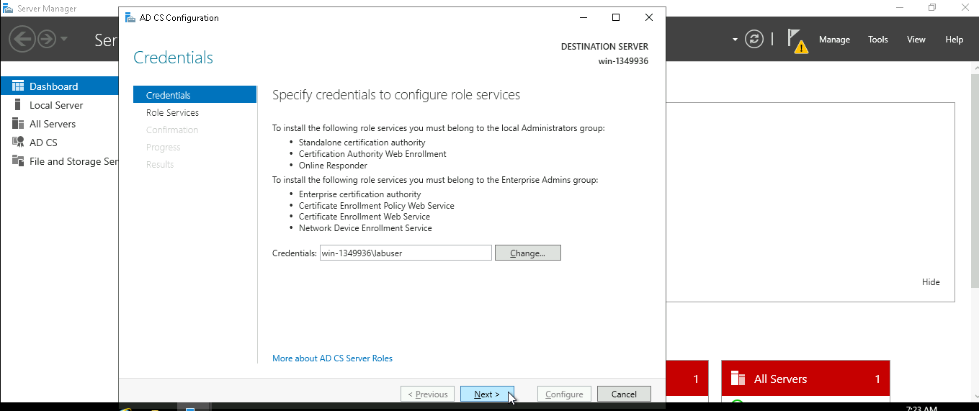

Step 17: Assign CA name.
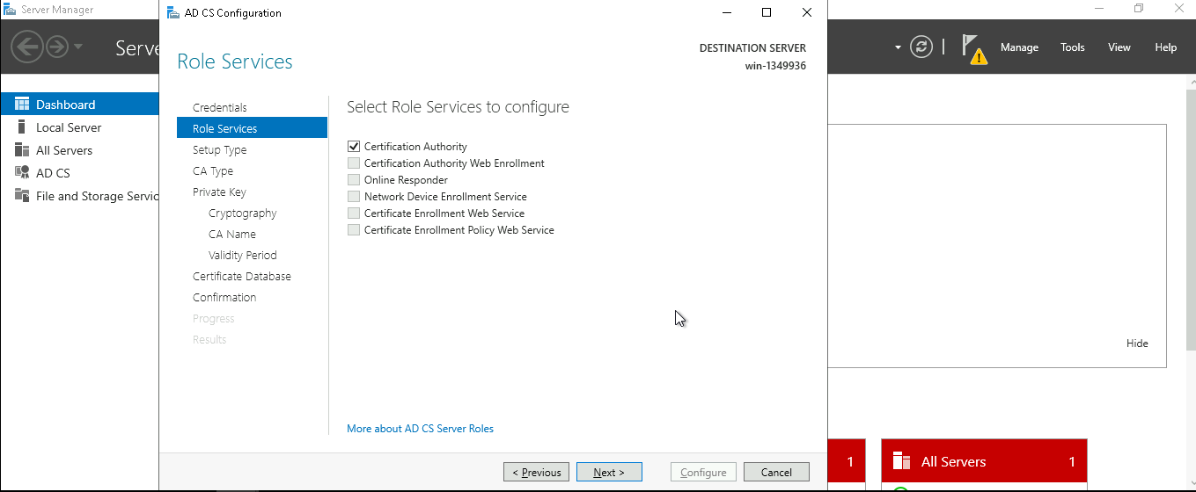

Step 18: Confirm and configure CA.
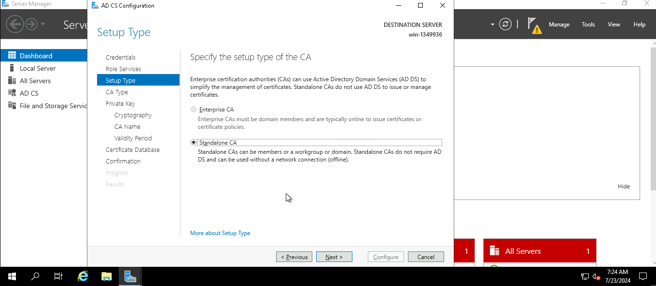

Step 19 : Specificy the type of CA
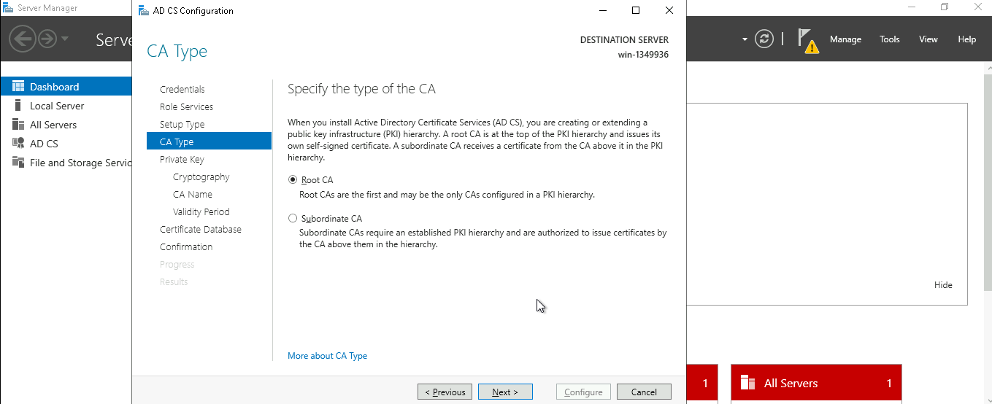

Step 20 :.Create a new private key.
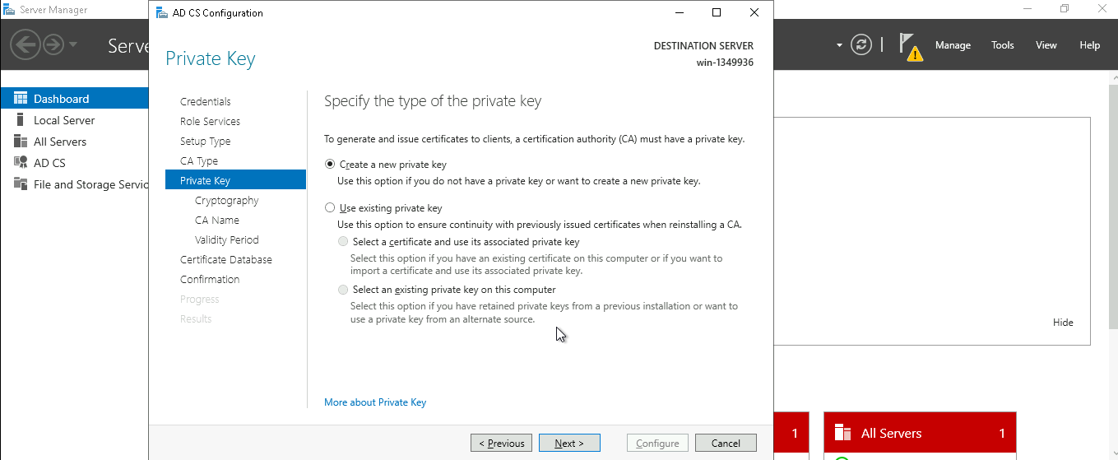

Step 21. Choose cryptographic provider.
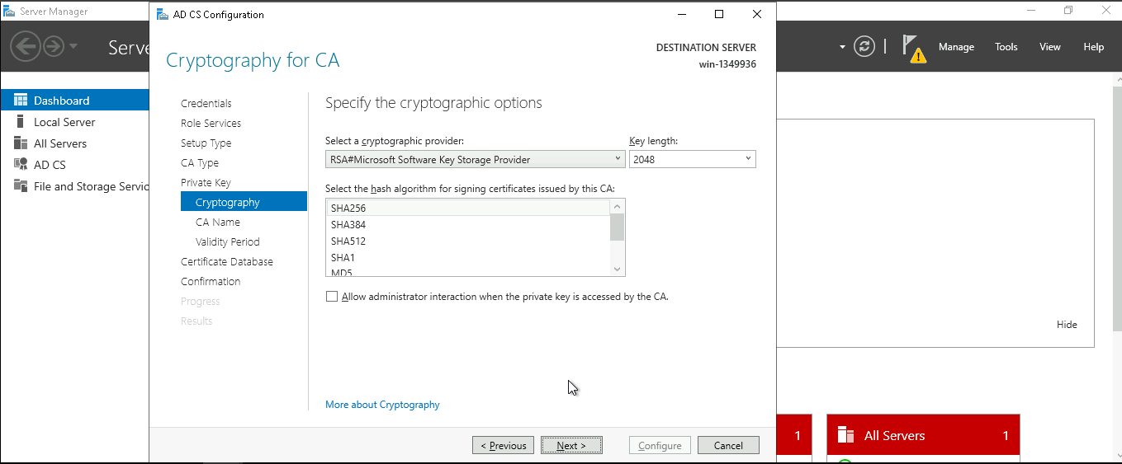

Step 22 : provide the CA name
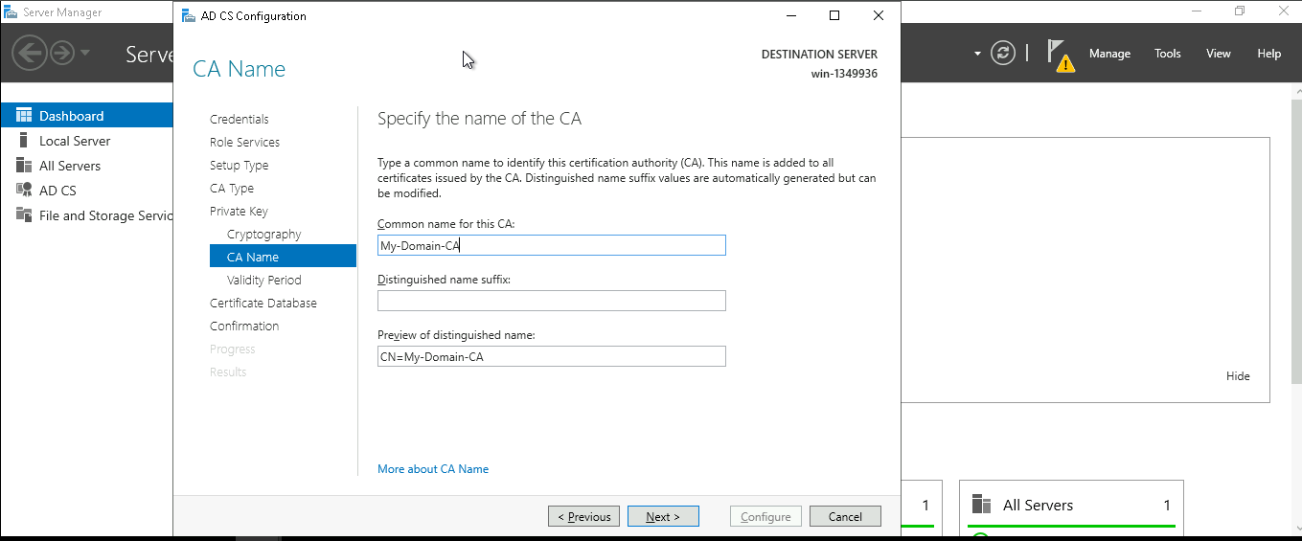

Step 23: Certificate validity period – We’ll ensure this aligns with organization compliance retention policy
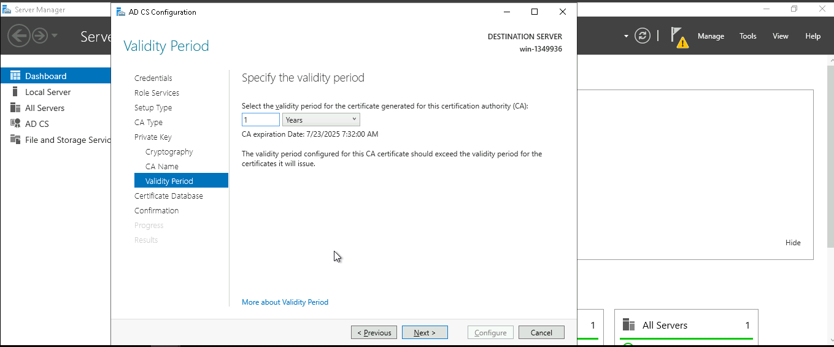

Step 24: Accept database locations.
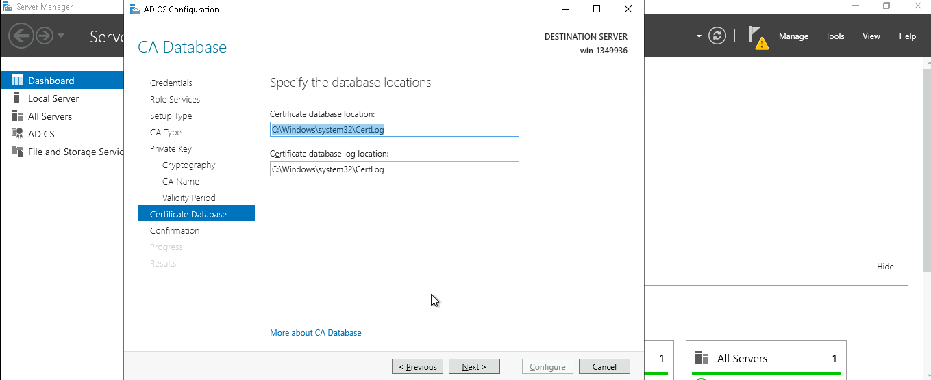

Step 25 Provide confirmation
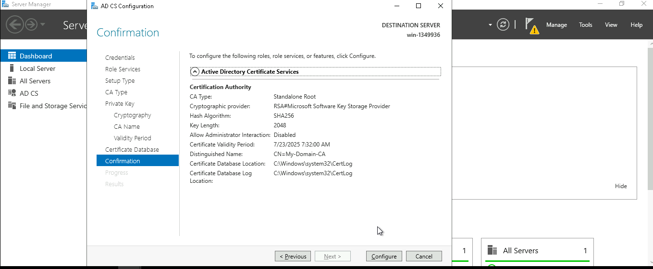

Step 26: Active Directory certificate services installed successfuly
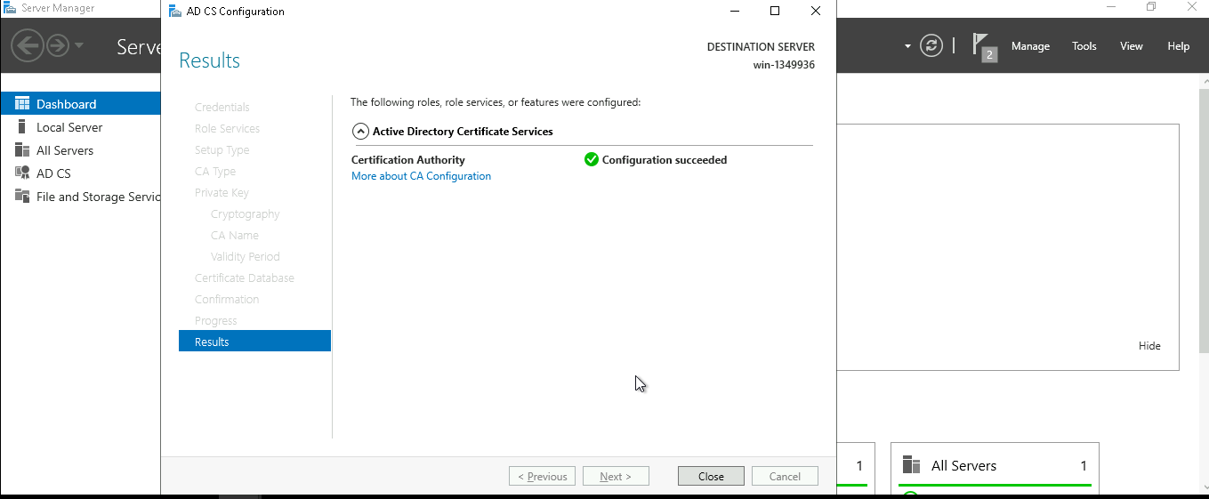
Outcome
Successfully deployed a fully functional Root Certification Authority for issuing and managing digital certificates.
This project strengthened my understanding of:
- PKI concepts
- Certificate issuance and lifecycle
- Root CA management
- Windows Server security components

