**3.6 Test your food search engine (10 pts)**

After finishing all the above functions, the next thing we are interested in is to test our food search engine by some requests from users. Suppose Alice has the following requirements:

1. Find all restaurants which has Japanese food in ’Sha Tin’ district with price-range $50-200.

2. Rank the filtered restaurants by their rating(the higher the better) and break ties by their bad reviews ratio of bad reviews(the lower the better).

Get all the URL of restaurants

../../Desktop/Screen%20Shot%202017-11-30%20at%2022.36.22.p../../Desktop/Screen%20Shot%202017-11-30%20at%2022.40.28.p

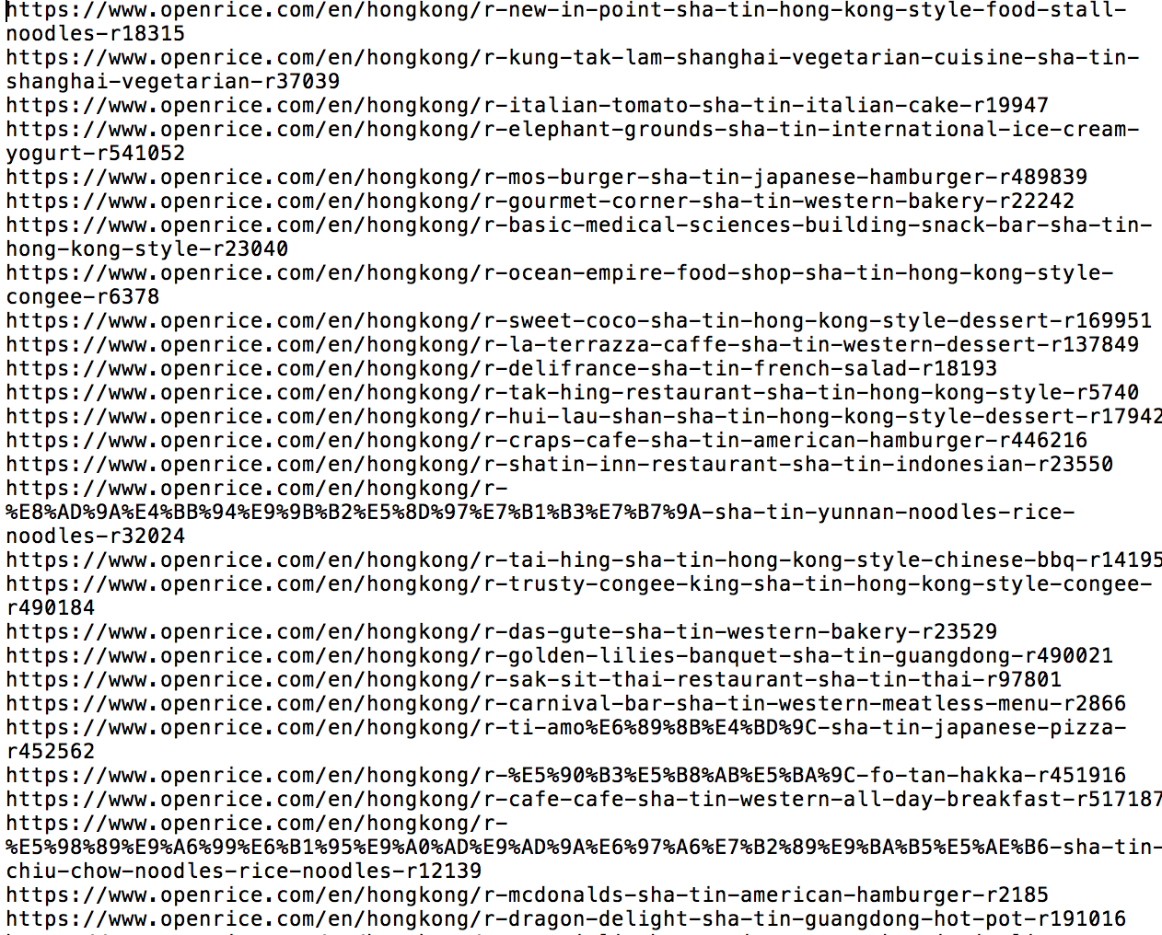

Set filter_data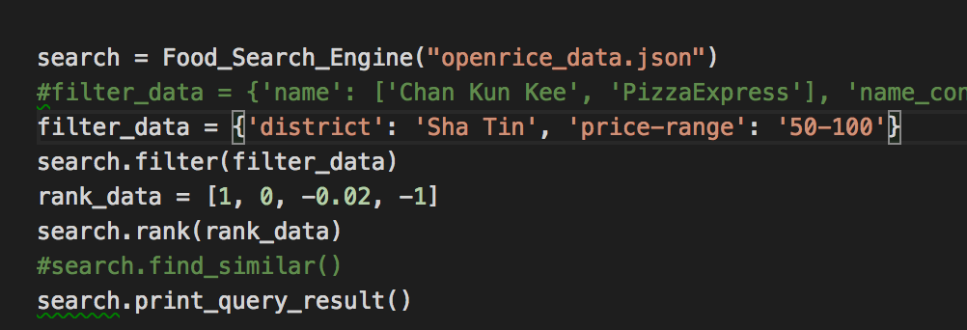

Results after ranking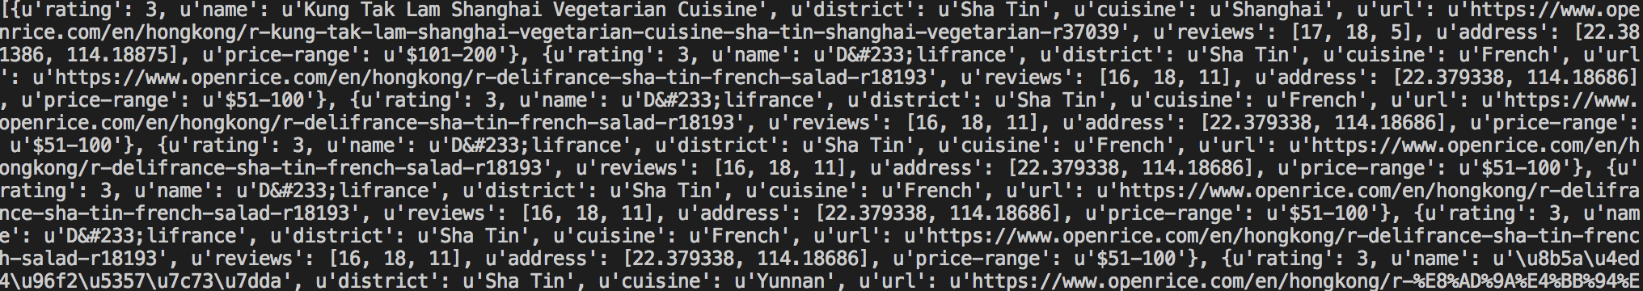

3. (optional) Find top-10 similar restaurants compared with the top-1 restaurant from the previous ranking result.

/

**4.1 Top-10 Most Reviewed Restaurants in Sha Tin (6 pts)**

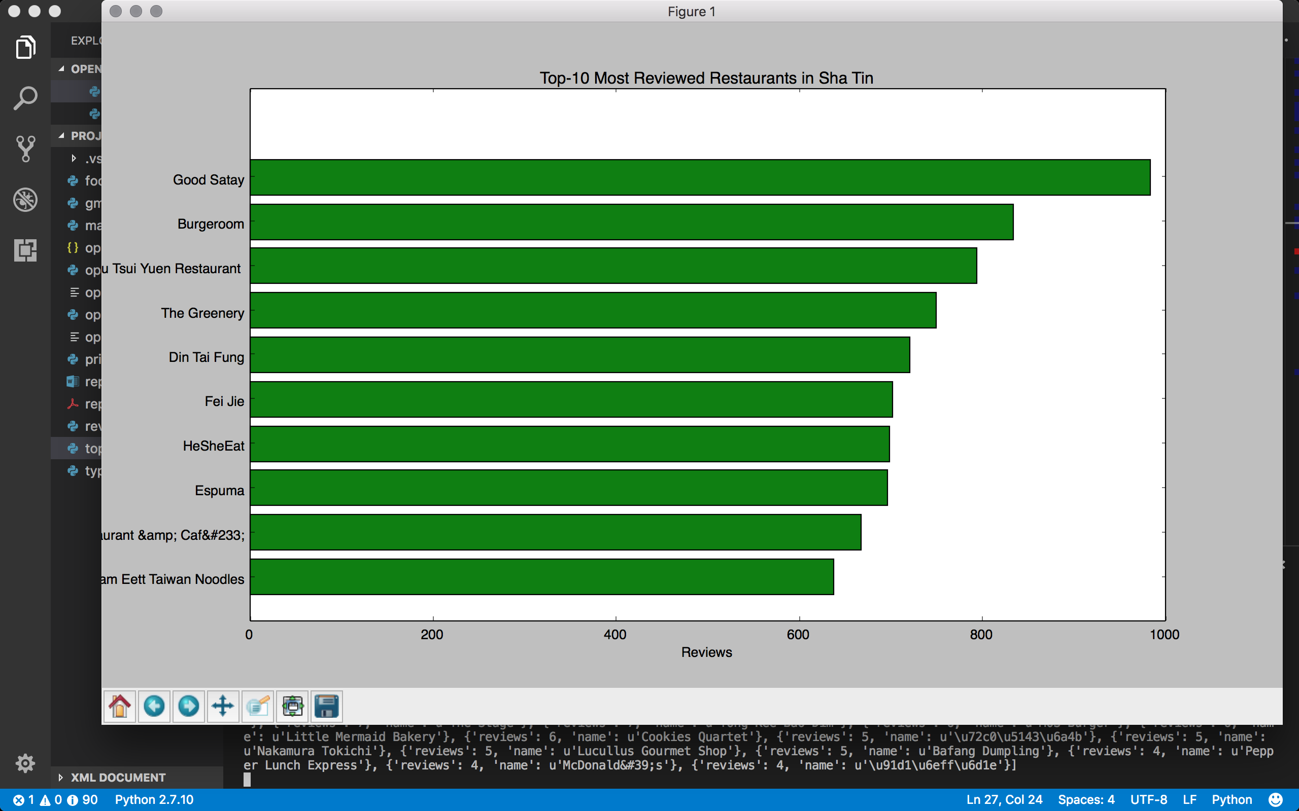

**4.2 The Distribution of Cuisine Types in Mong Kok (6 pts)**

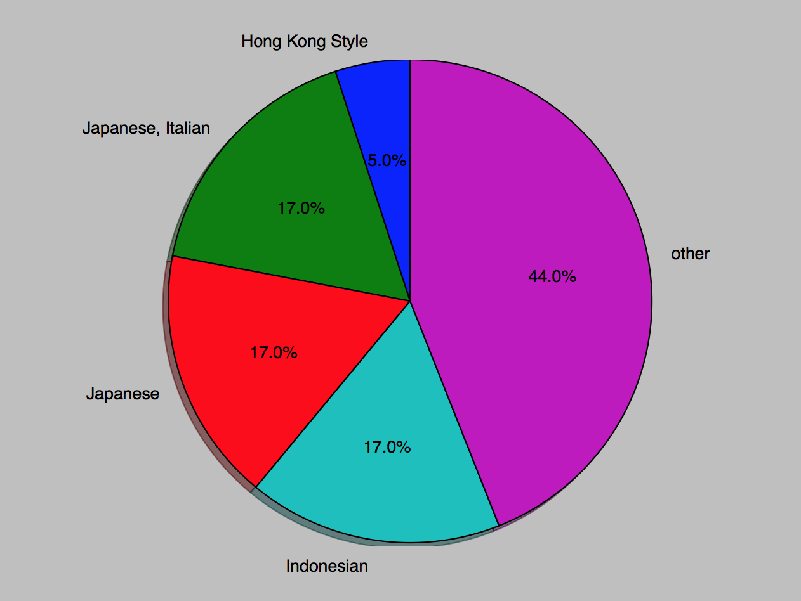

**The major styles are from other counties**

**4.3 Relationship Between Price and Popularity in Hong Kong (6 pts)**

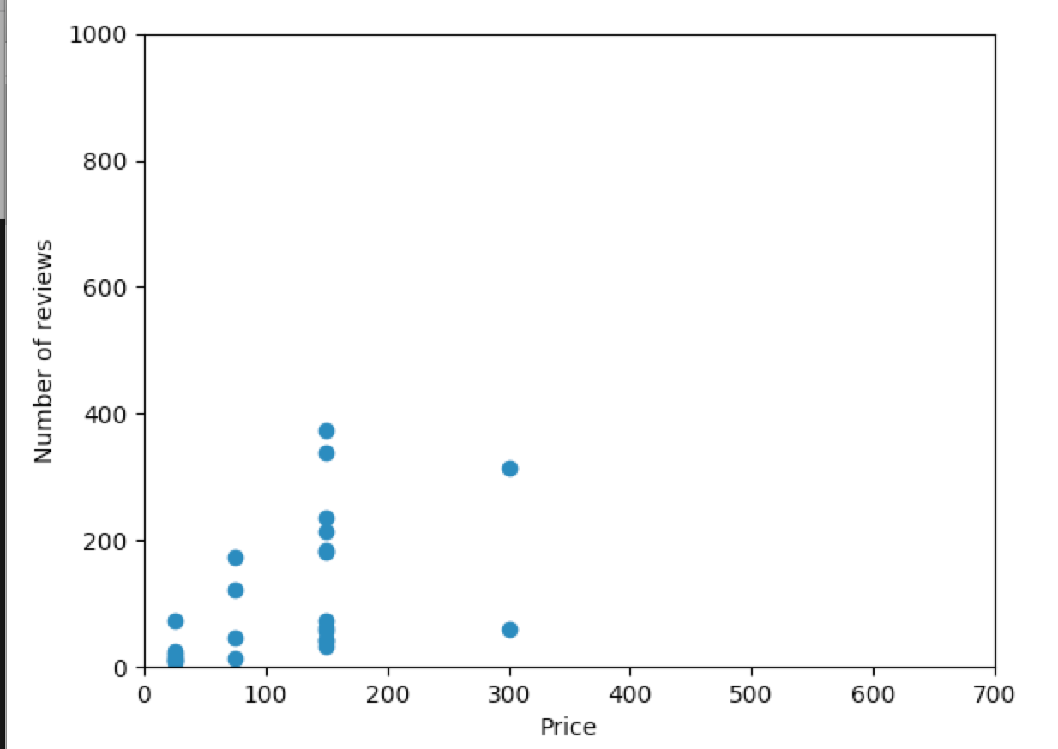

**The price below 200 is the major**

**4.4 The Distribution of the number of reviews in Tsim Sha Tsui (6 pts)**

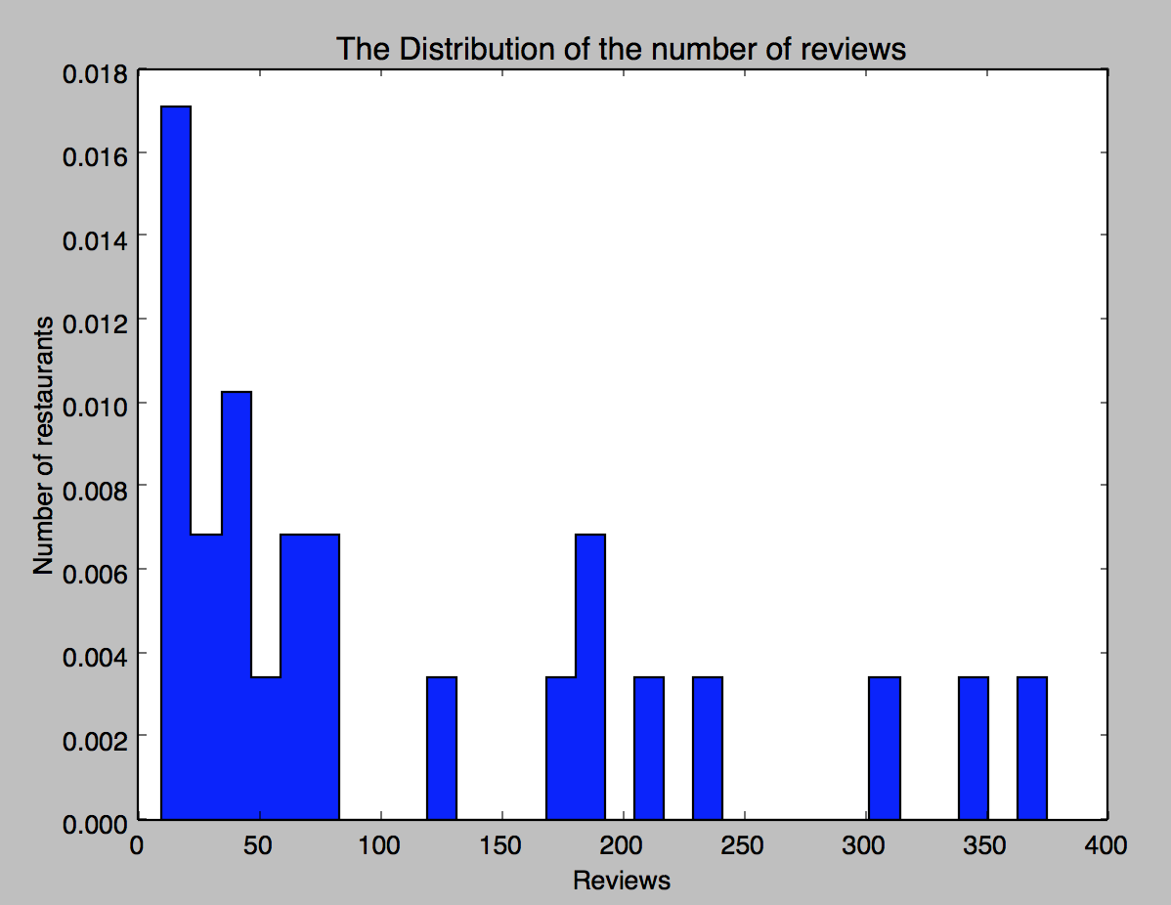

Customers are not willing to give review.

**5.1 Gmplot (10 pts)**

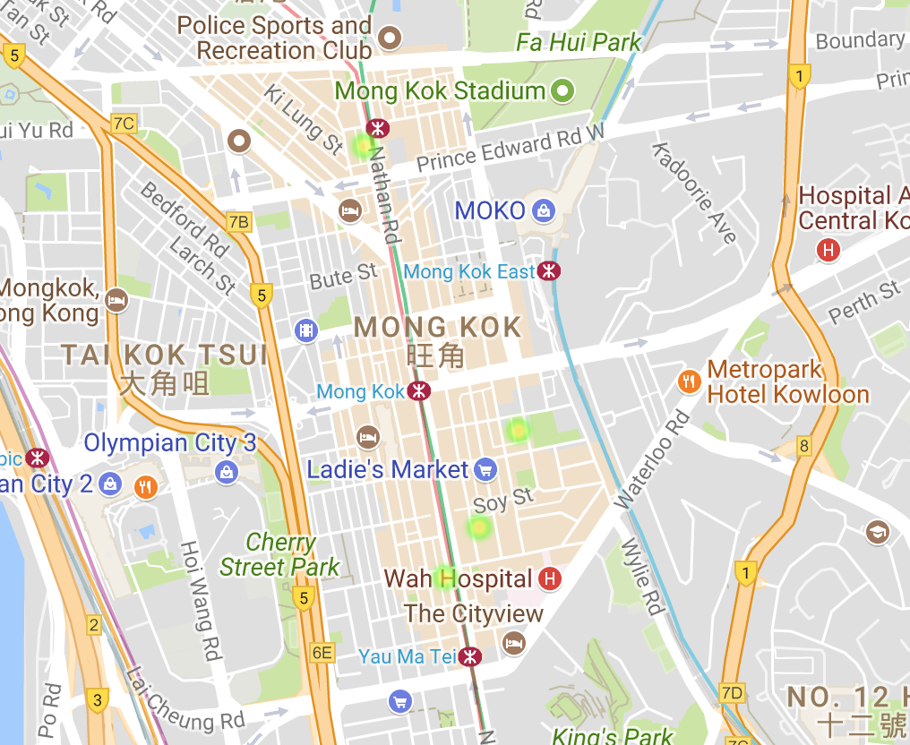

From heat-map, Tsim Sha Tsui will be better because there is less competitor