Software Project Management Plan (SPMP) for Blablabla Project

*Baseline version 0.1*

*Issued on : August 27, 2012*

Issued by : Blabla, Inc.

Issued for : AnotherBlabla Client

**Signature**

The following signature indicates approval of the enclosed Software Project Management Plan.

___________________________________________

AnotherBlabla Client Executive Committee representative

**Change History**

|  |  |  |  |
| --- | --- | --- | --- |
| **Version** | **Date** | **Author** | **Changes** |
| 0.1 | August 27, 2012 | ABlablaName | initial version |
|  |  |  |  |

**Preface**

*Use this part to generally describe the purpose of this document. You don’t have to mention all details about your project, only the general ideas that you consider as important. You also may need to mention which parties are in interest of using this document and why. Following is an example, and you don’t have to completely stick out to this guide. In fact, doing such thing will be considered as cheating which violates the rules that we have discussed at day 1.*

This document delivers the proposed plan to be taken by Blabla, Inc. to meet the needs of software for AnotherBlabla Client. In order to do so, it will deal only with the delivery of the software components in regards to the related project, which have dependencies on the hardware and network portions of the product, which AnotherBlabla Client has been notified beforehand.

This document is created purposely for AnotherBlabla Client executive committee. Prior to the acceptance from AnotherBlabla Client executive committee, this document will be used by AnotherBlabla Client’s project manager as well, and by project members and participants as a guidance to keep things accordingly.

***Important Notes for Soft-copy Viewing***

*At this part, you can mention any information for soft-copy readers. This information can include this document’s file type and its reader software (PDF is recommended). You can also mention special features that you have included for the soft-copy readers.*

**Table of Contents**

**List of Figures**

**List of Tables**

**Chapter 1**

**INRODUCTION**

* 1. **Project Overview**

*The following is an example, which once again you may not copy. Use this as a guide to create your own.*

* + 1. **Purpose, Scope, and Objectives**

The purpose of this project is to analyze the requirements of, design, implement, and maintain the software for AnotherBlabla Client, which is designated specifically to help in monitoring blablablabla according to the requirements specified by the client.

Any activity directly relates to the purpose is considered to be in scope, otherwise it is considered to be out of scope. For instance, hardware failure is out of scope of this project.

The objectives of the project are mentioned as follows :

* Complete the project by the due date
* Complete the project within the budget
* Provide all deliverables identified in section 1.1.3 by the due date
* Meet all the requirements that are mentioned in the SRS, which fall into one of these categories
  + Central database
  + Desktop application
  + Backend
  + …
    1. **Assumptions and Constraints**

Here is the list of all assumptions that are made :

* This project is a component of a larger project
* This project will deliver only the software components of the larger project
* The hardware is not included in this project, and is handled as a different project. Hardware is assumed to be ready at least by the end of this project.

Here is the list of all constraints that are made :

* Budget
  + $100,000
* Time
  + 8 months
  + After the software is installed on the hardware, it will take 30 days for AnotherBlabla Client to install the physical hardware in the permanent location
  + After the physical hardware is permanently installed, AnotherBlabla Client will have 60 days of free maintenance. After that, maintenance fee will not exceed $500 per year.
* Staff
  + A representative from AnotherBlabla Client will be required to assist in the requirements making. This representative will have the full authority in creating the final requirements, which will be evaluated and agreed by Blabla .Inc.
  1. **Project Deliverables**

Here is the list of all items that will be available by the completion of the project.

* Software program, along with its environment and supporting libraries.
* Software documentation
  + Installation documentation
  + End-user documentation
* Installation of software program along with its environment and supporting libraries.
* Software training for users
* Project documentation
  + Software Project Management Plan (SPMP)
  + Software Requirement Specification (SRS)
  + Software Design Description (SDD)
  + Software Test Documentation (STD)
  + Software Test Plan (STP)
  + Software Quality Assurance Plan (SQAP)
  + Software Configuration Management Plan (SCMP)

**Chapter 2**

**PROJECT ORGANIZATION**

1. **Software Process Model**

*Use this part to state what software process model that you choose. Mention any consideration that you put in choosing it. Remember, whatever software process model you choose here should affect the whole project’s run.*

1. **External Intefaces**

*Use this part to mention all project participants who aren’t necessarily in your team (hence external) and yet take parts in larger scale of your project. In order to make it clearer, you can provide this information using a chart. Following is an example of the chart.*

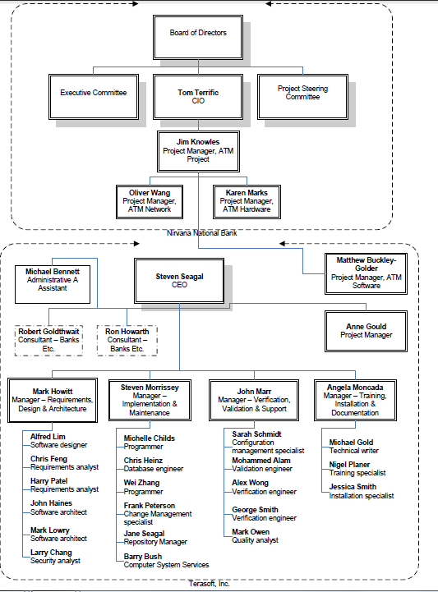

1. **Internal Structure**

*Use this part to mention who are involved in your team as project participants. Following is an example of a chart that gives that information.*

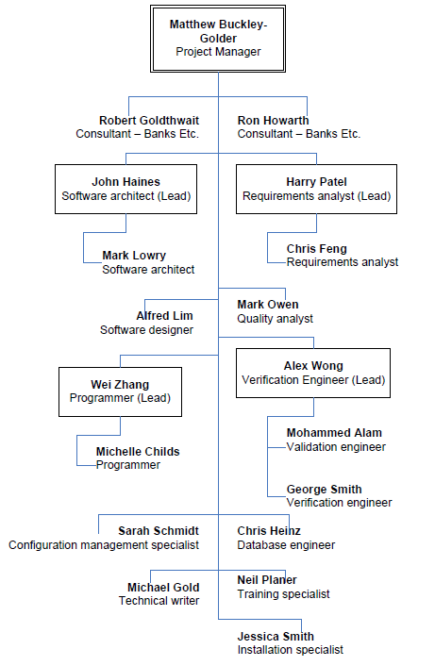

1. **Roles and Responsibilities**

*In general, this part gives information about who will be responsible in doing tasks or deliverables that are needed. As a suggestion, you can use Responsibility Assignment Matrix (RAM). Definition about RAM can be found online or on literature. Following is an example of how RAM looks like. As a side note, you are required to have at least 25 WBS (main WBS), therefore you should at least have 25 ID’s in this table. Every individual that is mentioned in your internal structure (2.3.) must be included in this table as well.*

|  |  |  |  |  |  |  |  |  |
| --- | --- | --- | --- | --- | --- | --- | --- | --- |
| ID | WBS | Deliverables | CEO | Project Manager | Requirement Analyst 1 (Lead) | Requirement Analyst 2 | Programmer 1 (Lead) | … |
|  | 1 | Blabla Project |  |  |  |  |  |  |
|  | 1.1 | Software Lifecycle Model Process |  |  |  |  |  |  |
| 1 | 1.1.1 | Select project model |  | L |  |  |  | … |
| … | … | … | … | … | … | … | … | … |
|  | 1.2.4 | Plan Project Management |  |  |  |  |  |  |
| 13 | 1.2.4.1 | Create baseline WBS |  | L | C |  | C | … |
| … | … | … | … | … | … | … | … | … |
|  | **Key** |  |  |  |  |  |  |  |
|  | A | Approval | 21 | 10 | … | … | … | … |
|  | L | Lead | 4 | 2 | … | … | … | … |
|  | S | Secondary | 0 | 4 | … | … | … | … |
|  | C | Contributor | 0 | … | … | … | … | … |
|  | R | Reviewer | 2 | … | … | … | … | … |

1. **Tools and Techniques**

*Use this part to list all tools and techniques that you will use in this project.*

**Chapter 3**

**PROJECT MANAGEMENT PLAN**

1. **Work Activities**

*In this part, you are required to list all your WBS. Remember, you need to have at least 25 main items, which means your ID here can go (or even, should) more than 25. Following is an example of how your WBS list should look like.*

|  |  |  |  |  |  |
| --- | --- | --- | --- | --- | --- |
| **ID** | **WBS** | **Task Name** | **Duration** | **Predecessors** | **Successors** |
| 1 | 1 | Blabla Project | 250 days |  |  |
| 2 | 1.1 | Software Lifecycle Model Process | 2 days |  |  |
| 3 | 1.1.1 | Select project model | 1 day | 2 |  |
| … | … | … | … | … | … |
| … | … | … | … | … | … |
| 200 | 1.15 | Maintenance | 1 day | 180 | 201 |
| 201 | 1.15.1 | Reapply a software lifecycle | 5 days | 198 |  |

1. **Activity Network**

*Using dependencies that you have from Work Activities above, you are required to make an activity network here. Example of how activity network looks like can be found at TM.*