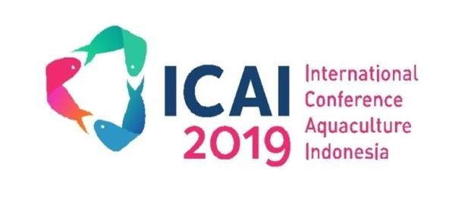
The 9*th International Conference of Aquaculture Indonesia 2019 October 4-5, 2019 – Surabaya, Indonesia
INVOICE # 26-09-2019-

Invoice To:

Participant : ……………………………………..

Description | Quantity | Unit Price | Summary
Participant Reguler of ICAI 2019 | 1 | 2.000.000 | 2.000.000
 | Total IDR |  | 2.000.000
Status | PAID

Regards,

Dhona Indah Kiswari Management Secretariat of ICAI 2019

