EXPERIMENT 4
1. FCFS — fcfs.sh
#!/bin/bash
echo "Enter Number of Processes"
read n
for ((i=0;i<n;i++))
do
echo "Enter Burst Time for P$((i+1))"
read bt[$i]
done
wt[0]=0
for ((i=1;i<n;i++))
do
wt[$i]=$((wt[i-1]+bt[i-1]))
done
echo
echo -e "Process\tBT\tWT\tTAT"
total_wt=0
total_tat=0
for ((i=0;i<n;i++))
do
tat[$i]=$((wt[i]+bt[i]))
total_wt=$((total_wt+wt[i]))
total_tat=$((total_tat+tat[i]))
echo -e "P$((i+1))\t${bt[i]}\t${wt[i]}\t${tat[i]}"
done
avg_wt=$(awk "BEGIN {printf \"%.2f\", $total_wt/$n}")
avg_tat=$(awk "BEGIN {printf \"%.2f\", $total_tat/$n}")
echo
echo "Average Waiting Time = $avg_wt"
echo "Average Turnaround Time = $avg_tat"
1. FCFS — fcfs.c
#include<stdio.h>
int main()
{
int n,i,bt[20],wt[20],tat[20];
float avg_wt=0,avg_tat=0;
printf("Enter Number of Processes: ");
scanf("%d",&n);
for(i=0;i<n;i++)
{
printf("Enter Burst Time for P%d: ",i+1);
scanf("%d",&bt[i]);
}
wt[0]=0;
for(i=1;i<n;i++)
wt[i]=wt[i-1]+bt[i-1];
printf("\nProcess\tBT\tWT\tTAT\n");
for(i=0;i<n;i++)
{
tat[i]=wt[i]+bt[i];
avg_wt+=wt[i];
avg_tat+=tat[i];
printf("P%d\t%d\t%d\t%d\n",i+1,bt[i],wt[i],tat[i]);
}
printf("\nAverage Waiting Time = %.2f",avg_wt/n);
printf("\nAverage Turnaround Time = %.2f\n",avg_tat/n);
return 0;
}
OUTPUT:
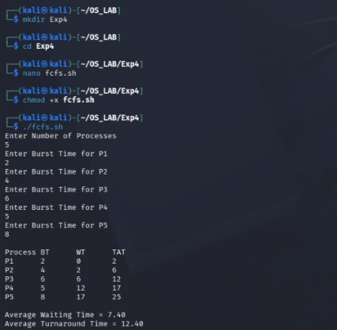
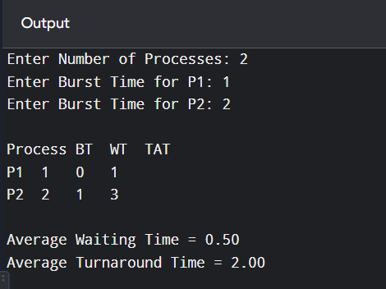
2. SJF — sjf.sh
#!/bin/bash
echo "Enter Number of Processes"
read n
for ((i=0;i<n;i++))
do
echo "Enter Burst Time for P$((i+1))"
read bt[$i]
done
for ((i=0;i<n-1;i++))
do
for ((j=i+1;j<n;j++))
do
if [ ${bt[i]} -gt ${bt[j]} ]
then
temp=${bt[i]}
bt[$i]=${bt[j]}
bt[$j]=$temp
fi
done
done
wt[0]=0
echo
echo -e "Process\tBT\tWT\tTAT"
total_wt=0
total_tat=0
for ((i=0;i<n;i++))
do
if [ $i -ne 0 ]
then
wt[$i]=$((wt[i-1]+bt[i-1]))
fi
tat[$i]=$((wt[i]+bt[i]))
total_wt=$((total_wt+wt[i]))
total_tat=$((total_tat+tat[i]))
echo -e "P$((i+1))\t${bt[i]}\t${wt[i]}\t${tat[i]}"
done
avg_wt=$(awk "BEGIN {printf \"%.2f\", $total_wt/$n}")
avg_tat=$(awk "BEGIN {printf \"%.2f\", $total_tat/$n}")
echo
echo "Average Waiting Time = $avg_wt"
echo "Average Turnaround Time = $avg_tat"
2. SJF — sjf.c
#include<stdio.h>
int main()
{
int n,i,j,temp,bt[20],wt[20],tat[20];
float avg_wt=0,avg_tat=0;
printf("Enter Number of Processes: ");
scanf("%d",&n);
for(i=0;i<n;i++)
{
printf("Enter Burst Time for P%d: ",i+1);
scanf("%d",&bt[i]);
}
for(i=0;i<n-1;i++)
for(j=i+1;j<n;j++)
if(bt[i]>bt[j])
{
temp=bt[i];
bt[i]=bt[j];
bt[j]=temp;
}
wt[0]=0;
for(i=1;i<n;i++)
wt[i]=wt[i-1]+bt[i-1];
printf("\nProcess\tBT\tWT\tTAT\n");
for(i=0;i<n;i++)
{
tat[i]=wt[i]+bt[i];
avg_wt+=wt[i];
avg_tat+=tat[i];
printf("P%d\t%d\t%d\t%d\n",i+1,bt[i],wt[i],tat[i]);
}
printf("\nAverage Waiting Time = %.2f",avg_wt/n);
printf("\nAverage Turnaround Time = %.2f\n",avg_tat/n);
return 0;
}
OUTPUT:
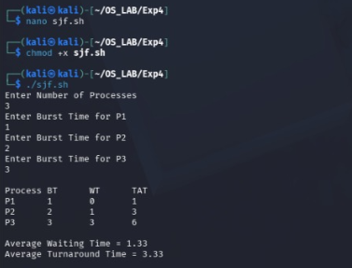
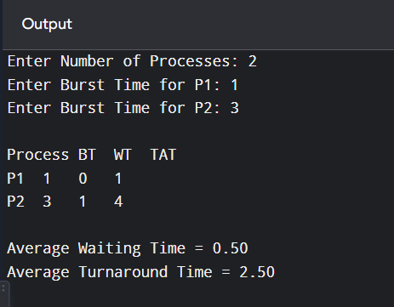
3. Priority — priority.sh
#!/bin/bash
echo "Enter Number of Processes"
read n
for ((i=0;i<n;i++))
do
echo "Enter Burst Time for P$((i+1))"
read bt[$i]
echo "Enter Priority for P$((i+1))"
read pr[$i]
done
for ((i=0;i<n-1;i++))
do
for ((j=i+1;j<n;j++))
do
if [ ${pr[i]} -gt ${pr[j]} ]
then
temp=${pr[i]}
pr[$i]=${pr[j]}
pr[$j]=$temp
temp=${bt[i]}
bt[$i]=${bt[j]}
bt[$j]=$temp
fi
done
done
wt[0]=0
echo
echo -e "Process\tPriority\tBT\tWT\tTAT"
total_wt=0
total_tat=0
for ((i=0;i<n;i++))
do
if [ $i -ne 0 ]
then
wt[$i]=$((wt[i-1]+bt[i-1]))
fi
tat[$i]=$((wt[i]+bt[i]))
total_wt=$((total_wt+wt[i]))
total_tat=$((total_tat+tat[i]))
echo -e "P$((i+1))\t${pr[i]}\t\t${bt[i]}\t${wt[i]}\t${tat[i]}"
done
avg_wt=$(awk "BEGIN {printf \"%.2f\", $total_wt/$n}")
avg_tat=$(awk "BEGIN {printf \"%.2f\", $total_tat/$n}")
echo
echo "Average Waiting Time = $avg_wt"
echo "Average Turnaround Time = $avg_tat"
3. Priority — priority.c
#include<stdio.h>
int main()
{
int n,i,j,temp,bt[20],pr[20],wt[20],tat[20];
float avg_wt=0,avg_tat=0;
printf("Enter Number of Processes: ");
scanf("%d",&n);
for(i=0;i<n;i++)
{
printf("Enter Burst Time for P%d: ",i+1);
scanf("%d",&bt[i]);
printf("Enter Priority for P%d: ",i+1);
scanf("%d",&pr[i]);
}
for(i=0;i<n-1;i++)
for(j=i+1;j<n;j++)
if(pr[i]>pr[j])
{
temp=pr[i]; pr[i]=pr[j]; pr[j]=temp;
temp=bt[i]; bt[i]=bt[j]; bt[j]=temp;
}
wt[0]=0;
for(i=1;i<n;i++)
wt[i]=wt[i-1]+bt[i-1];
printf("\nProcess\tPriority\tBT\tWT\tTAT\n");
for(i=0;i<n;i++)
{
tat[i]=wt[i]+bt[i];
avg_wt+=wt[i];
avg_tat+=tat[i];
printf("P%d\t%d\t\t%d\t%d\t%d\n",i+1,pr[i],bt[i],wt[i],tat[i]);
}
printf("\nAverage Waiting Time = %.2f",avg_wt/n);
printf("\nAverage Turnaround Time = %.2f\n",avg_tat/n);
return 0;
}
OUTPUT:
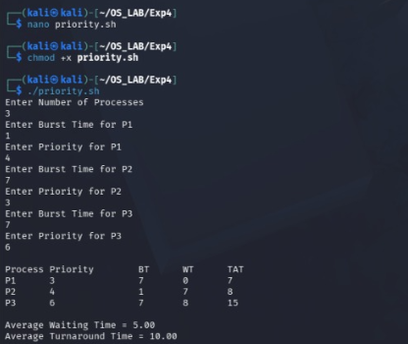
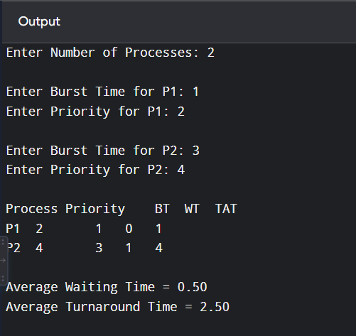

4. Round Robin — rr.sh
#!/bin/bash
echo "Enter Number of Processes"
read n
for ((i=0;i<n;i++))
do
echo "Enter Burst Time for P$((i+1))"
read bt[$i]
rem_bt[$i]=${bt[$i]}
done
echo "Enter Time Quantum"
read tq
time=0
while true
do
done=1
for ((i=0;i<n;i++))
do
if [ ${rem_bt[i]} -gt 0 ]
then
done=0
if [ ${rem_bt[i]} -gt $tq ]
then
time=$((time+tq))
rem_bt[$i]=$((rem_bt[i]-tq))
else
time=$((time+rem_bt[i]))
wt[$i]=$((time-bt[i]))
rem_bt[$i]=0
fi
fi
done
[ $done -eq 1 ] && break
done
echo
echo -e "Process\tBT\tWT\tTAT"
total_wt=0
total_tat=0
for ((i=0;i<n;i++))
do
tat[$i]=$((bt[i]+wt[i]))
total_wt=$((total_wt+wt[i]))
total_tat=$((total_tat+tat[i]))
echo -e "P$((i+1))\t${bt[i]}\t${wt[i]}\t${tat[i]}"
done
avg_wt=$(awk "BEGIN {printf \"%.2f\", $total_wt/$n}")
avg_tat=$(awk "BEGIN {printf \"%.2f\", $total_tat/$n}")
echo
echo "Average Waiting Time = $avg_wt"
echo "Average Turnaround Time = $avg_tat"
4. Round Robin — rr.c
#include<stdio.h>
int main()
{
int n,tq,i,bt[20],rem_bt[20],wt[20]={0},tat[20],time=0,done;
float avg_wt=0,avg_tat=0;
printf("Enter Number of Processes: ");
scanf("%d",&n);
for(i=0;i<n;i++)
{
printf("Enter Burst Time for P%d: ",i+1);
scanf("%d",&bt[i]);
rem_bt[i]=bt[i];
}
printf("Enter Time Quantum: ");
scanf("%d",&tq);
do
{
done=1;
for(i=0;i<n;i++)
if(rem_bt[i]>0)
{
done=0;
if(rem_bt[i]>tq)
{
time+=tq;
rem_bt[i]-=tq;
}
else
{
time+=rem_bt[i];
wt[i]=time-bt[i];
rem_bt[i]=0;
}
}
}while(!done);
printf("\nProcess\tBT\tWT\tTAT\n");
for(i=0;i<n;i++)
{
tat[i]=bt[i]+wt[i];
avg_wt+=wt[i];
avg_tat+=tat[i];
printf("P%d\t%d\t%d\t%d\n",i+1,bt[i],wt[i],tat[i]);
}
printf("\nAverage Waiting Time = %.2f",avg_wt/n);
printf("\nAverage Turnaround Time = %.2f\n",avg_tat/n);
return 0;
}
OUTPUT:
