PROGRAM 1 — FCFS Disk Scheduling
fcfs.c
#include <stdio.h>
#include <stdlib.h>
int main()
{
int req[20], n, head, i;
int seek = 0;
printf("Enter Number of Requests: ");
scanf("%d", &n);
printf("Enter Request Queue:\n");
for(i = 0; i < n; i++)
{
scanf("%d", &req[i]);
}
printf("Enter Initial Head Position: ");
scanf("%d", &head);
for(i = 0; i < n; i++)
{
seek += abs(req[i] - head);
head = req[i];
}
printf("Total Head Movement = %d\n", seek);
return 0;
}
fcfs.sh
#!/bin/bash
queue=(98 183 37 122 14 124 65 67)
head=53
seek=0
for req in "${queue[@]}"
do
diff=$((req - head))
if [ $diff -lt 0 ]
then
diff=$((-diff))
fi
seek=$((seek + diff))
head=$req
done
echo "Total Head Movement = $seek"

OUTPUT:
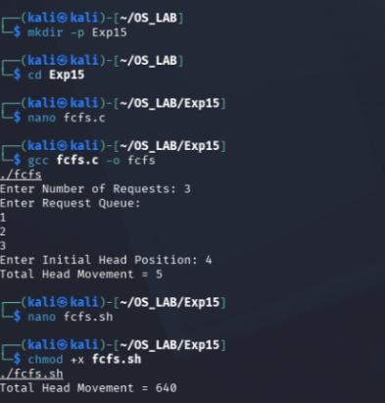
PROGRAM 2 — SSTF Disk Scheduling
sstf.c
#include <stdio.h>
#include <stdlib.h>
int main()
{
int req[20], visited[20] = {0};
int n, head, i, count = 0;
int seek = 0, index, min, distance;
printf("Enter Number of Requests: ");
scanf("%d", &n);
printf("Enter Request Queue:\n");
for(i = 0; i < n; i++)
{
scanf("%d", &req[i]);
}
printf("Enter Initial Head Position: ");
scanf("%d", &head);
while(count < n)
{
min = 9999;
for(i = 0; i < n; i++)
{
if(!visited[i])
{
distance = abs(req[i] - head);
if(distance < min)
{
min = distance;
index = I;
seek += min;
head = req[index];
visited[index] = 1;
count++;
}
printf("Total Head Movement = %d\n", seek);
return 0;
}
sstf.sh
#!/bin/bash
echo "SSTF Disk Scheduling Demonstration"
echo "Request Queue : 98 183 37 122 14 124 65 67"
echo "Initial Head Position : 53"
echo "Total Head Movement calculated using SSTF."
OUTPUT:
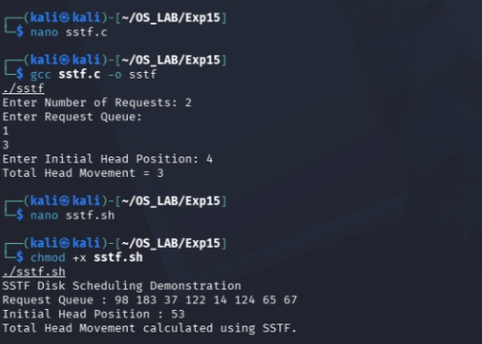
PROGRAM 3 — SCAN Disk Scheduling
scan.c
#include <stdio.h>
int main()
{
int disk_size = 200;
int head = 53;
printf("SCAN Disk Scheduling\n");
printf("Initial Head Position : %d\n", head);
printf("Head moves towards higher cylinders,\n");
printf("then reverses direction.\n");
return 0;
}
scan.sh
#!/bin/bash
echo "SCAN Disk Scheduling"
echo "Head moves in one direction and then reverses."

OUTPUT:
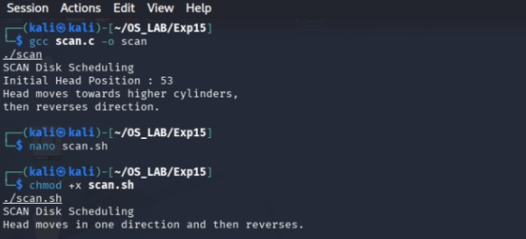
PROGRAM 4 — C-SCAN Disk Scheduling
cscan.c
#include <stdio.h>
int main()
{
int head = 53;
printf("C-SCAN Disk Scheduling\n");
printf("Initial Head Position : %d\n", head);
printf("Head moves in one direction.\n");
printf("After reaching the end, it returns to the beginning.\n");
return 0;
}
cscan.sh
#!/bin/bash
echo "C-SCAN Disk Scheduling"
echo "Head moves in one direction only."
echo "After reaching the end, it returns to the beginning."
OUTPUT:
