EXPERIMENT 3
1. Process Creation — process.c
#include <stdio.h>
#include <stdlib.h>
#include <unistd.h>
#include <sys/wait.h>

int main()
{
pid_t pid;
pid=fork();

if(pid<0)
{
printf("Fork Failed\n");
exit(1);
}
else if(pid==0)
{
printf("\nCHILD PROCESS");
printf("\nChild PID : %d",getpid());
printf("\nParent PID : %d\n",getppid());
exit(0);
}
else
{
wait(NULL);
printf("\nPARENT PROCESS");
printf("\nParent PID : %d",getpid());
printf("\nParent's Parent PID : %d\n",getppid());
}
return 0;
}
Shell Script — process.sh
#!/bin/bash
echo "Parent Process ID : $$"
(
echo "Child Process ID : $$"
echo "Parent Process ID : $PPID"
exit 0
) &
wait
echo "Child Process Completed"
OUTPUT:
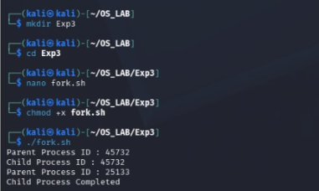
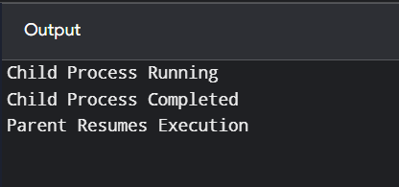
2. WAIT() System Call
#include <stdio.h>
#include <unistd.h>
#include <sys/wait.h>

int main()
{
pid_t pid;
pid=fork();

if(pid==0)
{
printf("Child Process Running\n");
sleep(5);
printf("Child Process Completed\n");
}
else
{
wait(NULL);
printf("Parent Resumes Execution\n");
return 0;
}
Shell Script
#!/bin/bash(
echo "Child Process Running"
sleep 5
echo "Child Process Completed"
) &wait
echo "Parent Resumes Execution"
OUTPUT:
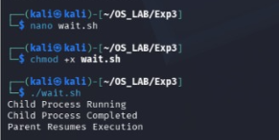

3. CLOSE() System Call
#include <stdio.h>
#include <fcntl.h>
#include <unistd.h>

int main()
{
int fd;
fd=open("sample.txt",O_RDONLY);

if(fd<0)
{
printf("File Opening Failed\n");
return 1;
}

printf("File Opened Successfully\n");
close(fd);
printf("File Closed Successfully\n");

return 0;
}
Shell Script
#!/bin/bash
exec 3<sample.txt
echo "File Opened Successfully"
exec 3<&-
echo "File Closed Successfully"
OUTPUT:
