# Create Jobs

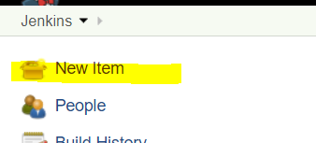

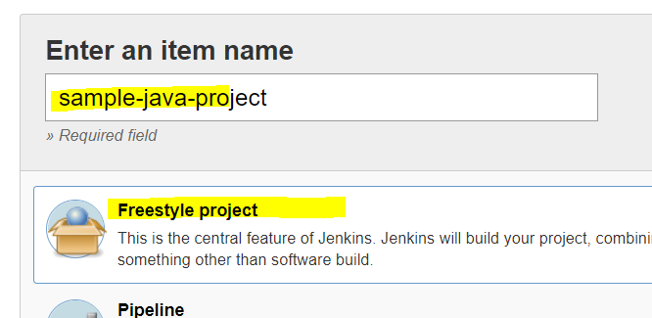

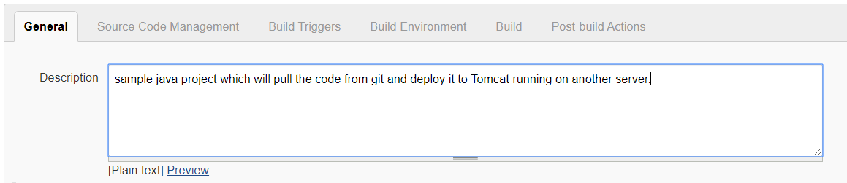

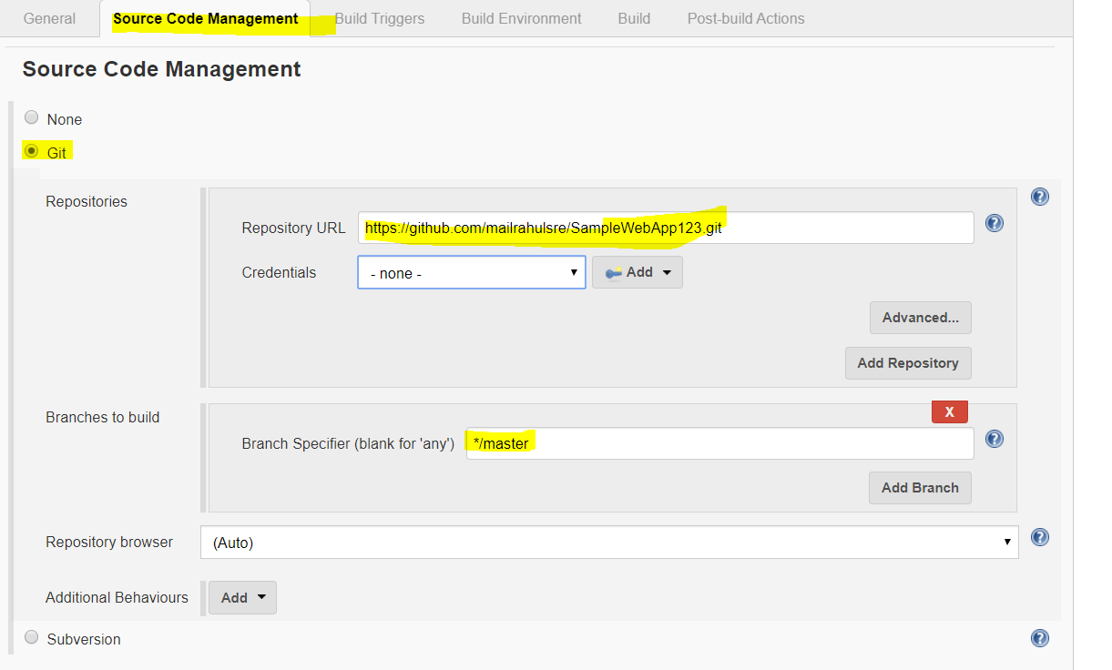

We may need to add credential by clicking on ADD button when the git repo is Private

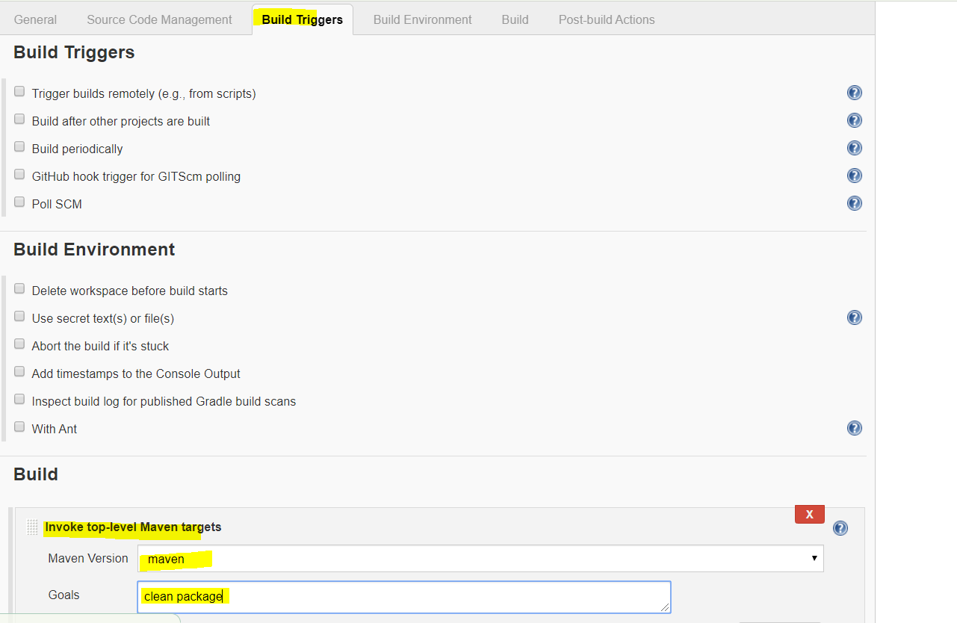

## Download the Jenkins plugin

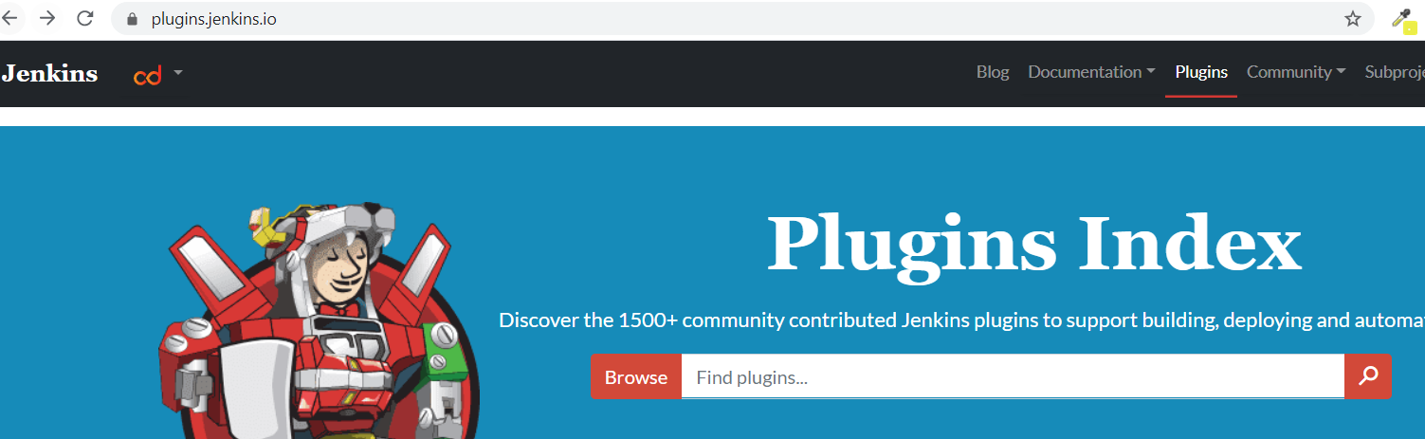

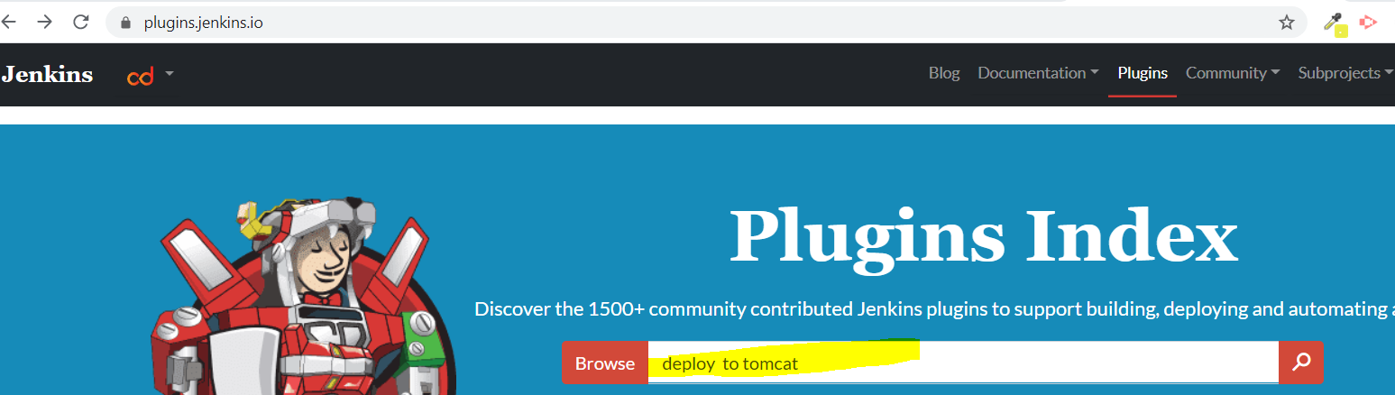

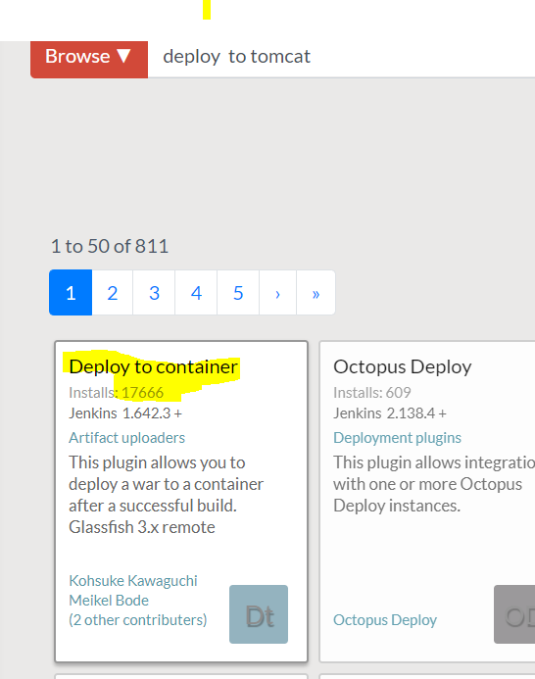

Manage Jenkins -🡪 Manage Plugins 🡪 Availaible 🡪 Search for “deploy to container” and **Install without Restart**

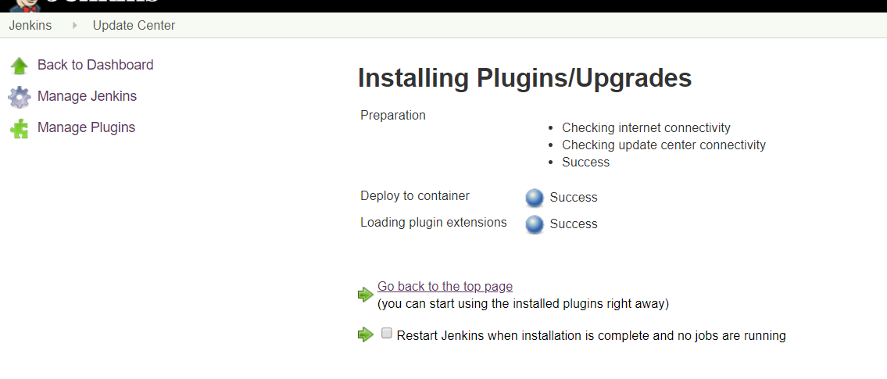

Go to job again and use the Plugin – **Deploy war/ear to a Container** under **“Post Build Action”**

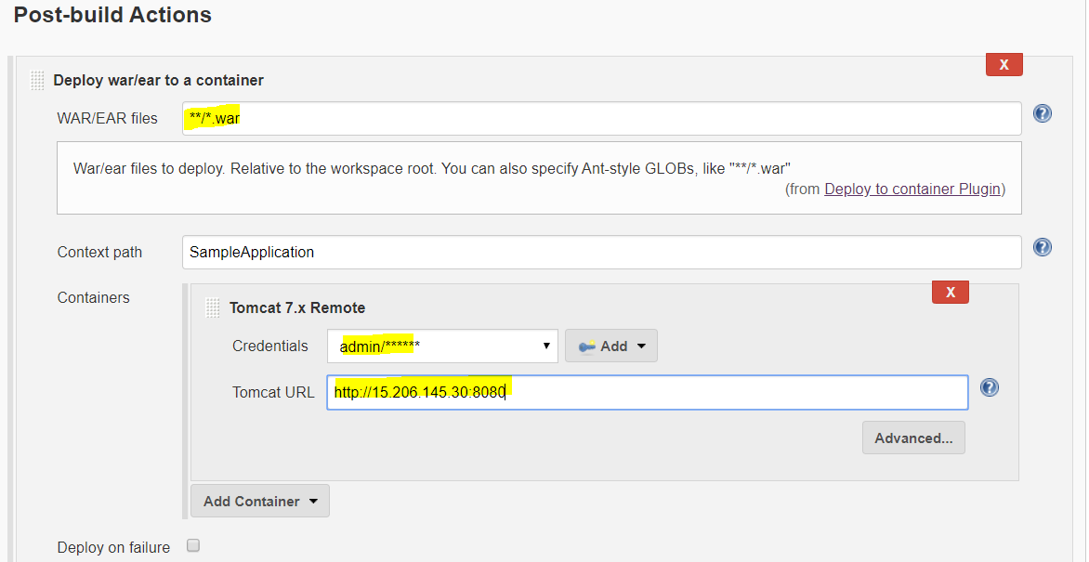

Click on SAVE

# Build a Job

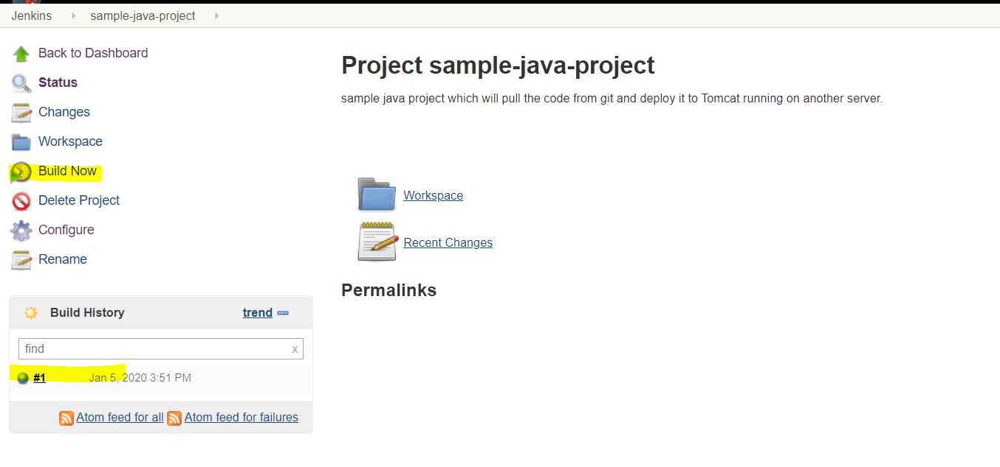

Check the log file

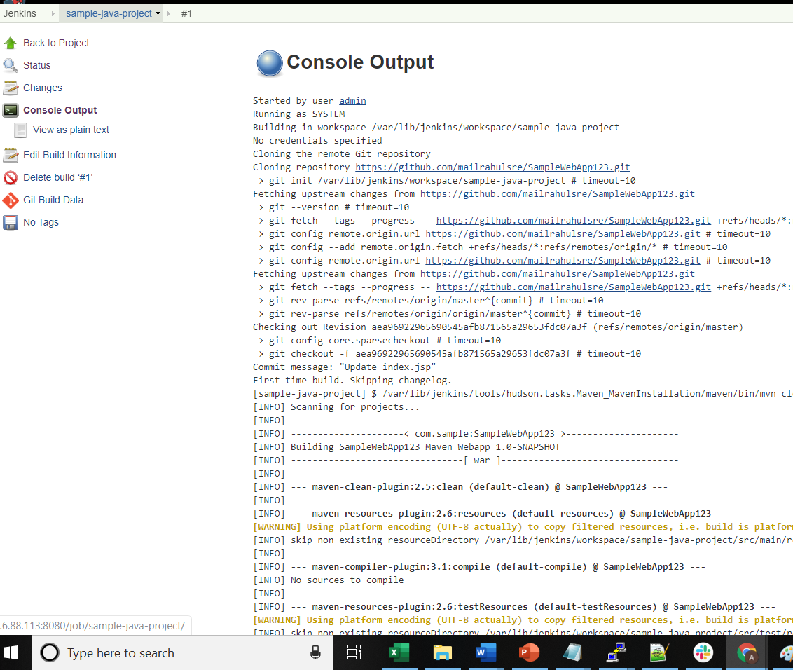

# Check the deployment in Tomcat running on another server or not

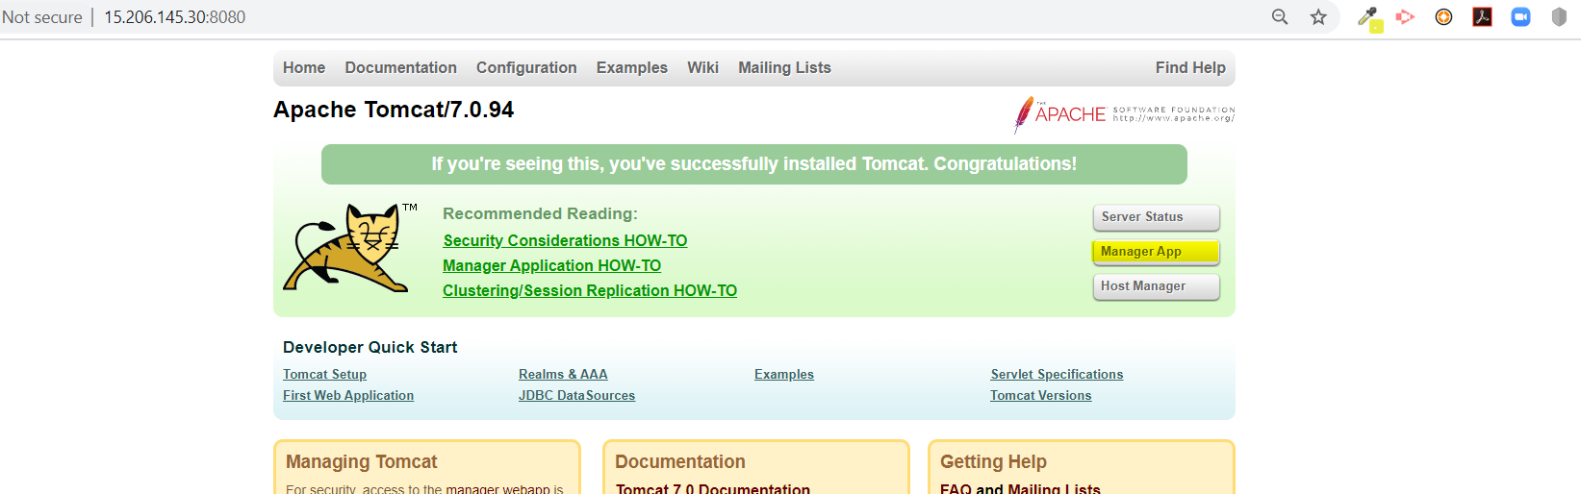

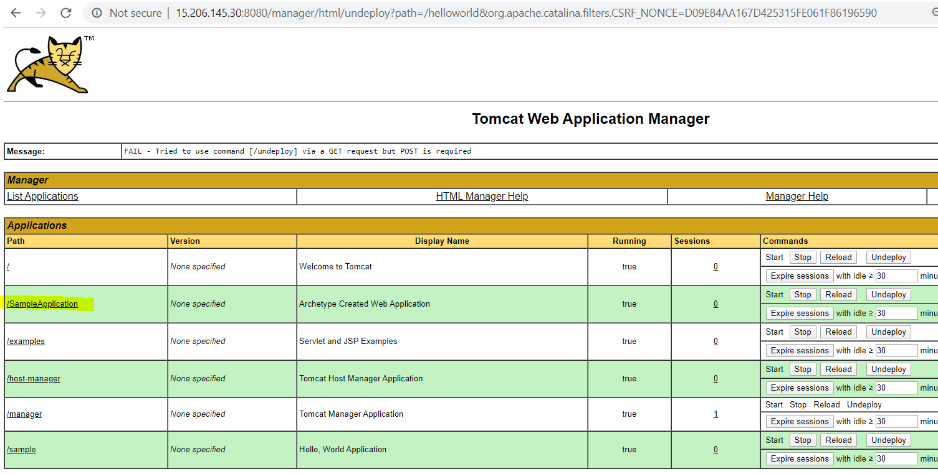

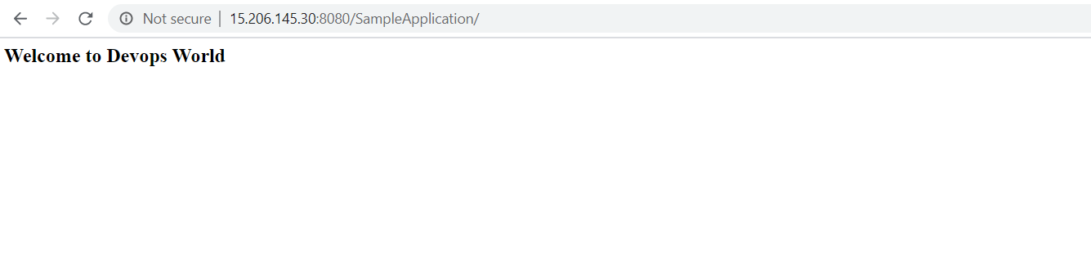

# Configure Jenkin job to auto deploy if git repo is committed with new code

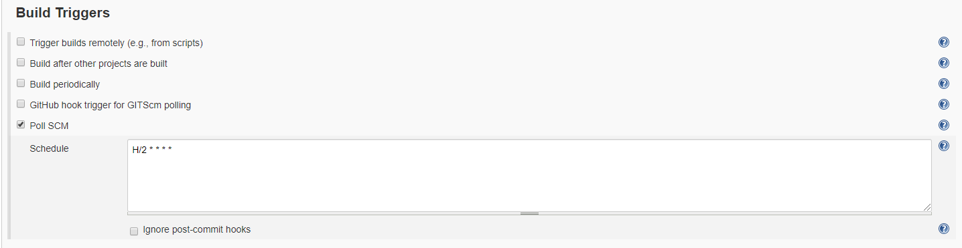

This is every 2 mins, it will check git repo and run the job if it is updated

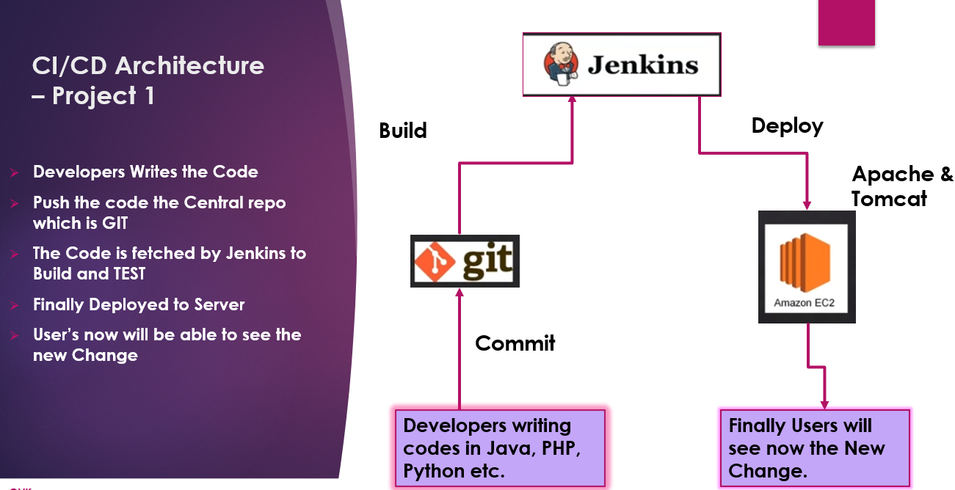

# How to change the HOME Directory

1. Create EBS Volume in AWS console and attach it to Server in same AZ  
     
   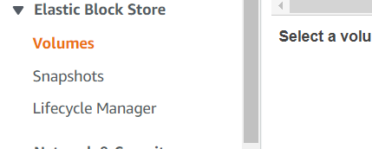

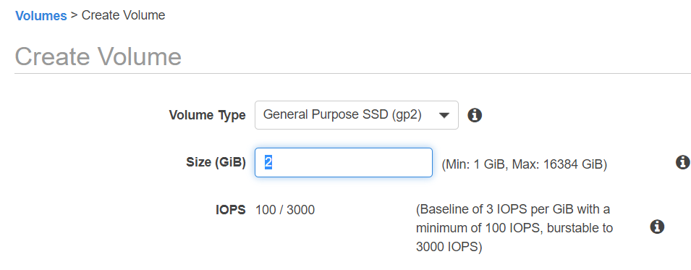

**Follow ‘aws EBS Mount.txt’ to format and mount your Volume**

1. Change the home directory in **/etc/sysconfig/jenkins**

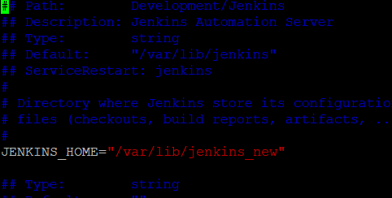

1. Copy the content from old HOME to New home

mkdir /var/lib/jenkins_new

nohup cp -RpH /var/lib/Jenkins/* /var/lib/jenkins_new &

chown -R jenkins:jenkins /var/lib/jenkins_new

1. **Restart the Jenkins Service** and go and check the Manage Jenkins 🡪 Configure Systems

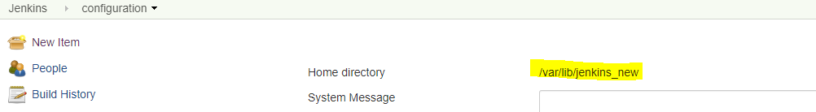

# How to Change the Thread to configure Jenkins with more threads for more builds

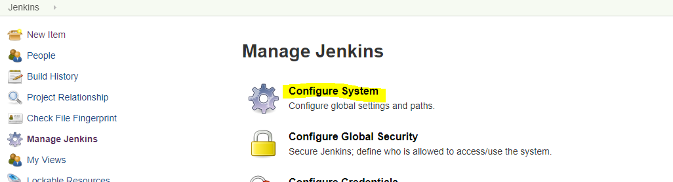

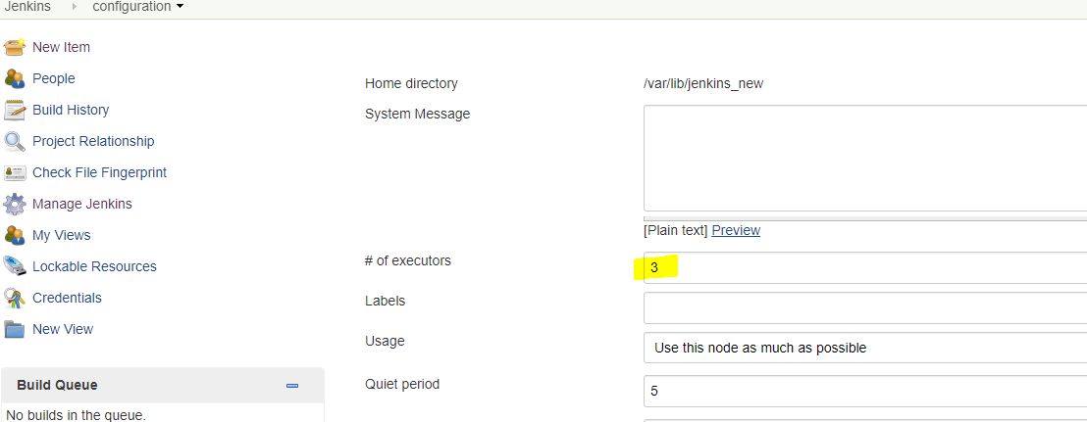

# How to use Jenkins CLI

1. Go to <http://3.6.88.113:8080/cli/>

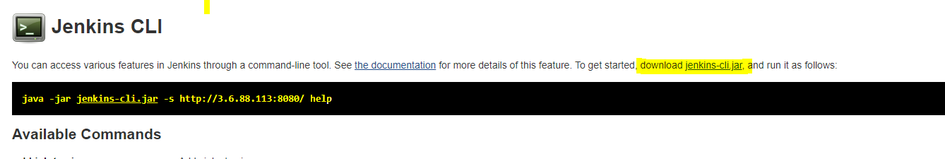

1. Download the Jenkins-cli.jar from above link using wget utility in the server and run it

cd /tmp  
wget <http://3.6.88.113:8080/jnlpJars/jenkins-cli.jar>

**create a password file**, passfile 🡪 admin:welcome1

[root@ip-172-31-40-69 ~]# java -jar jenkins-cli.jar -s http://3.6.88.113:8080/ -auth @passfile restart

java -jar jenkins-cli.jar -s http://52.91.24.255:8080/ -auth @passfile -webSocket disable-job sample

1. Check the log file in the /var/log/Jenkins to get the log file location for restart

[root@ip-172-31-46-135 ~]# for i in `cat jobs`; do java -jar jenkins-cli.jar -s http://13.127.47.58:9080/ -auth @passwordfile -webSocket **enable-job** $i; done





## Shell Scripts

[root@ip-172-31-41-179 tmp]# cat jenkins-enable-job.sh

#!/bin/bash

if [ $# -ne 1 ]; then

echo "Failure: Argument missing. Please check Syntax"

echo "Syntax - $0 <BusinessName>"

echo "Example - $0 flipkart"

exit 1

else

v_businessName=$1

java -jar jenkins-cli.jar -s http://34.232.70.252:9090/ -auth @passfile -webSocket list-jobs|grep $v_businessName > job-list.lst

fi

for i in $(cat job-list.lst);

do

java -jar jenkins-cli.jar -s http://34.232.70.252:9090/ -auth @passfile -webSocket enable-job $i

if [ $? -ne 0 ]; then

echo "Failure: Job $i is not enabled"

exit 1

else

echo "SUCCESS: Job $i is enabled"

echo ""

fi

done

[root@ip-172-31-41-179 tmp]# cat jenkins-disable-job.sh

#!/bin/bash

if [ $# -ne 1 ]; then

echo "Failure: Argument missing. Please check Syntax"

echo "Syntax - $0 <BusinessName>"

echo "Example - $0 flipkart"

exit 1

else

v_businessName=$1

java -jar jenkins-cli.jar -s http://34.232.70.252:9090/ -auth @passfile -webSocket list-jobs|grep $v_businessName > job-list.lst

fi

for i in $(cat job-list.lst);

do

java -jar jenkins-cli.jar -s http://34.232.70.252:9090/ -auth @passfile -webSocket disable-job $i

if [ $? -ne 0 ]; then

echo "Failure: Job $i is not disabled"

exit 1

else

echo "SUCCESS: Job $i is disabled"

echo ""

fi

done

# What to do when admin user password is not there

1. Disable the Security from **<useSecurity>true</useSecurity>** to <useSecurity>**false**</useSecurity> in $**JENKINS_HOME**/config.xml
2. Restart the Jenkins and you will be able to login
3. Change the password again and restart

# Change Jenkins Port

Backup of the file **/etc/sysconfig/jenkins**

Cp /etc/sysconfig/jenkins /etc/sysconfig/jenkins-back

Open the file - **/etc/sysconfig/jenkins** and search with **JENKINS_PORT="8080"**

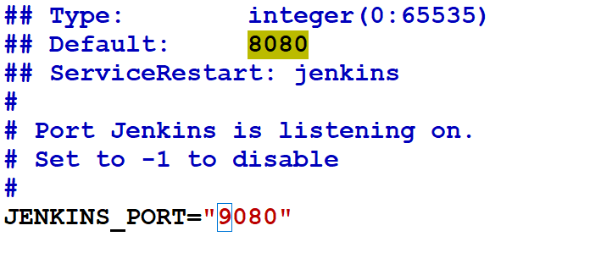

[root@ip-172-31-46-135 target]# service jenkins restart

Shutting down Jenkins [ OK ]

Starting Jenkins [ OK ]

[root@ip-172-31-46-135 target]#