**Web Output:**

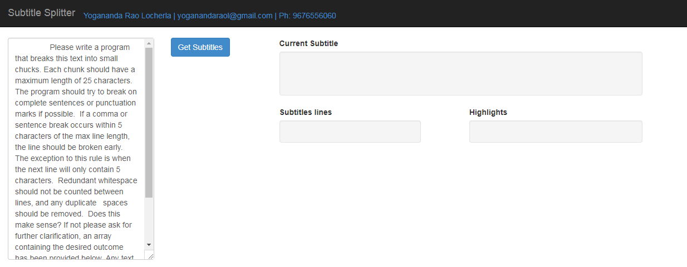

This screen default filled with sample text Subtitles provided in project.

Or Fill the text in textarea whatever you want to split.

Then click on Get Subtitles button. See the UI rendering as below

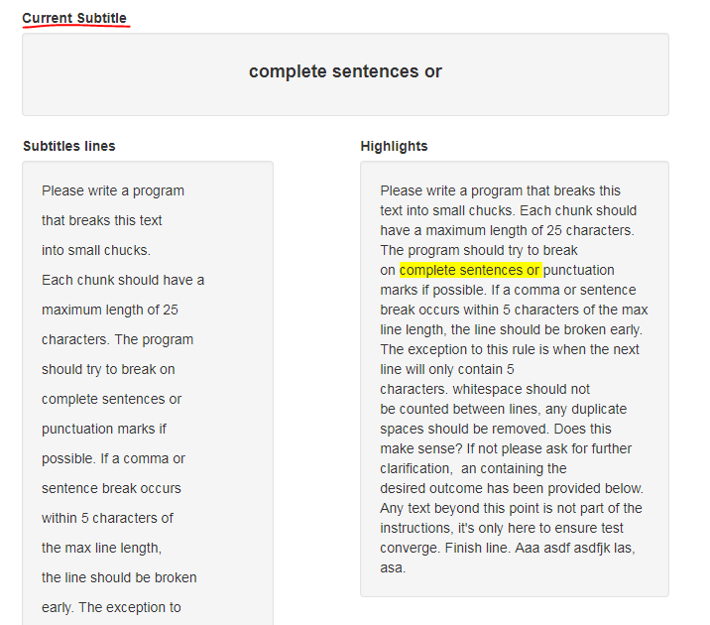

The top most div shows the **current subtitle**

The first div (Subtitle Lines) in second row **display all Subtitles in a single stretch with appropriate line breaks.**

The second div (Highlights) in second row **Highlights the current subtitle displayed** in top most div.

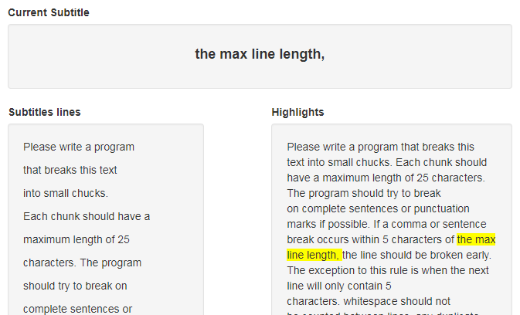

**Test Cases**

Below is the test cases screenshot which validates in 14 situations.

