**Better Than EBay**

Better than EBay represents an alternative to EBay. There are 12 Data Objects that interact with each other. The structured RESTful API allows user to get all the functionally of EBay.

**Data Object Model**

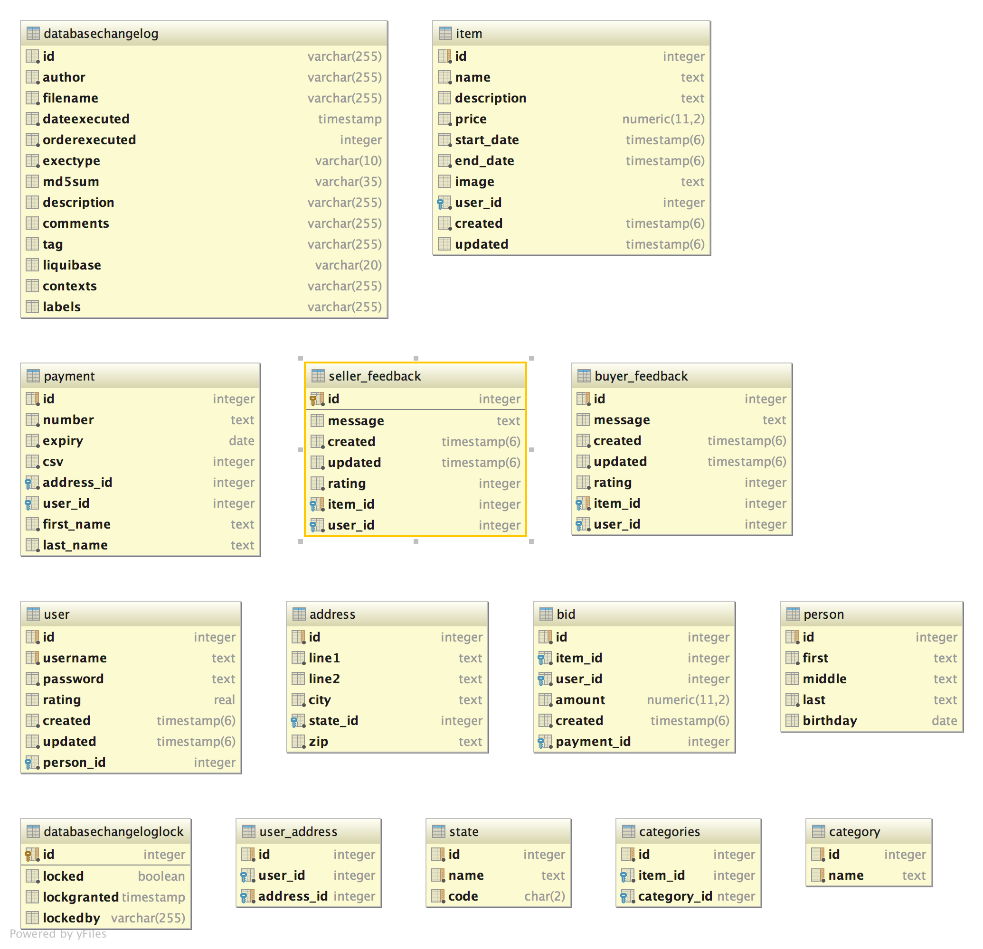

**Usage**

Item

Model

{

"id": 0,

"name": "string",

"description": "string",

"categories": [

{

"id": 0,

"name": "string"

}

],

"initialPrice": 0,

"startDate": "2016-08-03T20:47:20.533Z",

"endDate": "2016-08-03T20:47:20.533Z",

"image": "string",

"created": "2016-08-03T20:47:20.533Z",

"updated": "2016-08-03T20:47:20.533Z"

}

Calls

GET api/items

Returns a list of items matching the given parameters for item name, category, lowest price, highest price, item offset number, and size of item list.

POST api/items

Adds the given item to the logged in user's auctions

DELETE api/items/{itemId}

Deletes the item with given item ID

GET /items/{itemId}

If {itemId} exists, returns the corresponding item object

PUT /items/{itemId}

Updates the given item's auction details

GET /items/{itemId}/bids

Returns a list of all bids for the item

POST /items/{itemId}/bids

Places the given bid for the given item's auction

DELETE /items/{itemId}/bids/{bidId}

Deletes the bid with given bid ID

GET /items/{itemId}/bids/{bidId}

If {bidId} exists, returns the corresponding bid object

PUT /items/{itemId}/bids/{bidId}

Updates the given bid's details for the logged in user

POST /items/{itemId}/feedback

Adds the given feedback to the given item's details

DELETE /items/{itemId}/feedback/{feedbackId}

Deletes the feedback with given feedback ID and corresponding item ID

GET /items/{itemId}/feedback/{feedbackId}

If {feedbackId} exists, returns the corresponding feedback object

PUT /items/{itemId}/feedback/{feedbackId}

Updates the given feedback's details for the logged in user

GET /items/{itemId}/winning

Returns winning bid for item