

A PROJECT REPORT ON

**ATM INTERFACE**

BY

**Batch:** 2022 – 7905

**Center: Trichy-Thillai Nagar**

Under the Guidance of,

**Chittaranjan Ghosh.**

Technical Trainer

**EDUBRIDGE**

**(**School of Coding)

## Introduction:

An automated teller machine (ATM) or cash machine is an electronic telecommunications system that allows customers of banking firms to conduct financial transactions. The user must choose a choice from the options shown on the screen in the ATM application. For example, withdraw money, deposit money, check your balance, and exit the available options. To withdraw your funds, deposit your funds and check your account balance before exiting the program.

**Withdraw:** For withdrawing the funds, gets the withdrawal amount from the user, deduct it from the total balance, and display the message.

**Deposit:** For depositing the funds, gets the deposit amount from the user to add, add it to the total balance, and display the message.

**Check the balance:**For checking the balance, display the user’s total balance.

**Exit:** Return the user to the home page or initial screen by exiting the current Transaction mode.

**SOFTWARE REQUIREMENTS:**

* **Front End:** Core Java.
* **Back End :** MySQL workbench 8.0 CE.
* **Browser:** Best result on Google Chrome.
* **Operating System:** Windows 10.

**DATATABLE:**

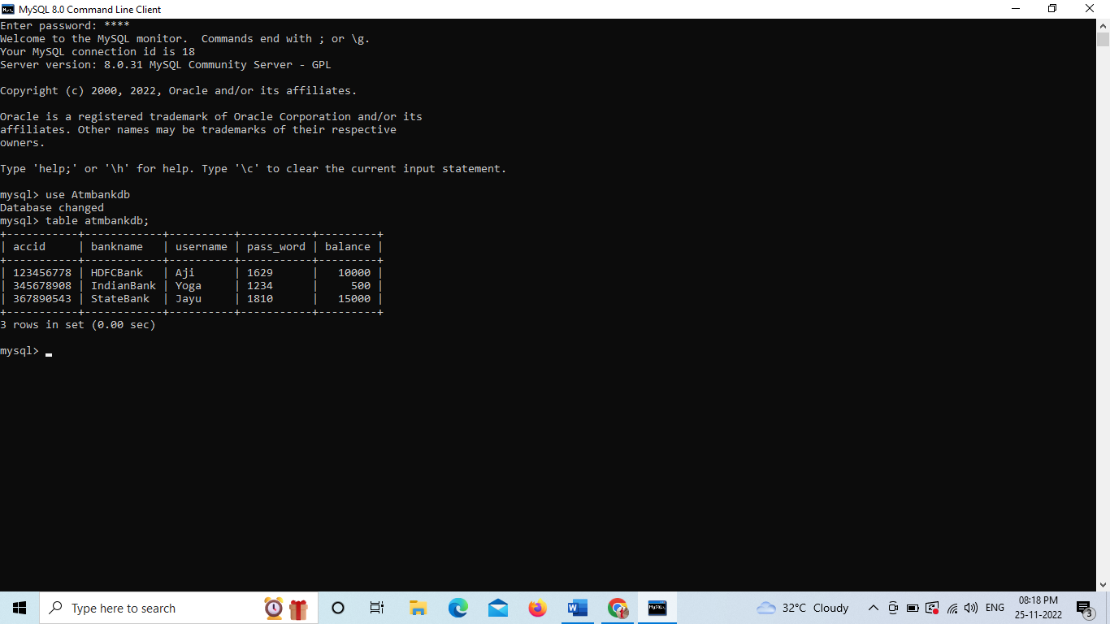

**OUTPUT SCREEN:**

**LOGIN PAGE:**

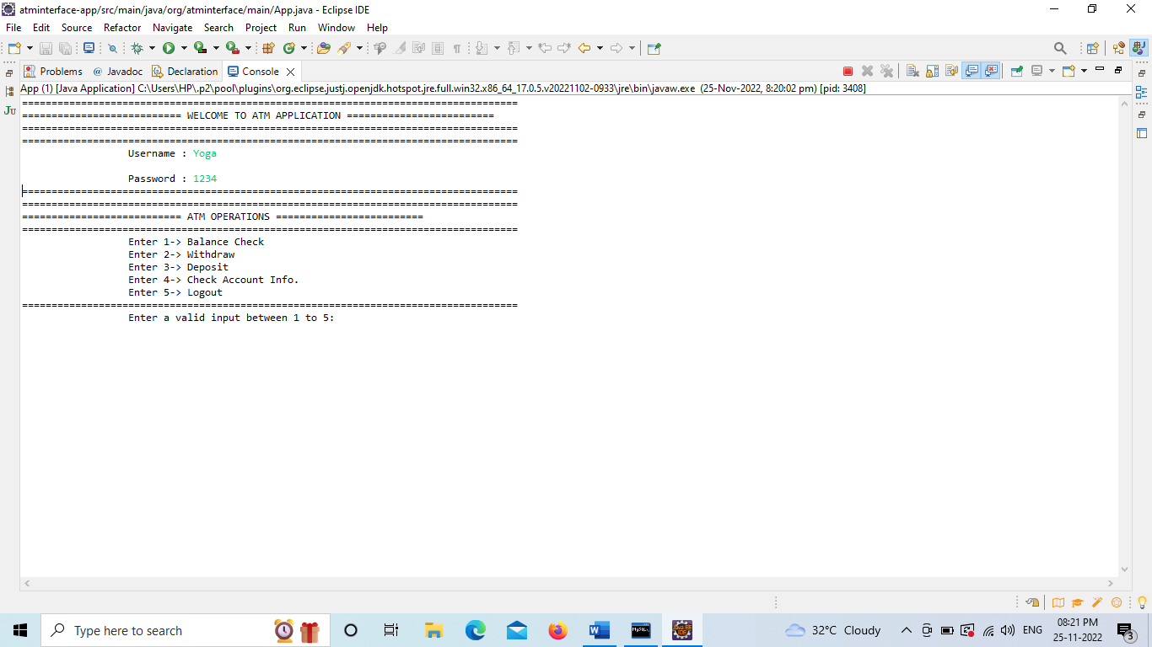

BALANCE CHECK PAGE:

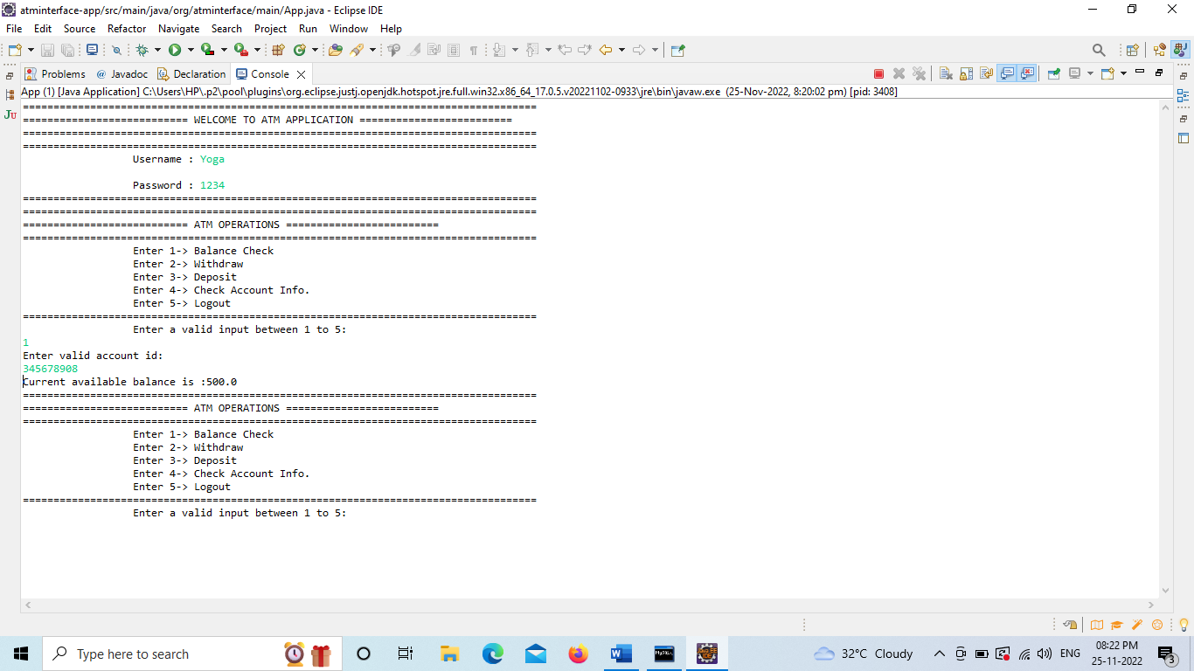

WITHDRAW PAGE:

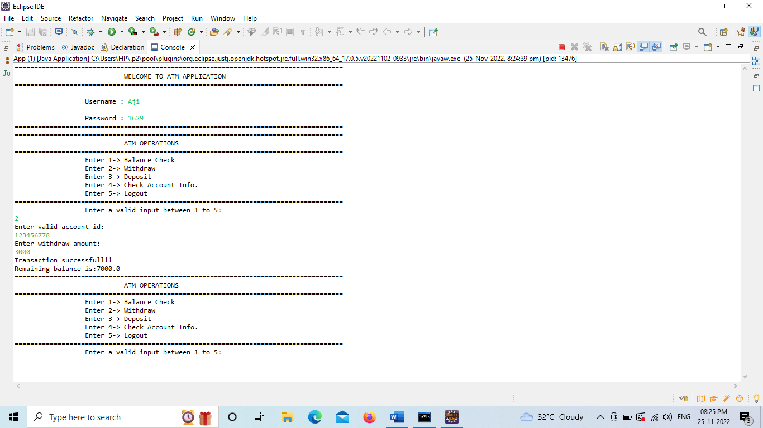

DEPOSIT PAGE:

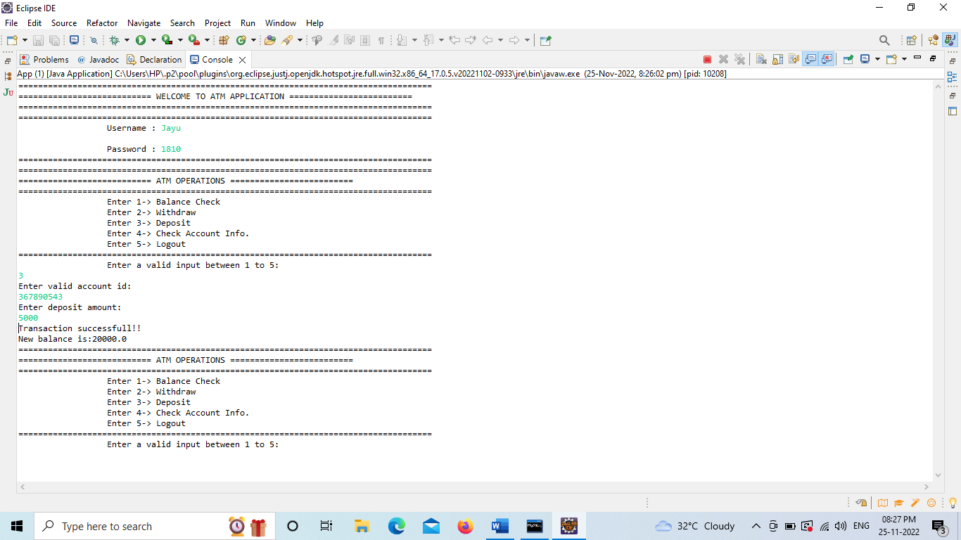

ACCOUNT INFO PAGE:

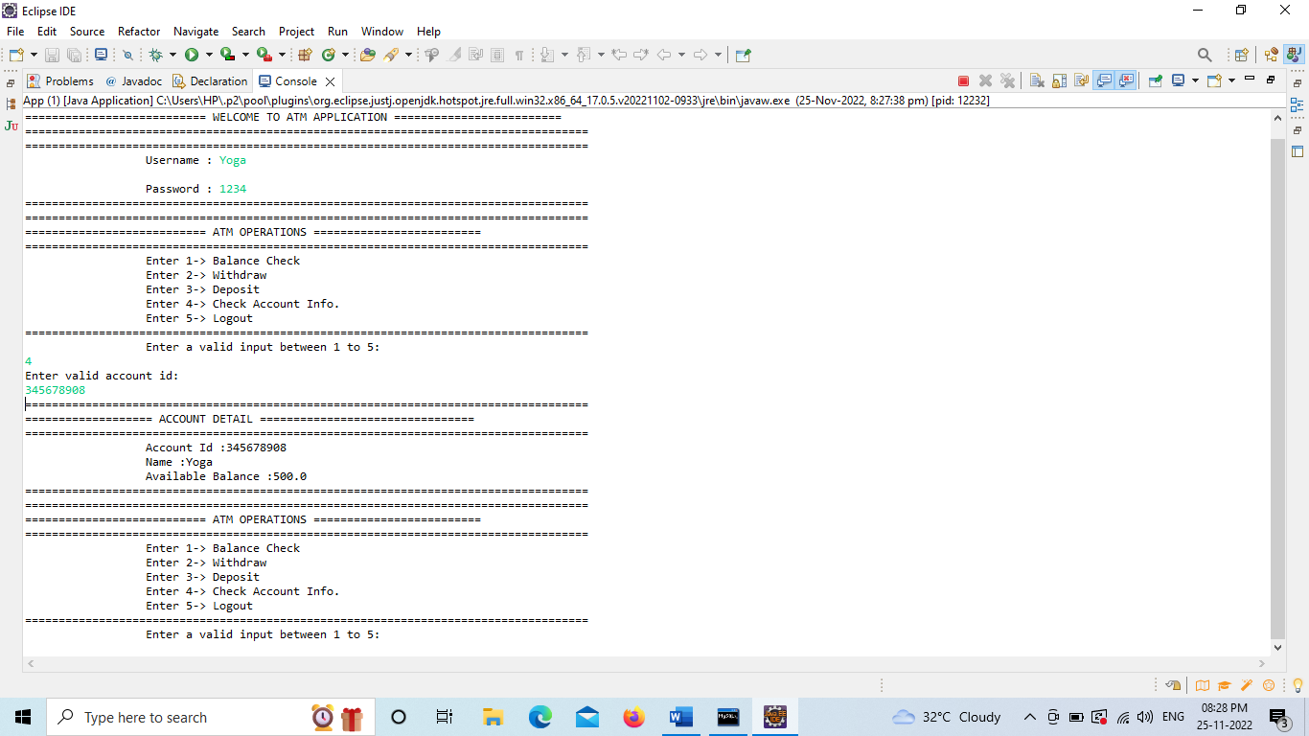

LOG OUT PAGE:

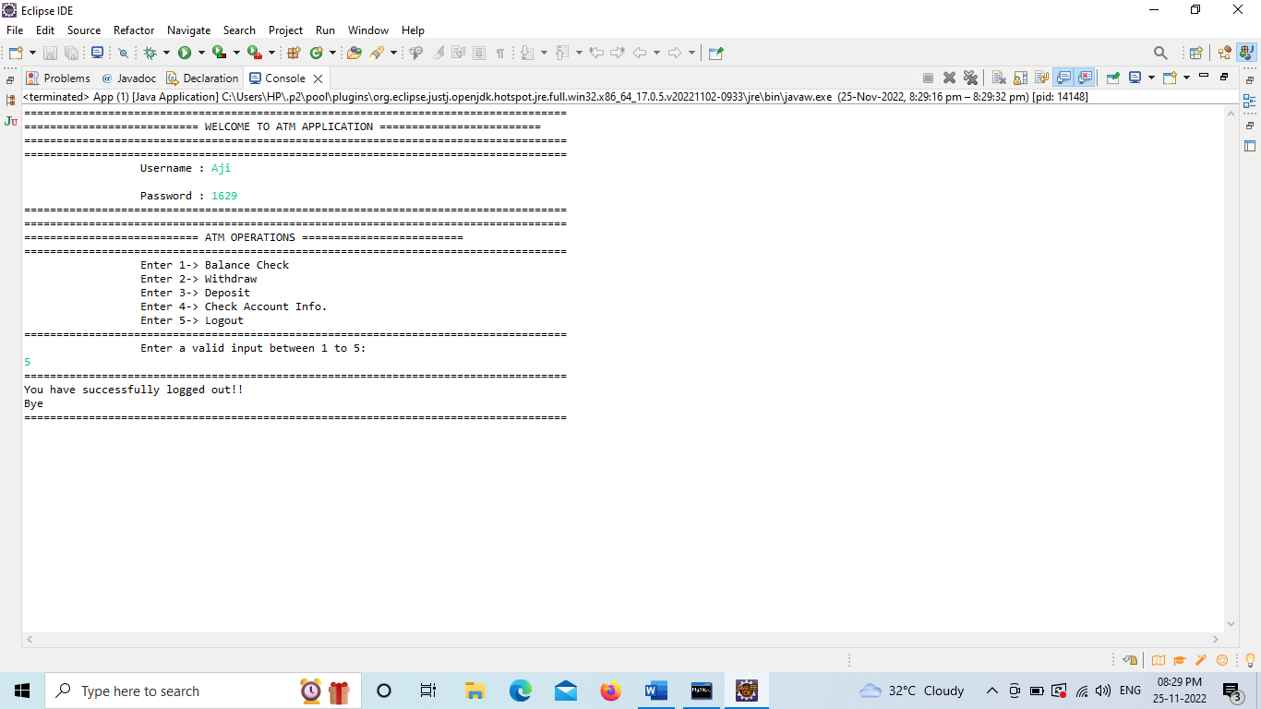

***************THANK YOU******************