Algorithm Exploration and Preliminary Model Design
Predictive Maintenance for Vehicle Fleets using Machine Learning (Python)
Virtual Machine Learning Implementation Intern - Week 2 Task
Submitted by: Yogapriya

1. Introduction
In Week 1, the problem was defined as predicting whether a fleet vehicle will suffer a component failure within the next 14 days, using sensor readings, mileage and repair history. This is a binary classification problem on structured (tabular) data with a heavily imbalanced target, because failures are rare. This report reviews common Python-based machine learning algorithms, compares them, justifies the choice of algorithms for this problem, and proposes a preliminary model design with an architecture diagram and pseudocode.

2. Literature Review of Algorithms

2.1 Logistic Regression
Logistic Regression models the probability of the positive class as a sigmoid of a weighted sum of the input features. It is trained by minimizing log-loss. Its main strengths are speed, simplicity and interpretability, since each coefficient shows how a feature changes the odds of failure. Its weakness is that it assumes a linear relationship between features and the log-odds, so it can miss complex interactions between sensors. In Python it is available as sklearn.linear_model.LogisticRegression.

2.2 Decision Tree and Random Forest
A Decision Tree splits the data repeatedly on feature thresholds to separate failures from healthy cases. A single tree overfits easily, so Random Forest builds many trees on random samples of rows and features (bagging) and averages their votes. This reduces variance, handles non-linear relationships and mixed feature types, needs little scaling, and provides feature importance. The drawbacks are larger model size, slower prediction than linear models, and lower interpretability. In Python: sklearn.ensemble.RandomForestClassifier.

2.3 Gradient Boosting (XGBoost)
Gradient boosting builds trees sequentially, where each new tree corrects the errors of the previous ones. XGBoost adds regularization, efficient handling of missing values, parallel training and built-in support for class weighting through scale_pos_weight. It is widely regarded as one of the strongest methods for tabular data and is frequently used in predictive maintenance studies. Its drawbacks are more hyperparameters to tune and a higher risk of overfitting if not regularized. In Python: the xgboost library.

2.4 Support Vector Machine (SVM)
An SVM finds the boundary that separates classes with the maximum margin, and with kernels (such as RBF) it can model non-linear boundaries. It works well on small to medium datasets with many features. However, training time grows quickly with the number of samples, it is sensitive to feature scaling, and it does not give probabilities directly. In Python: sklearn.svm.SVC.

2.5 LSTM (Recurrent Neural Network)
Long Short-Term Memory networks process sequences and can learn patterns over time, such as gradual sensor drift before a failure. They can capture temporal behaviour that tabular models need hand-made rolling features to represent. They need much more data and compute, are harder to explain and tune, and often do not beat boosted trees on small tabular datasets. In Python: TensorFlow/Keras or PyTorch.

3. Algorithm Comparison
Algorithm | Applicability to this problem | Complexity | Scalability | Robustness (noise / imbalance) | Interpretability
Logistic Regression | Good baseline; limited for non-linear patterns | Low | High | Medium; needs class weights | High
Random Forest | Very good; handles non-linear and mixed features | Medium | Medium-High | High; class_weight supported | Medium
XGBoost | Excellent for tabular sensor data | Medium-High | High | High; scale_pos_weight and regularization | Medium (SHAP helps)
SVM (RBF) | Fair; slow on large fleets | High | Low | Medium; sensitive to scaling | Low
LSTM | Good for raw time-series; data-hungry | Very High | Medium (GPU) | Medium; needs lots of data | Low

Pros and cons summary: Logistic Regression is fast and explainable but too simple on its own. Random Forest and XGBoost give the best balance of accuracy, robustness and practicality for structured data. SVM becomes expensive as the number of records grows. LSTM is powerful but only justified when large volumes of raw time-series data are available.

4. Selected Algorithms and Reasoning
- Logistic Regression is chosen as the baseline model. It sets a minimum performance level and is easy to explain to fleet managers.
- Random Forest is chosen as a robust mid-complexity model that captures non-linear sensor interactions with little tuning.
- XGBoost is chosen as the primary candidate model because it usually performs best on imbalanced tabular data and supports class weighting and regularization.
- SVM and LSTM are not selected for the first iteration because of scalability and data requirements, but LSTM can be explored later if high-frequency sensor streams become available.

5. Preliminary Model Design

5.1 Architecture Diagram
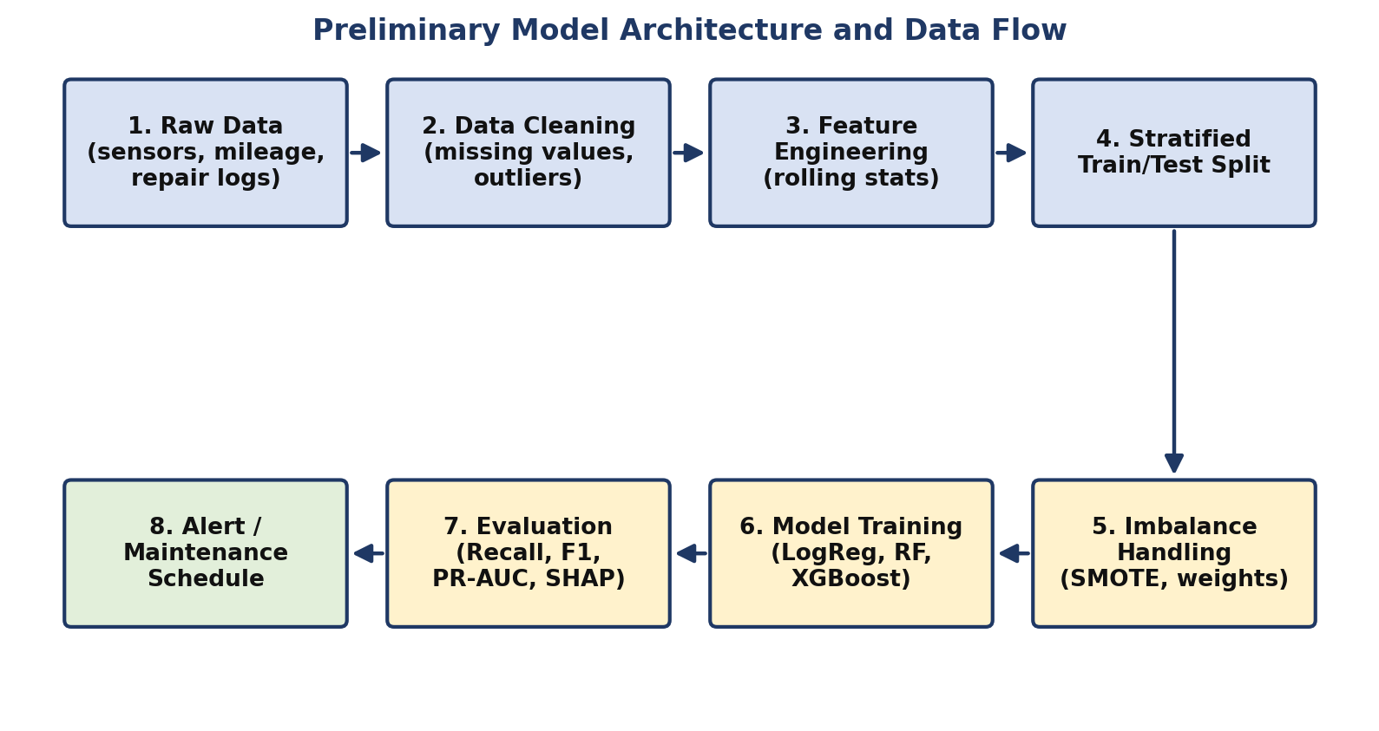

5.2 Data Flow and Processing Stages
- Input: vehicle sensor readings (temperature, vibration, oil pressure), mileage, and past repair records.
- Cleaning: fill missing values, remove duplicates, and cap outliers using the IQR rule.
- Feature engineering: rolling means and standard deviations, rate of change, kilometres since last service, and encoding of categorical fields.
- Split: stratified 80/20 train/test split performed before resampling or scaling, to prevent data leakage.
- Imbalance handling: SMOTE and class weights applied to the training set only.
- Training: Logistic Regression, Random Forest and XGBoost trained with 5-fold cross-validated hyperparameter search.
- Evaluation: recall, precision, F1-score, ROC-AUC and PR-AUC on the untouched test set, plus SHAP for explanation.
- Output: a failure probability for each vehicle; if it exceeds a chosen threshold, a maintenance alert is raised.

6. Pseudocode
# ---------- Predictive Maintenance Pipeline (Pseudocode) ----------
LOAD dataset FROM csv

# 1. Cleaning
FOR each column IN dataset:
FILL missing values (median for numeric, mode for categorical)
REMOVE duplicate rows
CAP outliers using IQR rule (Q1 - 1.5*IQR, Q3 + 1.5*IQR)

# 2. Feature engineering
ADD rolling_mean_temp, rolling_std_vibration (window = 7 days)
ADD km_since_last_service, rate_of_change_pressure
ENCODE categorical features (one-hot)

# 3. Split (before any resampling, to avoid data leakage)
X_train, X_test, y_train, y_test = STRATIFIED_SPLIT(X, y, test_size = 0.2)
FIT scaler ON X_train ONLY; APPLY scaler TO X_train and X_test

# 4. Imbalance handling (training data only)
X_train_bal, y_train_bal = SMOTE(X_train, y_train)

# 5. Train candidate models
models = [LogisticRegression, RandomForest, XGBoost]
FOR each model IN models:
best = GRID_SEARCH_CV(model, X_train_bal, y_train_bal, folds = 5, metric = "f1")
predictions = best.PREDICT(X_test)
RECORD recall, precision, f1, pr_auc

# 6. Select and explain
final_model = model WITH highest recall subject TO precision >= 0.60
COMPUTE SHAP values FOR final_model
SAVE final_model TO "model.joblib"

# 7. Predict
FUNCTION predict_failure(vehicle_data):
features = BUILD_FEATURES(vehicle_data)
probability = final_model.PREDICT_PROBA(features)
IF probability >= threshold: RETURN "Schedule maintenance"
ELSE: RETURN "Healthy"

7. Risks, Challenges and Assumptions
Challenge / Risk | Why it matters | How the selected approach addresses it
Class imbalance | Models can predict "no failure" always and still look accurate | SMOTE, class weights, scale_pos_weight, and recall / PR-AUC as metrics
Overfitting | Complex models may memorize training data | Cross-validation, tree depth limits, regularization in XGBoost
Data leakage | Inflated results that fail in real use | Split before preprocessing; fit scalers only on training data; time-ordered split
Noisy or missing sensor data | Reduces prediction quality | Median imputation, outlier capping, tree models that tolerate noise
Low interpretability | Managers will not trust unexplained alerts | Logistic Regression baseline, feature importance and SHAP values
Threshold selection | Too many false alarms or missed failures | Tune the decision threshold on validation data using the precision-recall curve

Assumptions: (1) enough historical failure examples exist to learn from; (2) sensor data is recorded consistently; (3) failures within 14 days leave detectable signs in the sensor data; (4) the public dataset used for prototyping is reasonably representative of real fleet behaviour.

8. Conclusion
After comparing five common algorithms, a staged approach is proposed: Logistic Regression as an interpretable baseline, Random Forest as a robust alternative, and XGBoost as the main candidate. The preliminary design covers data cleaning, feature engineering, leakage-safe splitting, imbalance handling, model training, evaluation and alert generation. This design will be implemented and tested in the coming weeks, with results compared against the baseline to validate the Week 1 hypothesis.

