Implementation Strategy and Code Architecture Outline
Predictive Maintenance for Vehicle Fleets using Machine Learning (Python)
Virtual Machine Learning Implementation Intern - Week 4 Task
Submitted by: Yogapriya

1. Introduction
Weeks 1 to 3 defined the problem (predict vehicle failure within 14 days), selected the algorithms (Logistic Regression, Random Forest, XGBoost) and designed the experiment (stratified cross-validation, recall-focused metrics, locked test set). This report explains how that plan will be turned into working Python code. It presents the implementation steps, a system architecture diagram, a UML class diagram, a breakdown of modules, pseudocode for the core functions, coding best practices, and a risk assessment for the implementation phase. The goal is a clean, modular and maintainable codebase that another developer can understand, test and extend.

2. Step-by-Step Implementation Strategy
- Set up the environment: create a Python virtual environment, install libraries (pandas, numpy, scikit-learn, imbalanced-learn, xgboost, shap, matplotlib, joblib, pytest) and record exact versions in requirements.txt.
- Create the repository structure: folders for config, data, src, tests, notebooks, models and reports, with a README that explains how to run the project.
- Implement data ingestion: load the dataset, validate that required columns and data types exist, and log basic statistics.
- Implement preprocessing: duplicate removal, missing-value handling and outlier capping, with statistics learned from training data only.
- Implement feature engineering: rolling statistics, rate of change, kilometres since last service, and categorical encoding.
- Implement the training module: stratified split, resampling inside cross-validation folds, hyperparameter search and model saving.
- Implement the evaluation module: metrics, threshold selection, error analysis and SHAP explanations as defined in Week 3.
- Implement the inference module: load the saved model and return a failure probability and maintenance alert for new vehicle data.
- Write tests for each module and run them automatically on every commit using continuous integration.
- Run the full pipeline from main.py, review the reports, refactor, and document results in the README.
Development follows an incremental approach: a minimal end-to-end version with Logistic Regression is built first, and the other models and refinements are added afterwards. This gives a working system early and reduces integration risk.

3. System Architecture
The system is organised as a pipeline of independent modules. Each module has a single responsibility and communicates with the next through well-defined inputs and outputs (pandas DataFrames, NumPy arrays, or saved model files). Configuration, logging, testing and version control are cross-cutting components used by every module.
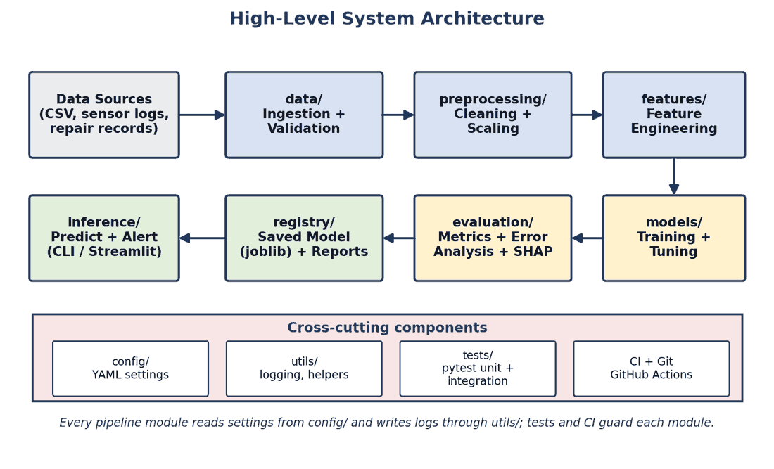

3.1 Component Interaction
- Data Sources supply raw CSV files, sensor logs and repair records.
- The data module loads and validates raw data and passes a DataFrame to preprocessing.
- Preprocessing returns cleaned data and the statistics learned from training data; features adds engineered columns.
- The models module trains and tunes the candidate algorithms and sends the best one to evaluation.
- Evaluation computes metrics, selects the threshold, performs error analysis and stores reports.
- The registry stores the trained model and reports; inference loads the model to generate predictions and alerts.

4. UML Class Diagram
The diagram below shows the main classes, their key attributes and methods, and how data flows between them. A Config object supplies settings to all classes; the Predictor reuses the model and preprocessor saved by the ModelTrainer.
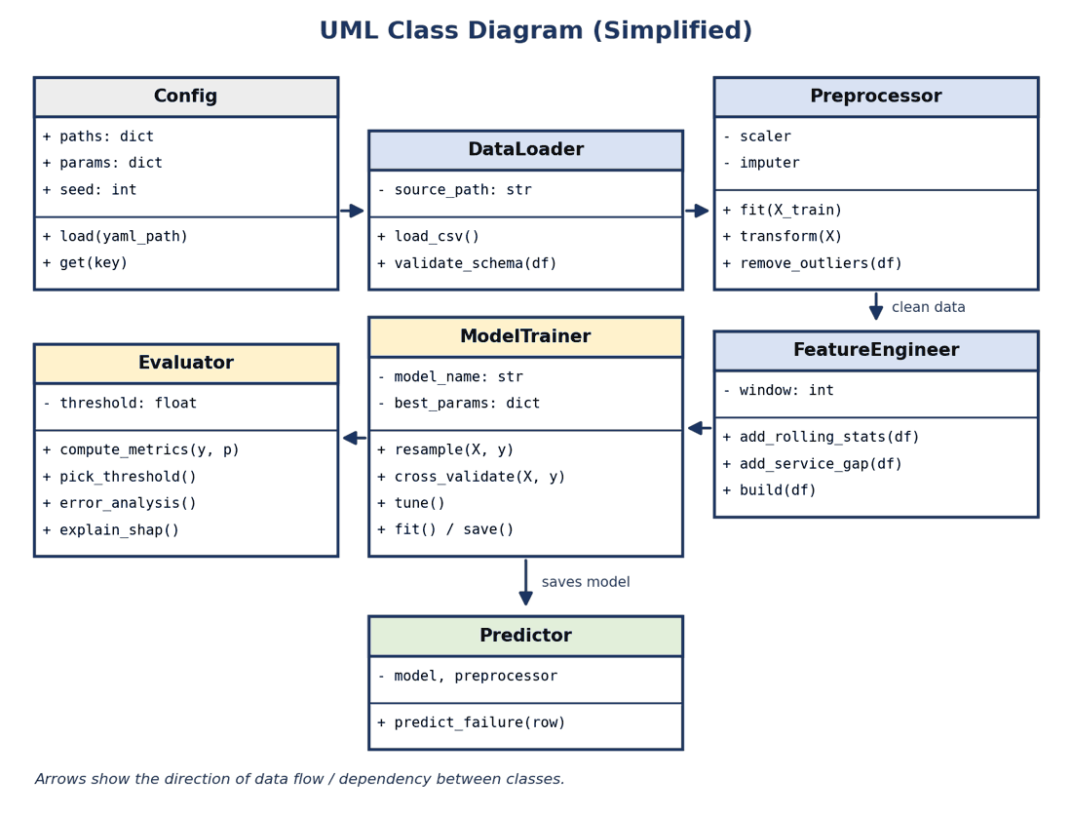

5. Modular Breakdown
Module / File | Class or Functions | Responsibility
config/config.yaml | Config.load(), Config.get() | Stores file paths, model parameters, split ratio and random seed so nothing is hard-coded in the code.
src/data_loader.py | DataLoader.load_csv(), validate_schema() | Reads raw data, checks columns and types, and raises clear errors if the data is invalid.
src/preprocessing.py | Preprocessor.fit(), transform(), remove_outliers() | Cleans data and applies imputation and scaling, learning values only from training data to prevent leakage.
src/features.py | FeatureEngineer.add_rolling_stats(), add_service_gap(), build() | Creates rolling means, standard deviations, rates of change and service-related features.
src/train.py | ModelTrainer.resample(), cross_validate(), tune(), fit(), save() | Handles stratified cross-validation, SMOTE inside folds, hyperparameter search and saving the best model.
src/evaluate.py | Evaluator.compute_metrics(), pick_threshold(), error_analysis(), explain_shap() | Calculates recall, precision, F1, ROC-AUC and PR-AUC, chooses the threshold and analyses errors.
src/predict.py | Predictor.predict_failure() | Loads the saved model and preprocessor, then returns a probability and an alert for new records.
src/utils.py | setup_logger(), set_seed(), save_report() | Shared helper functions used across modules.
tests/ | test_*.py files | Unit tests for each function and integration tests for the full pipeline.
main.py | main() | Entry point that runs the pipeline from data loading to evaluation.

5.1 Proposed Project Structure
fleet-maintenance-ml/
|-- config/
| `-- config.yaml # paths, parameters, random seed
|-- data/
| |-- raw/ # original dataset (never edited)
| `-- processed/ # cleaned and feature-ready data
|-- src/
| |-- data_loader.py # load and validate data
| |-- preprocessing.py # cleaning, scaling, outliers
| |-- features.py # feature engineering
| |-- train.py # resampling, CV, tuning, saving
| |-- evaluate.py # metrics, thresholds, error analysis, SHAP
| |-- predict.py # inference and alert logic
| `-- utils.py # logging, helpers
|-- tests/ # pytest unit and integration tests
|-- notebooks/ # exploration (EDA) only
|-- models/ # saved model files (.joblib)
|-- reports/ # metrics tables and plots
|-- main.py # runs the full pipeline
|-- requirements.txt
`-- README.md

6. Pseudocode for Core Functions

6.1 Data Ingestion, Preprocessing and Feature Engineering
FUNCTION load_data(path):
df = READ_CSV(path)
IF required_columns NOT IN df.columns: RAISE SchemaError
LOG "rows loaded", df.shape
RETURN df

FUNCTION clean_data(df, stats = None):
REMOVE duplicate rows
IF stats IS None: stats = {median, IQR bounds} COMPUTED FROM df # training only
FILL missing numeric values WITH stats.median
CAP values OUTSIDE stats.IQR bounds
RETURN df, stats

FUNCTION build_features(df, window = 7):
df["rolling_mean_temp"] = ROLLING_MEAN(df.temperature, window)
df["rolling_std_vib"] = ROLLING_STD(df.vibration, window)
df["pressure_change"] = DIFF(df.oil_pressure)
df["km_since_service"] = df.mileage - df.last_service_mileage
RETURN ONE_HOT_ENCODE(df)

6.2 Model Training
FUNCTION train_model(X_train, y_train, model_name, config):
model, param_grid = GET_MODEL(model_name)
cv = STRATIFIED_KFOLD(n_splits = 5, shuffle = True, seed = config.seed)
pipeline = PIPELINE([scaler, SMOTE, model]) # resampling stays inside each fold
search = RANDOMIZED_SEARCH(pipeline, param_grid, cv, scoring = "f1")
search.FIT(X_train, y_train)
LOG best parameters AND cross-validated scores
RETURN search.best_estimator

FUNCTION run_experiment(X_train, y_train, config):
results = {}
FOR name IN ["logistic_regression", "random_forest", "xgboost"]:
results[name] = train_model(X_train, y_train, name, config)
best_name = SELECT model WITH highest mean recall WHERE precision >= 0.60
SAVE results[best_name] TO "models/best_model.joblib"
RETURN results, best_name

6.3 Evaluation, Error Analysis and Prediction
FUNCTION evaluate(model, X_test, y_test, threshold):
probabilities = model.PREDICT_PROBA(X_test)[:, 1]
predictions = probabilities >= threshold
metrics = {
recall: RECALL(y_test, predictions),
precision: PRECISION(y_test, predictions),
f1: F1(y_test, predictions),
roc_auc: ROC_AUC(y_test, probabilities),
pr_auc: PR_AUC(y_test, probabilities),
confusion: CONFUSION_MATRIX(y_test, predictions)
}
SAVE metrics AND plots TO "reports/"
RETURN metrics

FUNCTION error_analysis(model, X_test, y_test, predictions):
false_negatives = X_test WHERE y_test == 1 AND predictions == 0
false_positives = X_test WHERE y_test == 0 AND predictions == 1
COMPARE feature distributions OF errors VS correct predictions
shap_values = SHAP(model, false_negatives)
RETURN summary_report

FUNCTION predict_failure(vehicle_row):
features = build_features(clean_data(vehicle_row, saved_stats))
p = best_model.PREDICT_PROBA(features)
RETURN "Schedule maintenance" IF p >= threshold ELSE "Healthy"

6.4 Main Workflow (Data Ingestion to Model Evaluation)
FUNCTION main():
config = LOAD_YAML("config/config.yaml")
df = load_data(config.data_path)
X_train, X_test, y_train, y_test = STRATIFIED_SPLIT(df, test_size = 0.2)
X_train, stats = clean_data(X_train)
X_test, _ = clean_data(X_test, stats) # reuse training statistics
X_train, X_test = build_features(X_train), build_features(X_test)
results, best = run_experiment(X_train, y_train, config)
threshold = pick_threshold(results[best], X_train, y_train)
metrics = evaluate(results[best], X_test, y_test, threshold)
error_analysis(results[best], X_test, y_test, ...)
LOG metrics

7. Best Practices for Maintainability and Modularity

7.1 Coding Standards
- Follow PEP 8 style and use a formatter (black) and linter (flake8 or ruff) to keep style consistent.
- Use meaningful names, type hints and docstrings for every function and class.
- Keep functions small and focused (single responsibility) and avoid duplicated code (DRY principle).
- Avoid hard-coded values: keep paths, parameters and seeds in config.yaml.
- Use Python logging instead of print statements so runs can be traced and debugged.

7.2 Modularity and Design Principles
- Separate data handling, modelling and evaluation into different modules so each can change without breaking the others.
- Use scikit-learn Pipelines so preprocessing, resampling and the model are applied together and consistently, which also prevents data leakage.
- Depend on interfaces (fit / predict methods) so a new algorithm can be added without changing the rest of the code.
- Keep notebooks for exploration only; move final logic into tested .py modules.

7.3 Version Control
- Use Git with a clear branching approach: main for stable code, feature branches for new work, merged through pull requests.
- Write small, meaningful commit messages and commit often.
- Add a .gitignore to exclude large data files, virtual environments and temporary files; track experiment settings instead of results where possible.

7.4 Testing Strategy
- Unit tests (pytest) for each function, for example checking that outlier capping works and that no missing values remain after cleaning.
- Data tests: confirm the schema, value ranges and that the train and test sets do not overlap.
- Integration test: run the pipeline on a small sample dataset and check that metrics are produced and the model file is saved.
- Regression test: fix the random seed and confirm that results remain stable after code changes.
- Continuous integration: run tests and linting automatically with GitHub Actions on every push.

7.5 Documentation and Reproducibility
- A README with setup, usage and folder explanations, plus docstrings that describe inputs and outputs.
- Fixed random seeds, pinned dependency versions and saved configuration for every experiment.
- A short changelog and decision log to explain why important design choices were made.

8. Risk Assessment: Implementation Challenges
Risk / Challenge | Possible impact | Mitigation
Dependency and version conflicts | Code works on one machine but fails on another | Use a virtual environment, pin versions in requirements.txt, and test on a clean environment
Data leakage introduced by coding mistakes | Unrealistically high scores | Use Pipelines, fit transformers on training data only, and add tests that check the split
Integration problems between modules | Output of one module does not match the input of the next | Define clear data formats and schema checks; add integration tests
Scalability with larger fleet data | Slow training and high memory use | Use efficient data types, sample data during development, and use XGBoost with parallel training
Long tuning time | Delays in delivery | Use randomized search, early stopping and a smaller parameter space first
Reproducibility issues | Results cannot be repeated | Fix seeds, log settings, and save the exact environment
Poorly maintained or untested code | Bugs appear when features are added | Follow coding standards, code reviews, tests and CI
Model deployment mismatch | Preprocessing in production differs from training | Save the preprocessor with the model and reuse the same code in the predict module
Changing data over time (drift) | Model accuracy decreases | Plan periodic evaluation and retraining; log prediction statistics

Assumptions: the dataset fits in the memory of a normal laptop, the required Python libraries are available, and the pipeline is first built as a batch (offline) system. If real-time predictions become necessary, the Predictor can be wrapped in a simple API in a later stage.

9. Conclusion
This report converts the plan from Weeks 1 to 3 into a concrete implementation strategy. The system is divided into small modules with clear responsibilities, supported by an architecture diagram, a UML class diagram and pseudocode that cover the workflow from data ingestion to model evaluation. Best practices in coding standards, version control, testing and documentation keep the code maintainable, while the risk assessment highlights the main implementation challenges and their solutions. The next stage will be to implement the modules in this order and validate the results with the experiment designed in Week 3.

