Deployment Planning, Ethical Considerations and Reflective Analysis
Predictive Maintenance for Vehicle Fleets using Machine Learning (Python)
Virtual Machine Learning Implementation Intern - Week 5 Task
Submitted by: Yogapriya

1. Introduction
This final report completes the internship project. Weeks 1 to 4 defined the problem (predicting vehicle failure within 14 days), compared algorithms, designed the experiment and planned the code architecture. This report explains how the trained model would be deployed in a production environment, which ethical issues must be managed once real decisions depend on the model, what was learned during the planning journey, and how deployment risks would be controlled.

2. Deployment Strategy

2.1 Deployment Approach
The model will be deployed in two modes. First, a nightly batch job scores every vehicle using the latest sensor and service data and produces a ranked maintenance list. Second, a lightweight REST API returns a failure probability on demand for a single vehicle. Batch scoring suits fleets whose telemetry is uploaded periodically, while the API supports dashboards and future near-real-time use. A phased rollout is proposed: shadow mode (model runs but its output is only compared with actual events), then a pilot with a small group of vehicles, and finally full release.
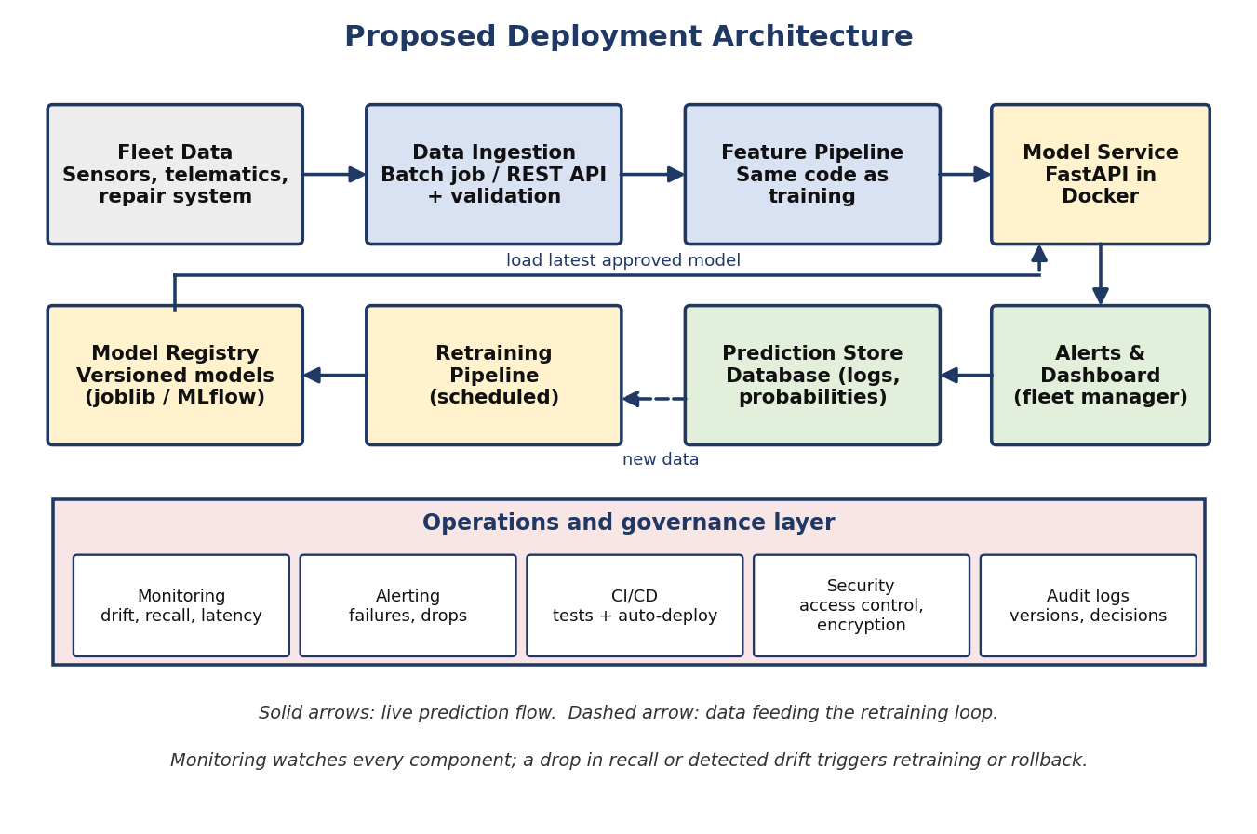

2.2 Infrastructure Overview
Component | Proposed technology | Purpose
Model service | Python, FastAPI, packaged in a Docker container | Loads the saved model and exposes a prediction endpoint with the same preprocessing used in training
Data ingestion | Scheduled batch job (cron / Airflow) and REST endpoint | Receives sensor, mileage and repair data and validates its schema before use
Storage | Relational database (PostgreSQL) and object storage | Stores predictions, input summaries, model versions and reports
Model registry | MLflow or versioned joblib files | Keeps every trained model with its parameters, metrics and data version
Hosting | Cloud virtual machines or managed containers (AWS, Azure or GCP) | Runs services with the option to scale up or down
CI/CD | GitHub Actions | Runs tests, builds the container and deploys approved versions
Monitoring | Logging with a dashboard (for example Grafana / Prometheus) | Tracks latency, errors, data drift and model performance

2.3 Step-by-Step Deployment Plan
- Freeze the final model, preprocessing statistics, decision threshold and configuration, and register them with a version number.
- Package the prediction code and model into a Docker image so it runs the same way on every machine.
- Run automated tests (unit, data schema and integration tests) in the CI pipeline.
- Deploy first to a staging environment and test with sample and historical data.
- Run in shadow mode for several weeks, comparing predictions with real breakdowns without acting on them.
- Pilot with a small group of vehicles and gather feedback from maintenance staff.
- Release to the full fleet, with the previous model kept ready for instant rollback.
- Monitor continuously and review performance on a fixed schedule (for example monthly).

2.4 Integration Procedures
- Data integration: connect to the fleet management or telematics system through an API or scheduled file export; validate every incoming record against the expected schema.
- Feature consistency: the same feature-building code is used for training and serving, preventing training-serving skew.
- Output integration: predictions and alerts are shown on a dashboard and can be sent as email or messages to the maintenance team; a maintenance work-order system can be linked later.
- API design: versioned endpoints (for example /v1/predict), input validation and clear error messages.

2.5 Scalability and Efficiency
- Horizontal scaling: run multiple container instances behind a load balancer when request volume grows.
- Batch processing: score vehicles in chunks, and use efficient data types so a large fleet can be processed quickly.
- Efficient models: tree-based models such as XGBoost predict quickly and need little compute; the model can be compressed or simplified if latency becomes an issue.
- Caching and scheduling: avoid re-scoring unchanged vehicles and schedule heavy jobs during low-usage hours to control cost.
- Cost control: monitor cloud usage and choose instance sizes based on measured load.

2.6 Maintenance Plan
- Performance monitoring: track recall, precision and the number of alerts, using confirmed breakdowns as ground truth when they become available.
- Drift detection: compare current input distributions with training data (for example with population stability index) and alert when they differ strongly.
- Scheduled retraining: retrain monthly or quarterly, or earlier if drift or a performance drop is detected; each new model must beat the current one on the same validation tests before it is promoted.
- Versioning and rollback: all models, code and data versions are tracked so any release can be reproduced or reversed.
- Documentation and ownership: a named owner, a runbook for incidents and a changelog for every update.

3. Ethical Considerations

3.1 Bias and Fairness
Although the model predicts machine failures rather than judging people, bias can still appear and cause unfair outcomes. If some vehicle types, routes, regions or older vehicles are under-represented in the training data, the model may be less accurate for them, causing missed failures or unnecessary servicing for those groups. If driver-related data is used, it could also unfairly blame drivers for failures caused by the vehicle or road conditions.
- Data audit: check that all vehicle types, ages and operating conditions are represented, and record known gaps.
- Segment evaluation: report recall and precision separately for each vehicle category, age band and region, and set a limit on how much performance may differ between groups.
- Feature review: avoid features that act as a proxy for sensitive information, and do not use individual driver identity unless there is a clear and justified need.
- Mitigation: collect more data for weak segments, use class or sample weights, and adjust thresholds per segment if justified.

3.2 Transparency and Explainability
- Explain each alert with SHAP values or feature contributions so staff can see why a vehicle was flagged.
- Provide a model card describing the purpose, training data, metrics, limitations and intended use.
- Show a probability and confidence level instead of a simple yes or no, and communicate that predictions are estimates.

3.3 Data Privacy and Security
- Data minimisation: collect only the data needed for failure prediction.
- Anonymisation: remove or pseudonymise driver names, licence details and exact location history wherever possible.
- Legal compliance: follow applicable data protection laws and company policy, such as the GDPR in Europe and India's Digital Personal Data Protection Act where relevant, including purpose limitation and retention limits.
- Security: encrypt data in transit and at rest, apply role-based access control, keep audit logs and store secrets securely.
- Retention: define how long raw data and prediction logs are kept and delete them afterwards.

3.4 Accountability and Human Oversight
- The model supports decisions but does not replace maintenance engineers; a person reviews high-impact decisions, particularly for safety-critical components.
- A clear owner is responsible for the model, with a process for staff to question or report wrong predictions.
- Safety first: the model must never be used as a reason to skip legally required inspections.

3.5 Other Ethical Concerns
- Over-reliance: staff may trust the model too much; training and periodic manual checks reduce this risk.
- Impact on workers: the system should be introduced as a tool that helps technicians prioritise work, and not as a tool to monitor or penalise them.
- Environmental benefit: better maintenance planning can reduce waste, emissions and unnecessary part replacement, which is a positive effect to track.

4. Risk Management Framework
Risks are identified, rated by likelihood and impact, assigned mitigation measures, and given a contingency plan that is executed if the risk occurs. The framework is reviewed after every release.
Risk | Likelihood | Impact | Mitigation (prevent) | Contingency (respond)
Data drift or concept drift | High | High | Drift monitoring, scheduled retraining | Retrain on recent data; fall back to the previous model or rule-based schedule
Training-serving skew | Medium | High | Share feature code; schema tests; shadow mode | Rollback to last stable version and fix the pipeline
Model service downtime | Medium | Medium | Health checks, multiple instances, auto-restart | Switch to batch results from the last successful run
Poor data quality or missing inputs | High | Medium | Validation rules at ingestion; alerts for missing fields | Reject or impute flagged records; notify the data owner
Too many false alarms (alert fatigue) | Medium | Medium | Threshold tuned for precision at least 60%; weekly review | Raise the threshold temporarily and re-tune
Missed failures (false negatives) | Medium | High | Recall-focused metric; periodic manual inspection kept in place | Investigate with error analysis; lower the threshold; add data
Security breach or data leak | Low | High | Encryption, access control, audit logs, regular updates | Incident response plan; revoke credentials; notify affected parties as required
Scalability bottlenecks | Medium | Medium | Load testing; autoscaling; efficient batch processing | Increase resources; scale out services
Bias against certain vehicle groups | Medium | Medium | Segment-wise evaluation; data audit | Retrain with more balanced data; apply segment thresholds
Loss of key staff or knowledge | Low | Medium | Documentation, runbooks, code reviews | Hand over using documentation; assign a backup owner
Regulatory or compliance change | Low | Medium | Regular legal and policy review | Update data handling and retention rules and re-document

Rollback criteria: if recall on recent confirmed events falls below an agreed limit (for example 70%) for two consecutive review periods, or a serious error is found, the previous approved model is restored while the cause is investigated.

5. Reflective Analysis

5.1 What I Learned
- A machine learning project is much more than choosing an algorithm. Defining the problem clearly, choosing the right metric and designing the pipeline carefully had more influence on success than any single model.
- Accuracy can be misleading. In Week 3, studying class imbalance showed me why recall, precision and PR-AUC are more meaningful for rare failure events.
- Data leakage is easy to introduce and hard to notice. Splitting data before preprocessing and keeping resampling inside cross-validation folds became a rule for the whole design.
- Good software structure matters. Splitting the code into modules, using a config file, tests and version control makes a project easier to maintain, which was the main lesson of Week 4.
- Deployment and ethics are part of the design from the beginning, not an afterthought. Monitoring, rollback, privacy and fairness decisions affect how the model should be built.

5.2 Challenges Faced
- Choosing between many algorithms and tools: there are many valid options, so I had to compare them against the specific problem and justify each choice.
- Balancing depth and time: the plan needed enough detail to be useful without trying to cover everything; organising the work week by week helped.
- Working without real fleet data: the project was designed around a public dataset and a hypothetical scenario, so some risks (for example drift and real-world label quality) could only be described and not tested.
- Turning ideas into clear documents: explaining technical decisions, diagrams and pseudocode in a simple and logical way took several revisions.

5.3 What Worked Well
- Connecting every week to the previous one (same problem, same targets, same metrics) kept the plan consistent.
- Using diagrams, tables and pseudocode made complex ideas easier to follow.
- Planning risks and contingencies early made each design decision more realistic.

5.4 Areas for Improvement and Future Work
- Implement the plan in code, run the experiment on the dataset and report the actual results against the targets set in Week 1.
- Test the approach with real fleet telemetry and compare it with the existing maintenance schedule.
- Explore time-series models such as LSTM, and survival analysis to predict the remaining useful life instead of only a yes or no answer.
- Build a small working demo (for example with Streamlit or FastAPI) and an automated monitoring dashboard.
- Estimate the financial benefit by comparing the cost of missed failures, false alarms and downtime with the cost of running the system.
- Involve maintenance engineers earlier to collect feedback on usefulness and trust.

6. Conclusion
The deployment strategy describes how the model would be packaged, integrated, scaled and maintained, with a phased rollout, monitoring and rollback to keep it reliable. The ethical analysis shows how bias, transparency, privacy, accountability and human oversight would be managed so the system is fair and safe to use. The risk management framework pairs each deployment risk with a prevention and a response plan. Finally, the reflection summarises the lessons learned over the five weeks and the next steps for turning this plan into a working, tested solution. Together, the five reports provide a complete roadmap from problem definition to responsible deployment.

