**#CODING TEST**

1. There is sample well data attached. Load the data into your favorite database (Mongo preferred).
2. Build a server with your favorite language (Node preferred) to communicate directly with the database and client (REST expected).
3. Build a React front-end with the following:
4. A React component containing a Leaflet map, which visualizes the well locations.
5. Please plot the latitude and longitude. Size the markers by the performance metric (here it’s fake_number). Add a hover-box which lists the UWI and Operator name.
6. A React component with a list of all UWIs and their associated lease, operator, and fake_number.
7. Host your site on Heroku
8. Share your github repository

**#PROGRESS**

1. 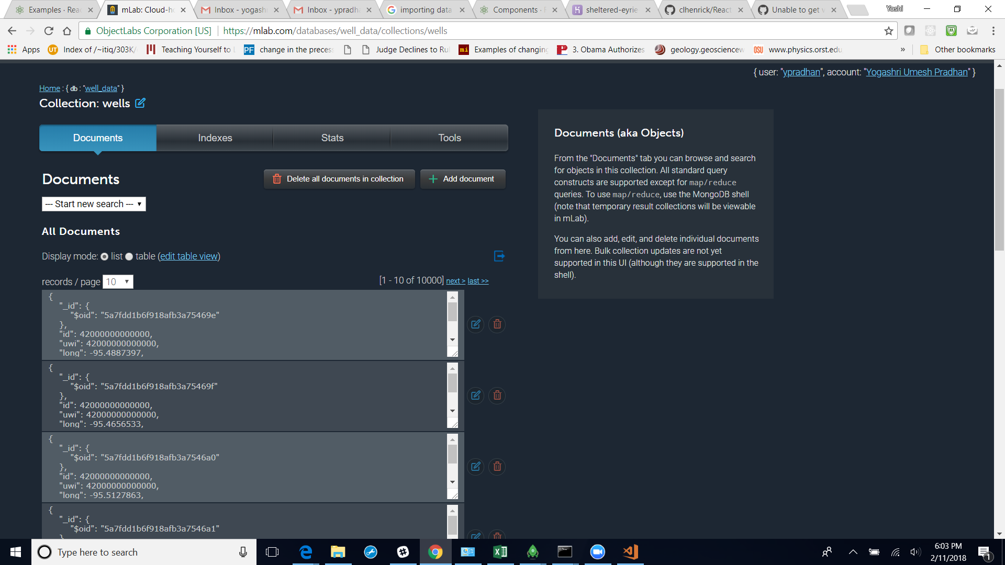Step one completed for importing into MongoDB

**Sources:**

<https://dba.stackexchange.com/questions/159390/mongodb-all-commands-spit-out-not-authorized-on-admin-to-execute-command>

<http://docs.mlab.com/migrating/>

Also, configured this database with the final Heroku application (created these two separately)

1. 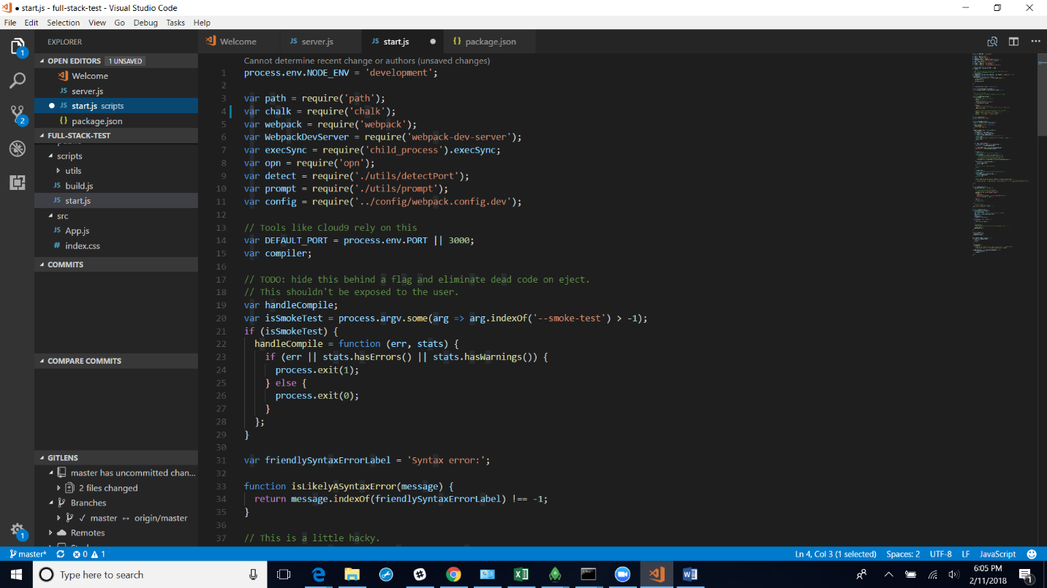Npm start is the server built for having the application to show up on the webpage
2. See github for folder structure and react components in src file to develop the map and see converted csv file to geoJSON for plotting. Used the React leaflet map demo as a reference point, but still working on rendering map onto the page

Extra folder to show previous iterations of this folder structure (see research folder)

<https://medium.com/@bryantheastronaut/react-getting-started-the-mern-stack-tutorial-feat-es6-de1a2886be50>

Credits for Map.js App. Js, Index.js, Scripts folder, config folder, and index.css: <https://github.com/clhenrick/React-Leaflet-demo>

Credits for map components for future rendering:

<https://react-leaflet.js.org/docs/en/components.html#maplayer>