Project Documentation

Project Title

**Cook Book: Your Virtual Kitchen Assistant**

**Team ID :** NM2025TMID44571

**Team Leader :** HAJIRA FATHIMA N fathimahajira337@gmail.com

**Team member :** YOGA SRI S syogasri819@gmail.com

**Team member :** MAHALAKSHMI S deepanmaha2006@gmail.com

**Team member :** DHARSHINI S dharshiniragav006@gmail.com

### ****1.Introduction****

**Cookbook: Your Virtual Kitchen Assistant** is a smart digital platform designed to simplify and enhance the cooking experience for users of all skill levels. It serves as an all-in-one kitchen companion that provides personalized recipes, cooking guidance, meal planning, grocery list management, and dietary recommendations based on user preferences and available ingredients.

**2. PROJECT OVERVIEW**

### ****purpose:****

The main goal of this project is to create an intelligent, interactive application that supports users throughout the cooking process—from planning meals and shopping for ingredients to preparing and serving dishes.

### ****Key Features:****

* **Personalized Recipe Suggestions:** Tailored recipes based on user preferences, dietary restrictions, and available ingredients.
* **Voice and Text Interaction:** Hands-free interaction through voice commands and chatbot support.
* **Step-by-Step Cooking Guidance:** Easy-to-follow instructions, including timers and video tutorials.
* **Smart Pantry Management:** Track pantry items and suggest recipes based on what’s on hand.
* **Meal Planning & Scheduling:** Weekly meal planner with nutritional insights.
* **Grocery List Automation:** Auto-generate grocery lists from selected recipes or meal plans.
* **Multilingual Support:** Recipes and instructions in multiple languages for global users.

**3. ARCHITECTURE**

### ****Frontend (Client Side)****

**Platform:** Mobile App (iOS& Android) – built using **Flutter** or **React Native**

**Components:**

* **User Interface (UI):** Clean, responsive, and easy-to-navigate design.
* **User Input Module:** Accepts input via text, touch, and voice.
* **Recipe Viewer:** Displays recipe steps, videos, and nutrition info.
* **Voice Assistant Interface:** Connects to backend AI services.
* **Grocery List & Pantry UI:** Allows users to add/remove items and track pantry stock.
* **Meal Planner UI:** Calendar-based view for planning meals.

### ****Backend (Server Side)****

**Platform:** Node.js / Django (Python) RESTful API

**Core Modules:**

* **User Management:**
  + Authentication (JWT or OAuth 2.0)
  + Profile & Preferences (dietary needs, allergies, favorite cuisines)
* **Recipe Engine:**
  + Recipe Database CRUD
  + Personalized Recipe Recommendations
  + Ingredient Matching (based on pantry)
* **Pantry & Grocery Module:**
  + Smart Pantry Tracking
  + Auto Grocery List Generation
  + Barcode/QR Code Scanner API
* **Meal Planner:**
  + Weekly schedule management
  + Notifications and Reminders
* **Voice/NLP Handler:**
  + Interfaces with AI services for voice and natural language understanding

**4. SETUP INSTRUCTIONS**

**Prerequisites:**

* Node.js
* MongoDB
* Git
* React.js
* Express.js
* Visual Studio Code
* Installation Steps:
* # Clone the repository
* git clone <repo-link>
* # Install client dependencies
* cd client
* npm install
* # Install server dependencies
* cd ../server
* npm install

**5. FOLDER STRUCTURE**

* InsightStream/
* │-- client/ # React frontend
* │ └── components/
* │ └── pages/
* │-- server/ # Node.js backend
* │ └── routes/
* │ └── models/
* │ └── controllers/
* │-- database/ # MongoDB collections

**6. RUNNING THE APPLICATION**

* Frontend:
* cd client
* npm start
* Backend:
* cd server
* npm start
* Access: Visit http://localhost:3000

**7. API DOCUMENTATION**

**User:**

* POST /api/user/register
* POST /api/user/login
* GET /api/user/profile
* PUT /api/user/profile

**Receipes:**

GET /api/recipes

GET /api/recipes/:id

POST /api/recipes

**Recipes suggesstions:**

POST /api/recipes/suggests

**Pantry management:**

GET /api/pantry

POST /api/pantry

**Grocery list:**

GET /api/grocery-list

POST /api/grocery-list

**Notifications:**

POST /api/notifications/subscribe

**Voice/NLP commands:**

POST /api/voice/command

**External APIs:**

/api/external/barcode/scan – scan barcode to get ingredient details

/api/external/recipe/search – pull recipes from public APIs

**8. AUTHENTICATION**

JWT-based authentication for secure login

Middleware protects private routes

**9. USER INTERFACE**

Landing Page

News Dashboard (categories, trending, sentiment)

Personalized Feed Page

Bookmark Manager

Admin Panel

**10. TESTING**

Manual Testing: During development milestones

Tools: Postman, Chrome Dev Tools, Jest (for frontend unit tests)

**11. SCREEN SHOTS**

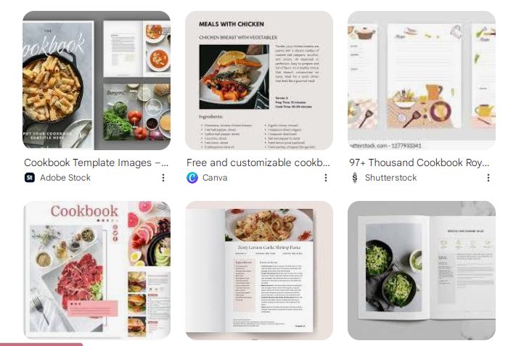

**12. KNOWN ISSUES**

Recipe Data Quality

Ingredient Recognition & Substitution

User Personalization

Voice / Chat Interaction Issue

Platform & Device Limitations

Usability Challenges

Integration Problems

Security & Privacy

**FUTURE ENHANCEMENTS**

Smart Personalization

Advanced Ingredient Handling

Voice & Gesture Control

Smart Kitchen Integration

Health & Nutrition Features

Shopping Assistance

Social & Community Features

Localization & Multilingual Support