EX:1

PROGRAM:

<html>
<head>
<title>Java Script </title>
<script>
document.write("JavaScript is a scripting language which is very easy to learn");
</script>
</head>
</html>

OUTPUT:

JavaScript is a scripting language which is very easy to learn

EX:2

PROGRAM:

<html>
<head>
<title>JavaScript Location </title>
<script>
function myFunction()
{
alert("JavaScript Code");
}
</script>
</head>
<body>
<button onclick="myFunction()">Popup</button>
</body>
</html>

OUTPUT:

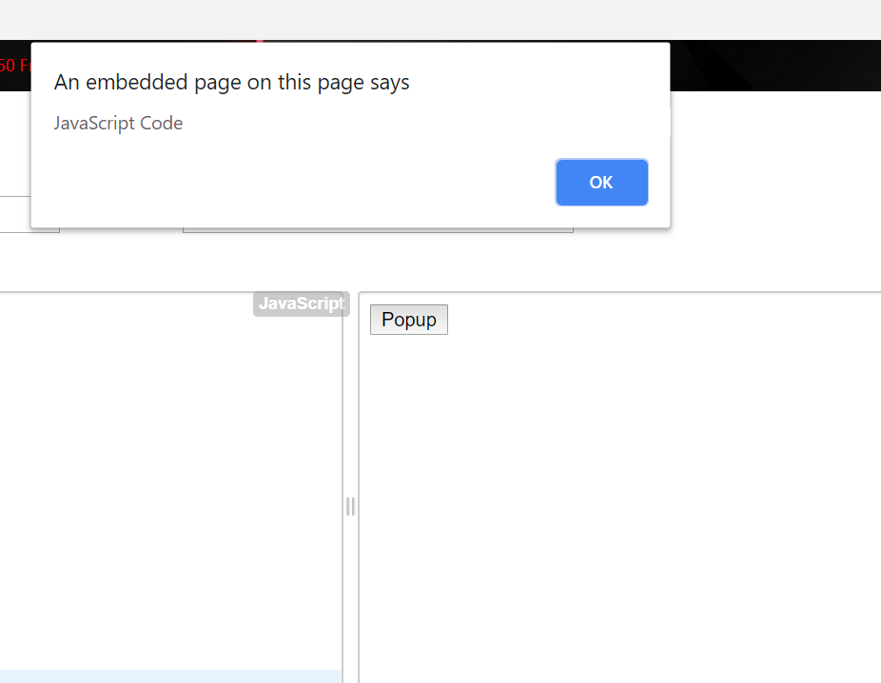

EX:3

PROGRAM:

<html>
<head>
<title>Ternary Operator</title>
<script>
var a =" yogasri";
var b = 19;
(typeof a == 'string')?document.write("Result - A is a string and B is numeric"):docu
ment.write("Result - A is a numeric and B is string");
</script>
</head>
<body>
<p id="demo"></p>
</body>
</html>

OUTPUT:

Result - A is a string and B is numeric

EX:4

PROGRAM:

<html>
<head>
<title>JavaScript Variables</title>
</head>
<body>
<p id="demo"> </p>
<script>
var a = "YOGA";
var b = " SRI";
var c = 19;
var pi= 3.14;
document.getElementById("demo").innerHTML = a + "<br>" + b + "<br>" + c +"<br>" + pi;
</script>
</body>
</html>

OUTPUT:

YOGA
SRI
19
3.14

EX:5

PROGRAM:

<html>
<head>
<title>JavaScript If</title>
</head>
<body>
<p id="demo"> </p>
<script>
var a = 20;
if(a > 18)
{
document.getElementById("demo").innerHTML ="Eligible for Voting";
}
else
{
document.getElementById("demo").innerHTML ="Not eligible for Voting";
}
</script>
</body>
</html>

OUTPUT:

Eligible for Voting

EX:6

PROGRAM:

<html>
<head>
<title>JavaScript Else If</title>
</head>
<body>
<p id="demo"> </p>
<script>
var a = 16;
if(a < 18)
{
document.getElementById("demo").innerHTML ="Minor, not eligible for voting";
}
else if(a > 60)
{
document.getElementById("demo").innerHTML ="Senior Citizen";
}
else
{
document.getElementById("demo").innerHTML ="Major, eligible for voting";
}
</script>
</body>
</html>

OUTPUT:

Minor, not eligible for voting

EX:7
PROGRAM:
<html>
<head>
<title>JavaScript While </title>
</head>
<body>
<p id="demo"> </p>
<script>
var a = ["January", "February", "March", "April", "May", "June", "July", "August", "September", "October", "November", "December"];
var m = 0;
var i = "";
while(a[m])
{
i +="<br>The month is " +a[m];
m++;
}
document.getElementById("demo").innerHTML = i;
</script>
</body>
</html>
OUTPUT:
The month is January
The month is February
The month is March
The month is April
The month is May
The month is June
The month is July
The month is August
The month is September
The month is October
The month is November
The month is December

EX:8

PROGRAM:

<html>
<head>
<title>JavaScript For </title>
</head>
<body>
<p id="demo"> </p>
<script>
var dept = ["IT", "CSE", "ECE", "MECH", "EEE", "Civil", "Aeronautical"];
var i;
for(i=0,len=dept.length,a ="";i<len;i++)
{
a += dept[i] + "<br>";
}
document.getElementById("demo").innerHTML = a;
</script>
</body>
</html>

OUTPUT:

IT
CSE
ECE
MECH
EEE
Civil
Aeronautical

EX:9

PROGRAM:

<html>
<head>
<title>JavaScript Arrays</title>
</head>
<body>
<p id="demo">
<script>
var bikes = ["Pulsar", "Royal Enfield", "Yamaha", "BMW" , "KTM", "R15"];
document.getElementById("demo").innerHTML = bikes;
</script>
</body>
</html>

OUTPUT:

Pulsar,Royal Enfield,Yamaha,BMW,KTM,R15

EX:10
PROGRAM:

<html>
<head>
<title>Alertbox </title>
<script>
function myFunction()
{
alert("This is JavaScript Alertbox");
}
</script>
</head>
<body>
<button onclick="myFunction()">Popup</button>
</body>
</html>

OUTPUT:

EX:11

PROGRAM:
<html>
<head>
<title>JavaScript Confirm</title>
</head>
<body>
<br>This is JavaScript code for Confirm Box</br>
<p id="demo">
<br> </br>
<button onclick="myFunction()">Try it</button>
<script>
function myFunction()
{
var text;
var r = confirm("Press a button");
if(r== true)
{
text="You Pressed OK";
}
else
{
text = "You pressed Cancel";
}
document.getElementById("demo").innerHTML = text;
}
</script>
</body>
</html>

OUTPUT:

EX:12

PROGRAM:
<html>
<head>
<title>JavaScript Prompt</title>
</head>
<body>
<br>This is the button to demonstrate prompt box</br>
<br></br>
<button onclick="myFunction()">Try It</button>
<p id="demo"> </p>
<script>
function myFunction()
{
var p = prompt("Enter your name","Swetha");
if(p!=null)
{
document.getElementById("demo").innerHTML = "Hello " + p + " . Which dept you belong to? ";
}
}
</script>
</body>
</html>

OUTPUT:

EX:13:
PROGRAM:
<html>
<head>
<title>Print</title>
</head>
<body>
This button is used to print the current page
<br> </br>
<button onclick="myFunction()">Print</button>
<script>
function myFunction()
{
window.print();
}
</script>
</body>
</html>

OUTPUT:

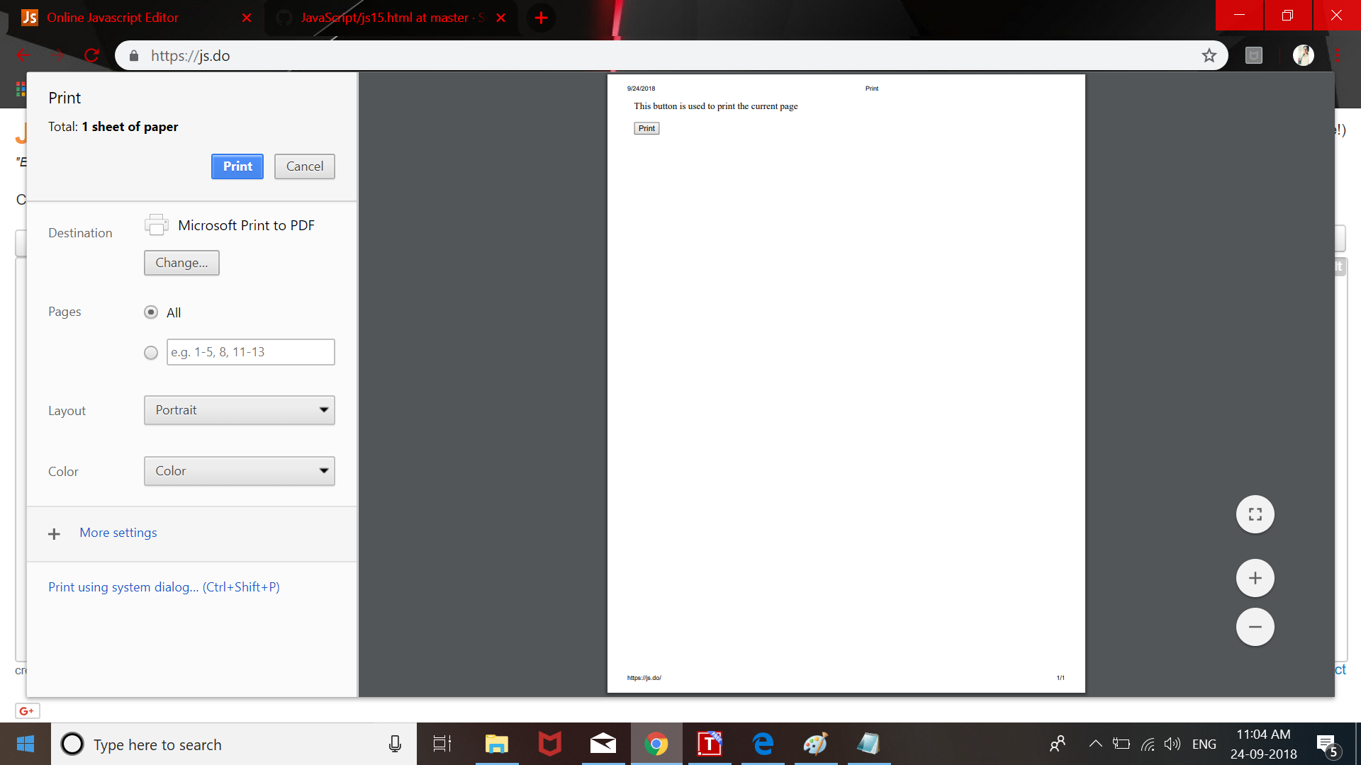

EX:14

PROGRAM:
<html>
<head>
<title>Redirect</title>
<script>
function Redirect()
{
window.location="http://www.yahoo.co.in";
}
document.write("<h2>You will be redirected to the main page.</h2>");
document.write("The page takes too long to respond. Please wait for few seconds.");
document.write("<h4>Sorry for the inconvenience.</h4>");
setTimeout('Redirect()', 10000);
</script>
</head>
<body>
</body>
</html>

OUTPUT:
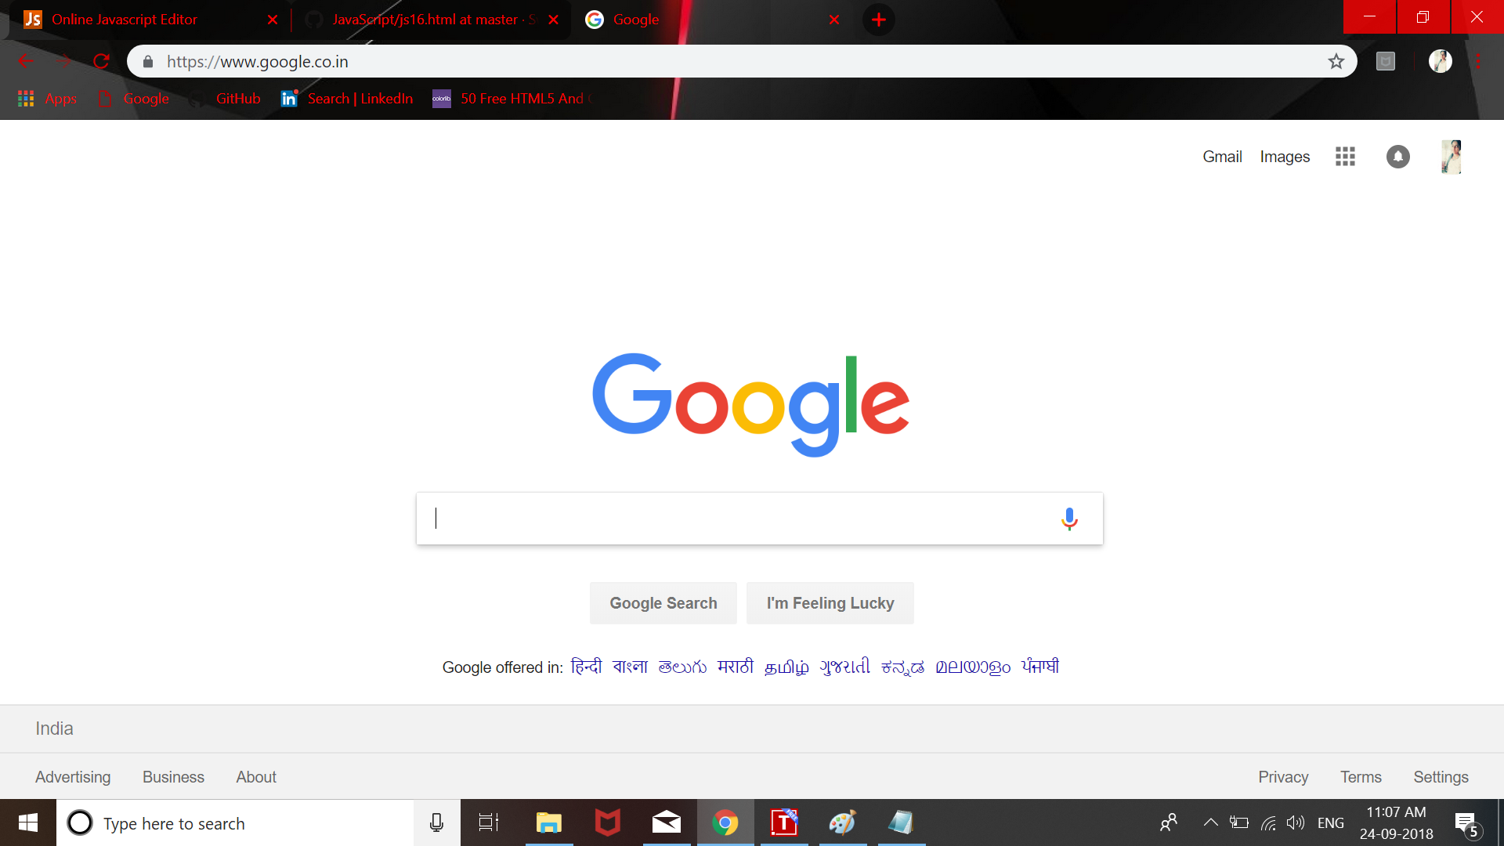

EX:15
PROGRAM:
<html>
<head>
<title>Popup New Browser</title>
</head>
<body>
<br>Click the button to open the web browser in new window</br>
<br></br>
<button onclick="myFunction()">Click me</button>
<script>
function myFunction()
{
var browser = window.open("http://www.yahoo.co.in", "_blank","toolbar=yes,scrollbars=yes,resizable=yes,top=500,left=500,width=500,height=400");
}
</script>
</body>
</html>

OUTPUT:

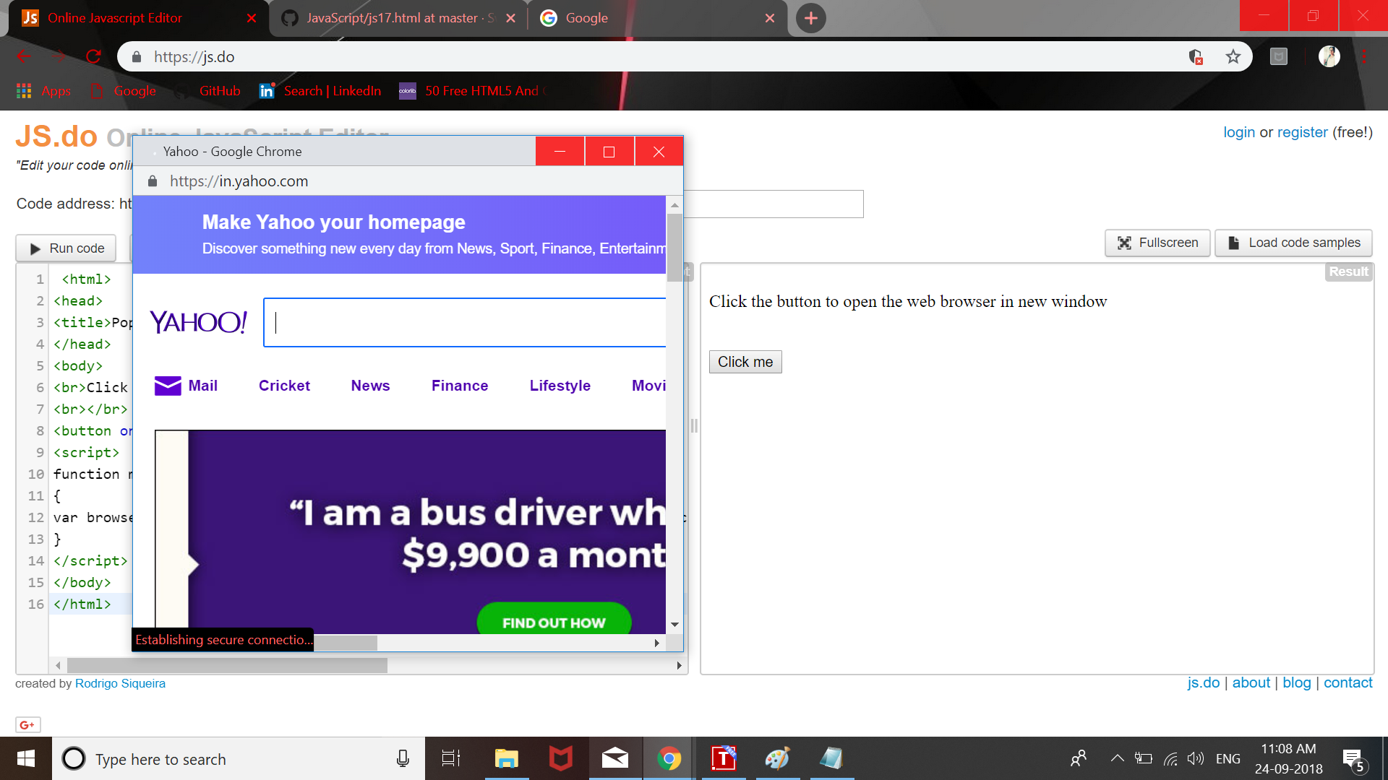

EX:16
PROGRAM:
<html>
<head>
<title>Date and Clock</title>
</head>
<body>
<script>
var dat = new Date();
var d, a, m, y, h, min, s;
d = dat.getDate();
a = dat.getDay();
m = dat.getMonth();
y = dat.getFullYear();
h = dat.getHours();
min = dat.getMinutes();
s = dat.getSeconds();
document.write ("<br>The current date is : </br>");
document.write("<br>DD : " + d + " MM : " + m + " YYYY : " + y + "</br>");
document.write ("<br>The current time is : </br>");
document.write("<br>hh : " + h + " mm : " + min + " ss : " + s + "</br>");
document.write("<br>Day : " + a +"</br>");
</script>
</body>
</html>

OUTPUT:

The current date is :
DD : 24 MM : 8 YYYY : 2018
The current time is :
hh : 11 mm : 9 ss : 51
Day : 1

EX:17
PROGRAM:
<html>
<head>
<title>Check non-empty</title>
<script>
function validateform()
{
var a = document.forms["sample"]["fname"].value;
if(a == "")
{
alert("Name field is to be filled");
return false;
}
}
</script>
</head>
<body>
<form name="sample" action = "js19ii.html" onsubmit="return validateform()" method="post">
Name : <input type = "text" name="fname">
<br></br>
<input type = "submit" name "Submit">
</form>
</body>
</html>
OUTPUT:

EX:18
PROGRAM:

<html>
<head>
<title>Check for numeric</title>
<script>
function myFunction()
{
var a = document.forms["sample"]["id"].value;
if(isNaN(a))
{
alert("Please enter the number");
return false;
}
}
</script>
</head>
<body>
<form name="sample" action="js20ii.html" onsubmit="return myFunction()" method="post">
ID : <input type = "text" name="id">
<br></br>
<input type = "submit" name ="Submit">
</form>
</body>
</html>

<html>
<body>
Your data has been received successfully
</body>
</html>
OUTPUT:
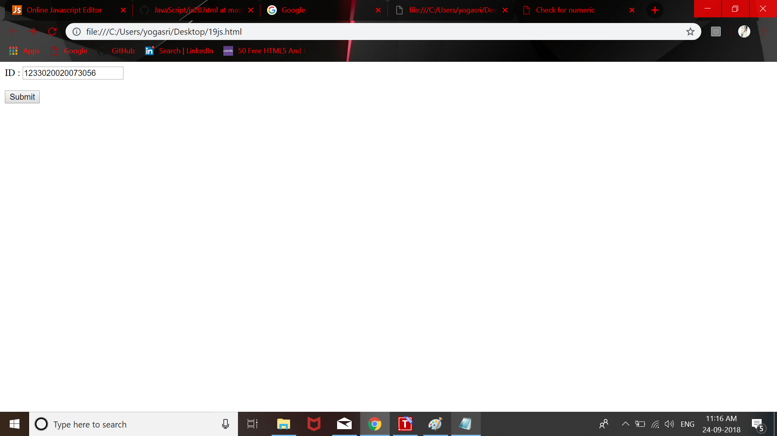

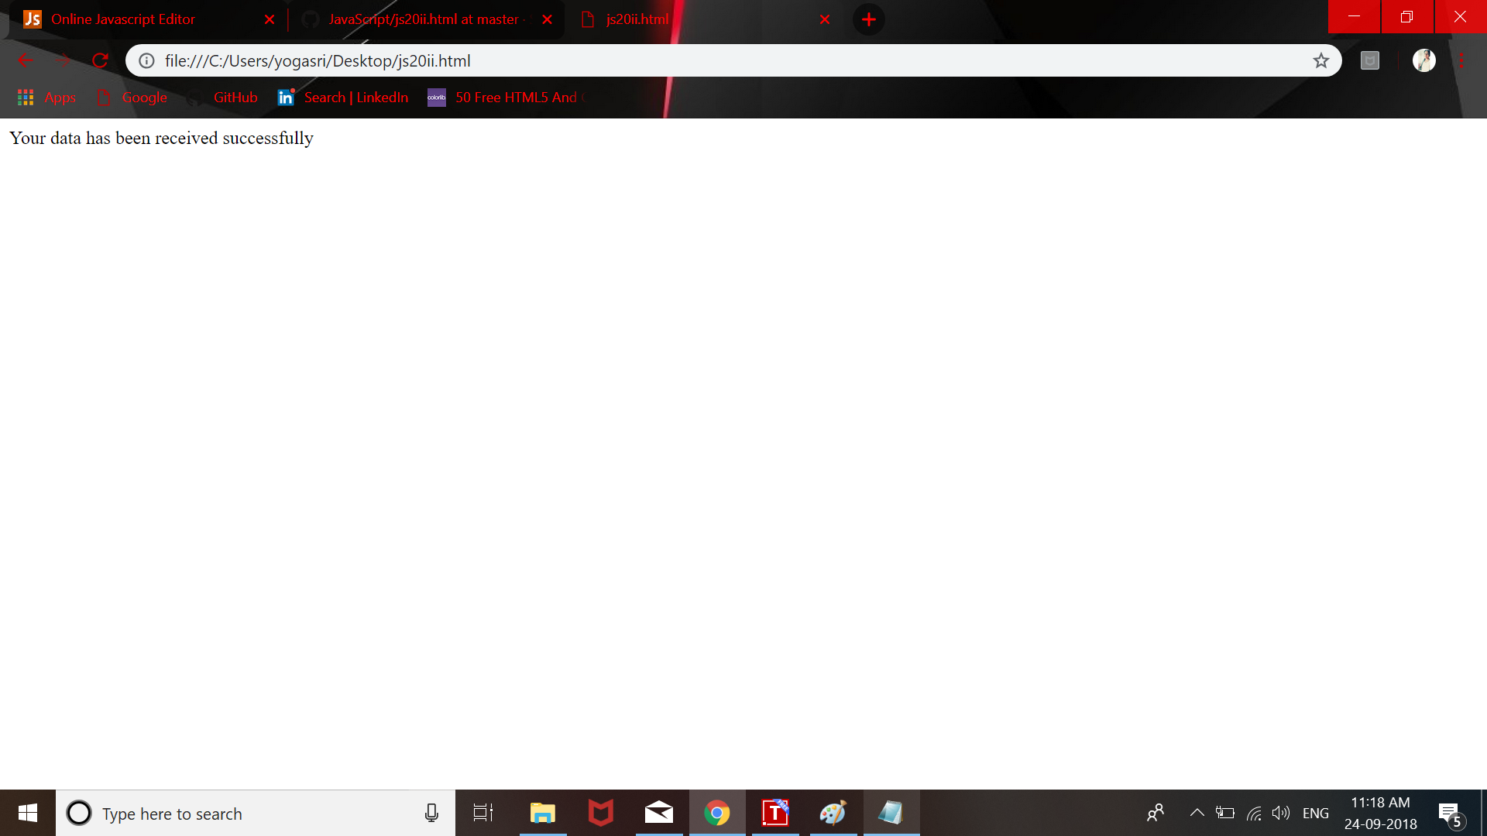

EX:19
PROGRAM:
<html>
<head>
<title>Check for letter</title>
<script>
function myFunction()
{
var a = document.forms["sample"]["fname"].value;
if(isNaN(a))
{
}
else
{
alert("Please enter the Letters");
return false;
}
}
</script>
</head>
<body>
<form name="sample" action="js21ii.html" onsubmit="return myFunction()" method="post">
Name : <input type = "text" name="fname">
<br></br>
<input type = "submit" name ="Submit">
</form>
</body>
</html>

OUTPUT:

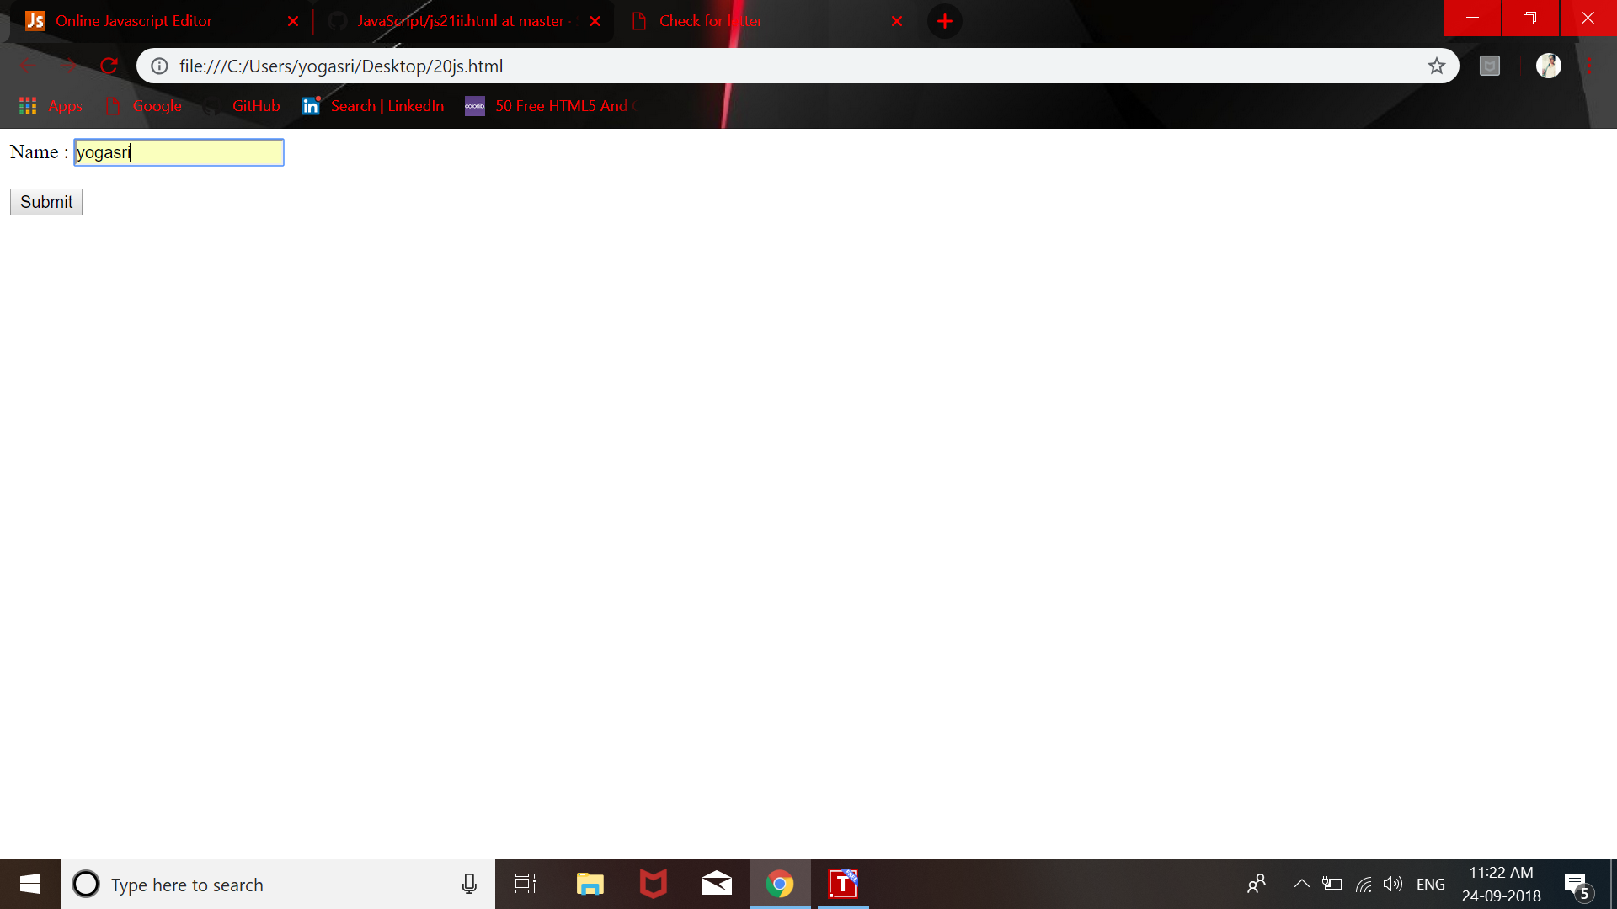

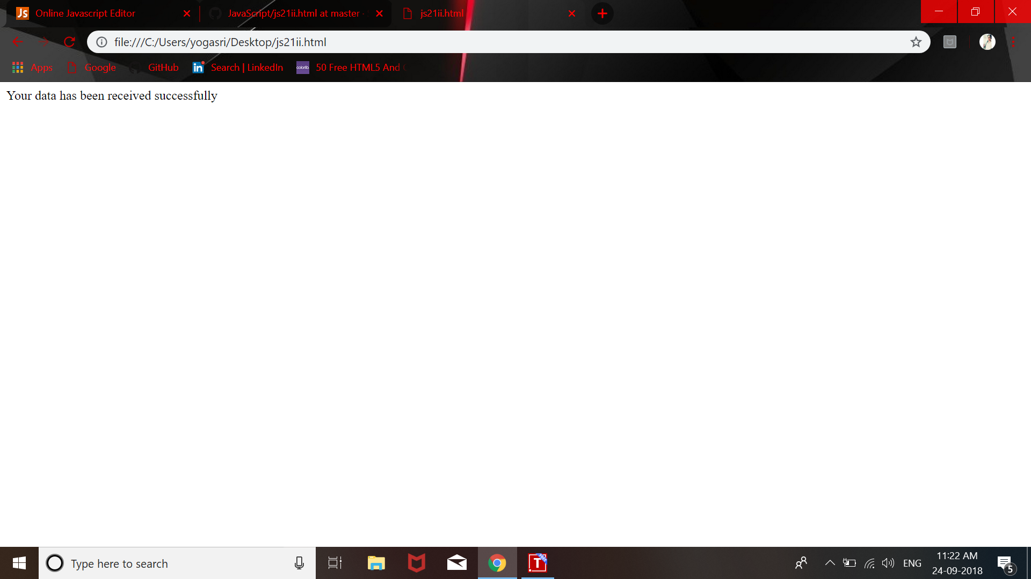

EX:20

PROGRAM:
<html>
<head>
<title>Check for letter and numbers</title>
<script>
function alphanumeric()
{
var a = document.forms["sample"]["fname"].value;
var letters = /^[0-9a-zA-Z]+$/;
if(a.match(letters))
{
}
else
{
alert("Please Enter the Alphanumeric Characters");
return false;
}
}
</script>
</head>
<body>
<form name="sample" action="js22ii.html" onsubmit="return alphanumeric()" method="post">
Name : <input type = "text" name="fname">
<br></br>
<input type = "submit" name ="Submit">
</form>
</body>
</html>

OUTPUT:
